$B$-Tubular Surfaces in Lorentzian Heisenberg Group $H^{3}$

Talat KÖRPINAR
Muş Alparslan University, Department of Mathematics
49250, Muş, TURKEY
e-mail: talatkorpinar@gmail.com

Abstract. In this paper, $B$-tubular surfaces in terms of biharmonic spacelike new type $B$-slant helices according to Bishop frame in the Lorentzian Heisenberg group $H^{3}$ are studied. necessary and sufficient conditions for new type $B$-slant helices to be biharmonic are obtained. $B$-tubular surfaces in the Lorentzian Heisenberg group $H^{3}$ are characterized. Additionally, main results in Fig.1,2,3,4 are illustrated.

Mathematics Subject Classifications: 31B30, 58E20.
Key words: Bienergy, Bishop frame, General helices Lorentzian Heisenberg group, New type $B$-slant helix, Tubular surface.

1 Introduction

Tubular surfaces are very useful for representing long thin objects, for instance, poles, 3D fonts, brass instrument or internal organs of the body in solid modeling. It includes natural quadrics (cylinder, cone and sphere), revolute quadrics, tori, pipes and Dupin cyclide. Also, canal surfaces are among the surfaces which are easier to describe both analytically and operationally, (CARMO, 1976), (FAROUKI; NEFF, 1990), (GRAY, 1998), (KORPINAR; TURHAN, 2011), (LU, 1994), (O'NEIL, 1983), (PETERNELL; POTTMANN, 1997), (TURHAN; KORPINAR, 2011a), (XU et al., (2006), (ZHU et al., 2005).
We remind that, if $γ$ is a space curve, a tubular surface associated to this curve is a surface swept by a family of spheres of constant radius (which will be the radius of the tube), having the center on the given curve. Alternatively, as we shall see in the next section, for them we can construct quite easily a parameterization using the Frenet frame associate to the curve. The tubular surfaces are used quite often in computer graphics, but we think they deserve more attention for several reasons. For instance, there is the problem of representing the curves themselves. Usually, the space curves are represented by using solids rather then tubes. There are, today, several very good computer algebra system (such as Maple, or Mathematica) which allow the vizualisation of curves and surfaces, in different kind of representations, (KORPINAR; TURHAN, 2012), (POTTMANN; PETERNELL, 1998).
The aim of this paper is to study tubular surfaces surrounding biharmonic spacelike $B$-slant helices according to Bishop frame in the Lorentzian Heisenberg group $H^{3}$.
Let $(M,g)$ and $(N,h)$ be Lorentzian manifolds and $φ:M→N$ a smooth map. Denote by $∇^{φ}$ the connection of the vector bundle $φ^{}\text{TN}$ induced from the Levi-Civita connection $∇^{h}$ of $(N,h)$. The second fundamental form $∇dφ$ is defined by
$\left(∇dφ\right)\left(X,Y\right)=∇_{X}^{φ}dφ\left(Y\right)−dφ\left(∇_{X}Y\right), X,Y∈Γ\left(\text{TM}\right)\text{.}$

Here $∇$ is the Levi-Civita connection of $(M,g)$. The tension field $τ\left(φ\right)$ is a section of $φ^{}\text{TN}$ defined by
$τ\left(φ\right)=\text{tr}∇dφ\text{.}$

A smooth map $φ$ is said to be harmonic if its tension field vanishes. It is well known that $φ$ is harmonic if and only if $φ$ is a critical point of the energy:
$E\left(φ\right)=\frac{1}{2}\int{}h\left(dφ,dφ\right){\text{dv}}_{g}$
over every compact region of $M$. Now let $φ:M→N$ be a harmonic map. Then the Hessian $H$ of $E$ is given by
$H_{φ}\left(V,W\right)=\int{}h\left(J_{φ}\left(V\right),W\right){\text{dv}}_{g}, V,W∈Γ\left(φ^{}\text{TN}\right)\text{.}$
Here the Jacobi operator $J_{φ}$ is defined by
$J_{φ}\left(V\right)\text{:=}Δ^{φ}V−R_{φ}\left(V\right), V∈Γ\left(φ^{}\text{TN}\right),$

$Δ^{φ}\text{:=}−_{i\text{=1}}^{m}\left(∇_{e_{i}}^{φ}∇_{e_{i}}^{φ}−∇_{∇_{e_{i}}e_{i}}^{φ}\right),R_{φ}\left(V\right)=_{i\text{=1}}^{m}R^{N}\left(V,dφ\left(e_{i}\right)\right)dφ\left(e_{i}\right),$
where $R^{N}$ and $\left\{e_{i}\right\}$ are the Riemannian curvature of $N$, and a local orthonormal frame field of $M$, respectively, (EELLS; SAMPSON, 1964), (JIANG, 1986a), (JIANG, 1986b), (TURHAN; KORPINAR, 2010).
Let $φ:(M,g)→(N,h)$ be a smooth map between two Lorentzian manifolds. The bienergy $E_{2}(φ)$ of $φ$ over compact domain $Ω⊂M$ is defined by
$h\left(τ\left(φ\right),τ\left(φ\right)\right){\text{dv}}_{g}\text{.}$

A smooth map $φ:(M,g)→(N,h)$ is said to be biharmonic if it is a critical point of the $E_{2}(φ)$.
The section $τ_{2}(φ)$ is called the bitension field of $φ$ and the Euler-Lagrange equation of $E_{2}$ is
$τ_{2}(φ)\text{:=}−J_{φ}\left(τ(φ)\right)\text{=0}\text{.}$

This study is organised as follows: Firstly, we give necessary and sufficient conditions for new type $B$-slant helices to be biharmonic. We characterize $B$-tubular surfaces in the Lorentzian Heisenberg group $H^{3}$. Secondly, we study $B$-tubular surfaces in terms of biharmonic spacelike new type $B$-slant helices according to Bishop frame in the Lorentzian Heisenberg group $H^{3}$. Finally, we illustrate our results in Fig.1,2,3,4.

2 The Lorentzian Heisenberg Group $H^{3}$

The Heisenberg group Heis${}^{3}$ is a Lie group which is diffeomorphic to $R^{3}$ and the group operation is defined as
$(x,y,z)⋅(\overline{x},\overline{y},\overline{z})=(x+\overline{x},y+\overline{y},z+\overline{z}−\overline{x}y+x\overline{y})\text{.}$

The identity of the group is $(\text{0,0,0})$ and the inverse of $(x,y,z)$ is given by $(−x,−y,−z)$ [RAHMANI; RAHMANI, 2006),. The left-invariant Lorentz metric on Heis${}^{3}$ is
$g=−{\text{dx}}^{2}+{\text{dy}}^{2}+(\text{xdy}+\text{dz})^{2}\text{.}$
The following set of left-invariant vector fields forms an orthonormal basis for the corresponding Lie algebra:
$\left\{e_{1}=\frac{∂}{∂z},e_{2}=\frac{∂}{∂y}−x\frac{∂}{∂z},e_{3}=\frac{∂}{∂x}\right\}\text{.}$ (2.1)
The characterising properties of this algebra are the following commutation relations:
$g(e_{1}{\text{,e}}_{1})=g(e_{2}{\text{,e}}_{2})\text{=1,} g(e_{3}{\text{,e}}_{3})=−1\text{.}$
Proposition 2.1. For the covariant derivatives of the Levi-Civita connection of the left-invariant metric $g$, defined above the following is true:
$∇=\left(\begin{matrix}0 & e_{3} & e_{2} \\ e_{3} & 0 & e_{1} \\ e_{2} & −e_{1} & 0\end{matrix}\right),$ (2.2)
where the $(i,j)$-element in the table above equals $∇_{e_{i}}e_{j}$ for our basis
$\left\{e_{k},k\text{=1,2,3}\right\}\text{.}$

Moreover we put
$R_{\text{ijk}}=R(e_{i}{\text{,e}}_{j})e_{k}, R_{\text{ijkl}}=R(e_{i}{\text{,e}}_{j}{\text{,e}}_{k}{\text{,e}}_{l}),$
where the indices $i,j,k$ and $l$ take the values $\text{1,2}$ and $3$.
$R_{\text{121}}=−e_{2}, R_{\text{131}}=−e_{3}, R_{\text{232}}\text{=3}e_{3}$
and
$R_{\text{1212}}=−\text{1,} R_{\text{1313}}\text{=1,} R_{\text{2323}}=−3\text{.}$

3 Spacelike Biharmonic New Type $B−$Slant Helices with Bishop Frame In The Lorentzian Heisenberg Group $H^{3}$

Let $γ:I→H^{3}$ be a non geodesic spacelike curve on the Lorentzian Heisenberg group $H^{3}$ parametrized by arc length. Let $\left\{\text{t,n,b}\right\}$ be the Frenet frame fields tangent to the Lorentzian Heisenberg group $H^{3}$ along $γ$ defined as follows:
$t$ is the unit vector field $γ^{'}$ tangent to $γ$, $n$ is the unit vector field in the direction of $∇_{t}t$ (normal to $γ$), and $b$ is chosen so that $\left\{\text{t,n,b}\right\}$ is a positively oriented orthonormal basis. Then, we have the following Frenet formulas, (TURHAN; KORPINAR, 2011b):
$∇_{t}t=κ\text{n,}$
$∇_{t}n=κt+τ\text{b,}$ (3.1)
$∇_{T}B=τn,$
where $κ$ is the curvature of $γ$ and $τ$ is its torsion and
$g\left(\text{t,t}\right)\text{=1,}g\left(\text{n,n}\right)=−\text{1,}g\left(\text{b,b}\right)\text{=1,}$
$g\left(\text{t,n}\right)=g\left(\text{t,b}\right)=g\left(\text{n,b}\right)\text{=0}\text{.}$

In the rest of the paper, we suppose everywhere $κ≠0$ and $τ≠0$.
The Bishop frame or parallel transport frame is an alternative approach to defining a moving frame that is well defined even when the curve has vanishing second derivative, (BISHOP, 1975). The Bishop frame is expressed as
$∇_{t}t=k_{1}m_{1}−k_{2}m_{2},$
$∇_{t}m_{1}=k_{1}t,$ (3.2)
$∇_{t}m_{2}=k_{2}t,$
where
$g\left(\text{t,t}\right)\text{=1,}g\left(m_{1},m_{1}\right)=−\text{1,}g\left(m_{2},m_{2}\right)\text{=1,}$
$g\left(T,M_{1}\right)=g\left(t,m_{2}\right)=g\left(m_{1},m_{2}\right)\text{=0}\text{.}$

Here, we shall call the set $\left\{{\text{t,m}}_{1}{\text{,m}}_{2}\right\}$ as Bishop trihedra, $k_{1}$ and $k_{2}$ as Bishop curvatures.
Also, $τ(s)=ψ^{'}\left(s\right)$ and $κ(s)=\sqrt{\left|k_{2}^{2}−k_{1}^{2}\right|}\text{.}$

With respect to the orthonormal basis $\left\{e_{1}{\text{,e}}_{2}{\text{,e}}_{3}\right\}$ we can write
$t=t^{1}e_{1}+t^{2}e_{2}+t^{3}e_{3},$
$m_{1}=m_{1}^{1}e_{1}+m_{1}^{2}e_{2}+m_{1}^{3}e_{3},$ (3.3)
$m_{2}=m_{2}^{1}e_{1}+m_{2}^{2}e_{2}+m_{2}^{3}e_{3}\text{.}$

Theorem 3.1. $γ:I→H^{3}$ is a spacelike biharmonic curve with Bishop frame if and only if
$k_{1}^{2}−k_{2}^{2}=\text{constant}=C≠\text{0,}$
$k_{1}^{\text{''}}+\left[k_{1}^{2}−k_{2}^{2}\right]k_{1}=−k_{1}\left[1+4{\left(m_{2}^{1}\right)}^{2}\right]+4k_{2}m_{1}^{1}m_{2}^{1},$ (3.4)
$k_{2}^{\text{''}}+\left[k_{1}^{2}−k_{2}^{2}\right]k_{2}=−4k_{1}m_{1}^{1}m_{2}^{1}−k_{2}\left[−1+4{\left(m_{1}^{1}\right)}^{2}\right]\text{.}$

Proof. Using Eq.(2.2) and Jacobi operator, we obtain above system. This completes the proof.

Definition 3.2. A regular spacelike curve $γ:I→H^{3}$ is called a new type slant helix provided the spacelike unit vector $m_{2}$ of the curve $γ$ has constant angle $Q$ with spacelike vector $u,$ that is
$g\left(m_{2}\left(s\right),u\right)=\text{cos}Q \text{for all }s∈I\text{.}$ (3.5)

The condition is not altered by reparametrization, so without loss of generality we may assume that slant helices have unit speed. The slant helices can be identified by a simple condition on natural curvatures.

To separate a spacelike new type slant helix according to Bishop frame from that of Frenet- Serret frame, in the rest of the paper, we shall use notation for the curve defined above as spacelike new type $B$-slant helix.

4 $B−$Tubular Surfaces in terms of Spacelike Biharmonic New Type $B−$Slant Helices according to Bishop Frame in the Heisenberg Group $H^{3}$

The envelope of a 1-parameter family of the spheres in the Lorentzian Heisenberg group $H^{3}$ is called a tubular surface in the Lorentzian Heisenberg group $H^{3}$. The curve formed by the centers of the spheres is called center curve of the tubular surface. The radius of the tubular surface is the function $r$ such that $r$ is the constant radius of the sphere.
To separate a tubular surface according to Bishop frame from that of Frenet- Serret frame, in the rest of the paper, we shall use notation for the surface defined above as $B$-tubular surface.

Theorem 4.1. Let $γ:I→H^{3}$ be a unit speed biharmonic spacelike new type $B−$slant helix with non-zero curvatures. Then the equation of $B−$tubular surface $M^{B}\left(s,t\right)$ is
$M^{B}\left(s,t\right)=[\text{sin}Qs−\frac{C_{2}}{C_{0}}\text{cos}Q\text{sinh}[C_{0}s+C_{1}]−\frac{1}{4C_{0}}{\text{cos}}^{2}Q(2[C_{0}s+C_{1}]+\text{sinh}2[C_{0}s+C_{1}])$
$+C_{4}+[\frac{1}{C_{0}}\text{cos}Q\text{cosh}[C_{0}s+C_{1}]+C_{2}][\frac{1}{C_{0}}\text{cos}Q\text{sinh}[C_{0}s+C_{1}]+C_{3}]$
$+r\text{cosh}t\text{cos}Q]e_{1}+[\frac{1}{C_{0}}\text{cos}Q\text{sinh}[C_{0}s+C_{1}]+C_{3}$ (4.1)
$+r\text{sinh}t\text{sinh}[C_{0}s+C_{1}]+r\text{cosh}t\text{sin}Q\text{cosh}[C_{0}s+C_{1}]]e_{2}$
$+[\frac{1}{C_{0}}\text{cos}Q\text{cosh}[C_{0}s+C_{1}]+C_{2}+r\text{sinh}t\text{cosh}[C_{0}s+C_{1}]$
$−r\left(s\right)r^{'}\left(s\right)\text{cos}Q\text{sinh}[C_{0}s+C_{1}]+r\text{cosh}t\text{sin}Q\text{sinh}[C_{0}s+C_{1}]]e_{3},$
where $C_{0},C_{1},C_{2},C_{3}$ are constants of integration and
$C_{0}=\frac{\sqrt{k_{2}^{2}−k_{1}^{2}}}{\text{cos}Q}−2\text{sin}Q\text{.}$

Proof. Assume that the center curve of $B−$tubular surface $M^{B}\left(s,t\right)$ is a unit speed spacelike biharmonic $B−$slant helix $γ$ and $M^{B}$ denote a patch that parametrizes the envelope of the spheres defining the tubular surface.
Thus, it is seen that
$M^{B}\left(s,t\right)=γ\left(s\right)+a\left(s,t\right)t\left(s\right)+b\left(s,t\right)m_{1}\left(s\right)+c\left(s,t\right)m_{2}\left(s\right),$ (4.2)
where $a$, $b$ and $c$ are differentiable on the interval on which $γ$ is defined.
So, without loss of generality, we take the axis of $γ$ is parallel to the spacelike vector $e_{1}$. Then,
$g\left(m_{2}{\text{,e}}_{1}\right)=m_{2}^{1}=\text{cos}Q,$ (4.3)
where $Q$ is constant angle.
On the other hand, the vector $m_{2}$ is a unit spacelike vector, we reach
$m_{2}=\text{cos}{Qe}_{1}+\text{sin}Q\text{cosh}A\left(s\right)e_{2}+\text{sin}Q\text{sinh}A\left(s\right)e_{3}\text{.}$ (4.4)

On the other hand, using Bishop formulas Eq.(3.2) and Eq.(2.1), we have
$m_{1}=\text{sinh}A\left(s\right)e_{2}+\text{cosh}A\left(s\right)e_{3}\text{.}$ (4.5)

It is apparent that
$t=\text{sin}{Qe}_{1}+\text{cos}Q\text{cosh}A\left(s\right)e_{2}+\text{cos}Q\text{sinh}A\left(s\right)e_{3}\text{.}$ (4.6)

A straightforward computation shows that
$∇_{t}t=(t_{1}^{'})e_{1}+(t_{2}^{'}+2t_{1}t_{3})e_{2}+(t_{3}^{'}+2t_{1}t_{2})e_{3}\text{.}$

Therefore, we use Bishop formulas Eq.(3.2) and above equation we get
$A\left(s\right)=[\frac{\sqrt{k_{2}^{2}−k_{1}^{2}}}{\text{cos}Q}−2\text{sin}Q]s+C_{1},$ (4.7)
where $C_{1}$ is a constant of integration.
From Eq.(4.6), we get
$t=(\text{cos}Q\text{sinh}[C_{0}s+C_{1}],\text{cos}Q\text{cosh}[C_{0}s+C_{1}],\text{sin}Q−x\text{cos}Q\text{cosh}[C_{0}s+C_{1}])\text{.}$ (4.8)

Since,
$$γ\left(s\right)=[\text{sin}Qs−\frac{C_{2}}{C_{0}}\text{cos}Q\text{sinh}[C_{0}s+C_{1}]−\frac{1}{4C_{0}}{\text{cos}}^{2}Q(2[C_{0}s+C_{1}]+\text{sinh}2[C_{0}s+C_{1}])+C_{4}$$
$+[\frac{1}{C_{0}}\text{cos}Q\text{cosh}[C_{0}s+C_{1}]+C_{2}][\frac{1}{C_{0}}\text{cos}Q\text{sinh}[C_{0}s+C_{1}]+C_{3}]]e_{1}$
$+[\frac{1}{C_{0}}\text{cos}Q\text{sinh}[C_{0}s+C_{1}]+C_{3}]e_{2}+[\frac{1}{C_{0}}\text{cos}Q\text{cosh}[C_{0}s+C_{1}]+C_{2}]e_{3},$
where $C_{0}=\frac{\sqrt{k_{2}^{2}−k_{1}^{2}}}{\text{cos}Q}−2\text{sin}Q\text{.}$
On the other hand, using definition of tubular surface, we have
$g\left(M^{B}\left(s,t\right)−γ\left(s\right),M^{B}\left(s,t\right)−γ\left(s\right)\right)=r^{2}\left(s\right)\text{.}$ (4.9)

Since $M^{B}\left(s,t\right)−γ\left(s\right)$ is a normal vector to the tubular surface, we get
$g\left(M^{B}\left(s,t\right)−γ\left(s\right),M_{s}^{B}\left(s,t\right)\right)\text{=0}\text{.}$ (4.10)
Using now Eq.(4.9) and Eq.(4.10), we get
$a^{2}\left(s\right)−b^{2}\left(s\right)+c^{2}\left(s\right)=r^{2}\left(s\right),$ (4.11)
$a\left(s\right)a_{s}\left(s\right)−b\left(s\right)b_{s}\left(s\right)+c\left(s\right)c_{s}\left(s\right)\text{=0}\text{.}$
When we differentiate Eq.(4.2) with respect to $s$ and use the Bishop formulas, we obtain
$M_{s}^{B}\left(s,t\right)=\left(1+a_{s}\left(s\right)+b\left(s\right)k_{1}+c\left(s\right)k_{2}\right)t\left(s\right)$ (4.12)
$+\left(a\left(s\right)k_{1}+b_{s}\right)m_{1}\left(s\right)+\left(c_{s}\left(s\right)−a\left(s\right)k_{2}\right)m_{2}\left(s\right)\text{.}$
Combining Eq.(4.9) and Eq.(4.10) we have
$a\left(s\right)=−r\left(s\right)r^{'}\left(s\right)\text{.}$ (4.13)
A further computation gives
$−b^{2}\left(s\right)+c^{2}\left(s\right)=r^{2}\left(s\right)\left(1−{\left(r^{'}\left(s\right)\right)}^{2}\right)\text{.}$ (4.14)
The solution of Eq.(4.14) can be written in the following form
$b\left(s\right)=r\text{sinh}t,$ (4.15)
$c\left(s\right)=r\text{cosh}t\text{.}$
Thus Eq.(4.2) becomes
$M^{B}\left(s,t\right)=γ\left(s\right)+r\text{sinh}{tm}_{1}\left(s\right)+r\text{cosh}{tm}_{2}\left(s\right)\text{.}$ (4.16)
Therefore, by Eqs.(4.4) - (4.6) and taking into account Eq.(4.16), we obtain the system Eq.(4.1). This completes the proof.

Theorem 4.2. Let $γ:I→H^{3}$ be a unit speed spacelike biharmonic new type $B−$slant helix with non-zero Bishop curvatures. Then, the parametric equations of $B−$tubular surface $M^{B}\left(s,t\right)$ are
$x_{M^{B}}\left(s,t\right)=[\frac{1}{C_{0}}\text{cos}Q\text{cosh}[C_{0}s+C_{1}]+r\text{sinh}t\text{cosh}[C_{0}s+C_{1}]+r\text{cosh}t\text{sin}Q\text{sinh}[C_{0}s+C_{1}]+C_{2}],$
$y_{M^{B}}\left(s,t\right)=[\frac{1}{C_{0}}\text{cos}Q\text{sinh}[C_{0}s+C_{1}]+r\text{sinh}t\text{sinh}[C_{0}s+C_{1}]+r\text{cosh}t\text{sin}Q\text{cosh}[C_{0}s+C_{1}]+C_{3}],$
$z_{M^{B}}\left(s,t\right)=[\text{sin}Qs−\frac{C_{2}}{C_{0}}\text{cos}Q\text{sinh}[C_{0}s+C_{1}]−\frac{1}{4C_{0}}{\text{cos}}^{2}Q(2[C_{0}s+C_{1}]+\text{sinh}2[C_{0}s+C_{1}])+C_{4}$
$+[\frac{1}{C_{0}}\text{cos}Q\text{cosh}[C_{0}s+C_{1}]+C_{2}][\frac{1}{C_{0}}\text{cos}Q\text{sinh}[C_{0}s+C_{1}]+C_{3}]$ (4.17)
$$+r\text{cosh}t\text{cos}Q]−[\frac{1}{C_{0}}\text{cos}Q\text{cosh}[C_{0}s+C_{1}]+C_{2}$$
$$+r\text{sinh}t\text{cosh}[C_{0}s+C_{1}]+r\text{cosh}t\text{sin}Q\text{sinh}[C_{0}s+C_{1}]][\frac{1}{C_{0}}\text{cos}Q\text{sinh}[C_{0}s+C_{1}]+C_{3}$$
$+r\text{sinh}t\text{sinh}[C_{0}s+C_{1}]+r\text{cosh}t\text{sin}Q\text{cosh}[C_{0}s+C_{1}]]$,

where $C_{0},C_{1},C_{2},C_{3}$ are constants of integration and
$C_{0}=\frac{\sqrt{k_{2}^{2}−k_{1}^{2}}}{\text{cos}Q}−2\text{sin}Q\text{.}$

Proof. Using Eq.(2.1) and Eq.(4.1), we have Eq.(4.17). Thus proof is complete.

The obtained parametric equations for Eq.(4.17) is illustrated in Fig.1,2,3 with helping the programme of Mathematica as follow:

${\text{itbpF}2\text{.}\text{37}\text{in}2\text{.}\text{4064}\text{in}0\text{inFigurelanguage}\text{ ital }ScientificWord\text{;}\text{type}\text{ ital }GRAPHIC\text{;}\text{maintain}−\text{aspect}−\text{ratioTRUE};\text{display}\text{ ital }USEDEF\text{;}{\text{valid}}_{f}\text{ile}\text{T}\text{;}\text{width}2\text{.}\text{37}\text{in};\text{height}2\text{.}\text{4064}\text{in};\text{depth}0\text{in};\text{original}−\text{width}5\text{.}\text{0283}\text{in};\text{original}−\text{height}5\text{.}\text{1081}\text{in};\text{cropleft}0\text{;}\text{croptop}1\text{;}\text{cropright}1\text{;}\text{cropbottom}0\text{;}\text{tempfilenam \{}e}^{'}M2D3\text{JT}\text{00}\text{.}\text{wm \{}f{}^{'};\text{tempfile}−\text{properties}\text{ ital }XPR\text{;}$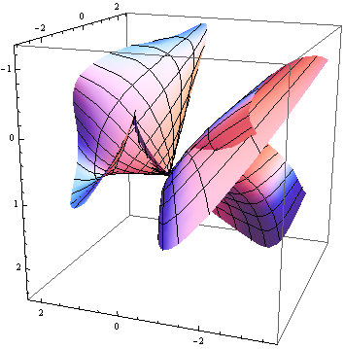
$\text{Fig}\text{.}\text{1:}$

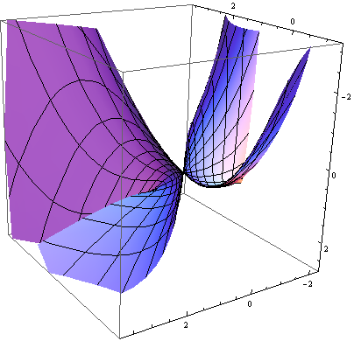
$\text{Fig}\text{.}\text{2:}$

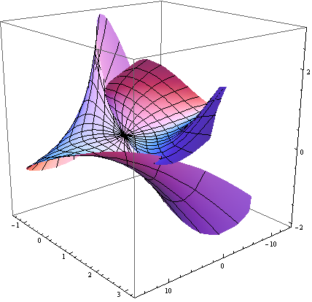
$\text{Fig}\text{.}\text{3:}$

Corollary 4.3. Let $γ:I→H^{3}$ be a unit speed biharmonic spacelike new type $B−$slant helix with non-zero Bishop curvatures. Then the equations of $γ$ are
$x\left(s\right)=\frac{1}{C_{0}}\text{cos}Q\text{cosh}[C_{0}s+C_{1}]+C_{2},$
$y\left(s\right)=\frac{1}{C_{0}}\text{cos}Q\text{sinh}[C_{0}s+C_{1}]+C_{3},$
$z\left(s\right)=\text{sin}Qs−\frac{C_{2}}{C_{0}}\text{cos}Q\text{sinh}[C_{0}s+C_{1}]$
$−\frac{1}{4C_{0}}{\text{cos}}^{2}Q(2[C_{0}s+C_{1}]+\text{sinh}2[C_{0}s+C_{1}])+C_{4},$
where $C_{0},C_{1},C_{2},C_{3}$ are constants of integration and
$C_{0}=\frac{\sqrt{k_{2}^{2}−k_{1}^{2}}}{\text{cos}Q}−2\text{sin}Q\text{.}$

If we use Mathematica in above system, we get:
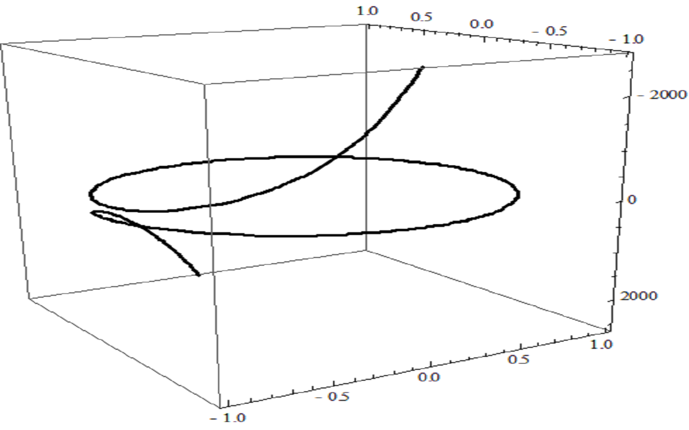

$\text{Fig}\text{.}4\text{.}$
4 Conclusion

A tubular surface associated to a curve is a surface swept by a family of spheres of constant radius (which will be the radius of the tube), having the center on the given curve. Alternatively, as we shall see in the next section, for them we can construct quite easily a parameterization using the Frenet frame associate to the curve.
In this work, $B$-tubular surfaces in the Lorentzian Heisenberg group $H^{3}$ are characterized.

Acknowledgements

The author wish to thank the referees for providing constructive comments and valuable suggestions.

References

BISHOP, L. R. There is More Than One Way to Frame a Curve. American Mathematical Monthly, v.82, n.3, p.246-251,1975.
CARMO, M.D. Differential Geometry of Curves and Surfaces. Prentice Hall, New Jersey, 1976.
EELLS, J.; SAMPSON, J. H. Harmonic mappings of Riemannian manifolds. American Journal of Mathematics, v.86 , p.109-160, 1964.
FAROUKI, R.T.; NEFF, C.A. Algebraic properties of plane offset curves. Comput. Aided Geom. Design, v.7, p.101-127, 1990.
GRAY, A. Modern Differential Geometry of Curves and Surfaces with Mathematica. CRC Press, 1998.
JIANG, G. Y. 2-harmonic isometric immersions between Riemannian manifolds. Chinese Annals of Mathematics Series A, v.7, n.2, p.130-144, 1986a.
JIANG, G. Y. 2-harmonic maps and their first and second variational formulas. Chinese Annals of Mathematics Series A, v.7, n.4, p.389-402, 1986b.
KORPINAR, T.; TURHAN, E. On characterization of B-canal surfaces in terms of biharmonic B-slant helices according to Bishop frame in Heisenberg group Heis${}^{3}$. Journal of Mathematical Analysis and Applications, v.382, p.57-65, 2011.
KORPINAR, T.; TURHAN, E. Tubular Surfaces Around Timelike Biharmonic Curves in Lorentzian Heisenberg Group Heis³. Analele Stiintifice ale Universitatii Ovidius Constanta, Seria Matematica, v.20 n.1, p.431-445, 2012.
LU, W. Rationality of the offsets to algebraic curves and surfaces. Applied Mathematics, v.9, n.B, p. 265-278, 1994.
O'NEIL, B. Semi-Riemannian Geometry. Academic Press, New York, 1983.
PETERNELL, M.; POTTMANN, H. Computing rational parametrizations of canal surfaces. Journal of Symbolic Computation, v.23, p.255-266, 1997.
POTTMANN, H.; PETERNELL, M. Applications of Laguerre geometry in CAGD. Computer Aided Geometric Design, v.15, p.165-186, 1998.
RAHMANI, N.; RAHMANI, S. Lorentzian Geometry of the Heisenberg Group, Geometriae Dedicata, v.118, n.1, p.133-140, 2006.
TURHAN, E.; KORPINAR, T. On Characterization Of Timelike Horizontal Biharmonic Curves In The Lorentzian Heisenberg Group Heis${}^{3}$. Zeitschrift für Naturforschung A- A Journal of Physical Sciences, v.65, n.a, p.641-648, 2010.
TURHAN, E.; KORPINAR, T. On Characterization Canal Surfaces around Timelike Horizontal Biharmonic Curves in Lorentzian Heisenberg Group Heis${}^{3}$. Zeitschrift für Naturforschung A- A Journal of Physical Sciences, v.66, n.a, p.441-449, 2011a.
TURHAN, E.; KORPINAR, T. Position vector of spacelike biharmonic curves in the Lorentzian Heisenberg group Heis³. Analele Stiintifice ale Universitatii Ovidius Constanta, Seria Matematica, v.19, n.1, p.285-296, 2011b.
XU, Z.; FENG, R.; SUN, J. Analytic and algebraic properties of canal surfaces. Journal of Computational and Applied Mathematics, v.195, n.1, p.220-228, 2006.
ZHU, L.; HAKER, S.; TANNENBAUM, A. Flattening Maps for the Visualization of Multibranched Vessels. IEEE Transactions on Medical Imaging, v.24, n.2, p.191-198, 2005.

