New type surfaces in terms of B-Smarandache Curves in ${\text{SOL}}^{3}$

Talat KÖRPINAR
Muş Alparslan University, Department of Mathematics
49250, Muş, TURKEY
e-mail: talatkorpinar@gmail.com

Abstract. In this work, new type ruled surfaces in terms of $B−$Smarandache ${\text{TM}}_{1}$ curves of biharmonic $B−$slant helices in the ${\text{SOL}}^{3}$ are studied. We characterize the $B−$Smarandache ${\text{TM}}_{1}$ curves in terms of their Bishop curvatures. Additionally, we express some interesting relations.

Mathematics Subject Classifications: 53A04, 53A10.
Keywords: Bienergy, B-slant helix, Sol Space, Curvature, Ruled surface .

1 Introduction

Ruled surfaces have been popular in architecture. Structural elegance, these and many other contributions are in contrast to recent free-form architecture. Applied mathematics and in particular geometry have initiated the implementation of comprehensive frameworks for modeling and mastering the complexity of today's architectural needs shapes in an optimal sense by ruled surfaces, (CARMO, 1976), (LIUA et al., 2007).
A smooth map $φ:N→M$ is said to be biharmonic if it is a critical point of the bienergy functional (CADDEO et al., 2004):
$\frac{1}{2}{\left|T(φ)\right|}^{2}{\text{dv}}_{h},$
where $T(φ)\text{:=}\text{tr}∇^{φ}dφ$ is the tension field of $φ\text{.}$
The Euler--Lagrange equation of the bienergy is given by $T_{2}(φ)\text{=0}$. Here the section $T_{2}(φ)$ is defined by
$T_{2}(φ)=−Δ_{φ}T(φ)+\text{tr}R\left(T(φ),dφ\right)dφ,$ (1.1)
and called the bitension field of $φ$. Non-harmonic biharmonic maps are called proper biharmonic maps, (ARSLAN et al., (2005), (DIMITRIC, 1992), (EELLS; LEMAIRE, 1978), (EELLS; SAMPSON, 1964), (JIANG, 1986).
New methods for constructing a canal surface surrounding a biharmonic curve in the Lorentzian Heisenberg group Heis³ were given, (KORPINAR; TURHAN, 2011), (KORPINAR; TURHAN, 2012), (KORPINAR; TURHAN, 2010). Also, in (TURHAN; KORPINAR, 2010a), (TURHAN; KORPINAR, 2010b) they characterized biharmonic curves in terms of their curvature and torsion. Also, by using timelike biharmonic curves, they give explicit parametrizations of canal surfaces in the Lorentzian Heisenberg group Heis³.
This study is organised as follows: Firstly, we study $B−$Smarandache ${\text{TM}}_{1}$ curves of biharmonic $B−$slant helices in the ${\text{SOL}}^{3}$. Additionally, we characterize the $B−$Smarandache ${\text{TM}}_{1}$ curves in terms of their Bishop curvatures. Finally, we express some interesting relations.

2 Riemannian Structure of Sol Space ${\text{SOL}}^{3}$

Sol space, one of Thurston's eight 3-dimensional geometries, can be viewed as $R^{3}$ provided with Riemannian metric
$g_{{\text{SOL}}^{3}}=e^{2z}{\text{dx}}^{2}+e^{−2z}{\text{dy}}^{2}+{\text{dz}}^{2},$
where $(x,y,z)$ are the standard coordinates in $R^{3}$.
Note that the Sol metric can also be written as:
$3ω^{i}⊗ω^{i},$
where
$ω^{1}=e^{z}\text{dx}, ω^{2}=e^{−z}\text{dy}, ω^{3}=\text{dz},$
and the orthonormal basis dual to the 1-forms is
$e_{1}=e^{−z}\frac{∂}{∂x}, e_{2}=e^{z}\frac{∂}{∂y}, e_{3}=\frac{∂}{∂z}\text{.}$ (2.1)

Proposition 2.1. For the covariant derivatives of the Levi-Civita connection of the left-invariant metric $g_{{\text{SOL}}^{3}}$, defined above the following is true:
$∇=\left(\begin{matrix}−e_{3} & 0 & e_{1} \\ 0 & e_{3} & −e_{2} \\ 0 & 0 & 0\end{matrix}\right),$ (2.2)
where the $(i,j)$-element in the table above equals $∇_{e_{i}}e_{j}$ for our basis
$\left\{e_{k},k\text{=1,2,3}\right\}=\left\{e_{1}{\text{,e}}_{2}{\text{,e}}_{3}\right\}\text{.}$

Lie brackets can be easily computed as, (BLAIR, 1976), (OU; WANG, 2008):
$\left[e_{1}{\text{,e}}_{2}\right]\text{=0,} \left[e_{2}{\text{,e}}_{3}\right]=−e_{2}, \left[e_{1}{\text{,e}}_{3}\right]=e_{1}\text{.}$

The isometry group of ${\text{SOL}}^{3}$ has dimension 3. The connected component of the identity is generated by the following three families of isometries:
$\left(x,y,z\right)→\left(x+c,y,z\right),$
$\left(x,y,z\right)→\left(x,y+c,z\right),$
$\left(x,y,z\right)→\left(e^{−c}x,e^{c}y,z+c\right)\text{.}$

3 $B−$Smarandache ${\text{TM}}_{1}$ Curves of Biharmonic $B−$Slant Helices in Sol Space ${\text{SOL}}^{3}$

Assume that $\left\{\text{T,N,B}\right\}$ be the Frenet frame field along $γ$. Then, the Frenet frame satisfies the following Frenet--Serret equations:
$∇_{T}T=κN,$
$∇_{T}N=−κT+τB,$ (3.1)
$∇_{T}B=−τN,$
where $κ$ is the curvature of $γ$ and $τ$ its torsion and
$g_{{\text{SOL}}^{3}}\left(\text{T,T}\right)\text{=1,}g_{{\text{SOL}}^{3}}\left(\text{N,N}\right)\text{=1,}g_{{\text{SOL}}^{3}}\left(\text{B,B}\right)\text{=1,}$ (3.2)
$g_{{\text{SOL}}^{3}}\left(\text{T,N}\right)=g_{{\text{SOL}}^{3}}\left(\text{T,B}\right)=g_{{\text{SOL}}^{3}}\left(\text{N,B}\right)\text{=0}\text{.}$

The Bishop frame or parallel transport frame is an alternative approach to defining a moving frame that is well defined even when the curve has vanishing second derivative. The Bishop frame is expressed as
$∇_{T}T=k_{1}M_{1}+k_{2}M_{2},$
$∇_{T}M_{1}=−k_{1}T,$ (3.3)
$∇_{T}M_{2}=−k_{2}T,$
where
$g_{{\text{SOL}}^{3}}\left(\text{T,T}\right)\text{=1,}g_{{\text{SOL}}^{3}}\left(M_{1},M_{1}\right)\text{=1,}g_{{\text{SOL}}^{3}}\left(M_{2},M_{2}\right)\text{=1,}$ (3.4)
$g_{{\text{SOL}}^{3}}\left(T,M_{1}\right)=g_{{\text{SOL}}^{3}}\left(T,M_{2}\right)=g_{{\text{SOL}}^{3}}\left(M_{1},M_{2}\right)\text{=0}\text{.}$

Here, we shall call the set $\left\{{\text{T,M}}_{1}{\text{,M}}_{2}\right\}$ as Bishop trihedra, $k_{1}$ and $k_{2}$ as Bishop curvatures and $U\left(s\right)=\text{arctan}\frac{k_{2}}{k_{1}}$, $τ(s)=U^{'}\left(s\right)$ and $κ(s)=\sqrt{k_{1}^{2}+k_{2}^{2}}\text{.}$
Bishop curvatures are defined by (BISHOP, 1975)
$k_{1}=κ(s)\text{cos}U\left(s\right),$
$k_{2}=κ(s)\text{sin}U\left(s\right)\text{.}$

The relation matrix may be expressed as
$\text{T=T,}$
$N=\text{cos}U\left(s\right)M_{1}+\text{sin}U\left(s\right)M_{2},$
$B=−\text{sin}U\left(s\right)M_{1}+\text{cos}U\left(s\right)M_{2}\text{.}$

On the other hand, using above equation we have
$\text{T=T,}$
$M_{1}=\text{cos}U\left(s\right)N−\text{sin}U\left(s\right)B$
$M_{2}=\text{sin}U\left(s\right)N+\text{cos}U\left(s\right)B\text{.}$

With respect to the orthonormal basis $\left\{e_{1}{\text{,e}}_{2}{\text{,e}}_{3}\right\}$ we can write
$T=T^{1}e_{1}+T^{2}e_{2}+T^{3}e_{3},$
$M_{1}=M_{1}^{1}e_{1}+M_{1}^{2}e_{2}+M_{1}^{3}e_{3},$ (3.5)
$M_{2}=M_{2}^{1}e_{1}+M_{2}^{2}e_{2}+M_{2}^{3}e_{3}\text{.}$

Theorem 3.1. $γ:I→{\text{SOL}}^{3}$ is a biharmonic curve according to Bishop frame if and only if
$k_{1}^{2}+k_{2}^{2}=\text{constant}≠\text{0,}$
$k_{1}^{\text{''}}−\left[k_{1}^{2}+k_{2}^{2}\right]k_{1}=−k_{1}\left[2M_{2}^{3}−1\right]−2k_{2}M_{1}^{3}M_{2}^{3}\text{,3}\text{.}6$ (3.6)
$k_{2}^{\text{''}}−\left[k_{1}^{2}+k_{2}^{2}\right]k_{2}\text{=2}k_{1}M_{1}^{3}M_{2}^{3}−k_{2}\left[2M_{1}^{3}−1\right]\text{.}$

Definition 3.2. A regular curve $γ:I→{\text{SOL}}^{3}$ is called a slant helix provided the unit vector $M_{1}$ of the curve $γ$ has constant angle $E$ with unit vector $u,$ that is
$g_{{\text{SOL}}^{3}}\left(M_{1}\left(s\right),u\right)=\text{cos}E\text{forall}s∈I\text{.}$ (3.7)

The condition is not altered by reparametrization, so without loss of generality we may assume that slant helices have unit speed. The slant helices can be identified by a simple condition on natural curvatures.

To separate a slant helix according to Bishop frame from that of Frenet- Serret frame, in the rest of the paper, we shall use notation for the curve defined above as $B$-slant helix.

Theorem 3.3. Let $γ:I→{\text{SOL}}^{3}$ be a unit speed non-geodesic biharmonic $B−$slant helix. Then, the parametric equations of $γ$ are
$x\left(s\right)=\frac{\text{cos}{Ee}^{\text{sin}Es−C_{3}}}{C_{1}^{2}+{\text{sin}}^{2}E}[\text{sin}E\text{cos}\left[C_{1}s+C_{2}\right]+C_{1}\text{sin}\left[C_{1}s+C_{2}\right]]+C_{4},$

$y\left(s\right)=\frac{\text{cos}{Ee}^{−\text{sin}Es+C_{3}}}{C_{1}^{2}+{\text{sin}}^{2}E}[C_{1}\text{cos}\left[C_{1}s+C_{2}\right]+\text{sin}E\text{sin}\left[C_{1}s+C_{2}\right]]+C_{5},$ (3.8)

$z\left(s\right)=−\text{sin}Es+C_{3},$
where $C_{1},C_{2},C_{3},C_{4},C_{5}$ are constants of integration.

Corollary 3.4. Let $γ:I→{\text{SOL}}^{3}$ be a unit speed non-geodesic biharmonic $B−$slant helix. Then, the position vector of $γ$ is
$γ\left(s\right)=[\frac{\text{cos}E}{C_{1}^{2}+{\text{sin}}^{2}E}[\text{sin}E\text{cos}\left[C_{1}s+C_{2}\right]+C_{1}\text{sin}\left[C_{1}s+C_{2}\right]]+C_{4}e^{−\text{sin}Es+C_{3}}]e_{1}$
$+[\frac{\text{cos}E}{C_{1}^{2}+{\text{sin}}^{2}E}[C_{1}\text{cos}\left[C_{1}s+C_{2}\right]+\text{sin}E\text{sin}\left[C_{1}s+C_{2}\right]]+C_{5}e^{\text{sin}Es−C_{3}}]e_{2}$
$+[−\text{sin}Es+C_{3}]e_{3},$ (3.9)
where $C_{1},C_{2},C_{3},C_{4},C_{5}$ are constants of integration$\text{.}$

To separate a Smarandache ${\text{TM}}_{1}$ curve according to Bishop frame from that of Frenet- Serret frame, in the rest of the paper, we shall use notation for the curve defined above as $B−$Smarandache ${\text{TM}}_{1}$ curve.

Definition 3.5. Let $γ:I→{\text{SOL}}^{3}$ be a unit speed $B−$slant helix in the Sol Space ${\text{SOL}}^{3}$ and $\left\{{\text{T,M}}_{1}{\text{,M}}_{2}\right\}$ be its moving Bishop frame. $B−$Smarandache ${\text{TM}}_{1}$ curves are defined by
$γ_{{\text{TM}}_{1}}=\frac{1}{\sqrt{2k_{1}^{2}+k_{2}^{2}}}\left(T+M_{1}\right)\text{.}$ (3.10)

Theorem 3.6. Let $γ:I→{\text{SOL}}^{3}$ be a unit speed biharmonic $B−$slant helix in the Sol Space ${\text{SOL}}^{3}\text{.}$ Then, the equation of $B−$Smarandache ${\text{TM}}_{1}$ curves of biharmonic $B−$slant helix is given by
$γ_{{\text{TM}}_{1}}\left(s\right)=\frac{1}{\sqrt{2k_{1}^{2}+k_{2}^{2}}}[\text{cos}E\text{cos}\left[C_{1}s+C_{2}\right]+\text{sin}E\text{cos}\left[C_{1}s+C_{2}\right]]e_{1}$
$+\frac{1}{\sqrt{2k_{1}^{2}+k_{2}^{2}}}[\text{sin}E\text{sin}\left[C_{1}s+C_{2}\right]+\text{cos}E\text{sin}\left[C_{1}s+C_{2}\right]]e_{2}$ (3.11)
$+\frac{1}{\sqrt{2k_{1}^{2}+k_{2}^{2}}}[\text{cos}E−\text{sin}E]e_{3},$
where $C_{1},C_{2}$ are constants of integration, [(KORPINAR; TURHAN, 2013) 12].

We can use Mathematica in Theorem 3.3, yields
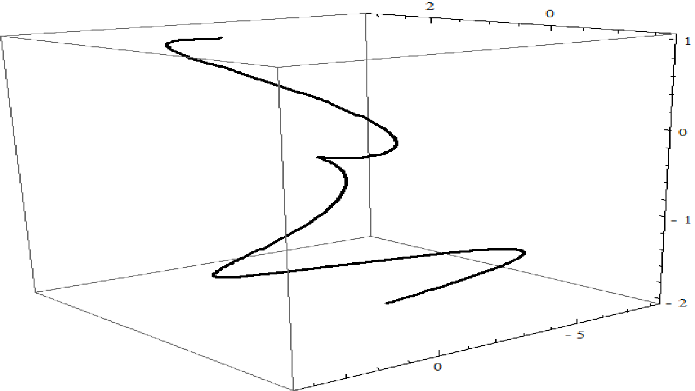
$\text{Fig}\text{.}1\text{.}$

Also, we may use Mathematica in Theorem 3.6, yields

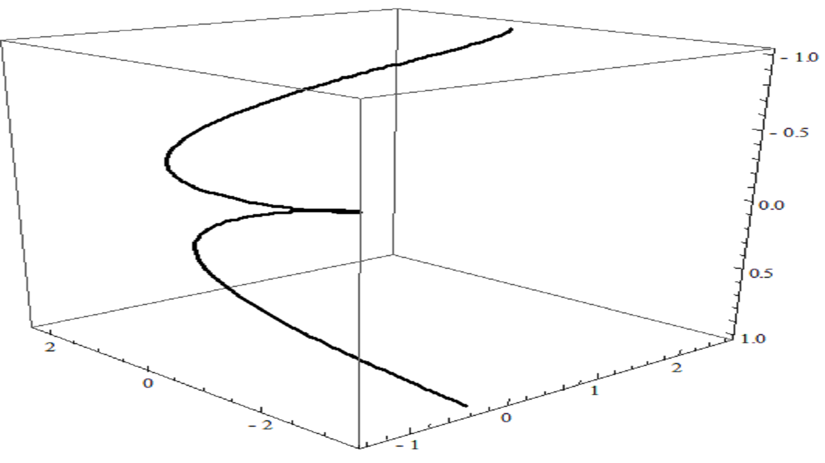
$\text{Fig}\text{.}2$

4 New Type Ruled Surfaces of $B−$Smarandache ${\text{TM}}_{1}$ Curves of Biharmonic $B−$Slant Helices in Sol Space ${\text{SOL}}^{3}$

The purpose of this section is to construct new type ruled surfaces of $B−$Smarandache ${\text{TM}}_{1}$ curves of biharmonic $B−$slant helices in Sol Space ${\text{SOL}}^{3}\text{.}$
We define new type ruled surface
$A_{{\text{TM}}_{1}}\left(s,u\right)=γ\left(s\right)+{uγ}_{{\text{TM}}_{1}}\left(s\right)\text{.}$ (4.1)

Theorem 4.1. Let $γ:I→{\text{SOL}}^{3}$ be a unit speed biharmonic $B−$slant helix and $A$ its new type ruled surface in the Sol Space ${\text{SOL}}^{3}\text{.}$ Then, the equation of new type ruled surface of $B−$Smarandache ${\text{TM}}_{1}$ curves of biharmonic $B−$slant helix is given by
$A_{{\text{TM}}_{1}}\left(s,u\right)=[[\frac{\text{cos}E}{C_{1}^{2}+{\text{sin}}^{2}E}[\text{sin}E\text{cos}\left[C_{1}s+C_{2}\right]+C_{1}\text{sin}\left[C_{1}s+C_{2}\right]]+C_{4}e^{−\text{sin}Es+C_{3}}$
$+\frac{u}{\sqrt{2k_{1}^{2}+k_{2}^{2}}}[\text{cos}E\text{cos}\left[C_{1}s+C_{2}\right]+\text{sin}E\text{cos}\left[C_{1}s+C_{2}\right]]]e_{1}$
$+[[\frac{\text{cos}E}{C_{1}^{2}+{\text{sin}}^{2}E}[C_{1}\text{cos}\left[C_{1}s+C_{2}\right]+\text{sin}E\text{sin}\left[C_{1}s+C_{2}\right]]+C_{5}e^{\text{sin}Es−C_{3}}]$ (4.2)
$+\frac{u}{\sqrt{2k_{1}^{2}+k_{2}^{2}}}[\text{sin}E\text{sin}\left[C_{1}s+C_{2}\right]+\text{cos}E\text{sin}\left[C_{1}s+C_{2}\right]]]e_{2}$
$+[[−\text{sin}Es+C_{3}]+\frac{u}{\sqrt{2k_{1}^{2}+k_{2}^{2}}}[\text{cos}E−\text{sin}E]]e_{3},$
where $C_{1},C_{2}$ are constants of integration.

Proof. Assume that $γ$ is a non geodesic biharmonic B-slant helix according to Bishop frame.
For non-constant $u$, we obtain
$M_{1}=\text{sin}E\text{cos}\left[C_{1}s+C_{2}\right]e_{1}+\text{sin}E\text{sin}\left[C_{1}s+C_{2}\right]e_{2}+\text{cos}{Ee}_{3},$ (4.3)
where $C_{1},C_{2}∈R$.
Using Bishop frame, we have
$T=\text{cos}E\text{cos}\left[C_{1}s+C_{2}\right]e_{1}+\text{cos}E\text{sin}\left[C_{1}s+C_{2}\right]e_{2}−\text{sin}{Ee}_{3}\text{.}$ (4.4)

Substituting (4.3) and (4.4) in (4.1) we have (4.2), which completes the proof.

In terms of Eqs. (2.1) and (4.2), we may give:

Corollary 4.2. Let $γ:I→{\text{SOL}}^{3}$ be a unit speed biharmonic $B−$slant helix in the Sol Space ${\text{SOL}}^{3}\text{.}$ Then, the parametric equations of new type ruled surface of $B−$Smarandache ${\text{TM}}_{1}$ curves of biharmonic $B−$slant helix are given by
$x_{A_{{\text{TM}}_{1}}}\left(s,u\right)=[\frac{\text{cos}{Ee}^{\text{sin}Es−C_{3}}}{C_{1}^{2}+{\text{sin}}^{2}E}[\text{sin}E\text{cos}\left[C_{1}s+C_{2}\right]+C_{1}\text{sin}\left[C_{1}s+C_{2}\right]]+C_{4}$
$+\frac{e^{−\frac{1}{\sqrt{2k_{1}^{2}+k_{2}^{2}}}[\text{cos}E−\text{sin}E]}}{\sqrt{2k_{1}^{2}+k_{2}^{2}}}u[\text{cos}E\text{cos}\left[C_{1}s+C_{2}\right]+\text{sin}E\text{cos}\left[C_{1}s+C_{2}\right]]],$
$y_{A_{{\text{TM}}_{1}}}\left(s,u\right)=[\frac{\text{cos}{Ee}^{−\text{sin}Es+C_{3}}}{C_{1}^{2}+{\text{sin}}^{2}E}[C_{1}\text{cos}\left[C_{1}s+C_{2}\right]+\text{sin}E\text{sin}\left[C_{1}s+C_{2}\right]]+C_{5}$ (4.5)
$+\frac{{\text{ue}}^{\frac{1}{\sqrt{2k_{1}^{2}+k_{2}^{2}}}[\text{cos}E−\text{sin}E]}}{\sqrt{2k_{1}^{2}+k_{2}^{2}}}[\text{sin}E\text{sin}\left[C_{1}s+C_{2}\right]+\text{cos}E\text{sin}\left[C_{1}s+C_{2}\right]]],$
$z_{A_{{\text{TM}}_{1}}}\left(s,u\right)=[−\text{sin}Es+C_{3}+\frac{u}{\sqrt{2k_{1}^{2}+k_{2}^{2}}}[\text{cos}E−\text{sin}E]],$
where $C_{1},C_{2}$ are constants of integration.

Proof. Substituting (2.1) to (4.2), we have (4.5) as desired.

We can use Mathematica in Corollary 4.3, yields

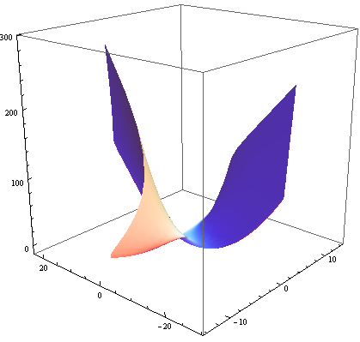
$\text{Fig}\text{.}3\text{.}$

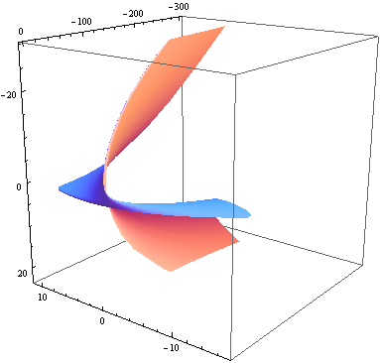
$\text{Fig}\text{.}4\text{.}$
5 Conclusion

Ruled surfaces is that they can be generated by straight lines. A practical application of ruled surfaces is that they are used in civil engineering. Since building materials such as wood are straight, they can be thought of as straight lines. The result is that if engineers are planning to construct something with curvature, they can use a ruled surface since all the lines are straight.
In this paper, new type ruled surfaces in terms of $B−$Smarandache ${\text{TM}}_{1}$ curves of biharmonic $B−$slant helices in the ${\text{SOL}}^{3}$ are studied.

Acknowledgements

The author wish to thank the referees for providing constructive comments and valuable suggestions.

References

K. ARSLAN, EZENTA$S$, R.; MURATHAN, C.; SASAHARA, T. Biharmonic submanifolds 3-dimensional ($κ$,$μ$)-manifolds, International Journal of Mathematics and Mathematical Sciences, v.22, p.3575-3586, 2005.
BISHOP,L. R. There is More Than One Way to Frame a Curve, American Mathematical Monthly, v.82, n.3, p.246-251, 1975.
BLAIR, D. E. Contact Manifolds in Riemannian Geometry, Lecture Notes in Mathematics, Springer-Verlag 509, Berlin-New York, 1976.
CADDEO, R.; ONICIUC, C.; PIU, P. Explicit formulas for non-geodesic biharmonic curves of the Heisenberg group. Rendiconti del Seminario Matematico Università e Politecnico di Torino, v. 62, n.3, p.265-277, 2004.
CARMO, M.D. Differential Geometry of Curves and Surfaces. Prentice Hall, New Jersey, 1976.
DIMITRIC, I. Submanifolds of $E^{m}$ with harmonic mean curvature vector, Bulletin of the Institute of Mathematics. Academia Sinica, v.20, p.53--65 1992.
EELLS, J.; LEMAIRE, L. A report on harmonic maps, Bulletin of the London Mathematical Society, v.10, p.1--68, 1978.
EELLS, J.; SAMPSON, J. H. Harmonic mappings of Riemannian manifolds, American Journal of Mathematics, v.86, p.109--160, 1964.
JIANG, G. Y. 2-harmonic isometric immersions between Riemannian manifolds. Chinese Annals of Mathematics Series A, v.7, n.2, p.130--144, 1986.
KORPINAR, T.; TURHAN, E. On characterization of B-canal surfaces in terms of biharmonic B-slant helices according to Bishop frame in Heisenberg group Heis${}^{3}$. Journal of Mathematical Analysis and Applications, v.382, p.57-65, 2011.
KORPINAR, T.; TURHAN, E. On Horizontal Biharmonic Curves In The Heisenberg Group Heis³, Arabian Journal for Science and Engineering Section A, v.35, n.1, p.79-85, 2010.
KORPINAR, T.; TURHAN, E. Tubular Surfaces Around Timelike Biharmonic Curves in Lorentzian Heisenberg Group Heis³. Analele Stiintifice ale Universitatii Ovidius Constanta, Seria Matematica, v.20 n.1, p.431-445, 2012.
LIUA, Y.-J.; TANGB, K.; JONEJAC, A. Modeling dynamic developable meshes by the Hamilton principle, Computer-Aided Design, v.39, p.719--731, 2007.
OU, Y.; WANG, Z. Linear Biharmonic Maps into Sol, Nil and Heisenberg Spaces, Mediterranean Journal of Mathematics, v.5 , p.379--394, 2008.
TURHAN, E.; KORPINAR, T. Position vector of spacelike biharmonic slant helices with timelike principal normal according to Bishop frame in Minkowski 3-space, International Journal of Physical Sciences, v.5, n.12, p.1824-1829, 2010a.
TURHAN, E.; KORPINAR, T. On Characterization Of Timelike Horizontal Biharmonic Curves In The Lorentzian Heisenberg Group Heis${}^{3},$ Zeitschrift für Naturforschung A- A Journal of Physical Sciences v.65, n.a, p.641-648, 2010b.

