TECHNICAL EVALUATION OF VEHICLE IGNITION SYSTEMS: CONDUCT DIFFERENCES BETWEEN A HIGH ENERGY CAPACITIVE SYSTEM AND A STANDARD INDUCTIVE SYSTEM

High energy CDI versus TCI standard

RESUMO

Uma combustão eficiente depende de muitos fatores, tais como injeção de combustível, turbulência e características de ignição. Com a melhoria dos motores de combustão interna a intensidade de turbulência e a pressão interna vêm aumentando, demandando sistemas de ignição mais potentes e eficientes. Em motores de injeção direta, as cargas estratificadas resultantes do spray direto, guiado por paredes ou escoamento, requerem ainda mais energia. A lei de Paschen mostra que a folga de vela e a densidade da mistura são proporcionais à voltagem de ruptura do dielétrico. É sabido que maiores folgas de vela promovem maior eficiência nos motores de combustão interna, uma vez que a taxa de reação da mistura aumenta proporcionalmente. No entanto, o sistema de ignição deve estar adequado à folga de vela imposta, não somente em energia, mas também em voltagem e duração da centelha. Para este trabalho foram feitas duas bancadas de teste: uma com ignição indutiva padrão e uma com ignição capacitiva de alta energia, com voltagem e capacitância variáveis. A influência dos importantes parâmetros energia e voltagem de ignição na duração da centelha, bem como folga e formato de eletrodo, foram analisados. Também foi investigada a utilização de uma bobina com baixos valores de resistência e indutância, bem como velas com e sem resistências internas.

PALAVRAS CHAVE

Desempenho de módulos de ignição, combustão, medição de bobina.

ABSTRACT

An efficient combustion depends on many factors, such as injection, turbulence and ignition characteristics. With the improvement of internal combustion engines the turbulence intensity and internal pressure have risen, demanding more efficient and powerful ignition systems. In direct injection engines, the stratified charge resultant from the wall/air-guided or spray-guided system requires even more energy. The Paschen’s law shows that spark plug gap and mixture density are proportional to the dielectric rupture voltage. It is known that larger spark gaps promote higher efficiency in the internal combustion engines, since the mixture reaction rate rises proportionally. However, the ignition system must be adequate to the imposed gap, not only on energy, but also on voltage and spark duration. For the reported study in this work two test benches were built: a standard inductive ignition system and a capacitive discharge high energy ignition system, with variable voltage and capacitance. The influence of the important parameters energy and ignition voltage on the spark duration, as well as the electrode gap and shape, were analyzed. It was also investigated the utilization of a coil with lower resistance and inductance values, as well as spark plugs with and without internal resistances.

KEYWORDS

Ignition modules performance, combustion, coil measurement

INTRODUCTION

One cause of the efficiency decrease on partial loads in spark ignition engines is the throttle power control. Diluting the admitted mixture with air excess (lean burn) or with burned gases (exhaust gas recirculation) may reduce the pumping losses, improving the fuel consumption. However, the maximum mixture dilution rate permitted is limited by the tolerated cyclic variation on the engine design. A powerful ignition system has influence on the partial load cyclic variations and on maximum dilution rate acceptable.
The waveform obtained measuring the primary winding of the ignition system permits good conclusions about its energy and performance. However, the actual duration and power delivered on spark are influenced by electrical and mechanical parameters not easily estimated.
The focus of this work is the main voltage and current signals acquisitions related to ignition systems. Arc formation delays and its duration connected to the variables described before will be also observed.
The Paschen’s law (Obert, 1971) relates that the required voltage for sparking depends of some variables, is given by Eq. 1:
$V=c\text{.}ρ\text{.}d=\frac{c\text{.}p\text{.}d}{R\text{.}T}$ (1)

Where: V is the dielectric voltage, p local pressure, d electrode gap, R medium constant, T medium temperature, ρ medium density, and c a constant that depends of the medium composition, and is also influenced by the local turbulence intensity.
In this equation, can be observed that the major ignition system exigency is on high loads (i.e., high combustion chamber pressures), large spark plug gaps and engines with high turbulence at the spark plug region (turbo-charged or direct injection engines, which increases the constant value). In modern engines the turbulence intensity have been increased, which demands better ignition systems in order to avoid smaller spark gaps (which would plenty affect the engine performance).
A linear model referring the necessary voltage for the air dielectric breakdown, suggested by Pashley et al. (2000), also considers pressure, temperature and spark gap, in according with Eq. 2:

$V=4,3+\text{136}\frac{p}{T}+\text{324}\frac{p}{T}d$ (2)

Where: voltage is given in kV, pressure in bar (10⁵ Pa), temperature in Kelvin and distance in millimeters.

MATERIAL AND METHODS

Typically, on vehicular engines, two ignition system types are usual: inductive and capacitive. These two systems will be compared on the various conditions described previously (various sparks gaps, spark plugs, energies and coils).
The available energy on inductive ignition system is given by Eq. (3):

$E_{\text{ind}}=0,5\text{.}L\text{.}I^{2}$ (3)

Where L is the coil primary winding inductance and I the current through the winding in the discharge moment.
In this work the ignition module set as standard is of inductive type, widely used on Brazil’s VW Gol Mi family. This system is composed of a module (Bosch Company, Germany, model 0227100142) and a standard inductances and resistances (SIR) coil (Bosch Company, Brazil, model F000ZS0105). This module limits the maximum coil current on approximately 7,5 A, avoiding internal damage due to high currents, which was verified increasing the coil dwell time by the command signal width. Since after 3,5 ms of dwell time (design value for this module) the primary current did not increase significantly, this same time was maintained, which corresponds to 7 A of current. Figure 1 shows this conduct until 4,2 ms of dwell time. With this current (7 A) and the inductance of the tested coil (3,2 mH - Tab. 3), the Eq. (3) results on 78 mJ of ignition energy for this module.
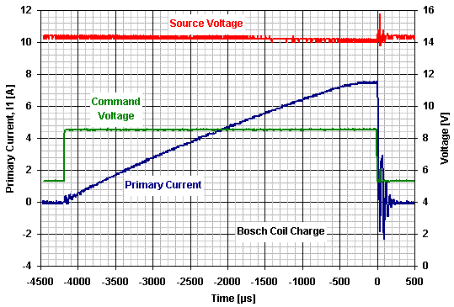

Figure 1. Inductive system coil charge conduct according to the command pulse

The available energy on capacitive ignition system (CDI) is given by Eq. (4):

$E_{\text{cap}}=0,5\text{.}C\text{.}U^{2}$ (4)

Where C is the module capacitance and U the capacitor charge voltage.
The second module tested in this work was a high energy CDI module (CM Racing Company, Porto Alegre - RS, Brazil, model TNT). In this ignition type, the coil do not participate on the charge circuit, therefore, there is only significant current flowing in the coil during the discharge phase. This ignition can attain up to 500 mJ, varying the capacitors charge voltage (up to 630 V) and its capacitance values (up to 2,5 μF, with steps of 0,5 μF).
The modules, spark plugs and coils main characteristics are shown in Tables 1, 2 and 3, respectively. The spark plug wires utilized did not have significant impedance, and the spark plugs had the mass electrode removed.
During test bench various parameters combinations were tested, according to the possibility and significance of each one. These parameters are shown in Table 4. As reference, the calculated necessary voltage for dielectric breakdown is calculated according to Eq. (2), maintaining the same average environment conditions during the tests (24,0 $±$2,0 °C and 953,0 $±$2,0 mbar).
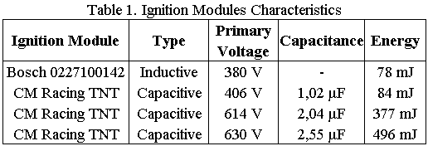

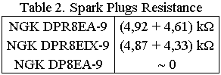

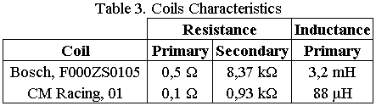

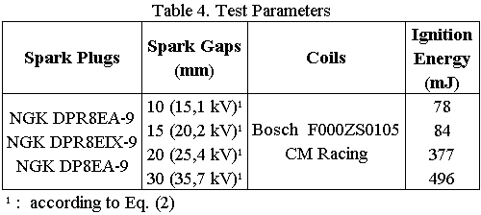

For the constructed test bench, the Paschen’s Law variables was simulated only by spark gap variation between the electrodes, in other words, the Eq. (1) right side numerator product will be represented only by the electrodes gap, while the environmental conditions are the local atmospheric, monitored during the trial. The main bench components are showed on Fig. 2.
To contribute to the ignition module source voltage stability, three 6800 μF capacitors were put on the source outlet. The maximum coil source ripple observed was about 200 mV.
Circuit characteristic waveforms for different spark plugs and gaps were measured on the standard inductive ignition system. The module energy is limited on 78 mJ. The source voltage was always maintained on 14,4 V (standard value on today’s vehicles).
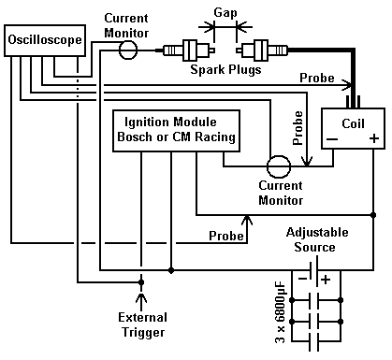

Figure 2. Test bench scheme

The same measurements were performed on the CDI module, also varying the delivered energy. Then, each energy level was tested with a low inductances and resistances (LIR) coil (CM Racing Company, Porto Alegre – RS, Brazil, model 01). Different energies were obtained by capacitance variation and/or module source voltage, which influences directly the internal capacitors charge voltage.
For each operation condition the sparking limit was determined. The judgment for establish the sparking limit was one fail at each 50 sparks.
Operation conditions with small gaps were not explored, since are not representative in internal combustion engines, and furthermore, large gaps are always pursuit to improve engines efficiency (Obert, 1971).
The spark duration can be determined by the distinct current circulation on the high voltage circuit of the system, while spark delivered energy and power are function of the current intensity and its duration. So, the spark duration will be considered since the initial current occurrence on secondary circuit until its extinction.
Although the measured values were very repetitive, the results of waveform were obtained from averages of 16 shots.

RESULTS AND DISCUSSION

The Figures 3 to 10 show the spark duration of both analyzed systems (inductive and capacitive), with various spark plugs, energies, coils and gaps, as well as the measured current on this time range. Zero time represents the command signal shot moment (Fig. 1, fall border, i.e., fall trigger).
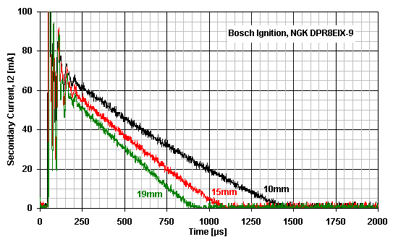

Figure 3. Current conduct through high voltage circuit. Inductive ignition module. SIR coil.
Spark plugs: NGK DPR8EIX-9. Values in millimeters represent the utilized spark plug gap.
Results with NGK DPR8EA-9 did not have significant differences.
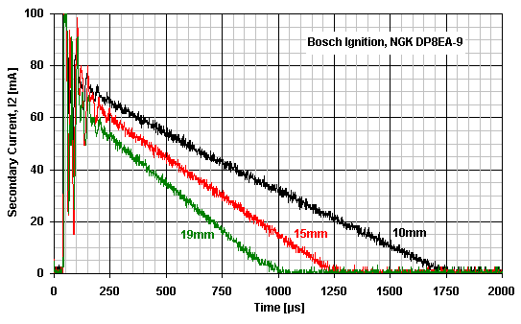

Figure 4. Current conduct through high voltage circuit. Inductive ignition module. SIR coil.
Spark plugs: NGK DP8EA-9. Values in millimeters represent the utilized spark plug gap.

On Figures 3 to 4, was observed 45 + 5 μs delay from the command signal to the arc opening, depending on the utilized spark gap. Regardless the noise region during the arc opening it was noticed that the initial current is about 70 mA, independent of the utilized gap, decreasing linearly with time. This current range is a typical glow discharge, where the energy transfer efficiency to the plasma is small, about 30 % (Heywood, 1988). As gap is increased, the spark duration decreases substantially. The big electrical noise occurred during the current circulation start (where it grows rapidly) is probably originated by the big emission caused by the electrical arc opening. The spark duration (for the same gaps) practically was not altered between the conventional resistive spark plugs and the iridium spark plugs (also resistive, but with thinner central electrode). With the direct spark plugs (DP8EA-9), the spark duration for equivalent gaps was increased, remitted by more available energy. For example, comparing Figs. 3 and 4, the spark duration with 10 and 15 mm gap increased from 1400 and 1050 μs to 1700 and 1225 μs, respectively.
To prove the results validity on a real engine, tests were made in a passenger vehicle with similar ignition system (VW Gol 1.6 Mi, year 2000), but with three mass electrodes (where naturally, due the electrodes shape, the spark stand in a backward place, on a minor turbulence region). In this vehicle, also was noticed the great spark duration difference depending on the engine load. With road light load, the spark duration is about 1500 μs, while on wide open throttle (WOT) this duration decreases to approximately 800 μs.
The maximum gap values obtained are shown on each figure (19 mm), since above these values the ignition system start to fail. Small deviations on maximum possible gap are acceptable due environmental variations.
The measures with the DPR8EA-9 spark plugs have obtained practically the same waveforms of the Fig. 3.
In Figures 5 and 6, one can notice that applying the same inductive system’s energy level on CDI (around 80 mJ), the peak currents were higher (150 against 70 mA) and the spark delay smaller (30 against 45 μs). With higher energies (377 and 496 mJ), the spark delay was decreased to under 20 μs, and the currents increased substantially, reaching 490 mA. According to Heywood (1988), this current level fits to the arc type discharge, which has higher energy transfer efficiency to the plasma, about 50 %. The spark duration has insignificant variation with the spark gap, and the delay time is slightly increased as function of gap (but, smaller than inductive system in all conditions). For this ignition module, small gaps were not studied, because it do not have significant variations on the waveforms, and for it be much below of the module sparking limit, beyond the others causes described before yet (large gaps improve engines efficiency).
The measures with DPR8EA-9 spark plugs have obtained practically the same waveforms of the Figs. 5 and 6.
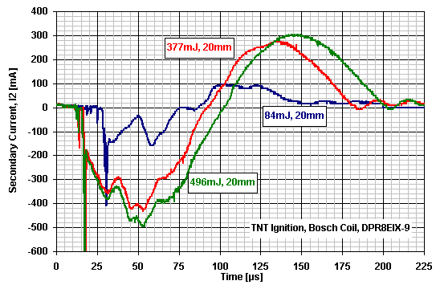

Figure 5. Current conduct through the high voltage circuit. CDI module. SIR coil.
Spark plugs: NGK DPR8EIX-9. Values in mJ and millimeters represent the ignition energy and the spark plug gap. Results with NGK DPR8EA-9 did not have significant differences.
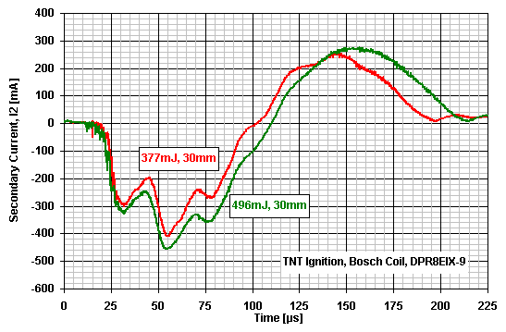

Figure 6. Current conduct through the high voltage circuit. CDI module. SIR coil.
Spark plugs: NGK DPR8EIX-9. Values in mJ and millimeters represent the ignition energy and the spark plug gap. Results with NGK DPR8EA-9 did not have significant differences.

Until 20 mm of spark gap, it was possible to obtain sparking with 84 mJ, and above this only with the higher energies, independent of the utilized spark plug or coil.
For gaps above 20 mm, was necessary an additional isolation with silicon, to minimize the escapes on the SIR coil. Gaps about 40 and up to 50 mm was obtained with this module, without spark fail, but with sporadic occurrence of quench, followed by a second spark in the same shot (i.e., a re-striking), which decrease the spark delivery energy. Despite this occurrence do not symbolize a spark fail, this measures was discarded for repeatability reasons. Gaps above 50mm were not investigated, to guarantee the coil isolation integrity.
An additional verification with this module was the sparking test with 614 V capacitors charge and distinct capacitances. For this charge voltage, 30 mm gap and 1 μF (188 mJ) was noticed a significant fail rate. Suddenly increasing the capacitance to 2 μF (377 mJ), the sparking fail disappeared, permitting gaps up to 50 mm without fails, as described before. This occurrence shows the combined importance of the capacitance (and energy) on the dielectric breakdown capacity.
With direct spark plugs (Figs. 7 and 8) was observed again that higher currents are obtained during the whole discharge, for all energies. With 84 mJ, the peak current was increased about 20 mA, and with 377 and 496 mJ, the peak current was increased about 40 mA, reaching up to 530 mA (7,5 times the inductive system current).
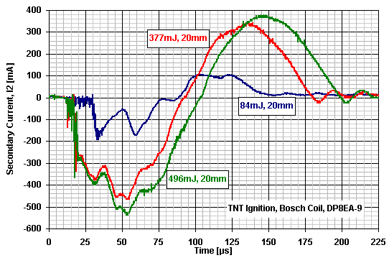

Figure 7. Current conduct through the high voltage circuit. CDI module. SIR coil.
Spark plugs: NGK DP8EA-9. Values in mJ and mm represent ignition energy and spark gap.
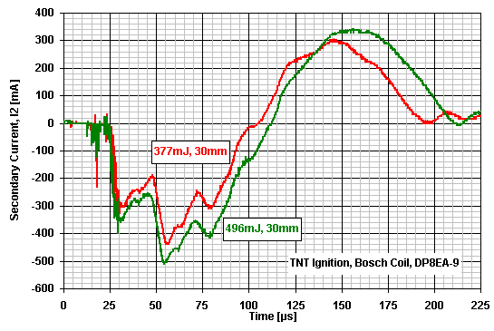

Figure 8. Current conduct through the high voltage circuit. CDI module. SIR coil.
Spark plugs: NGK DP8EA-9. Values in mJ and mm represent ignition energy and spark gap.

Utilizing direct spark plugs and the LIR coil (Figs. 9 and 10), the obtained currents was much greater, attaining up to 2,35 A (i.e., 33 times the inductive system current), with a very small spark delay: 7 to 8 μs for 84 mJ, and just 4 to 5 μs for 377 and 496 mJ (i.e., a spark delay about 10 times smaller than the inductive system). With this coil, the 84 mJ condition did not have sparking above 20 mm of gap again.
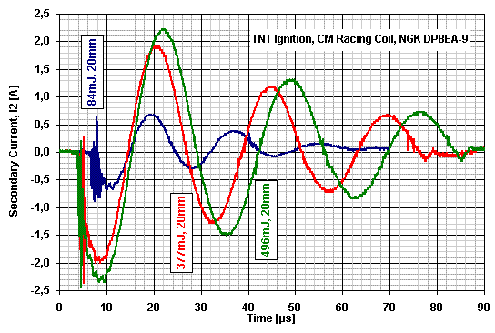

Figure 9. Current conduct through the high voltage circuit. CDI module. LIR coil.
Spark plugs: NGK DP8EA-9. Values in mJ and mm represent ignition energy and spark gap.
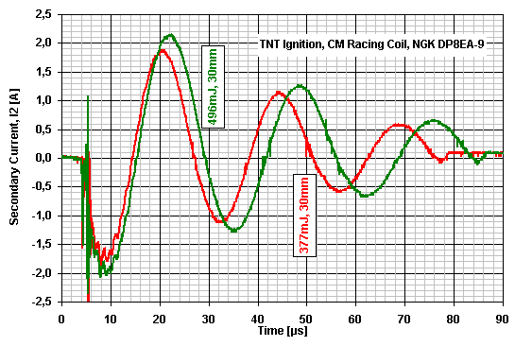

Figure 10. Current conduct through the high voltage circuit. CDI module. LIR coil.
Spark plugs: NGK DP8EA-9. Values in mJ and mm represent ignition energy and spark gap.

Above 30 mm of gap it was observed big current escapes on the high voltage isolation for this last coil, turning trustful measures with larger gaps impossible.
Due the electrical noise of the attained high currents, two re-striking signals were occurred on the command signal generator external circuit. The spark duration with this configuration, without re-striking, is about 29 μs for 377 mJ and 34 μs for 496 mJ. However, with these occurred re-striking, can be observed on the waveforms encountered, that was considerable useful energy to be dissipate on the spark for this configuration, turning advantageous the liberation of part of remaining energy.
Is known that a lot of engine performance is lost when the spark advance is retarded about 4 or 5 degrees (from the maximum brake torque). In other words, if a good burn does not have developed at the first 4 or 5 spark duration degrees, there is no advantage to sustain a spark above this point, because the explosion in question would be with a very retarded ignition point, injuring the engine power. Logically, the duration (in milliseconds) of an efficient spark is directly connected to the engine speed, i.e., as the engine speed increases, the spark duration have to be faster, granting engine efficiency. For example, to sustain a 5 degrees spark operation at 2000 rpm it would be necessary 420 μs of spark duration; at 4000 rpm would be necessary 210 μs; and at 10000 rpm approximately 85 μs. So, about the vehicular spark ignition engines speed range, the spark duration obtained in this configuration, with re-striking, has presented suitable (80-90 μs).
This configuration conduct (CDI module, LIR coil and spark plugs without resistances) was proved in a passenger car (GM Opala 2.5 1990’), since the spark duration has maintained practically unaltered, independent of the engine load.

CONCLUSIONS

The high energy CDI showed better performance on the test bench and on the real engine, due to very stable spark duration and greater delivery currents, independent of the applied load on system, while inductive system showed that spark duration and secondary current suffer a lot of reductions as the load increases (even on test bench or on real engine).
While in inductive system the peak secondary current encountered was about 70 mA, the CDI attained up to 530 mA with the same coil and conditions (spark plug and gap). The last module combined with a LIR coil obtained much higher currents, up to 2350 mA (33 times of the inductive system current). This means that more energy and power can be delivered to the fresh mixture at the ignition moment, which is highly wished, since releases a higher burn rate, increasing the combustion chamber pressure, and consequentially improving engines performance, in the same way, it permits to retard the engines ignition point, reducing the compression stroke work.
Another positive point on CDI module was the minor ignition delay with the same coil – 20 to 30 μs against 45 to 50 μs on inductive system – attaining very small times, about 4 to 5 μs, on utilizing a coil with smaller resistances and inductances. This faster system response provides a more precise control of the real ignition point, especially on high speed engines, where the strokes are so fast, and the spark delay deviations turn more significant.
On test bench, the maximum gap obtained between the electrodes without spark fail was 19 mm for the inductive system, and at least 50 mm for the CDI. It permits to utilize more generously spark gaps with this system, resulting in more power and less fuel consumption.
In future work will be analyzed the tension measurement and plasma shlieren photographs.

REFERENCES

HEYWOOD, J. Internal Combustion Engine Fundamentals, McGraw-Hill, 1988.
OBERT, E. Motores de Combustão Interna, Ed. Globo, Porto Alegre, 1971.
PASHLEY, N.; STONE R.; ROBERTS, G. Ignition System Measurement Techniques and Correlations for Breakdown and Arc Voltages and Currents. SAE Paper 2000-01-0245, 2000.

