**Drug release kinetics and transport mechanisms of doxorubicin from core-shell delivery systems**

**Özlem Gökçe Kocabay1,2\*****[ORCID.jpg](https://orcid.org/0000-0003-4352-3453) and Osman İsmail1**

1Department of Chemical Engineering, Faculty of Chemical and Metallurgical Engineering, Yildiz Technical University, Davutpaşa Campus, 34210 Istanbul, Turkey. 2Istanbul Restoration and Conservation Center and Regional Laboratory Directorate, Istanbul, Turkey. *Author for correspondence. E-mail: [ozlemmgokce@hotmail.com](mailto:ozlemmgokce@hotmail.com)

**ABSTRACT.** In the current research drug release kinetics and transport mechanisms of doxorubicin (DOX) from DOX, DOX/valspodar (PSC 833) and DOX/ᴅ-α- tocopheryl polyethylene glycol 1000 succinate (TPGS 1000) loaded polymeric micelle (PM) delivery systems were studied. Mathematical modeling has shown that the best suitability for release at pH 5.0 medium (*R2* > 0.98) is provided by Korsmeyer-Peppas model and drug release kinetics are both anomalous transport (non-Fickian) and Super case II transport. The drug release was considered to fits in both the Korsmeyer-Peppas and Weibull models for DOX release from DOX-PM, DOX/PSC 833-PM, DOX/TPGS 1000-PM at pH 6.5 and pH 7.4 medium.

**Keywords:** diffusion; dissolution; drug release mechanism; drug release modeling; erosion; swelling.

Received on November 15, 2023.

Accepted on June 13, 2024.

**Introduction**

Polymeric micelles (PMs) possess a specific core–shell architecture and are nanosized. The internal part is hydrophobic intrinsically and provides of the entrapment for hydrophobic drugs, while the shell is hydrophilic and provides watery solubility and stability. PMs are produced from amphiphilic polymers (Mubeen et al., 2024).

Polycaprolactone (PCL) is a biodegradable aliphatic polyester which has been suggested for the evolution of drug release applications. PCL degradation is in general too slowly and proceeds nearly two to three years; for this reason, mentioned biopolymer is a appropriate choice for long life drug release systems. If a faster degradation is needed, the academical literature proposes to adjust PCL crystallihity by mixing PCL with hydrophilic polymers, to exemplify polyethylene glycol (PEG). PEG is a polymer validated on the part of Food and Drug Administration (FDA) which might rise the hydrophilicity and degradability of PCL basis vehicles (Guastaferro et al., 2022).

One of the most common anti-cancer drugs is doxorubicin (DOX), that is utilized to cure metastatic and early stage breast cancer. Regrettably, due to its oxidative stress impact, using of DOX is connected with the emerge of serious cumulative dosage-linked cardiotoxicity, myelosupression, and treatment-resistance. Consequently, combination with another anti-cancer agents is preferred so as to reduce its dose without sacrificing efficiency (Effat, et al., 2024). Vitamin E d-ɑ-tocopheryl poly(ethylene glycol) 1000 succinate (TPGS), synthesised via esterification of vitamin E succinate with poly(ethylene glycol) (PEG) 1000, is a water soluble derivativ of natural vitamin E. TPGS possess an amphiphilic architecture consisting of a hydrophilic polar head and a lipophilic alkyl tail. TPGS might be made functional as a great solubiliser, disperser, permeation and bioavailability adjuvant of hydrophobic medications. At the same time, TPGS might behave as an anti-cancer agent, that has been proved to induce apoptogenic activity opposite to several cancer kinds. TPGS might selectively induce apoptosis in tumor cells when showed non-toxicity to normal cells and tissues (Yang et al., 2018a). P-glycoprotein (P-gp) inhibitors display important activity in reducing multidrug resistance (MDR) and enhancing the therapeutical impacts of chemotherapy medicines in-vitro and in-vivo. These are generally loaded in nano-particles accompanied by anticancer medicines. To exemplify, PSC 833 was encapsulated in nano-liposomes in the presence of doxorubicin, which were then employed for curing breast cancer cells. Coencapsulation of doxorubicin and valspodar decreased MDR, leading to an efficient anticancer effect (Kim et al., 2021).

Drug release mechanism from a polymer matrix might be classified with respect to 3 major processings, these are: i. Diffusion controlled system; ii. Swelling controlled system; iii. Erosion controlled system (Arifin et al., 2006).

Mathematical modeling is an essential tool to optimize drug dosage protocols (Yang et al., 2018b). So, the purpose of present study is to investigate the foremost mathematical models advanced to define drug release from produced various polymeric micelle pharmaceutical systems. As far as we know, the release kinetics of doxorubicin from DOX/PSC 833 and DOX/TPGS 1000 loaded polymeric micelle were studied for the first time. The release kinetic was investigated by zero-order, first order, Higuchi, Hixson-Crowell, Korsmeyer-Peppas, Baker-Lonsdale and Weibull model.

**Material and methods**

**Material**

PEG (Molecular weight = 1450, 3350, 12000 g moL-1) (Sigma), CL (Sigma), stannous octoate Sn(Oct)2 (Sigma Aldrich), DOX-HCL (Sigma Aldrich), PSC 833 (Sigma), TPGS 1000 (Sigma), Tween 80, sodium azide (Merck), buffer solutions (Sigma), whole solvents and chemical agents which are present on the market (Merck Chemical Co.), cellulose dialysis membrane [molecular weight cut off (MWCO) = 3.5 kDa] (Sigma-Aldrich, USA) were purchased.

**Synthesis of PCEC polymeric micelles and loading of anti-cancer drugs**

Poly(ε-caprolactone)-poly(ethylene glycol)-poly(ε-caprolactone) (PCL-PEG-PCL, PCEC) triblock copolymers have been synthesised via ring opening polymerisation of Ɛ-CL initiated by PEG in compliance with publishing in the literature (Kocabay & Ismail, 2018). PCEC polymeric micelles have been produced without surface active agent via nanoprecipitation technique. DOX loaded and DOX/PSC 833 and DOX/TPGS 1000 coloaded particles were synthesized using a nanoprecipitation method as previously described (Gökçe Kocabay & İsmail, 2020).

**Proton nuclear magnetic resonance-spectroscopy (1H NMR)**

Formulations, measurements for 1H NMR are given in the previous work (Kocabay & Ismail, 2018). The triblock architecture was characterized in detail by 1H NMR spectra.

**FT-IR analysis**

The molecular structure of various agents, mixtures and drug-loaded polymeric products has been characterised via fourier transform infrared spectroscopy (FTIR, Shimadzu Corporation, IRPrestige21, Kyoto, JAPAN) using KBr pellets in the 4000-400 cm-1 wave number range.

**Drug delivery workings**

In the former study in-vitro drug release outcomes were obtained (Gökçe Kocabay & İsmail, 2023). In this work mentioned data were used in kinetic procedures to derive the order and mechanism of drug release.

**Mathematical modeling and mechanisms of drug release**

To evaluate the drug release mechanism, in-vitro release patterns have been analysed employing seven kinetic models.

* Zero-order model

Drug dissolution from dosing forms which don’t dissociate and release the drug slow might be indicated via the Equation (1):

$\text{Q}\text{0}\text{ - Q}\text{t}\text{ = K}\text{0}\text{t}$ (1)

Recomposition of Equation (1) produces Equation (2):

$\text{Q}\text{t}\text{ = Q}\text{0}\text{ + K}\text{0}\text{t}$ (2)

here *Qt* is the quantity of drug dissolved at time *t*, *Q0* is the beginning quantity of drug in the solution (mostly, *Q0* = 0) and *K0* is the zero-order release constant stated in units of concentration/time.

In order to examine the release kinetics, findings acquired as a result of in-vitro drug release experiments have been drawn in the form of cumulative amount of drug released vs. time.

* First order model

First order model was employed for defining absorption and/or elimination of certain drugs. The release of the drug that fitted in first-order kinetics might be stated via Equation (3):

$\frac{\text{dC}}{\text{dt}}\text{ = -K}\text{c}$ (3)

here *K* represents the first-order rate constant stated in units of time-1.

Equation (3) might be arranged in the form of Equation (4):

$\text{log C = log C}\text{0}\text{ - Kt / 2.303}$ (4)

where *C0*, *K* and *t* represent the initial concentration of the drug, the first-order rate constant, and time, respectively. The results acquired are drawn in the way that log cumulative percentage of drug remaining versus time that will give a straight line with a slope of -K/2.303 (Dash et al., 2010).

* Higuchi model

The model statement is expressed via the Equation (5):

$\text{f}\text{t}\text{ = Q = A }\sqrt{\text{D(2C - C}\text{s}\text{) C}\text{s}\text{ t}}$ (5)

here *Q*, *C*, *Cs* and *D* represent the quantity of drug released at time *t* per unit area *A*, the initial concentration of drug, the drug solubility in the matrix medium and the diffusivity of the drug molecules (diffusion coefficient) in the matrix substance, respectively.

For analyzing the dissolution from a planary heterogeneous matrix system, in which the drug concentration in the matrix is lower than solubility of drug and the release takes place by means of pores in the matrix, the statement is represented via Equation (6):

$\text{f}\text{t}\text{ = Q = }\sqrt{\frac{\text{D }\text{δ}}{\text{τ}}\text{(2C - }\text{δ}\text{C}\text{s}\text{) C}\text{s}\text{ t}}$ (6)

here *D*, *δ* and *τ* represent the diffusion coefficient of the drug molecule in the solvent, porosity of the matrix and tortuisity of the matrix, respectively. Tortuisity refers to the dimensions of radius and branching of the pores and channels inside the matrix. The Higuchi model can be made simpler to the following formula:

${\text{f}\text{t}\text{ = Q = K}\text{H}\text{ x t}}^{1/2}$ (7)

here, *KH* represents the Higuchi dissolution constant.

The results acquired have been drawn in the form of cumulative percentage drug release vs. square root of time.

* Hixson-Crowell model

Hixson and Crowell (1931) formed Equation (8):

${\text{W}}_{\text{0}}^{\text{1/3}}{\text{ - W}}_{\text{t}}^{\text{1/3}}\text{ = }\text{κ}\text{ t}.......$ (8)

here *W0*, *Wt* and *κ* (kappa) represent the beginning quantity of drug into the pharmaceutical dosage form, the remainder quantity of drug into the pharmaceutical dosage form at time *t* and a constant containing the surface-to-volume relationship, respectively. The results acquired have been drawn in the form of cube root of drug percentage remaining inside the matrix vs. time.

* Korsmeyer-Peppas model

Korsmeyer et al. (1983) formed a simplistic equation.

For getting the mechanism of drug release, first 60% drug release data are fitted in Korsmeyer-Peppas model:

$\text{M}\text{t}\text{ / M}∞{\text{ = Kt}}^{\text{n}}......$ (9)

here *Mt / M∞*, *k* and *n* represent a fraction of drug released at time *t*, the release rate constant, and the release exponent, respectively. The value of *n* is employed for characterising diverse release for cylindrical shapely matrixes. Information on diffusional release mechanisms from polymeric films is given in the Table 1.

**Table 1.** Knowledge about diffusional release mechanisms wherefrom polymeric films (Dash et al., 2010).

|  |  |  |
| --- | --- | --- |
| Release exponent (n) | Drug transport mechanism | Rate as a function of time |
| 0.5 | Fickian diffusion | *t -0.5* |
| 0.45 ˂ *n* = 0.89 | Non-Fickian transport | *t n-1* |
| 0.89 | Case II transport | Zero-order release |
| Greater than 0.89 | Super case II transport | *t n-1* |

For getting the exponent *n* the part of the release curve, in which *Mt / M∞* < 0.6 should merely be employed. The results acquired from in-vitro drug release experiments are drawn in the form of log cumulative percentage drug release vs. log time.

According to Equation (9), if the exponent *n* gets the value 1.0, the drug release rate will be time dependent. Mentioned circumstance match up to zero order release kinetics. In the case of slabs, the mechanism which builds the zero order release is gone by the name of case-II transport. In which the relaxation process of the macromolecules taking place onto water suction into the system is the rate-controlling step. Water serves in the form of a plasticiser and reduces the glass-transition temperature of the polymer. When *Tg* is equivalent to the temperature of the system, the polymer chains change over the glassy to the rubbery condition, with incremental activity of the macromolecules and volume expansion. Equation (9) therefore possesses 2 different physical factual meanings at the 2 particular situations of *n*=0.5 (displaying diffusion controlled drug release) and *n*=1.0 (displaying swelling controlled drug release). Values of *n* between 0.5 and 1.0 might be considered of an indicative for the overlapping of both phenomena (anomalous transport). The 2 extremal values for exponent *n*, 0.5 and 1.0, are solely gone for slab geometry. When it comes to sphere and cylinder values in Table 2 apply.

**Table 2.** Exponent *n* of the power law and drug release mechanism from polymeric controlled delivery systems with divergent geometry (Siepmann & Peppas, 2001).

|  |  |  |  |
| --- | --- | --- | --- |
| Exponent, *n* | | | Drug release mechanism |
| Thin film | Cylinder | Sphere |  |
| 0.5 | 0.45 | 0.43 | Fickian diffusion |
| 0.5 ˂ *n* ˂ 1.0 | 0.45 ˂ *n* ˂ 0.89 | 0.43 ˂ *n* ˂ 0.85 | Anomalous transport |
| 1.0 | 0.89 | 0.85 | Case-II transport |

* Baker-Lonsdale model

The controlled release of a drug from a spherical matrix might be shown like this:

$\text{f}\text{1}\text{ = }\frac{\text{3}}{\text{2}}\left[\text{1- }{\left(\text{1 - }\frac{\text{M}\text{t}}{\text{M}∞}\right)}^{\frac{\text{2}}{\text{3}}}\right]\text{- }\frac{\text{M}\text{t}}{\text{M}∞}\text{ = }\frac{\text{3D}\text{m}\text{C}\text{ms}}{{\text{r}}_{\text{0}}^{\text{2}}\text{c}\text{0}}\text{- t}$ (10)

here *Mt*, *M∞*, *Dm*, *Cms*, r0 and *C0* represent the quantity of drug released at time *t*, the quantity of drug released at an infinite time, the diffusion coefficient, the drug solubility in the matrix, the radius of the spherical matrix and the beginning concentration of the drug in the matrix, respectively.

In case the matrix is not homogen and contains fractures or capillaries which might make a contribution to the drug release, the Equation (11) is employed:

$\text{f}\text{1}\text{ = }\frac{\text{3}}{\text{2}}\left[\text{1- }{\left(\text{1 - }\frac{\text{M}\text{t}}{\text{M}∞}\right)}^{\frac{\text{2}}{\text{3}}}\right]\text{- }\frac{\text{M}\text{t}}{\text{M}∞}\text{ = }\frac{\text{3D}f\text{C}fsε}{{\text{r}}_{\text{0}}^{\text{2}}\text{c}\text{0} τ}\text{- t}$ (11)

where *Df*, *Cfs*, *τ* and *ε* represent the diffusion coefficient, the drug solubility in the liquid enclosing the matrix, the tortuosity factor of the capillary system and the porosity of the matrix, respectively. Matrix porosity might be defined as Equation (12):

$\text{ε}\text{ = }\text{ε}\text{0}\text{ + KC}\text{0}$ (12)

here *Ɛ0* and *K* represent the beginning porosity and the drug specifical volume, respectively. In the case of *Ɛ0* is little, Equation (11) might be rearranged into Equation (13):

$\text{f}\text{1}\text{ = }\frac{\text{3}}{\text{2}}\left[\text{1- }{\left(\text{1 - }\frac{\text{M}\text{t}}{\text{M}∞}\right)}^{\frac{\text{2}}{\text{3}}}\right]\text{- }\frac{\text{M}\text{t}}{\text{M}∞}\text{ = }\frac{\text{3D}f\text{KC}fs}{{\text{r}}_{\text{0}}^{\text{2}} \text{τ}}\text{ – t}$ (13)

So the Baker-Lonsdale model could be defined by Equation (14):

$\text{f}\text{1}\text{ = }\frac{\text{3}}{\text{2}}\left[\text{1- }{\left(\text{1 - }\frac{\text{M}\text{t}}{\text{M}∞}\right)}^{\frac{\text{2}}{\text{3}}}\right]\text{- }\frac{\text{M}\text{t}}{\text{M}∞}\text{ = kt}$ (14)

here the release constant, *k*, is equal to the slope.

Here graphical notation of the left side of the formula vs. time is going to be linear provided that the determinated circumstances were performed (Amarachi et al., 2013).

* Weibull model

This model is defined in the following equation for different dissolution processes:

$\text{M = M}\text{0} \left[{\text{1 - e}}^{\text{- }{\left(\frac{t-T}{a}\right)}^{b}}\right]$ (15)

here, *M* and *M0* represent the quantity of drug dissolved as a function of time *t* and sum quantity of drug released, respectively (Ramteke et al., 2014).

*T* represents the lag time. The equation parameter ‘*a*’ indicates a scale parameter which identifies the time dependence, whilst ‘*b*’ indicates the shape of the dissolution curve progression (Khan et al., 2020).

When *b* takes the value 1, the shape of the curve completely matches the shape of an exponential profile with the constant *k = 1/a* (Equation (16)).

$\text{M = M}\text{0} \left({\text{1 - e}}^{\text{-k}\left(\text{t - T}\right)}\right)$ (16)

In case *b* is greater than 1, the shape of the curve will be sigmoidal with a turning point. In case *b* is less than 1, the shape of the curve will increase more steeply than if *b* is equal to 1.

The time, by the time 50 and 90% (w/w) of the drug in every formulation was released, was computed employing the inverse function of the Weibull equation:

${\text{t}}_{\left(\text{50\% resp. 90\% dissolved}\right)}\text{ = }{\left(\text{ - a In }\frac{\text{M - M}\text{0}}{\text{M}\text{0}}\right)}^{\text{1/b}}\text{ + T}$ (17)

The Equation (15) can be readjusted in logarithmical form:

$\text{log[-ln(1- m)] = b log (t- Ti) - log a }$ (18)

Through this equation a linear relation might be acquired for a log–log plotting of *-ln (1-m)* vs. time, *t*. The shape parameter (*b*) can be acquired from the slope of the line and the scale parameter, *a*, can be obtained from the ordinate value (*1/a*) at time *t=1* (Ramteke et al., 2014). The parameter, *a*, might be changed places with the more informational dissolution time, *Td*, which is identified as *a = (Td)b* and is read from the plot as the time value corresponding to the ordinate *-ln(1-m) = 1*.

Because of *-In(1-m) = 1* is equivalent to *m = 0.632*, *Td* stands for the time range required to dissolve or release 63.2% of the drug available into the pharmaceutics dosage form. For pharmaceutics systems fitting mentioned model, the logarithm of the dissolved quantity of drug vs. the logarithm of time graph is going to be linear (Costa & Lobo, 2001).

**Statistical analysis**

These analyzes are performed using Statistica 6.0 (StatSoft Inc., USA) software package. Non-linear regression analysis is fulfilled based upon the Levenberg-Marquardt algorithm to calculate relative parameters of every mathematical model (shown in Tables 3-5).

**Results and discussion**

**1H NMR spectroscopy analysis**

The molecular weight and compositions of the polymers are acquired from proton nuclear magnetic resonance-spectroscopy. 1H NMR spectra of PCECs in CDCl3 are given in Figure 1.

The molecular weights of PCL block and PCEC were 486 and 1936 g mol-1, respectively, as indicated with 1H NMR.

**FTIR analysis of drugs, micelles and drug-loaded micelles**

The chemical structures of various polymeric micelles and the probabilities of chemical and physical interactivities are investigated with FTIR spectroscopy.

Figure 2 shows the FTIR spectra of the TPGS 1000, TPGS 1000-PCEC mixing, DOX-TPGS 1000-PCEC mixing, TPGS 1000-PCEC, PSC 833-PCEC, DOX-TPGS 1000-PCEC, DOX-PSC 833-PCEC.



**Figure 1.** 1H NMR spectrum of the copolymer at CDCl3.

According to the results obtained, no new chemical bonds had formed in the micelles loaded with DOX, DOX/TPGS 1000, DOX/PSC 833 checked against free DOX, TPGS 1000, PCEC. The drug micelle interactivities made solely some minor shifts in the characteristical peaks of the drug and polymer, in other words the interactivities are physical interactivities something like Van Der Waals or hydrophobic interactivities. The physical interactivity among the drug and the micelle did not alter the chemical constitution of the drug molecules and thus the remainder potentiality of the drug. The data obtained validated the chemical stability of the drug, the continuity of its biologic activities, and the possibility of the drug's sustainable release system profile. For DOX, the significant peaks at 707 and 795 cm−1 are ascribed to C=C and C-H out of plane bending of the aromatic moieties, respectively.These peaks were also obtained in this study. Mentioned peaks are moreover present at the FTIR spectrum of DOX-loaded micelles. The emergence of mentioned characteristical bands demonstrated the miscibility of DOX with TPGS 1000 and PCEC micelle (Figure 2c), as well as the successful loading of DOX in the DOX/TPGS 1000-PM (Figure 2f) and DOX/PSC 833-PM (Figure 2g) system. Two peaks belonging to DOX are seen at 1726 and 795 cm-1 in the DOX/TPGS 1000-PM spectrum, two peaks belonging to DOX were observed at 1409 and 795 cm-1 in the DOX/PSC 833-PM spectrum, however theirs intensities reduced. The FT-IR spectrum of TPGS 1000 is shown in Figure 2a. The TPGS 1000 spectrum indicated characteristical peaks at 2888.2 cm-1 (C-H stretch band), 1737.5 cm-1 (ester C=O stretch band), and 1114.7 cm-1 (C-O-C stretch band). An analogous conclusion was acquired in the previous work of Hao et al. (2015). The FT-IR spectrum of DOX/TPGS 1000-PM was similar to that of pure TPGS 1000. The peak belonging to TPGS 1000 at 2888 cm-1 was also observed in the FT-IR spectrum of TPGS 1000-PM, but its intensity decreased. The amount of valspodar available in this study is insufficient. However, valspodar is a cyclosporine derivative (Vila et al., 2020). The cyclosporin A (CyA) bands at 1620 cm-1 correspond to the [C=O] group (Varun et al., 2019). Mansur et al. stated that CyA showed main characteristic bands at 1750 cm-1 in conjunction with the presence of amides (Ogbaga et al., 2017). In this study, peaks at 1620 and 1750 cm-1 were observed in polymeric micelles loaded with PSC 833 and DOX/PSC 833. The FT-IR spectra corresponding to the DOX/TPGS 1000 and DOX/PSC 833 loaded polymeric micelles showed characteristical bands of drug and micelle without whatsoever spectral shift in both bands.

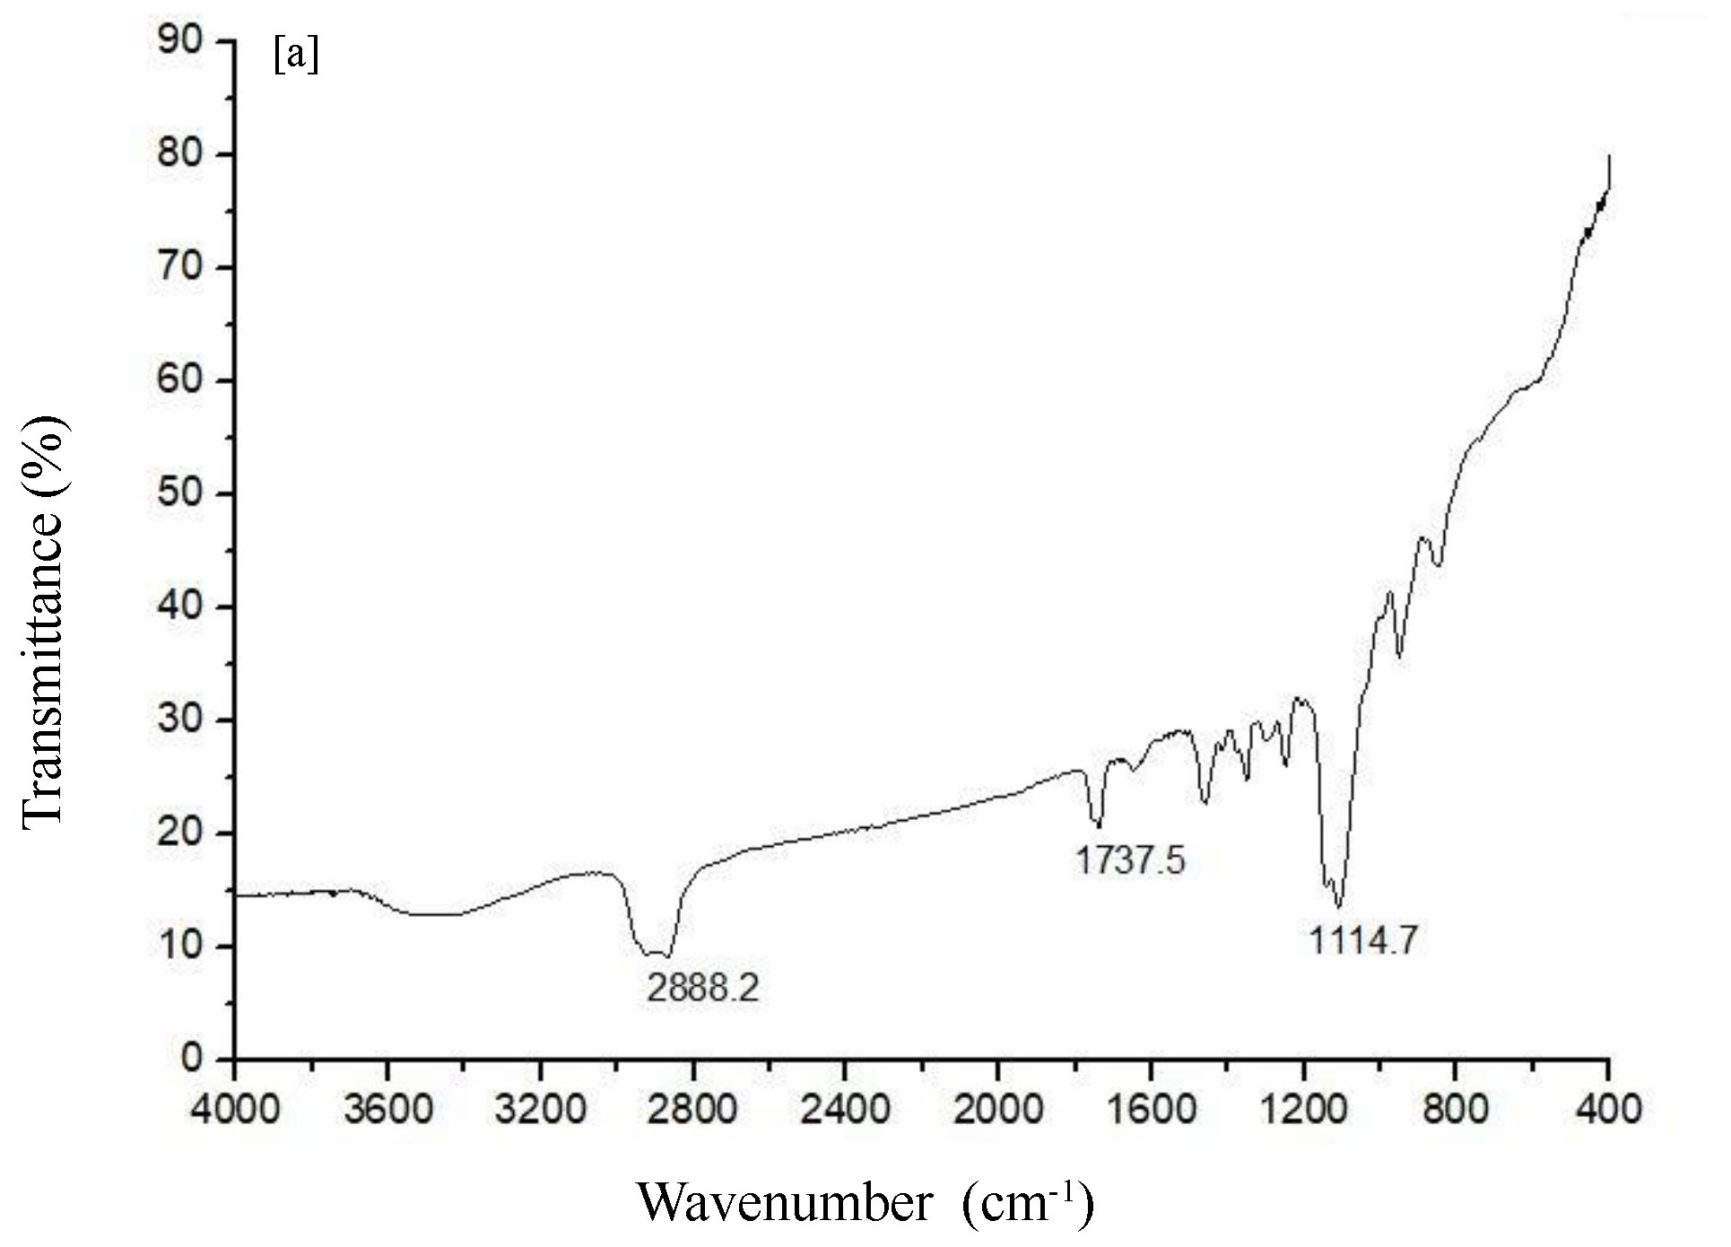 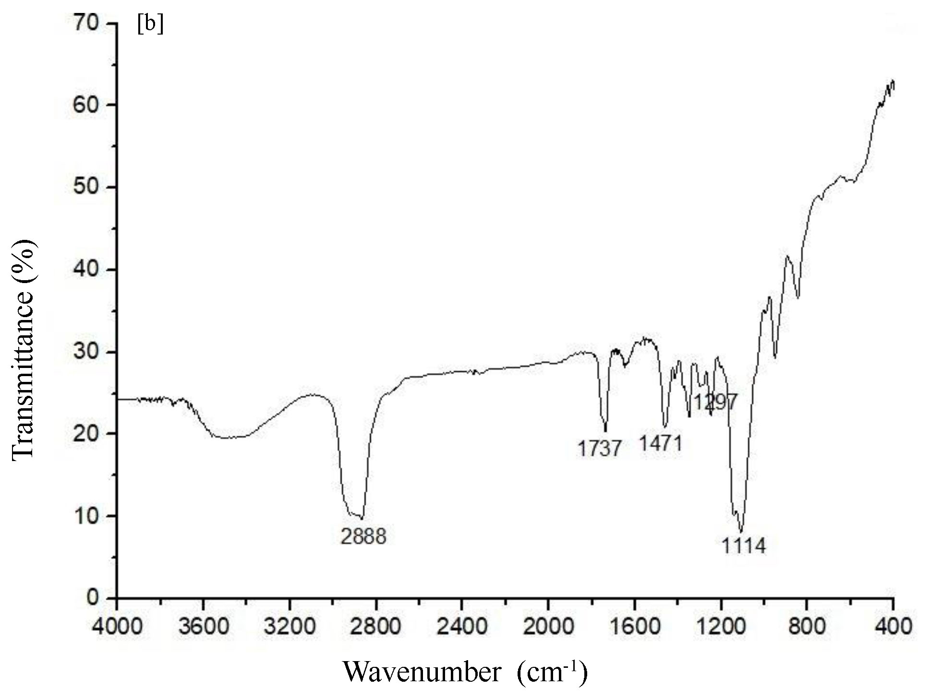

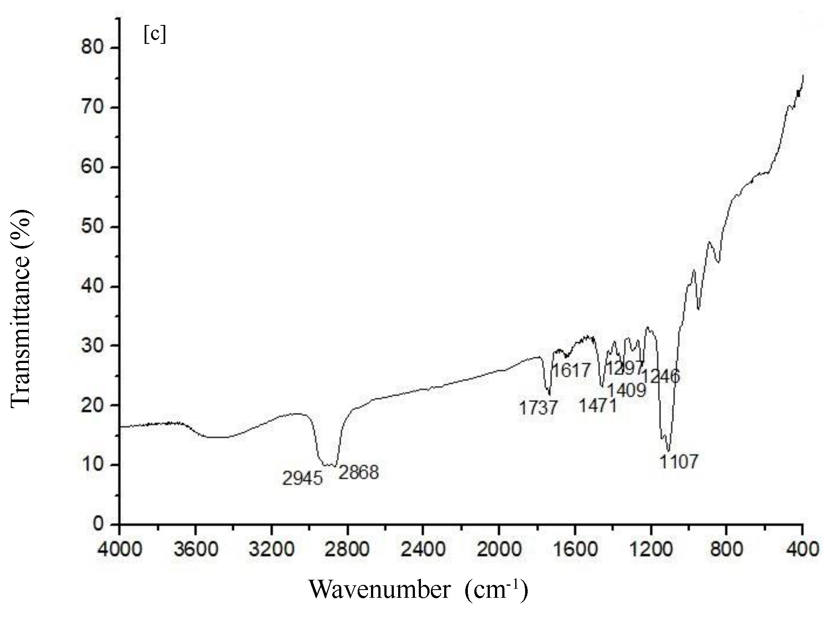 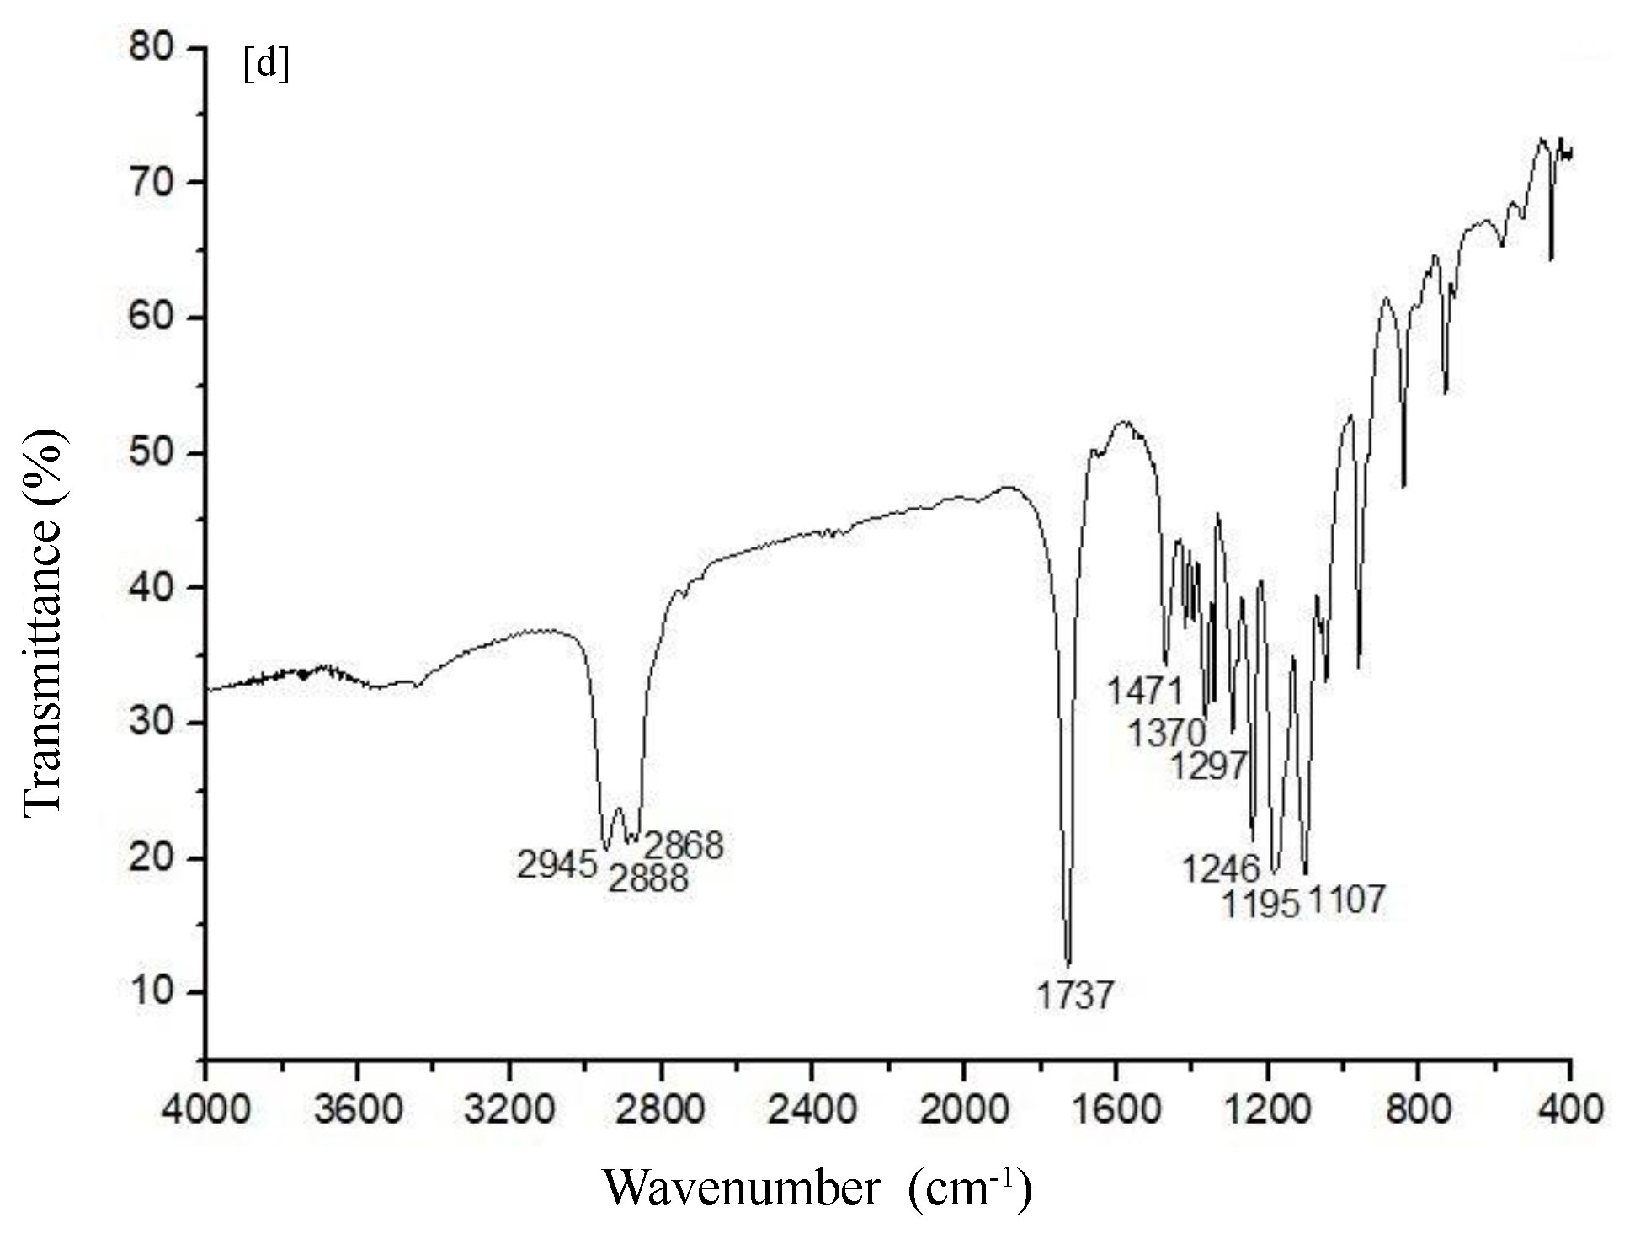

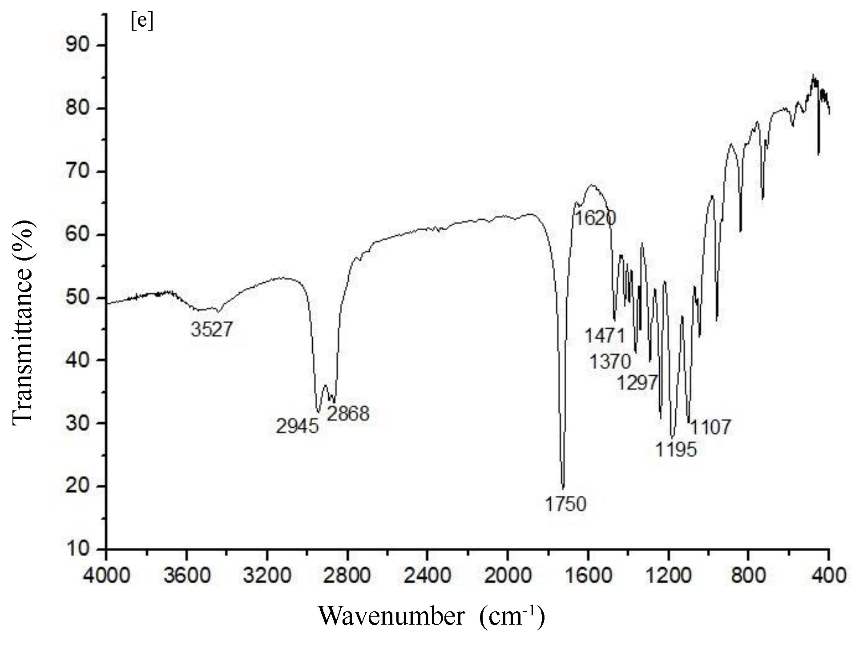 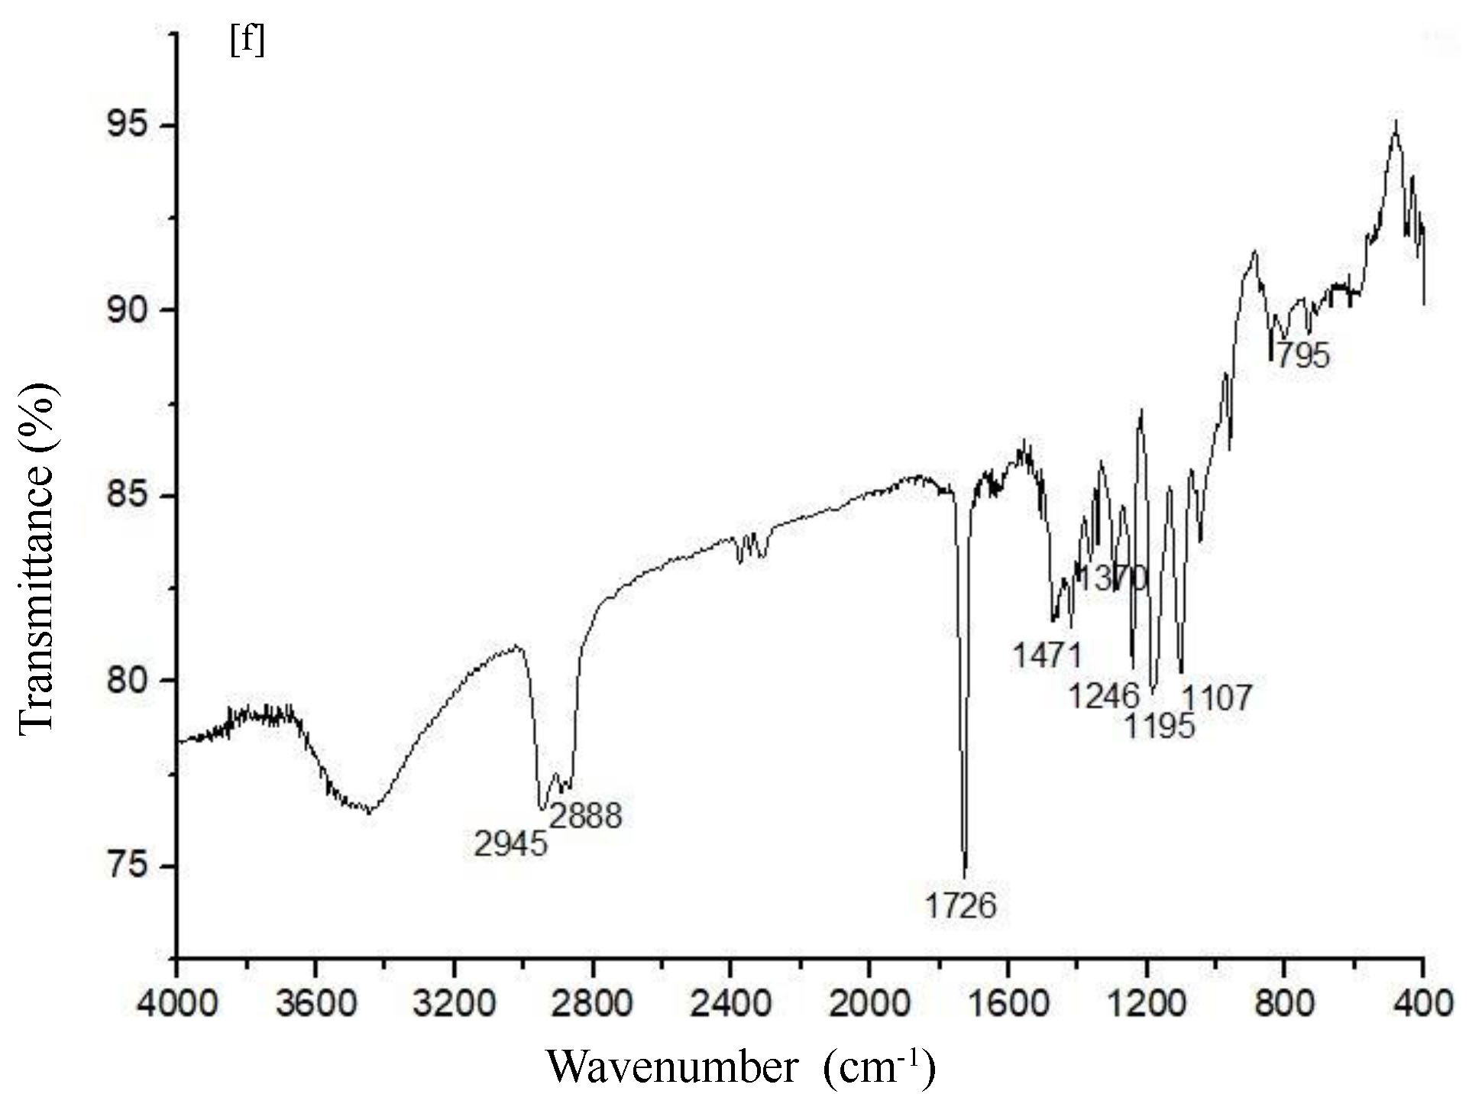

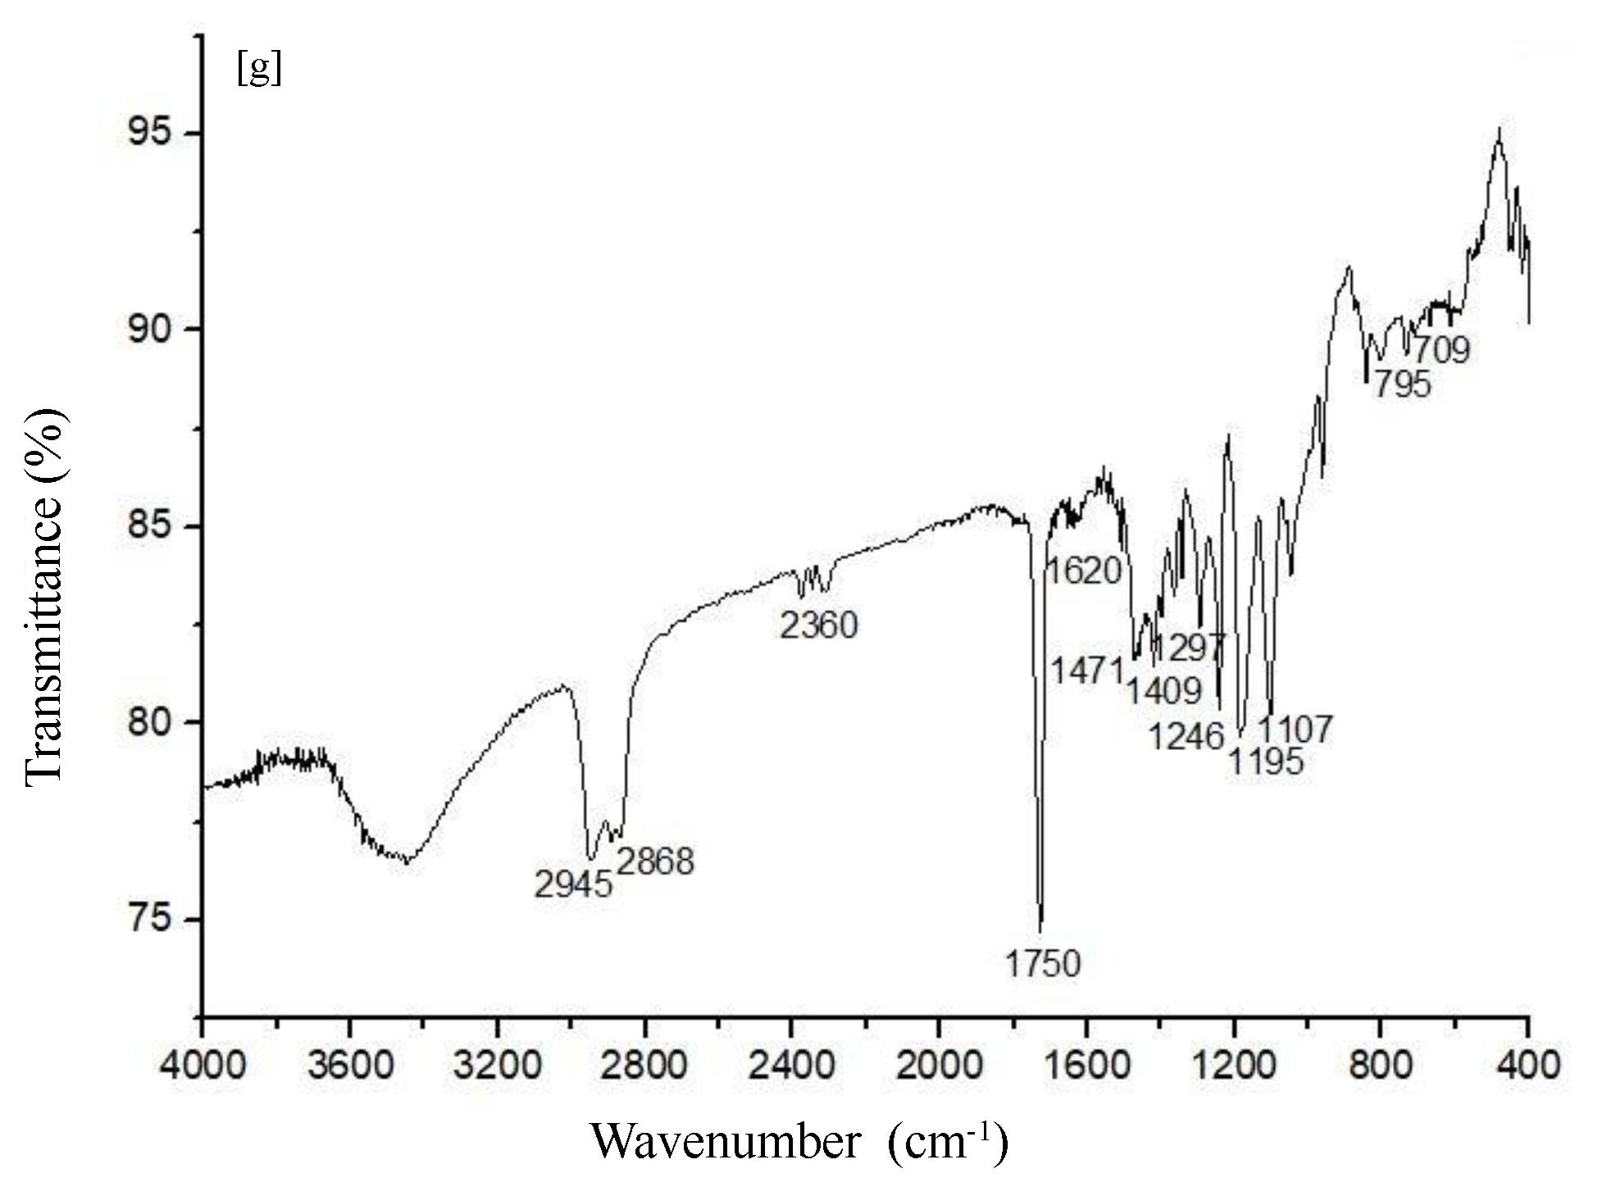

**Figure 2.** FT-IR spectrum: a. TPGS 1000, b. TPGS 1000-PCEC mixing, c. DOX-TPGS 1000-PCEC mixing, d. TPGS 1000-PCEC, e. PSC 833-PCEC, f. DOX-TPGS 1000-PCEC, g. DOX-PSC 833-PCEC.

**Kinetics and mechanism of release analysis**

Mathematical models are a significant vehicle for finding out the drug release kinetics of a dosing form. DOX release from polymeric micelles changed contingenting upon the kind of drugs utilized in its production.

The in vitro drug release profile was fitted to various mathematical models, displayed graphically and finally assessed using the correlation coefficients (*R2*) given in Tables 3, 4 and 5.

**Table 3.** Data from kinetic calculations for DOX release from DOX loaded PCEC polymeric micelles in different buffer solutions.

|  |  |  |  |  |
| --- | --- | --- | --- | --- |
| Kinetic models | Constants | pH 5.0 | pH 6.5 | pH 7.4 |
| Zero order | k0 (h-1)  R2 | 3.0852  0.5355 | 2.0374  0.6068 | 0.7198  0.4686 |
| First-order | k1 (h-1)  R2 | -0.0576  0.8271 | -0.0149  0.6955 | -0.0037  0.4938 |
| Higuchi | kH (h-1/2)  R2 | 19.9990  0.7864 | 12.8620  0.8453 | 4.7966  0.7314 |
| Hixson-Crowell | kHC (h-1/3)  R2 | -0.1168  0.7324 | -0.0444  0.6674 | -0.0125  0.4854 |
| Korsmeyer-Peppas | n  R2  kKP (h-n) | 2.0614  0.9893  18.9845 | 0.8989  0.9372  10.5877 | 0.5672  0.8852  7.2394 |
| Baker-Lonsdale | kBL (h-1)  R2 | 0.0157  0.7997 | 0.0037  0.7809 | 0.0004  0.6118 |
| Weibull | b  Td  R2 | 1.4826  1.5875  0.8962 | 0.8761  31.4835  0.9207 | 0.5913  3.0577 0.8932 |

**Table 4.** Data from kinetic calculations for DOX release from DOX/PSC 833 co-loaded PCEC polymeric micelles in different buffer solutions.

|  |  |  |  |  |
| --- | --- | --- | --- | --- |
| Kinetic models | Constants | pH 5.0 | pH 6.5 | pH 7.4 |
| Zero order | k0 (h-1)  R2 | 2.9339 0.4879 | 1.4347 0.4333 | 0.6140 0.4939 |
| First-order | k1 (h-1)  R2 | -0.0536 0.7682 | -0.0094 0.4889 | -0.0031 0.5122 |
| Higuchi | kH (h-1/2)  R2 | 19.4040 0.7387 | 9.7391 0.6788 | 4.0515 0.7441 |
| Hixson-Crowell | kHC (h-1/3)  R2 | -0.1100 0.6735 | -0.0290 0.4705 | -0.0104 0.5061 |
| Korsmeyer-Peppas | n  R2  kKP (h-n) | 1.4977 1.0000  35.1965 | 0.8164 0.7857  8.8247 | 0.5718 0.8739  5.7082 |
| Baker-Lonsdale | kBL (h-1)  R2 | 0.0148  0.7453 | 0.0020 0.5797 | 0.0003 0.6170 |
| Weibull | b  Td  R2 | 1.0572  2.1541  0.9166 | 0.8835 12.8197  0.8076 | 0.5929 2.2005 0.8810 |

**Table 5.** Data from kinetic calculations for DOX release from DOX/TPGS 1000 co-loaded PCEC polymeric micelles in different buffer solutions.

|  |  |  |  |  |
| --- | --- | --- | --- | --- |
| Kinetic models | Constants | pH 5.0 | pH 6.5 | pH 7.4 |
| Zero order | k0 (h-1)  R2 | 2.7251 0.5375 | 1.9166 0.6812 | 0.6079  0.3627 |
| First-order | k1 (h-1)  R2 | -0.0336 0.7610 | -0.0129 0.7634 | -0.0031 0.3705 |
| Higuchi | kH (h-1/2)  R2 | 17.7750 0.7640 | 11.6210 0.8971 | 4.2420  0.6333 |
| Hixson-Crowell | kHC (h-1/3)  R2 | -0.0818 0.6837 | -0.0395 0.7369 | -0.0104  0.3681 |
| Korsmeyer-Peppas | n  R2  kKP (h-n) | 1.4781 0.9893  21.9129 | 0.8236 0.9030  8.1997 | 0.5816  0.8627  6.7717 |
| Baker-Lonsdale | kBL (h-1)  R2 | 0.0101  0.7974 | 0.0029 0.8655 | 0.0003  0.3903 |
| Weibull | b  Td  R2 | 0.9604  4.1404  0.8711 | 0.8826 9.3689  0.9246 | 0.6029  2.8256  0.8691 |

The maximum value of *R2* indicates the favorable mathematical model which pursues drug release kinetics (Gouda et al., 2017).

Drug release kinetics have been demonstrated by various kinetic models at different pH environments (Figures 3, 4, 5, 6, 7, 8 and 9).

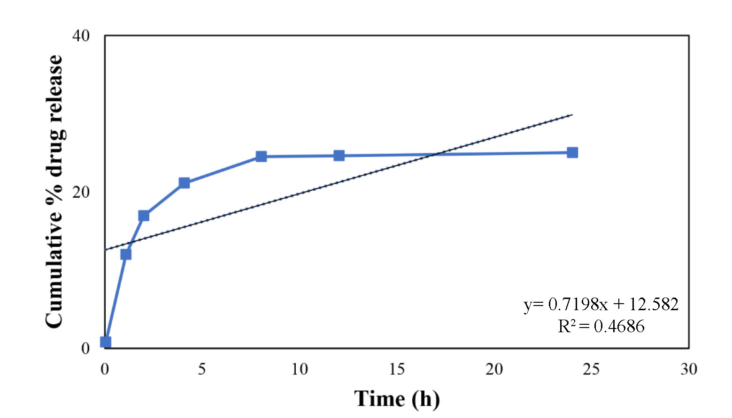

**Figure 3.** Zero-order release model of DOX from DOX-PMs at pH 7.4.

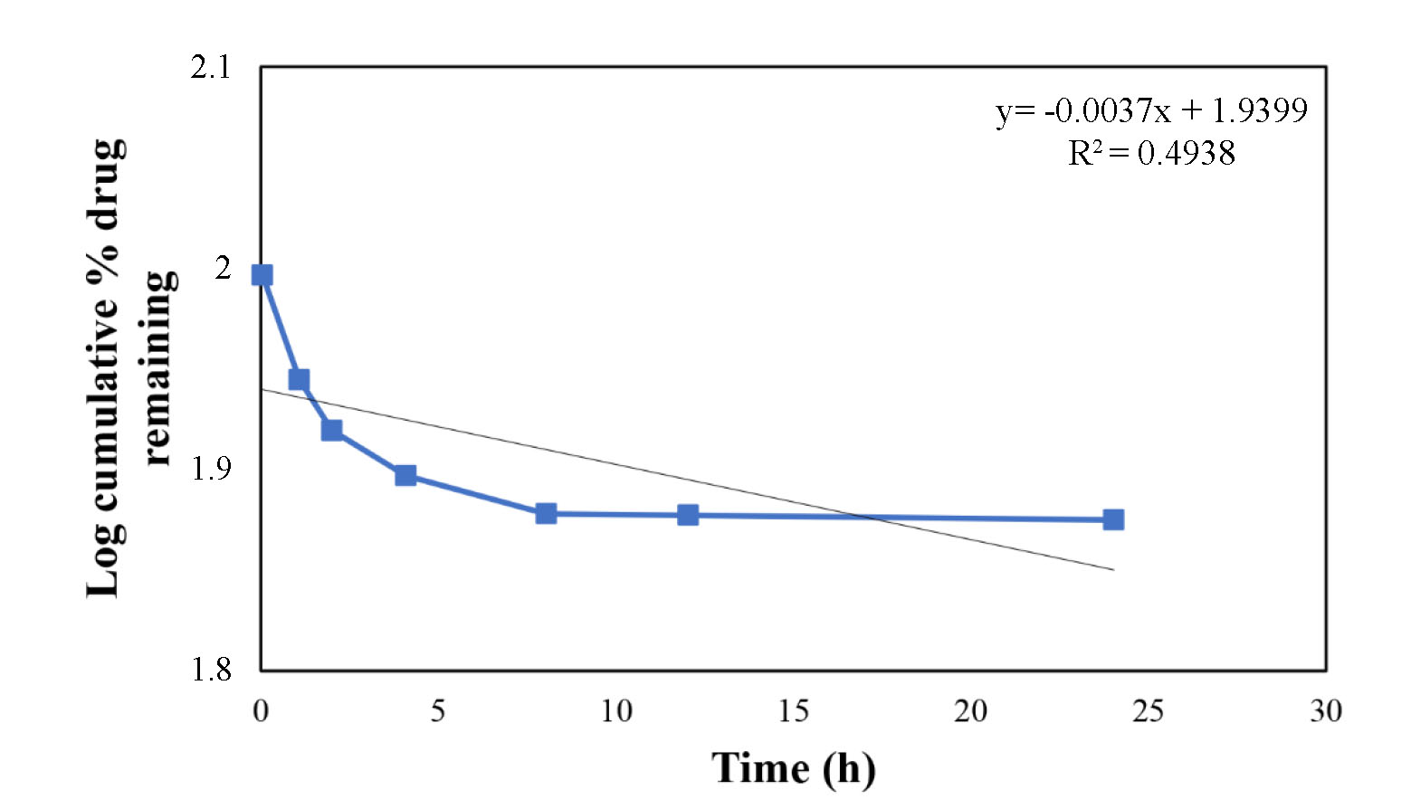

**Figure 4.** First-order release model of DOX from DOX-PMs at pH 7.4.

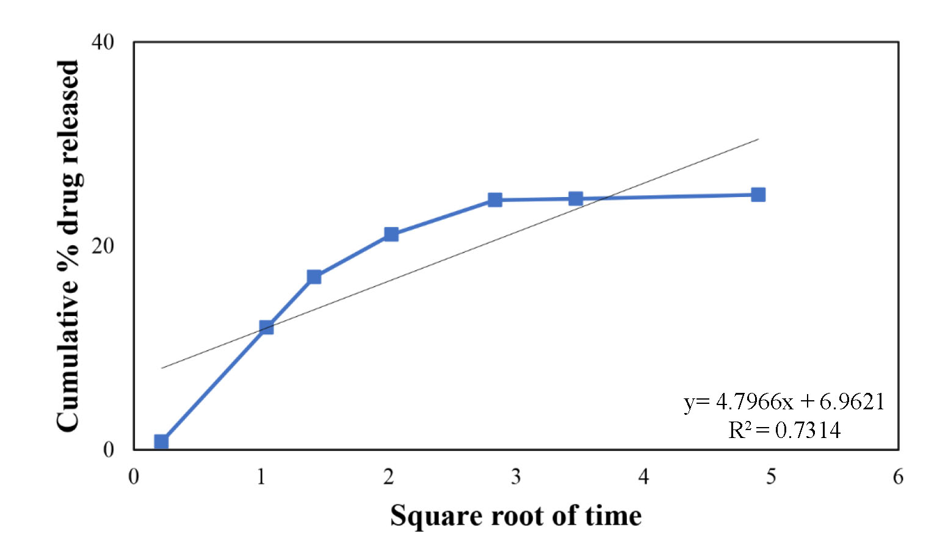

**Figure 5.** Higuchi release model of DOX from DOX-PMs at pH 7.4.

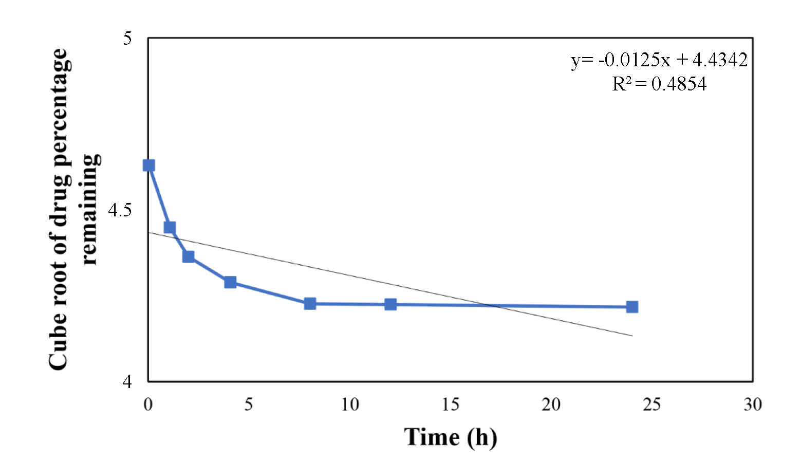

**Figure 6.** Hixson-Crowell cube root graphics of DOX from DOX-PMs at pH 7.4.

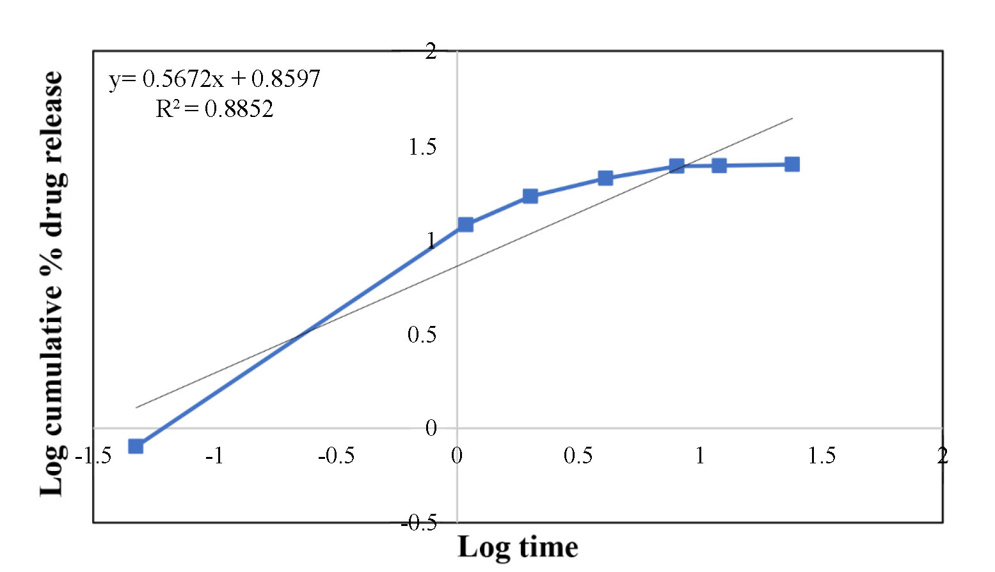

**Figure 7.** Korsmeyer-Peppas model for mechanism of DOX release from DOX-PMs at pH 7.4.

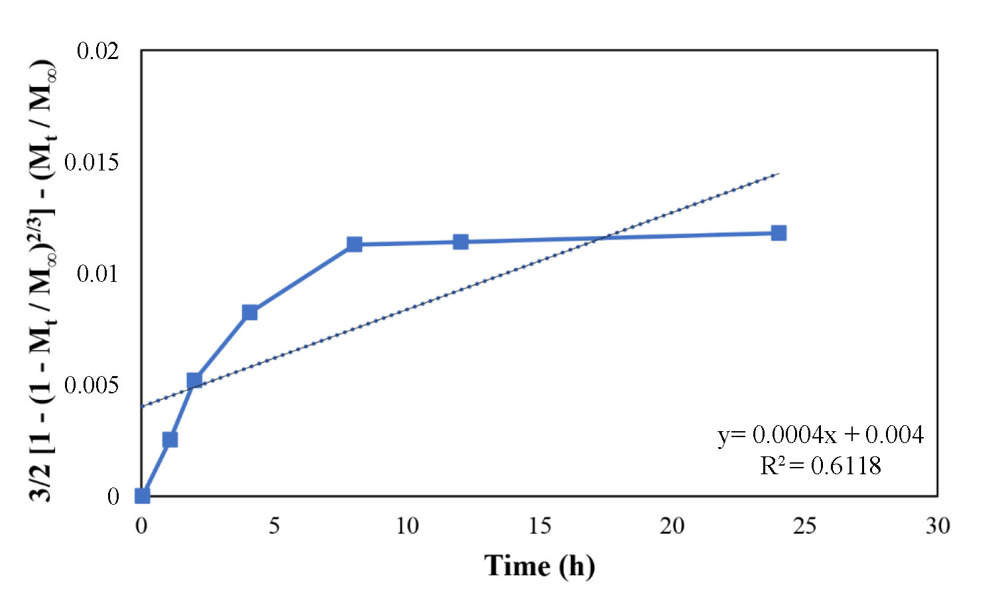

**Figure 8.** Baker-Lonsdale model of DOX from DOX-PMs at pH 7.4.

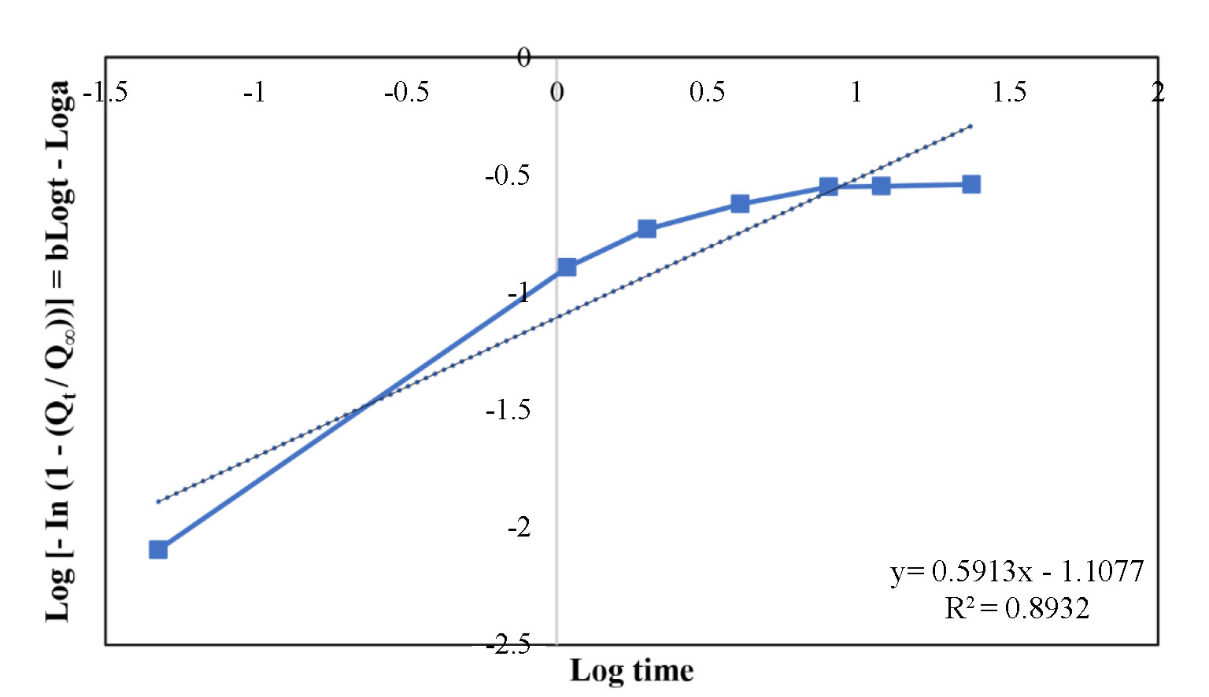

**Figure 9.** Weibull model of DOX from DOX-PMs at pH 7.4.

The data acquired from the mathematical models are given (Table 3).

On the purpose of specifying the drug release model, the correlation coefficient (*R2*) obtained with kinetic calculations was compared and the drug release model with the highest *R2* value was determined. The optimum suitability for release at pH 5.0 medium is provided by Korsmeyer-Peppas model (as a result of calculations made, *R2* values of DOX-PM, DOX/PSC 833-PM, DOX/TPGS 1000-PM were found to be 0.9893, 1.000, 0.9893, respectively) and drug release kinetics are both anomalous transport (non-Fickian) and Super case II transport. The Korsmeyer-Peppas model is employed for in-vitro drug release behaviour analyze for several pharmaceutics formulations for differentiating amongst several release mechanisms: Fickian release (diffusion-controlled release), non-Fickian release (anomalous transport) and case II transport (relaxation controlled release).

In the calculations for DOX release from DOX-PM at pH 6.5 medium where the Korsmeyer-Peppas model is priority but also suitable for the Weibull model, *R2* values are calculated as 0.9372 and 0.9207 for the Korsmeyer-Peppas and Weibull models, resp.

However, in calculations for DOX release from DOX-PM at pH 7.4 medium where the Weibull model is priority but also suitable for the Korsmeyer-Peppas model, *R2* values for the Weibull and Korsmeyer-Peppas models are 0.8932 and 0.8852, respectively; in the calculations made for DOX release from DOX/PSC 833-PM at pH 6.5 medium, *R2* values for Weibull and Korsmeyer-Peppas models are 0.8076 and 0.7857, respectively; in the calculations made for DOX release from DOX/PSC 833-PM at pH 7.4 medium, *R2* values for Weibull and Korsmeyer-Peppas models are 0.8810 and 0.8739, respectively; in the calculations made for DOX release from DOX/TPGS 1000-PM at pH 6.5 medium, *R2* values for Weibull and Korsmeyer-Peppas models are 0.9246 and 0.9030, respectively; in the calculations made for DOX release from DOX/TPGS 1000-PM at pH 7.4 medium, *R2* values were calculated as 0.8691 and 0.8627 for the Weibull and Korsmeyer-Peppas models, respectively. Since the *R2* values in these mentioned formulations are approximately the same, drug release was considered to fit both the Korsmeyer-Peppas and Weibull models. Accordingly, the DOX released during the release is of more than one type.

The “*n*” values specified via the Korsmeyer-Peppas semi-empirical model changed in the range of 0.5672-2.0614 as shown in Table 3. As a result of calculations made for DOX release from DOX-PM, DOX/PSC 833-PM, DOX/TPGS 1000-PM at pH 5.0 medium and for DOX release from DOX-PM at pH 6.5 medium, *n* values were obtained as 2.0614, 1.4977, 1.4781 and 0.8989, respectively; this showed that the formulations exhibited Super case II transport mechanism (*n* > 0.85) thus indicating that drug release was governed via non-Fickian diffusion and that the predominant mechanism for drug transport was resulted from polymer matrix relaxation (Stanković et al., 2014).

As a result of calculations made for the release of DOX from DOX/PSC 833-PM and DOX/TPGS 1000-PM at pH 6.5 medium and for the release of DOX from DOX-PM, DOX/PSC 833-PM, DOX/TPGS 1000-PM at pH 7.4 medium, *n* values were obtained as 0.8164, 0.8236, 0.5672, 0.5718 and 0.5816, respectively which showed that the formulations exhibit non-Fickian diffusion (anomalous transport) mechanism (0.43 ˂ *n* ˂ 0.85). This situation has been attributed to the union of Fickian diffusion and polymer matrix relaxation, drug release is controlled via multiple processes (Lowalekar & Chauhan, 2016).

The relatively high *R2* (0.934-0.957) values obtained in one study indicate a good fit for the Korsmeyer-Peppas model. The *n* values for carbonic anhydrase release from the 50[PCL-PEG1500]-50[PCL] polymer (*n* = 0.597) indicate that besides diffusion the release depends on polymer degradation, it suggests an anomalous transport similar to Lys (Lowalekar & Chauhan, 2016).

In another study, the equations tendered super case-II transport, i.e. drug release was governed via diffusion, relaxation phenomena and erosion, however mainly via erosion (de Almeida et al., 2015).

In a study, it was stated that the Korsmeyer-Peppas model is the best fit model showing Fickian diffusion as the drug release mechanism.

It was also reported that the Korsmeyer-Peppas release exponent '*n*' (0.45 ≤ *n* ≤ 0.89) shows that the nanoparticles release the drug via a combination of both diffusion of the drug from the polymer and dissolution of the polymer (Jain et al., 2016).

In this study, with the Korsmeyer-Peppas model as described above, higher determination coefficients were obtained from Weibull distribution with parameters defining the types and dissolution times of dissolution profiles. Accordingly, parameter *b* values are less than 1, except for the release kinetics of DOX from DOX-PM and DOX/PSC 833-PM at pH 5.0 medium. The time parameter is 31.4835 for the release kinetics of DOX from the DOX-PM formulation at pH 6.5 medium and has the highest value.

According to a study in the literature, the Weibull model shows the optimum fit for drug release from a sustained release matrix and provides proof for dissolution/release (Guo et al., 2017).

The conclusions showed that the using different types of drugs all together in drug loaded micelle preparation does not change the release kinetics.

**Conclusion**

A wide range of mathematical models defining DOX release from PCEC basis controlled release systems was improved.

Mathematical modeling for in vitro release data has shown that the best suitability for release at pH 5.0 medium (*R2* > 0.98) is provided by Korsmeyer-Peppas model and drug release kinetics are both anomalous transport (non-Fickian) and Super case II transport. Since the *R2* values are approximately the same in the calculations made for DOX release from DOX-PM, DOX/PSC 833-PM and DOX/TPGS 1000-PM at pH 6.5 and pH 7.4 medium, the drug release was thought to fit both Korsmeyer-Peppas and Weibull models.

**Acknowlegements**

The present study is promoted via Research Fund of the Yildiz Technical University [Project Number: 2014-07-01-DOP04].

**References**

Amarachi, C. S., Onunkwo, G., & Onyishi, I. (2013). Kinetics and mechanisms of drug release from swellable and non swellable matrices: a review. *Research Journal of Pharmaceutical Biological and Chemical Sciences*, *4*(2), 97-103.

Arifin, D.-Y., Lee, L. Y., & Wang, C.-H. (2006). Mathematical modeling and simulation of drug release from microspheres: implications to drug delivery systems. *Advanced Drug Delivery Reviews*, *58*(12-13), 1274-1325. https://doi.org/10.1016/j.addr.2006.09.007

Costa, P., & Lobo, J. M. S. (2001). Modeling and comparison of dissolution profiles. *European Journal of Pharmaceutical Sciences*, *13*(2), 123-133. https://doi.org/10.1016/S0928-0987(01)00095-1

Dash, S., Murthy, P. N., Nath, L., & Chowdhury, P. (2010). Kinetic modeling on drug release from controlled drug delivery systems. *Acta Poloniae Pharmaceutica - Drug Research*, *67*(3), 217-223.

de Almeida, R. R., Magalhães, H. S., de Souza, J. R. R., Trevisan, M. T. S., Vieira, Í. G. P., Feitosa, J. P. A., Araújo, T. G., & Ricardo, N. M. P. S. (2015). Exploring the potential of *Dimorphandra gardneriana* galactomannans as drug delivery systems. *Industrial Crops and Products,* *69*, 284-289. https://doi.org/10.1016/j.indcrop.2015.02.041

Gouda, R., Baishya, H., & Qing, Z. (2017). Application of mathematical models in drug release kinetics of carbidopa and levodopa ER tablets. *Journal of Developing Drugs, 6*(2), 1000171. https://doi.org/10.4172/2329-6631.1000171

Gökçe Kocabay, Ö., & İsmail, O. (2023). Design and fabrication of anticancer drug-loaded poly(ε-caprolactone)-poly(ethylene glycol)-poly(ε-caprolactone) micelles as controlled release system. *ChemistrySelect,* *8*(4), e202204543. https://doi.org/10.1002/slct.202204543

Gökçe Kocabay, Ö., & İsmail, O. (2020). Preparation and optimization of biodegradable self-assembled PCL-PEG-PCL nano-sized micelles for drug delivery systems. *International Journal of Polymeric Materials and Polymeric Biomaterials, 70*(5), 328-337. https://doi.org/10.1080/00914037.2020.1713784

Guo, F., Guo, D., Zhang, W., Yan, Q., Yang, Y., Hong, W., & Yang, G. (2017).Preparation of curcumin-loaded PCL-PEG-PCL triblock copolymeric nanoparticles by a microchannel technology. *European Journal of Pharmaceutical Sciences, 99*, 328-336. https://doi.org/10.1016/j.ejps.2017.01.001

Hao, T., Chen, D., Liu, K., Qi, Y., Tian, Y., Sun, P., ... Li, Z. (2015). Micelles of d-α-tocopheryl polyethylene glycol 2000 succinate (TPGS 2K) for doxorubicin delivery with reversal of multidrug resistance. *ACS Applied Materials and Interfaces*, *7*(32), 18064-18075. https://doi.org/10.1021/acsami.5b04995

Jain, A., Thakur, K., Sharma, G., Kush, P., & Jain, U. K. (2016). Fabrication, characterization and cytotoxicity studies of ionically cross-linked docetaxel loaded chitosan nanoparticles. *Carbohydrate Polymers,* *137*, 65-74. https://doi.org/10.1016/j.carbpol.2015.10.012

Khan, A. M., Hanif, M., Bukhari, N. I., Shamim, R., Rasool, F., Rasul, S., & Shafique, S. (2020). Artificial neural network (ANN) approach to predict an optimized pH-dependent mesalamine matrix tablet. *Drug Design Development and Therapy, 14*, 2435-2448. https://doi.org/10.2147/DDDT.S244016

Kim, M., Park, S. C., & Lee, D. Y. (2021).Glycyrrhizin as a nitric oxide regulator in cancer chemotherapy. *Cancers (Basel), 13*(22), 5762. https://doi.org/10.3390/cancers13225762

Kocabay, Ö. G., & Ismail, O. (2018).Synthesis and characterization of poly(ɛ-caprolactone)-poly(ethylene glycol)-poly(ɛ-caprolactone) copolymers: investigation of the effect of blocks on micellization. *Revue Roumaine de Chimie, 63*(12), 1157-1167.

Effat, H., Abosharaf, H. A., & Radwan, A. M. (2024). Combined effects of naringin and doxorubicin on the JAK/STAT signaling pathway reduce the development and spread of breast cancer cells. *Scientific Reports, 14*, 2824. https://doi.org/10.1038/s41598-024-53320-9

Lowalekar, R., & Chauhan, L. S. (2016). In-vitro release kinetics, in-vitro buoyancy studies and in-vivo floating behaviour of gastro-retentive tablets of ciprofloxacin and metronidazole. *Journal of Innovations in Pharmaceutical and Biological Sciences, 3*(4), 67-72.

Guastaferro, M., Baldino, L., Cardea, S., & Reverchon, E. (2022). Supercritical processing of PCL and PCL-PEG blends to produce improved PCL-based porous scaffolds. *The Journal of Supercritical Fluids*, *186*, 105611. https://doi.org/10.1016/j.supflu.2022.105611

Ogbaga, C. C., Miller, M. A. E., Athar, H., & Johnson, G. N. (2017). Fourier transform infrared spectroscopic analysis of maize (Zea mays) subjected to progressive drought reveals involvement of lipids, amides and carbohydrates. *African Journal of Biotechnology*, *16*(18), 1061-1066. https://doi.org/10.5897/AJB2017.15918

Ramteke, K. H., Dighe, P. A., Kharat, A. R., & Patil, S. V. (2014). Mathematical models of drug dissolution: a review. *Scholars Academic Journal of Pharmacy*, *3*(5), 388-396.

Mubeen, I., Abbas, G., Shah, S., & Assiri, A. A. (2024).Conjugated linoleic acid–carboxymethyl chitosan polymeric micelles to improve the solubility and oral bioavailability of paclitaxel. *Pharmaceutics*, *16*(3), 342. https://doi.org/10.3390/pharmaceutics16030342

Siepmann, J., & Peppas, N. A. (2001).Modeling of drug release from delivery systems based on hydroxypropyl methylcellulose (HPMC). *Advanced Drug Delivery Reviews*, *48*(2-3), 139-157. https://doi.org/10.1016/s0169-409x(01)00112-0

Stanković, M., Tomar, J., Hiemstra, C., Steendam, R., Frijlink, H. W., & Hinrichs, W. L. J. (2014). Tailored protein release from biodegradable poly(ε-caprolactone-PEG)- b-poly(ε-caprolactone) multiblock-copolymer implants. *European Journal of Pharmaceutics and Biopharmaceutics*, *87*(2), 329-337. https://doi.org/10.1016/j.ejpb.2014.02.012

Varun, Sonam, & Kakkar, R. (2019). Isatin and its derivatives: a survey of recent syntheses, reactions, and applications. *Medicinal Chemistry Communications*, *10*(3), 351-368. https://doi.org/10.1039/c8md00585k

Vila, J., Moreno-Morales, J., & Balleste-Delpierre, C. (2020). Current landscape in the discovery of novel antibacterial agents. *Clinical Microbiology and Infection*, *26*(5), 596-603. https://doi.org/10.1016/j.cmi.2019.09.015

Yang, C., Wu, T., Qi, Y., & Zhang, Z. (2018a).Recent advances in the application of vitamin E TPGS for drug delivery. *Theranostics*, *8*(2), 464-485. https://doi.org/10.7150/thno.22711

Yang, H., Villani, R. M., Wang, H., Simpson, M. J., Roberts, M. S., Tang, M., & Liang, X. (2018b). The role of cellular reactive oxygen species in cancer chemotherapy. *Journal of Experimental and Clinical Cancer Research*, *37*(1), 266. https://doi.org/10.1186/s13046-018-0909-x