Rheological properties of mixed oleogels: lecithin, sucrose ester, and monoacylglycerol interactions toward high-oleic sunflower oil structuring
Ana Nathália Fernandes da Cruz¹, Maria Aliciane Fontenele Domingues^{2*}, Gustavo das Graças Pereira¹ and Kivia Mislaine Albano¹
¹Centro de Ciências da Natureza, Universidade Federal de São Carlos, Buri, São Paulo, Brasil. ²Centro de Ciências Agrárias, Universidade Federal de São Carlos, Rodovia Anhanguera, km 174, SP-330, 13600-970, Araras, São Paulo, Brasil. *Author for correspondence. E-mail: aliciane@ufscar.br
ABSTRACT. This study aimed to understand how oleogels are formed from a combination of monoacylglycerol (MAG), soy lecithin (SL), and sucrose fatty ester (SE) in high-oleic sunflower oil (HOSO). In this study, thirteen tests were conducted with binary (no SL) and ternary (SE + SL + MAG) mixture designs. To create the oleogels, the HOSO was heated to 70°C, and the structuring agents were added until completely melted. The samples were then kept at 5°C for 24 hours in a controlled environment to structure and stabilize the gel network. Afterward, the temperature was raised to 25°C for another 24 hours. The mechanical properties were analyzed using the backward extrusion method. Flow curves were obtained from ramps downward and upward at 25°C. Gap assessment, apparent viscosity curves, and thixotropic area assessment were also obtained. The results indicated that lecithin had a significant influence on the mechanical properties of oleogels in ternary interactions. All samples showed similar behavior: at high shear rates on the downward ramp, they were more structured, but with continued shear, they had Newtonian behavior. On the upward ramp, they had pseudoplastic behavior and thixotropy, as evidenced by the apparent viscosity curves, indicating a change in structure due to the alignment of the long chains of macromolecules decreasing resistance to flow. In conclusion, samples with higher SE contents in ternary interactions resulted in more structured materials, minimizing changes in apparent viscosity, with the most structured sample having intermediate SL values.
Keywords: lipid structurants; ternary interactions; binary interactions; mechanical properties; viscosity; thixotropy of oleogel.
Received on March 10, 2024.
Accepted on November 16, 2024.
Introduction
Traditionally, the lipid phase in industrialized food products is structured with crystalline materials, such as triacylglycerols (TAG). These materials consist mainly of saturated fatty acids (SFAs), which are known to negatively affect risk markers for cardiovascular diseases. Therefore, it is desirable to replace SFAs by unsaturated fatty acid sources to improve the nutritional profile of people’s everyday diet (Tavernier et al., 2017; WHO, 2023). However, as the physical properties of solid fats provide several functional and technological characteristics to processed foods, their replacement with liquid oils can negatively impact the performance and acceptability of food products (Aguilar-Zárate et al., 2019).
Alternative methods have been researched to anticipate this consumer demand, including the development of oleogels. Oil gelation has attracted attention as a viable method of structuring lipid-based products. Oleogels are semi-solid systems consisting of vegetable oils in the continuous phase, which are physically trapped in a three-dimensional network of self-assembled or self-supported structuring molecules (Patel & Dewettinck, 2016).
Monoacylglycerols, sucrose fatty esters, and soy lecithin are examples of structuring agents. Monoacylglycerols — monoesters of a single fatty acid residue esterified to a glycerol molecule — are amphipathic molecules, which provide stability to the emulsion by reducing the surface tension in the interface between the water and oil phases (Yang et al., 2005). Sucrose fatty esters are mixtures of esterified sucrose derivatives with fatty acids. In addition to its surfactant properties, it is not toxic, does not have taste or odor, besides being non-irritating and biodegradable. Sucrose fatty esters are versatile compared to other emulsifiers and can be used in food and pharmaceutical products, in cosmetics, paints, and varnishes. Finally, soy lecithin dominates the natural emulsifiers market through various sources, formats, and functionalities. It can play several essential roles in forming and stabilizing oleogels, capitalizing on their unique amphiphilic nature and emulsifying properties (Harasym & Banas, 2024).
Considering market demands to reduce the use and consumption of the so-called saturated fats, oleogel is an important technological alternative in the oil and fat industries. Researchers and industries have been striving to develop oleogels for application in food, accentuating their better nutritional properties compared to saturated fats. Several government programs within the scope of public health are being implemented based on improving health through nutrition. This quest has become an essential premise for nations around the world. The combined action between structure and health benefits supports the value of these oleogels in food products (Patel & Dewettinck, 2016). Therefore, knowing the structural properties of oleogels with different compositions is essential.
In this sense, the objective of the present work was to develop and characterize the structural properties of edible oleogels. The oleogels had a continuous liquid phase of high-oleic sunflower oil and, as structuring agents, monoacylglycerol, soy lecithin, and sucrose fatty ester based on an extreme vertices mixture design. Furthermore, the specific objectives were to characterize the mechanical properties of oleogels in terms of firmness, consistency, cohesiveness and viscosity, and to study the rheological behavior of the oleogels obtained.
Materials and methods
Sucrose fatty ester (RYOTO™ Sugar Ester), monoacylglycerol (GRINDSTED® CRYSTALLIZER), and high-oleic sunflower oil were supplied by Mitsubishi-Kagaku Foods (Japan), DuPont Nutrition & Health (Barueri, SP, Brazil), and Triângulo Alimentos (Itapolis, SP, Brazil), respectively. Soy lecithin was purchased from the brand Grings at a local market.
Extreme vertices mixture design
Extreme vertices experiments are utilized when a particular component in a mixture has a maximum or minimum limit. In this case, the concentration of the structuring agent blend was 6% of the oil mass at maximum (Godoi et al., 2019). The maximum and minimum concentrations of each component are outlined in Table 1.
Table 1. Experiment limits of extreme vertices.
Structuring components | Lower limit (%) | Upper limit (%)
Sucrose Ester (ES) | 0.25 | 0.5
Soy Lecithin (SL) | 0.0 | 0.5
Monoacylglycerol (MAG) | 5.0 | 6.0

Three components were used in this experiment as structuring agents in 13 trials and 3 degrees of lattice (complete cubic model). The vertices represent the points where each component is at one of its limits and constraints. In a basic experiment without linear constraints, the number of vertex points equals the number of components (Minitab, 2018). Table 2 shows the data from the randomized experiment.
Table 2. Extreme vertices experiment (randomized) in mass proportion (%).
Trials | Type | SE (%) | SL (%) | MAG (%)
1 | 0 | 0.3750 | 0.2500 | 5.3750
2 | 2 | 0.2500 | 0.2500 | 5.5000
3 | 1 | 0.5000 | 0.5000 | 5.0000
4 | -1 | 0.3125 | 0.1250 | 5.5625
5 | -1 | 0.3125 | 0.3750 | 5.3125
6 | -1 | 0.4375 | 0.1250 | 5.4375
7 | 1 | 0.2500 | 0.5000 | 5.2500
8 | -1 | 0.4375 | 0.3750 | 5.1875
9 | 2 | 0.3750 | 0.0000 | 5.6250
10 | 2 | 0.5000 | 0.2500 | 5.2500
11 | 1 | 0.2500 | 0.0000 | 5.7500
12 | 2 | 0.3750 | 0.5000 | 5.1250
13 | 1 | 0.5000 | 0.0000 | 5.5000

Oleogels preparation
The structuring agents were added to the high-oleic sunflower oil, previously heated at 70°C, and stirred until completely melted. After this step, the still-liquid samples were transferred to 100 mL beakers and kept in a static condition at 5°C for 24 hours in a BOD incubator, allowing the gel network to structure and stabilize. Then, oleogels were kept at 25°C for another 24 hours before the analyses (Godoi, 2017). Table 3 shows the formulations of each oleogel sample.
Table 3. Distribution of each component in the formulation of oleogels.
Trials | SE (g) | SL (g) | MAG (g) | HOSO (g)
E1 | 0.1875 | 0.1250 | 2.6900 | 47.0000
E2 | 0.1250 | 0.1250 | 2.7500 | 47.0000
E3 | 0.2500 | 0.2500 | 2.5000 | 47.0000
E4 | 0.1562 | 0.0625 | 2.7812 | 47.0000
E5 | 0.1562 | 0.1875 | 2.6562 | 47.0000
E6 | 0.2187 | 0.0625 | 2.7187 | 47.0000
E7 | 0.1250 | 0.2500 | 2.6250 | 47.0000
E8 | 0.2187 | 0.1875 | 2.5937 | 47.0000
E9 | 0,1875 | 0.0000 | 2.8125 | 47.0000
E10 | 0.2500 | 0.1250 | 2.6250 | 47.0000
E11 | 0.1250 | 0.0000 | 2.8750 | 47.0000
E12 | 0.1875 | 0.2500 | 2.5625 | 47.0000
E13 | 0.2500 | 0.0000 | 2.7500 | 47.0000

Visual stability measurements of oleogels
The oleogels were visually analyzed to verify the occurrence of instability, such as phase separation and exudation of liquid oil from the surface. The samples were prepared according to item 2.2. and visual analysis of the oleogels was performed after 7 days of storage at 25°C. Oleogels were classified as 1 (totally liquid), 2 (weak), 3 (medium), 4 (firm), and 5 (totally firm) (Godoi, 2017).

Mechanical deformation measurements of oleogels
Results for the firmness, consistency, cohesiveness, and viscosity indices were obtained by the indirect extrusion method (Backward Extrusion) (MAY2/BEC STABLE MICRO SYSTEMS, 2006) using a TA-XT plus Texture Analyzer (Stable Micro Systems). The test was conditioned to the measuring compression force mode, using a 5-kg load cell and a 35-mm diameter cylindrical probe. The samples in a 43-mm diameter beaker (50 mL) were compressed at a test speed of 1.0 mm s⁻¹ and 25-mm penetration distance. All measurements were performed in triplicate.

Rheological measurements of oleogels
The rheological analyses of the flow curve were carried out in a rotational rheometer (MCR 102 Anton Paar, Austria) using a stainless steel grooved parallel plates geometry with a diameter of 40 mm. The gap was defined in preliminary tests at the 200 to 1000-μm range. The analysis temperature was controlled at 25°C by a Peltier system. The system remained at rest for 2 minutes for the sample to reach the measurement temperature. The ‘solvent trap’ accessory was attached to avoid the influence of the environment on the sample (Albano et al., 2014).

Steady shear
Flow curves were obtained through two shear rate ramps: downward ramp 1 (100 to 0.01 𝑠⁻¹) and upward ramp 2 (0.01 to 100 𝑠⁻¹), at 25ºC and with the selected ideal gap (800 μm). Apparent viscosity curves were also obtained (Albano et al., 2014). Additionally, the Power Law model (Equation 1) was adjusted to obtain the rheological parameters. The determinations were carried out in triplicate,
$τ=k{\overset{˙}{γ}}^{n}$ (1)
where: 𝜏: shear stress (Pa); K: consistency index (Pa.𝑠^{𝑛}); 𝑛: fluid behavior index (dimensionless); $\overset{˙}{γ}$: strain rate (1 s⁻¹).

Oscillatory shear
The viscoelastic properties of oleogels were evaluated at a constant temperature (25ºC) through rheological measurements in oscillatory shear to classify their behavior according to mechanical spectra (Albano et al., 2014). Tests were carried out to determine the linear viscoelasticity region (LVR) of the samples under their extreme conditions (E2 and E13) to verify whether it was possible to determine the mechanical spectra of all samples. The tests were carried out at different frequency values (0.1 rad s⁻¹, 1 rad s⁻¹, and 10 rad s⁻¹) in an increasing strain range from 1⁻⁵ to 100, and 1⁻¹⁵ to 10 (Albano et al., 2014). Due to the rheological characteristics, the samples did not present a linear region, so frequency sweeps were not performed.

Statistical analysis
The texture parameters were submitted to one-way ANOVA (treatment as a factor), followed by the Tukey test at 5% significance. All data analyses were performed with the Minitab 19 software.
RESULTS AND DISCUSSION

Visual stability of oleogels
Figure 1 shows that samples E2, E5, E7, E9, E11, and E13 remained firm when tilting the beaker (classification 4), yet not hard (classification 5), considering the classification reported by Godoi (2017). The remaining samples were liquid (1) and, therefore, discarded.
By observing Table 2, we can suggest that samples containing a higher proportion of lecithin in comparison to sucrose ester were more solid. It was also observed that the binary samples (E9, E11 e E13) were firm.
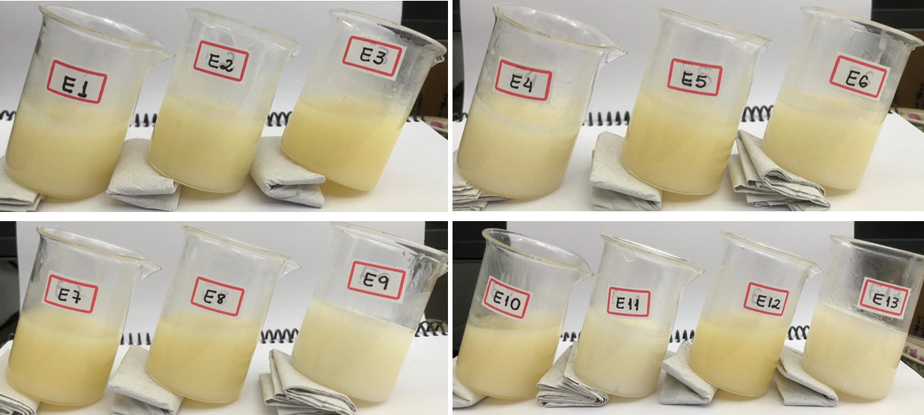
Figure 1. Physical stability of samples after 7 days of storage at 25°C.

Texture parameters
The indirect extrusion test (Back Extrusion) provides information about the firmness, consistency, cohesiveness, and viscosity index of viscous or semisolid food products, characterizing their texture properties.
When penetrating the sample, the probe generates a peak of maximum force, which is attributed to firmness: the greater the force, the firmer the sample. The area under the peak force curve is the measure of consistency: the higher the value, the thicker the sample. The removal of the probe generates a negative region resulting from the lifted weight of the sample, which indicates the cohesion and resistance of the sample to separate (flow) from the probe. The maximum negative force indicates cohesiveness (adhesive strength): the more negative the value, the more adherent the sample. The negative area is known as adhesiveness (viscosity index — energy required to break contact between the sample and the probe). It can indicate the cohesive forces of the molecules in the sample: the more negative the values, the more energy is required to break contact between the sample and the probe as the probe withdraws from the sample (Kasparaviciene et al., 2018).
Table 4 shows that, in general, samples E2, E5, and E7 had the best results for texture, with greater firmness and cohesiveness (p < 0.05). Sample E7 also stood out regarding consistency (p < 0.05), an essential attribute for an oleogel to perform similarly to fats with higher levels of saturated fatty acids in food matrices. A possible justification for the better texture characteristics observed in samples E2, E5, and E7 is the combination of the three structuring elements in their formulation. (SE + SL + MAG).
Table 4. Texture parameters of the oleogels¹.
Samples | Firmness (N) | Consistency (N s⁻¹) | Cohesiveness (N) | Viscosity index (N s⁻¹)
E2 | 3.30 ± 0.59ª | 21.75 ± 6.21^{bc} | -2.00 ± 0.66^{b} | -7.66 ± 1.21ª
E5 | 2.90 ± 0.43ª | 27.31 ± 3.02^{b} | -1.72± 0.26^{b} | -9.57 ± 1.95ª
E7 | 4.14 ± 0.96ª | 44.54 ± 10.89ª | -2.58 ± 0.59^{b} | -10.38 ± 7.99ª
E9 | 1.20 ± 0.26^{b} | 10.71 ± 3.65^{c} | -0.44± 0.15ª | -2.79 ± 1.29ª
E11 | 1.32 ± 0.15^{b} | 13.49 ± 2.02^{bc} | -0.47 ± 0.07ª | -3.31 ± 0.68ª
E13 | 0.8 ± 0.05^{b} | 7.95 ± 0.55^{c} | -0.28± 0.037ª | -2.03 ± 0.23ª
¹The results are given as the mean ± standard deviation (n = 3). Means followed by different letters in the same column are significantly different by Tukey’s test (p < 0.05).
It is well known that pure lecithin alone cannot structure non-polar solvents; however, its combination with other elements, such as sorbitan tristearate (STS) (Pernetti et al., 2007), small amounts of a polar solvent (Shchipunov, 2001), alpha-tocopherol (Nikiforidis & Scholten, 2014), phytosterols (Okuro et al., 2018), and ethylcellulose (Aguilar-Zárate et al., 2019), can result in the gelation of lipid material.
Nikiforidis and Scholten (2014) hypothesized that the formation of spreadable and non-pourable gel, as a result of the addition of lecithin and α-tocopherol to sunflower oil, is due to a change in the packing geometry of the reverse micelles of lecithin. In the case of lecithin, the small hydrophilic and large hydrophobic areas favor the formation of small reverse spherical micelles. The addition of a larger hydrophilic molecule in the form of α-tocopherol leads to a combination of the geometry of the structurants, which would favor closer packing of cylindrical micelles or lamellar phases, reducing the molecular packing parameter. Reverse spherical micelles cannot overlap to form networks that span space. However, the involvement of α-tocopherol in spherical reverse micelles most likely induces the creation of supramolecular structures, also known as supramolecular polymers, that are physically cross-linked and entangled due to non-covalent bonds, such as van der Waals and hydrogen bonds. These bonds induce the formation of a comprehensive network and, thus, the gelation of the system.
According to Sintang et al. (2017), the gelation of sucrose esters in combination with sunflower oil lecithin can be attributed to the entropic hydrophobic effect. This effect minimizes the hydrophilic head group-solvent interaction, thus modulating the systems' self-assembly behavior, where lecithin induced such conformational changes.
In this sense, the combination of sucrose fatty ester and monoacylglycerol in the presence of lecithin (ternary mixture) possibly produced oleogels with supramolecular structures capable of sustaining greater amounts of oil in their crosslink. Lecithin may have induced better structural organization of oleogels by increasing the lipophilic volume of the system (Rodrigues-Abreu et al., 2005). Da Silva and Danthine (2023) also reported an improvement in the oleogels structure of sucrose esters and monoacylglycerol through the addition of lecithin.
It is noteworthy that texture properties alone cannot predict the stability of the oleogels, as the samples E9, E11, and E13 (binary interaction) were solid and did not flow when inverted, despite having relatively low firmness values.

Rheological properties

Gap determination
Initially, tests were carried out to determine a suitable gap for the different samples, ensuring that their structure was not destroyed (crushing) and that they were well accommodated between the geometry and the rheometer base.
Table 5 shows that the increase in gap values provided an increase in the consistency index obtained from the power law model (R² > 0.99), mainly for sample E13, as the small space between the plates causes structural changes in the sample (Albano et al., 2014). From the gap of 800 µm, in both samples (E2 and E13), the K values did not change considerably, ensuring no structure destruction and/or sample overflow. This indicated good accommodation in the equipment, which was decisive for choosing this gap value.
Table 5. Values of the consistency index (K) for tests E2 and E13 at different gap settings.
Sample | Gap (µm) | K (Pa.s)
E2 | 200  500  800  1000 | 0.17  0.20  0.21  0.22
E13 | 200  500  800  1000 | 0.43  0.36  0.51  0.52

Steady shear
Data show a good adjustment to the power law model R² > 0.99. Table 6 shows that the samples presented shear-thinning behavior (0.52 < n < 0.85) in the ramp 2 (downward). However, the values of behavior index (n) were higher for samples E2, E5, and E7 (n > 0.8), demonstrating a trend toward Newtonian fluid behavior. This result explains the lower values obtained for the consistency index and the flow curves (Figure 2).
Table 6. Index consistency (K, Pa.s^{n}) and index behavior (n) at 25ºC of oleogels¹.
 | Rep | K | n
E2 | 1 | 0.54 | 0.84
E2 | 2 | 0.55 | 0.84
E2 | 3 | 0.52 | 0.85
E5 | 1 | 0.54 | 0.82
E5 | 2 | 0.53 | 0.82
E5 | 3 | 0.53 | 0.82
E7 | 1 | 0.64 | 0.80
E7 | 2 | 0.62 | 0.81
E7 | 3 | 0.59 | 0.82
E9 | 1 | 1.19 | 0.63
E9 | 2 | 1.25 | 0.62
E9 | 3 | 1.10 | 0.64
E11 | 1 | 2.13 | 0.52
E11 | 2 | 2.05 | 0.53
E11 | 3 | 1.93 | 0.54
E13 | 1 | 0.52 | 0.79
E13 | 2 | 0.55 | 0.77
E13 | 3 | 0.65 | 0.75
¹1, 2, and 3 correspond to triplicates of each sample.
The thixotropy of the oleogels was evaluated by quantifying the area under the flow curves corresponding to each shear rate ramp, using the area under the first downward curve as a reference, equivalent to 100% (Albano et al., 2014). Therefore, the greater the distance from 100%, the greater the thixotropy of the oleogel (Table 7). The thixotropy beginning was observed when there was distance between ramp 1 and 2, which occurred at a different shear rate for each sample.
All the samples had slight thixotropy. The values for the ternary samples (E2, E5 and E7) were similar when compared to those of the binary ones (E9, E11 and E13). The latter, though, presented higher variation (from 24.80 to 37.89%), indicating a higher effect of the system composition and shear rate. Many food products have thixotropy, which is directly related to their apparent viscosity. In the thixotropy, the structure is broken down under shear and rebuilt at rest (Steffe, 1996, Nadire et al., 2024). This shows that some food products can recover their structure after shear (at constant stress or shear rate) (Rao, 2010; Naderi et al., 2024).
Ternary samples were more resistant, mainly because the thixotropy began at higher values of shear rate, namely sample E2 at 60s⁻¹, E5 at 70 s⁻¹, and E7 at 60s⁻¹ (Figures 2a, 2b, 2c respectively). These results were consistent with the texture analyses of the ternary mixture, which showed that the presence of lecithin had a significant influence (p < 0.05) and showed higher firmness and consistency.
Sample E5 showed a smaller reduction in thixotropy (28.15%) for the ternary samples according to Table 3, which allows us to suggest that higher levels of SE (0.3125%) combined with intermediate SL values 0.3750%) can make the materials more resistant to shearing when subjected to higher shear rates. Further research might test higher levels of SE (0.1562 < g < 0.2187) with intermediate values of SL to enhance the flow resistance of oleogels. This approach may further minimize changes in apparent viscosity and enable applications in specific industrial processes, such as extrusion, mixing, pumping, sedimentation, and even during chewing (100 to 10³ s⁻¹) (Barnes et al., 1989; Steffe, 1996).
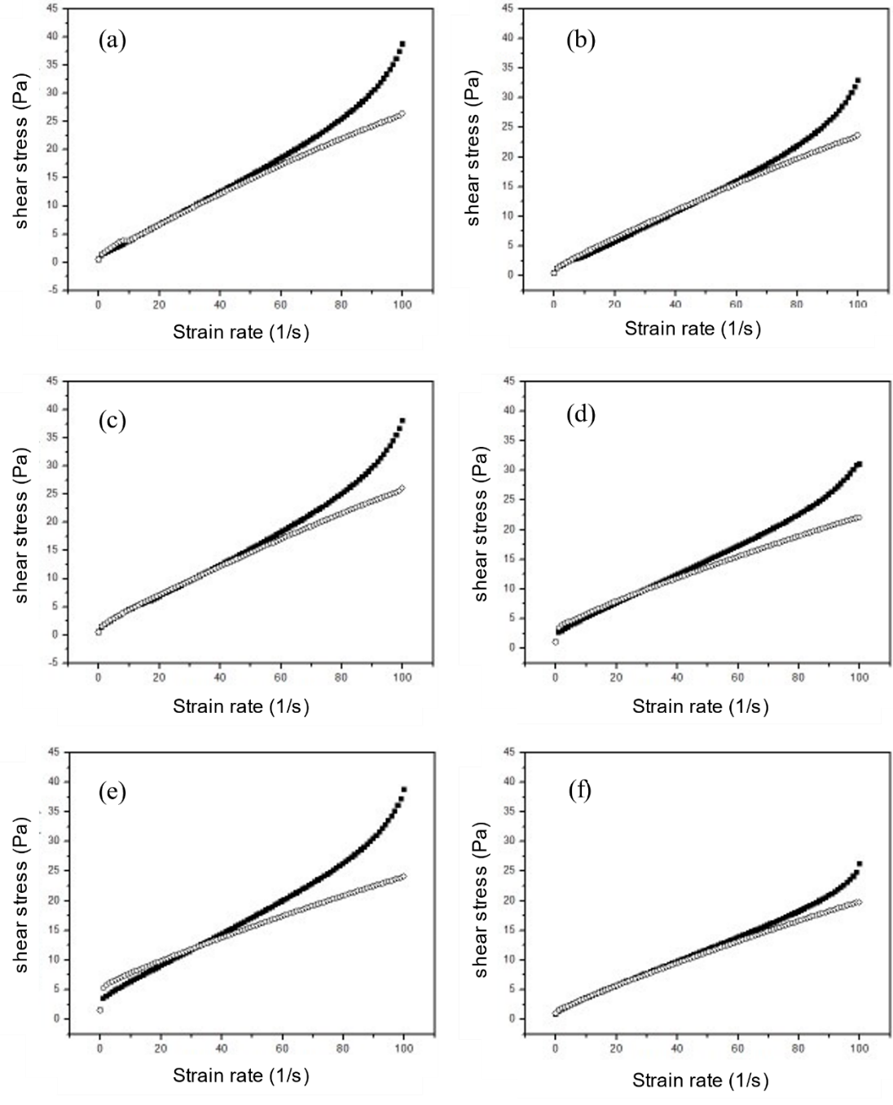
Figure 2. Flow curves in the downward (■) and upward (○) shear rate ramps for the samples (a) E2, (b) E5, (c) E7, (d) E9, (e) E11 and (f) E13.
Table 7. Area under flow curves (1st downward and 2nd upward ramps) of oleogels containing different lipid structuring.
Ramp area | E2 | E5 | E7 | E9 | E11 | E13
1 | 38.72 (100%) | 32.93 (100%) | 38.06 (100%) | 31.03 (100%) | 38.70 (100%) | 26.23 (100%)
2 | 26.38 (68.13%) | 23.66 (71.85%) | 26.00 (68.32%) | 22.07 (71.12%) | 24.03 (62.11%) | 19.73 (75.20%)
Thixotropic area | 12.34 (31.87%) | 9.27 (28.15%) | 12.06 (31.68%) | 8.96 (28.88%) | 14.66 (37.89%) | 6.50 (24.80%)

It is also noticeable that the greater interaction and effect of the components are related to the critical proportions of SE and SL, since when increasing or decreasing the SL content for the same SE value in samples E2 and E7 (Table 1), the intensity of thixotropy increased (Table 7).
For samples E9, E11, and E13 (Figures 2d, 2e, 2f, respectively), it is important to evidence that none of these samples have any initial SL content. The K values of the binary systems (Table 6) were higher than those of the ternary systems and the values for apparent viscosity of sample E13 were lower compared to samples E9 and E11, which can be justified by the system composition. In sample E13, there were higher concentrations of SE, and in sample E11, there was a higher concentration of MAG. Based on this, apparently, the higher MAG content (2.87g) of E11 was efficient as a structuring agent just at very low shear rates (< 35s⁻¹), where the upward ramp overlapped the downward ramp (Figure 2e) and, later thixotropy was prominent.
It was observed in all the samples at rest (beginning of ramp 2) that the material tends to increase its apparent viscosity, recovering some of its structure (Figure 3). In the thixotropic behavior of materials, two main phenomena are observed: structural degradation and structural recovery of the product as a function of time (Naderi et al., 2024; Miao et al., 2025). For sample E11, this behavior was prominent, and it was proven by the higher consistency index values and apparent viscosity (Table 6, Figure 3e).
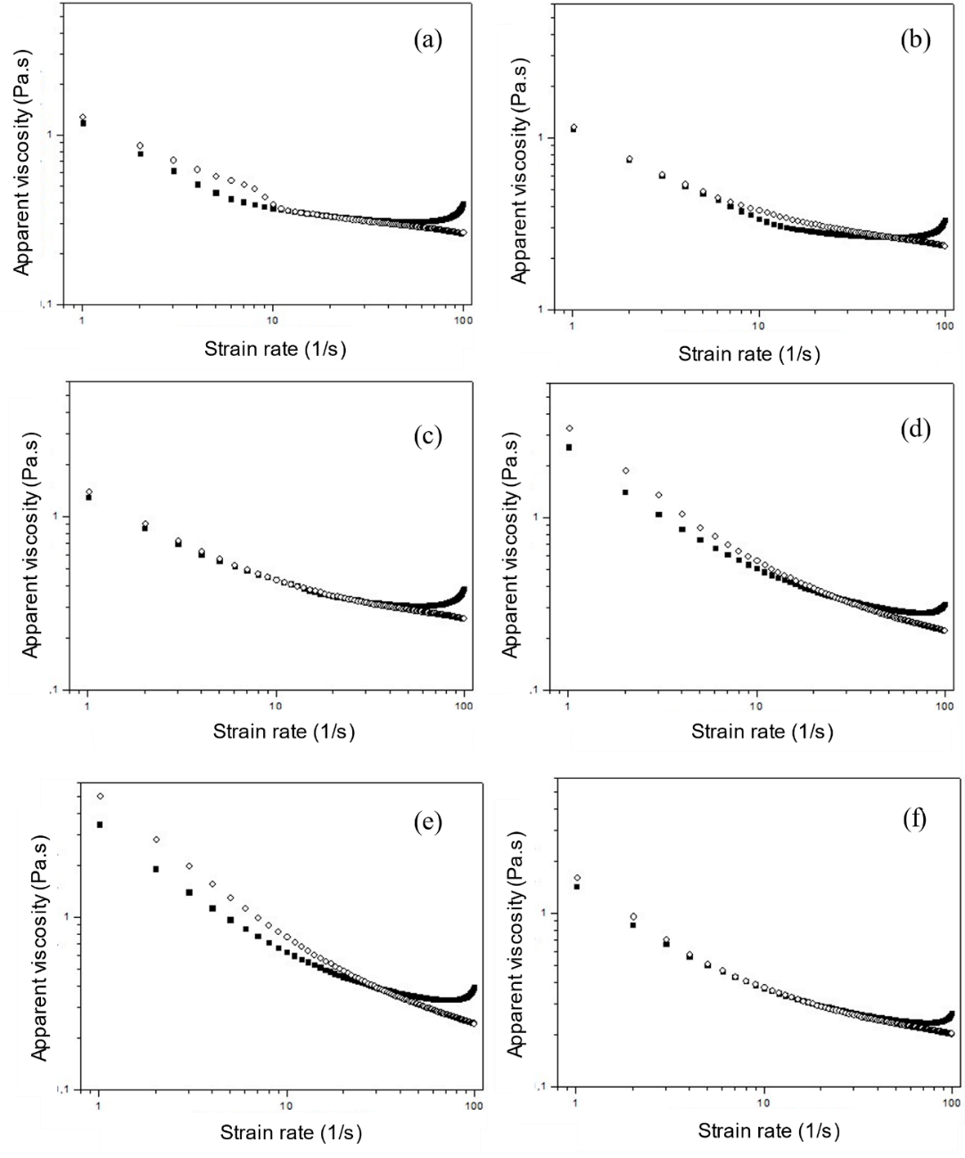
Figure 3. Apparent viscosity curves in the downward (■) and upward (○) shear rate ramps for the samples (a) E2, (b) E5, (c) E7, (d) E9, (e) E11 and (f) E13.
Additionally, the apparent viscosity of binary systems was higher than that of ternary systems. This increase is attributed to the formation of stronger intermolecular networks (Ding et al., 2024; Gao et al., 2024; Kwon and Chang, 2022). Ding et al. (2024) reported that denser oleogels with internal self-assembled structures have higher shear resistance. However, while binary systems showed higher viscosity, thixotropy began at lower shear rates (~35 s⁻¹), indicating that materials with higher MAG content are more shear-sensitive, which may be problematic for industrial processes operating at higher shear rates (Barnes et al., 1989; Steffe, 1996). This sensitivity can negatively impact food properties, such as texture and structure during processing. It is important to emphasize that although the K values and apparent viscosity were higher for the binary mixtures, these samples are much more sensitive to shear, which corroborates the lower values of firmness, consistency, and cohesiveness obtained from the texture analyses.
Ding et al. (2024) found similar results for using MAG. They evaluated the differences in physical properties, crystal structure, and stability of oleogels made with diglyceride-oil and triglyceride-oil combined with MAG and beeswax. The authors found that viscosity decreased for all samples and attributed the destruction of the oleogel structure to forces generated during shearing (Li et al., 2021). Besides that, the oleogels with MAG were weaker and less stable due to weaker intermolecular network formation in the oleogel.
Although all samples showed thixotropy, it occurred in a narrow range, mainly for ternary mixtures. Another important characteristic was that some oleogels showed a strong tendency toward Newtonian behavior, which is promising when trying to guarantee the rheological properties of the fluid during the process.
Another factor to be considered is the material's ability to recover at low shear rates, as seen in the apparent viscosity curves (Figure 3). This is extremely important; it shows that, after shearing, the sample tends to recover some of its structure, which is a desirable characteristic for food products subjected to industrial processes, in order to guarantee their attributes, such as viscosity. This behavior is useful and may be further researched in the future.
Conclusion
Results indicate that the examined material has shear-thinning behavior with low thixotropy, which means that its apparent viscosity changes at different shear rates.
It is noteworthy that, although all the systems showed thixotropy, the level of thixotropy observed was relatively low compared to many other food systems, and it occurred above a certain shear rate value. Additionally, materials with shear-thinning behavior are expected to have thixotropy under specific process conditions.
Oleogels made from a binary mixture showed better recovery of structure at low shear rates and higher apparent viscosity values, even though they were less resistant to shear, possibly due to the tested MAG content.
Furthermore, oleogels made from a ternary mixture showed greater firmness and cohesiveness, with a strong tendency toward Newtonian behavior (n > 0.8). It was evident that the combination of the three structuring agents resulted in more structured materials when compared to those without lecithin, despite having lower apparent viscosity values.
The addition of SE in the sample with the three structuring agents, especially at higher concentrations, resulted in an oleogel with greater shear resistance. However, further formulation studies are required to improve resistance for practical application in food formulations and industrial processes. Another area for potential research involves testing the SE with SL, as the presence of MAG did not promote system structuring.
Acknowledgments
The authors acknowledge Mitsubishi-Kagaku Foods (Japan) for the donation of sucrose fatty ester (RYOTO™ Sugar Ester), Triângulo Alimentos (Itápolis, SP, Brazil) for the donation of high-oleic sunflower oil, and DuPont Nutrition & Health (Barueri, SP, Brazil) for the donation of monoacylglycerol (GRINDSTED® CRYSTALLIZER).
References
Aguilar-Zárate, M., Macias-Rodriguez, B. A., Toro-Vazquez, J. F., & Marangoni, A. G. (2019). Engineering rheological properties of edible oleogels with ethylcellulose and lecithin. Carbohydrate Polymers, 205, 98–105. https://doi.org/10.1016/j.carbpol.2018.10.032
Albano, K. M., Franco, C. M., & Telis, V. R. (2014). Rheological behavior of Peruvian carrot starch gels as affected by temperature and concentration. Food Hydrocolloids, 40, 30–43. https://doi.org/10.1016/j.foodhyd.2014.02.003
Barnes, H. A., Hutton, J. F., & Walters, K. (1989). An introduction to rheology. Elsevier.
Da Silva, T. L. T., & Danthine, S. (2023). Sucrose esters as oleogelators in mono or binary structured oleogels using different oleogelation routes. Gels, 9(5), Artigo 399. https://doi.org/10.3390/gels9050399
Ding, D., Zhao, S., Xu, W., Yang, C., Xiong, L., Zheng, M., & Li, S. (2024). Insights into the difference between diglyceride-oil based and triglyceride-oil based oleogels: Physical property, crystal structure and stability. Food Structure, 41, Artigo 100382. https://doi.org/10.1016/j.foostr.2024.100382
Gao, P., Liu, Y., Wang, S., Huang, C., Zhong, W., Yin, J., Hu, C., He, D., & Wang, X. (2024). Effects of different oleogelators on the structural properties and composition of iron walnut-oil oleogels. Ultrasonics Sonochemistry, 102, Artigo 106729. https://doi.org/10.1016/j.ultsonch.2023.106729
Godoi, K. R. R., Basso, R. C., Ming, C. C., da Silva, V. M., da Cunha, R. L., Barrera-Arellano, D., & Ribeiro, A. P. B. (2019). Physicochemical and rheological properties of soybean organogels: Interactions between different structuring agents. Food Research International, 124, Artigo 108475. https://doi.org/10.1016/j.foodres.2019.05.023
Harasym, J., & Banaś, K. (2024). Lecithin’s roles in oleogelation. Gels, 10(3), Artigo 169. https://doi.org/10.3390/gels10030169
Kasparaviciene, G., Kalveniene, Z., Pavilonis, A., Marksiene, R., Dauksiene, J., & Bernatoniene, J. (2018). Formulation and characterization of potential antifungal oleogel with essential oil of thyme. Evidence-Based Complementary and Alternative Medicine, 2018(1), Artigo 9431819. https://doi.org/10.3390/gels10030169
Kwon, U. h., & Chang, Y. H. (2022). Rheological and physicochemical properties of oleogel with esterified rice flour and its suitability as a fat replacer. Foods, 11(2), Artigo 242. https://doi.org/10.3390/foods11020242
Li, J., Guo, R., Bi, Y., Zhang, H., & Xu, X. (2021). Comprehensive evaluation of saturated monoglycerides for the forming of oleogels. LWT - Food Science and Technology, 151, Artigo 112061. https://doi.org/10.1016/j.lwt.2021.112061
Miao, W., Zhang, Z., Lin, Q., McClements, D. J., Ji, H., Jiang, L., Wen, J., Jin, Z., & Qiu, C. (2025). Preparation of emulsion-template oleogels: Tuning properties by controlling initial water content and evaporation method. Food Hydrocolloids, 158, Artigo 110519. https://doi.org/10.1016/j.foodhyd.2024.110519
Naderi, M., Ziaiifar, A. M., Rashidi, L., & Jafari, S. M. (2024). Rapeseed oleogels based on monoacylglycerols and methylcellulose hybrid oleogelators: Physicochemical and rheological properties. Food Chemistry: X, 23, Artigo 101520. https://doi.org/10.1016/j.fochx.2024.101520
Nikiforidis, C. V., & Scholten, E. (2014). Self-assemblies of lecithin and α-tocopherol as gelators of lipid material. RSC Advances, 4(5), 2466–2473. https://doi.org/10.1039/C3RA46584E
Okuro, P. K., Malfatti-Gasperini, A. A., Vicente, A. A., & Cunha, R. L. (2018). Lecithin and phytosterols-based mixtures as hybrid structuring agents in different organic phases. Food Research International, 111, 168–177. https://doi.org/10.1016/j.foodres.2018.05.022
Patel, A. R., & Dewettinck, K. (2016). Edible oil structuring: An overview and recent updates. Food & Function, 7(1), 20–29. https://doi.org/10.1039/C5FO01006C
Pernetti, M., van Malssen, K. F., Flöter, E., & Bot, A. (2007). Structuring of edible oils by alternatives to crystalline fat. Current Opinion in Colloid & Interface Science, 12(4-5), 221–231. https://doi.org/10.1016/j.cocis.2007.07.002
Rao, M. A. (2010). Rheology of fluid and semisolid foods: Principles and applications. Springer Science & Business Media.
Shchipunov, Y. A. (2001). Lecithin organogel: A micellar system with unique properties. Colloids and Surfaces A: Physicochemical and Engineering Aspects, 183, 541–554. https://doi.org/10.1016/S0927-7757(01)00511-8
Sintang, M. D. B., Danthine, S., Patel, A. R., Rimaux, T., Van De Walle, D., & Dewettinck, K. (2017). Mixed surfactant systems of sucrose esters and lecithin as a synergistic approach for oil structuring. Journal of Colloid and Interface Science, 504, 387–396. https://doi.org/10.1016/j.jcis.2017.05.114
Steffe, J. F. (1996). Rheological methods in food process engineering. Freeman Press.
Tavernier, I., Doan, C. D., Van de Walle, D., Danthine, S., Rimaux, T., & Dewettinck, K. (2017). Sequential crystallization of high and low melting waxes to improve oil structuring in wax-based oleogels. RSC Advances, 7(20), 12113–12125. https://doi.org/10.1039/C6RA27650D
Yang, T., Rebsdorf, M., Engelrud, U., & Xu, X. (2005). Enzymatic production of monoacylglycerols containing polyunsaturated fatty acids through an efficient glycerolysis system. Journal of Agricultural and Food Chemistry, 53(5), 1475–1481. https://doi.org/10.1021/jf048405g

