“AUTOMATIC DESIGN OF THE FLEXURAL STRENGTHENING OF REINFORCED CONCRETE BEAMS USING FIBER REINFORCED POLYMERS”

Rafael Alves de Souza
Associate Professor - State University of Maringá
e-m: rsouza@uem.br

Vladimir José Ferrari
Associate Professor - State University of Maringá
e-mail: vladimirjf@hotmail.com

Abstract: Changing the functions of a building, the presence of some design or construction errors, the incidence of seismic actions and even the updating of design codes may demand the strengthening of certain structures. In the specific case of reinforced concrete structures it is desirable the application of a technique of strengthening which is fast, economic and efficient, in order to provide advantages when an intervention is necessary. The technique of strengthening chosen must provide less disorder as possible as well as the guaranty of safety. Taking into account this scenery, fiber reinforced polymers have been working as a very attractive alternative for rehabilitating in-service structures. In that way, the present study aims at presenting the main properties of this new material as well as the design routines for flexural strengthening of reinforced concrete beams. Finally, a package-software developed into the MATLAB platform is presented, intending to generate a simple tool for the automatic design using fiber reinforced polymers.

Key words: Strengthening, Reinforced Concrete, Design, Fiber Reinforced Polymers.

INTRODUCTION

Every concrete structure, according to the NBR 6118 (2003), must meet requirements of strength (security against rupture), performance in service (full conditions of use, without damages that partial or completely compromise its use or safety) and durability (resistance to environmental influences) during its construction and throughout its useful life. Nevertheless, the load capacity of the structures predicted in the design can be affected by some of the following reasons:

- Some of the loads can be inadvertently underestimated, still in project stage;
- Architectonic projects, with great heights and free spans create more difficulties for design of the structural elements and thus increase the chances of errors;
- The utilization of slender elements in the more varied ways and with excessive flexibility, based on the advancement of materials technology and the use of high strength concrete and steel with high mechanical strength;
- The emergence of sophisticated computational tools that promote the development of more accurate computational models with consequent reduction in safety margin. Indeed, the structures continue to be designed safely, but with a minor “safety reserve”, which was previously considered as a function of the ignorance of certain phenomena of structural behavior;
- The change in the nature and intensity of loading over time. For instance, the increase in speed and weight of the vehicles (more loads and more axes) on the structures of the bridges;
- In the project stage, disregard the dynamic effect of the actions, in order to ensure natural frequencies of minimum vibrations to the structure and the compliance with maximum limits of speed and acceleration.
The items previously cited compete to configure, in a time not so far, structures with strength lower than the ideal. In such condition, the structure's performance is only reestablished through the implementation of strengthening. This procedure can be seen as a response to the problems of deteriorating structures, inadequate projects, problems in the construction phase, and also in anticipation to the placing of additional loads on the structure.

Several techniques of structures reinforcement have been employed by professionals working in recovery and strengthening of structures. In the area of reinforced concrete structures subjected to bending, such as beams, the most widespread techniques are those traditional like the bonding of steel plates, with or without bolts on the concrete surface; the addition of new concrete or mortar with high performance in the tensile zone with new longitudinal steel bars (Figure 1.a); and more recently the external bonding of Carbon Fiber Reinforced Polymers (CFRP) using structural epoxy resin (Figure 1.b).

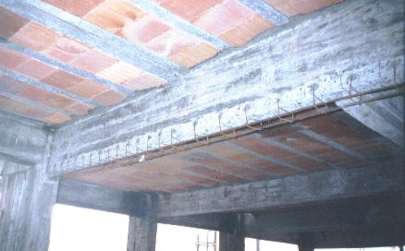 | 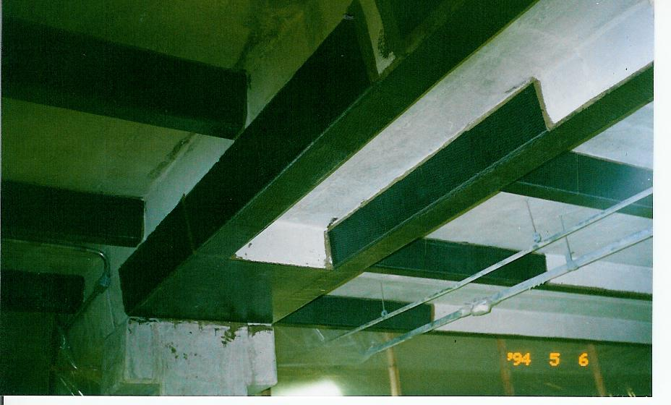
- addition of steel bars | b) bonding of CFRP
Figure 1 – Flexural strengthening of reinforced concrete beams

Since 1940, the fiber-based composites have been applied to perform important functions in the field of the military engineering, aerospace, naval, rail and automobile industry (Juvandes et al., 1996). Due to its satisfactory performance, they have come to occupy a prominent place in buildings, as a viable alternative in the strengthening of structures by the combination of polymers with carbon fibers.

The CFRP are appropriate for structural strengthening of concrete elements due to the high mechanical performance of carbon fibers, ease to application, increase of strength, and maintenance of the original section of the reinforced part. Its use has been significant in several countries like Japan, especially in applications related to problems caused by earthquakes. In Europe, the applications are more focused to rehabilitation of infrastructure of national heritage, and in North America, the focus is on the durability of the buildings (Juvandes, 1999).

Increasingly in recent years, the knowledge about the behavior of concrete elements strengthened with CFRP has advanced in terms of characterizing the failure modes associated with the connection, in terms of application methodology and considering the inspection of the reinforcement technique. Some of its main characteristics for structural applications are related as follow:

- Resistance to electrochemical corrosion;
- High tensile strength (around seven-fold higher than the steel);
- Low specific weight (around four times lower than the steel);
- Due to its flexibility, it adapts easily to varied shapes;
- It is traded in any length, but in general it is sold in rolls of 50 or 100 meters;
- The carbon fiber, under fire situation, is able to maintain its mechanical properties up to approximately 1000°C (FIB, 2000). According to Beber (2003), the composite material carbonizes rather than burn, keeping the reinforcement working for a period longer than a reinforcement with steel plates bonded;
- It keeps the original dimensions of the cross section of the reinforced beam due to the small thickness of the composite;
- The structure can be put into service in a short time period after being reinforced. The curing of the adhesive is fast, but it is needed to wait the curing time recommended by the manufacturer, at least 48 hours.

In this way, regarding all the potentials and advantages reported previously, the goal of the present study was to present the main mechanical properties of the carbon fiber reinforced polymers. The calculation routines needed for the design of flexural strengthening of concrete beams using the referred material are also presented, in order to demystify this process. At last, we also present a computer program conceived within the MATLAB platform, which aims to be a versatile tool for design the flexural strengthening of reinforced concrete beams by using the CFRP.

STRENGHTENING SYSTEM WITH CFRP AND ITS MECHANICAL PROPERTIES

The carbon fiber composites to be used in buildings as a way of structural reinforcement of concrete elements can be found in two distinct forms of systems pre-fabricated and molded in loco. The pre-fabricated systems (Figure 2) are made by continuous layers of unidirectional fibers impregnated by resins, through a pultrusion process, controlling the thickness and width (Ferrari, 2007).

 | 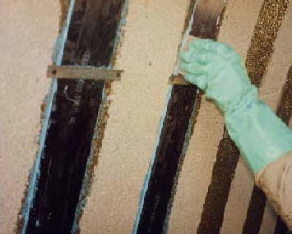
a) carbon fiber laminate | b) application of the laminate
Figure 2 – Appearance and application of the carbon fiber laminate

The product is named in the international literature as laminate, plate or strip, but in Brazil it is known as laminate or pultruded plate. In the marketing of this product there are variations among manufacturers, especially of characteristics as the carbon content, thickness, width, modulus of elasticity, and deformation in rupture. For this, the warning is for the professional attention regarding the correct observation of the properties’ values of the products in technical catalogs (Ferrari, 2007).
With rare exceptions, there is an omission as for the information about the average or expected mechanical properties of the composites. In most cases, it is only showed the presentation of the carbon fiber properties. Below are some properties of the pultruded composite, according to the manufacturer Sika Brasil S/A, listed in the technical catalog:
- Tensile strenght: 2,400 MPa;
- Modulus of elasticity: 155 GPa;
- Maximum deformation: 19‰;
- Thickness: 1.2 mm;
- Width: 50 mm;
- Cross section: 60 mm²;
- Density: 1,600 kg/m³;
- Usually applied in a single layer and on flat surfaces through thixotropic adhesives.

The systems molded in loco are composed of bundles of continuous fibers, in the form of yarn, blanket or tissues, dry or prepreg state, i.e., with a resin layer without full cure – prepreg. They are applied on a layer of epoxy adhesive distributed on a concrete surface previously prepared.

The final thickness of this system, cured in loco, is smaller than the thickness of a pre-fabricated system, and is also more difficult to be determined. The composite system is only formed after the hardening of the adhesive. Figure 3 illustrates the appearance of the blanket and one example of strengthened beams using this system.

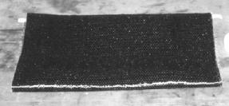  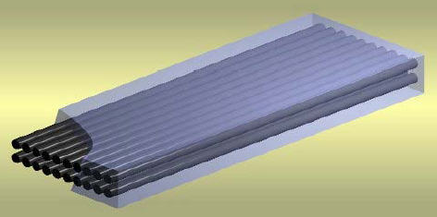  matrix  fibers | 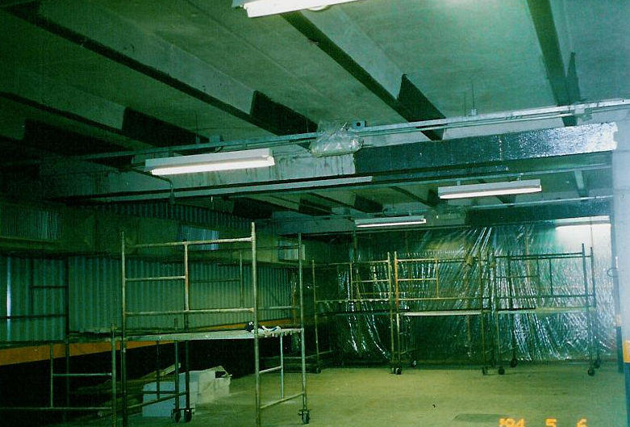
a) blanket and the formed composite | b) application of the blanket
Figure 3 – Appearance and application of the carbon fiber blanket

According to the manufacturer of the carbon fiber blanket there are variations, in general, in blanket weight, in the direction of the fibers, its length and in mechanical properties of the fibers. The basic information of the fibers and composite (blanket + adhesive) are listed below, according to Sika Brasil S/A:

- Status: dry or prepreg;
- Tensile strenght: 3,500 MPa (blanket) and 960 MPa (composite);
- Modulus of elasticity: 230 GPa (blanket) and 76 GPa (composite);
- Maximum deformation: 15‰ (blanket) and 13.3‰ (composite);
- Thickness: 0.13 mm (blanket) and 0.40 mm (composite);
- Width: 60 cm;
- Density: around 1,780 kg/m³;
- Frequently applied in more than one layer, regardless the surface shape, taking care with rounded corners and with the use of low viscosity adhesive.

The blankets and tissues have been developed in the early 90’s and in general have tensile strength and modulus of elasticity higher than the laminate at raw state, i.e., when not impregnated with epoxy adhesive. They also have advantages of being flexible, and can be applied involving structural elements. The blanket has carbon fibers in just one direction (unidirectional), while in the tissue, the fibers are arranged in more than one direction.

More recently, it has emerged another way of using the CFRP laminate for strengthening of beams; consisting in its insertion into slots made in the concrete cover as shown in Figure 4. The system uses carbon fiber laminates with small dimensions (about 10 mm width and 1.4 mm thickness) and it is known as the technique of near-surface mounting (NSM) fiber-reinforced polymer (FRP) bars/strips.

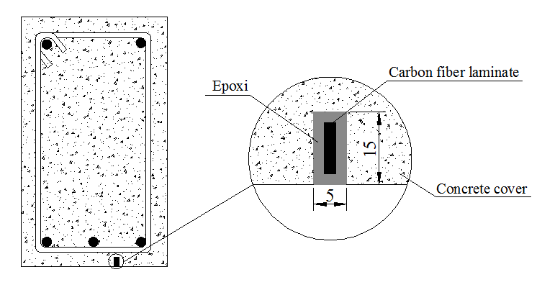 | 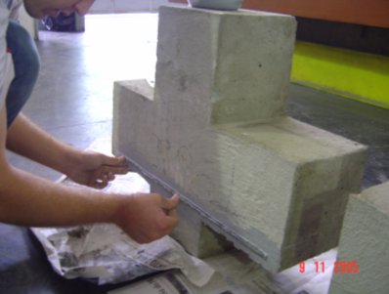
a) strengthening of beams | b) strengthening of corbels
Figure 4 – Near-surface mounting fiber-reinforced polymer (a) of beams and (b) short corbels

According to De Lorenzis et al. (2000), the technique is interesting to increase the resistant capacity of structural elements subjected to bending. Souza et alli (2006), on the other hand, have obtained a good performance of the technique on the strengthening of short corbels, where the shear is predominant (‘D Regions’)

According to Fortes (2004) the technique of inserting laminates into slots on concrete cover has been studied by some researchers with the purpose to improve the effectiveness in the use of laminate. The results so far have shown that this technique presents excellent behavior in relation to the resistant capacity, thermal effect, and especially as for the rupture mode, preventing the peeling-off effect.

FORMULATING THE DESIGN FOR FLEXURAL STRENGTHENING

Afterwards, it is presented the main steps needed for flexural strengthening of reinforced concrete beams using CFRP, observing that future studies will approach the reinforcements for other situations such as shear and torsion. Further information about strengthening using CFRP is found in Juvandes (1999), Machado (2002), FIB (2000), ACI-440 (1996, 2000 and 2001).

Initially, in order to decide on the need of strengthening, one should respond which is the maximum load that can be absorbed by reinforced concrete beam with its initial characteristics. Once observed the necessity of strengthening for the structural element to bending, i.e., if the ultimate bending of the beam is lower than the new demanded ultimate bending, then it is carried out the calculation of the required strengthening using carbon fibers, whether in the form of blankets or rigid bars.

The procedure for determining the maximum bending supported by the reinforced concrete beam is based on the use of simplified rectangular diagram for concrete and also considers the fundamental principles of strain compatibility, equilibrium and constitutive relations of materials (steel and concrete). The formulation described below is primarily based on the recommendations of NBR6118 (2003) and Hulse & Mosley (1986).

Maximum Bending Absorbed by the Reinforced Concrete Beam

The input parameters required for executing the proposed routine are: negative reinforcement (A’_{s}), positive reinforcement (A_{s}), effective height of negative reinforcement (d’), effective height of positive reinforcement (d); beam height (h); beam width (b); concrete characteristic strength to compression (f_{ck}), characteristic strength of steel to yielding (f_{yk}), modulus of elasticity of the steel (E_{s}), ultimate bending of strengthening (M_{uk}). Once are defined the input data, the routine can be then conducted for determining the ultimate bending (M_{ud}) supported by the beam.

a) Initially it is assumed a value for the neutral axis depth x, which should vary incrementally from the effective height of the negative reinforcement (d’) up to the effective height of the positive reinforcement (d).

b) From the value specified for x, it is possible to calculate the strains in the compressed reinforcement (ε_{sc}), in the tensile reinforcement (ε_{st}), and in the compressed concrete (ε_{cu}), as illustrated in Figure 5 and following expressions that consider the strains prescribed in NBR6118 (2003):

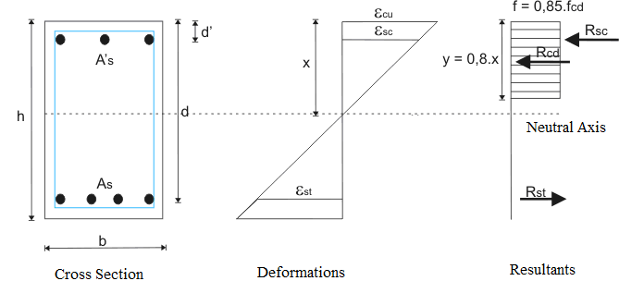
Figure 5 – Compatibility of strains and resultants of stresses in reinforced concrete beams

If x ≤ 0.259.d → Ultimate Limit State in Domain 2 | (1)
$$ε_{\text{cu}}=\frac{0\text{.}\text{010}\text{.}x}{(\text{d-x})}≤0\text{.}\text{0035}$$ | (1.a)
$$ε_{\text{sc}}=\frac{(x−\text{d'})\text{.}0\text{.}\text{010}}{(\text{d-x})}$$ | (1.b)
$$ε_{\text{st}}=0\text{.}\text{010}$$ | (1.c)
If 0.259.d < x ≤ 0.628.d → Ultimate Limit State in Domain 3 | (2)
$$ε_{\text{cu}}=0\text{.}\text{0035}$$ | (2.1)
$$ε_{\text{sc}}=\frac{(x−\text{d'})\text{.}0\text{.}\text{0035}}{x}$$ | (2.2)
$$0\text{.}\text{00207}≤ε_{\text{st}}=\frac{0\text{.}\text{0035}\text{.}(\text{d-x})}{x}≤0\text{.}\text{010}$$ | (2.3)
If x > 0.628.d → Ultimate Limit State in Domain 4 | (3)
$$ε_{\text{cu}}=0\text{.}\text{0035}$$ | (3.1)
$$ε_{\text{sc}}=\frac{(x−\text{d'})\text{.}0\text{.}\text{0035}}{x}$$ | (3.2)
$$ε_{\text{st}}=\frac{0\text{.}\text{0035}\text{.}(\text{d-x})}{x}<0\text{.}\text{00207}$$ | (3.3)

c) From the stress-strain diagram of the steel, it is possible to determine the stresses acting on the compressed (σ_{sc}) and tensile reinforcement (σ_{st}), according to the following expressions:

σ_{sc} = E_{s}. ε_{sc} for ε_{sc} ≤ ε_{yd} = f_{yd}/E_{s} | (4.1)
σ_{sc} = f_{yk}/γ_{s} = f_{yd} for ε_{sc} > ε_{yd} | (4.2)
σ_{st} = E_{s}. ε_{sc} for ε_{sc} ≤ ε_{yd} = f_{yd}/E_{s} | (5.1)
σ_{st} = f_{yk}/γ_{s} = f_{yd} for ε_{sc} > ε_{yd} | (5.2)

d) With the previous stresses, it is calculated the resultant of compressed concrete (R_{ct}) above the neutral axis depth, as well as the resultant of tensile steel (R_{st}), below the neutral line, as the following expressions:

R_{ct} = R_{cd} + R_{sc} | (6)
R_{cd} = 0.85.f_{cd}.b.0.8.x = 0.68.f_{cd}.b.x | (7)
R_{sc} = A’_{s}. σ_{sc} | (8)
R_{st} = R_{sd} = A_{s}. σ_{st} | (9)

e) If the resultants of concrete compression (R_{ct}) and tensile steel (R_{st}) are not equal, admitting a certain level of tolerance (error), then we return to step (a), and the process is repeated until obtaining the equality in these resultants. When achieved this equality, we proceed to step (f);

f) The ultimate bending of the beam (M_{ud}) is obtained by taking the moment resultants around the tensile reinforcement, as the following expression:

M_{ud} = 0.68.f_{cd}.b.x.(d – 0.4.x) + A’_{s}. σ_{sc}.(d – d’) | (10)

g) If the ultimate bending of the calculation obtained (M_{ud}) is higher than the bending for which is questioned the reinforcement (M_{ur}), the beam does not need flexural strengthening. Otherwise, if the beam needs flexural strengthening it is necessary to follow the routine described in details in the next section.

Design of the flexural strengthening with CFRP

Once confirmed the need of flexural strengthening, then it is necessary to define the type of strengthening will be adopted, i.e., blanket or bars of CFRP. In this way, one can define the limit strains for the fibers (ε_{f,limite}), as well as the modulus of elasticity of the used material (E_{f}), needed to determine the reinforcement area. Besides that, it is necessary to inform the characteristic maximum bending due to the self weight of the beam (M_{gk}), since there will be necessary to subtract it from the fiber total strain the specific strain caused by the load when applying the reinforcement.

The methodology proposed is basically a hybrid formulation between the proposals of Machado (2002) and GangaRao et alli (2006), always aiming at obtaining a reinforcement of minimum area that lead to a situation of ductility at ultimate limit state, i.e., rupture of the concrete simultaneously with the yielding of the reinforcements and suitable level of strain for the carbon fiber. The procedure is described below and the equations of equilibrium and compatibility are obtained from the Figure 6:

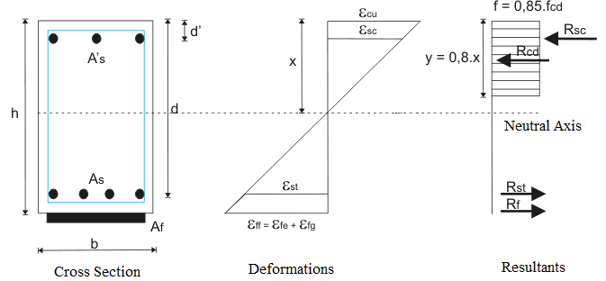
Figure 6 – Compatibility of strains and resultants of stress in reinforced concrete beam strengthened with CFRP

a) Initially one must calculate the height of the neutral axis depth (x_{g}) for the isolated action of the maximum bending caused by permanent loading (M_{gk}), as follows:

$x_{g}=1\text{.}\text{25}\text{.}d\text{.}\left[1−\sqrt{1−\frac{γ_{f}\text{.}M_{\text{gk}}}{0\text{.}\text{425}\text{.}b_{w}\text{.}d^{2}\text{.}\frac{f_{\text{ck}}}{γ_{c}}}}\right]$, with γ_{f} = γ_{c} =1.4 | (11)

b) Once calculated the height of the neutral axis for permanent loading, the strain in the tensile reinforcement (ε_{stg}), in the compressed concrete (ε_{cg}), in the tensile carbon fiber (ε_{fg}) and in the compressed reinforcement (ε_{scg}) are determined, as follows:

z = d – 0.4.x_{g} | (12)
F_{s} = M_{gk} / z | (13)
σ_{st} = F_{s} / A_{s} | (14)
ε_{stg} = σ_{st} / E_{s} | (15)
ε_{cg} = (ε_{stg} . x_{g}) / (d - x_{g}) | (16)
ε_{fg} = (ε_{cg} / x_{g}) . (h - x_{g}) | (17)
ε_{scg} = ((x_{g} – d’) / x_{g}) . ε_{cg} | (18)

c) It is assumed a value for the neutral axis depth x, which should vary incrementally from the limit of the domains 3 and 4 (x₃₄ = 0.628.d) to the limit of the domains 2 and 3 (x₂₃ = 0.259.d), since it is intended to obtain a balanced reinforcement. In this way, it is possible to obtain an economic design for the ultimate limit state, with the yielding of tensile reinforcements and the rupture of the compressed concrete;

d) Then, regarding the assumed value of x, it is calculated the strains, the stresses and the resultants for both concrete and reinforcements employing all the expressions in the interval from (1) to (9);

e) In the sequence, it is calculated the maximum stress allowed for the carbon fiber (σ_{uf}) based on the specification of the limit stress of the composite material (ε_{f,limite}). Regarding the stresses calculated in the section (d), one should calculate the active stress (ε_{ff}) and effective stress on the carbon fiber, taking into account the initial stress due to its self weight (ε_{fg}). Finally, it is calculated the stress acting on the carbon fiber (σ_{fe}):

σ_{fu} = E_{f}.ε_{f,limite} | (19)
ε_{ff} = (ε_{cu} / x).(h - x) | (20)
ε_{fe} = (ε_{ff} - ε_{fg}) | (21)
σ_{fe} = E_{f}.ε_{fe} | (22)

e) After that, are calculated the resultant forces on the carbon fiber, considering the sum of moments around the positive reinforcement, around the negative reinforcement and around the resultant of compressed concrete. The tensile force in the carbon fiber (R_{fc}) is taken as being the highest value among the three previous resultants, as follows:

R_{f1} = (M_{ur} - (R_{sc}.(d – d’) + R_{cd}.(d – 0,4.x)))/(h – d) | (19)
R_{f2} = (M_{ur} - (R_{st}.(d – d’) - R_{cd}.(0,4.x – d’)))/(h – d’) | (20)
R_{f3} = (M_{ur} - (R_{sc}.(0.4.x – d’) + R_{st}.(d – 0.4.x)))/(h – 0.4.x) | (21)
$$R_{f}≥\left\{\begin{matrix}R_{\text{f1}} \\ R_{\text{f2}} \\ R_{\text{f3}}\end{matrix}\right.$$ | (22)

f) Once known the resultant force in the carbon fiber (R_{f}) it is possible to calculate the amount of fiber required for the reinforcement (A_{f}):

A_{f} = (R_{f} / σ_{fe} ) | (23)

g) When the reinforcement area is determined, it is calculated the final position of the neutral axis depth (x_{new}), as follows. If the new value of x coincides with the value of x specified in item (a), considering a certain tolerance, the process can be ended, and the reinforcement area is determined. Otherwise, the process should be repeated from the item (a), taking as a value of x in the section (a) the height of the neutral line found in the item (x_{nex}). The process is iterative and usually has rapid convergence.

x_{new} = ((A_{s}.σ_{st}) + (A_{f} .σ_{fe}) - (A’_{s}.σ_{sc})) / (0.68.b.f_{cd}) | (24)
If x = x_{new} → the process converged | (25)
If x ≠ x_{new} → x = x_{new} → Back to item (a) of the for a new iteration | (26)

EXAMPLE OF AUTOMATIC CALCULATION USING MATLAB

According to Chapman (2003), the MATLAB package (abbreviation for MATrix LABoratory) is a computer program for specific use, optimized to execute scientific and engineering calculations. Among the main advantages of using MATLAB for technical programming are: the ease of use, the platform independence, the existence of pre-defined functions, device-independent diagrams, graphical user interface and an own compiler

Different from other languages, the MATLAB has several commands for images and graphs, which can be created more easily than in other languages. Furthermore, it can be created graphical interfaces that ease the communication between the programs and inexperienced users. The technical programming using MATLAB is undoubtedly easier and effective, regarding the existence of pre-defined functions.

In agreement with Marchand & Holland (2002), MATLAB is not only a package for mathematical calculations, but also a versatile and flexible tool that permit producing sophisticated visual graphs and interfaces, with the level of sophistication dependent on the imagination and creativity of the creator.

For simple calculations, the command can be typed directly into the MATLAB Command Window. However, for more complex programs that require a great number of operations, the commands can be grouped into a single file, known in MATLAB as ‘M-file’.

The M-Files are nothing more than script files and when their names are typed in the MATLAB Command Window, all the pre-programmed routine is executed. Figure 7, for instance, illustrates the MATLAB Command Window, as well, as the M-File (“frp.m”) created to calculate the strengthening of reinforced concrete beams using carbon fibers.

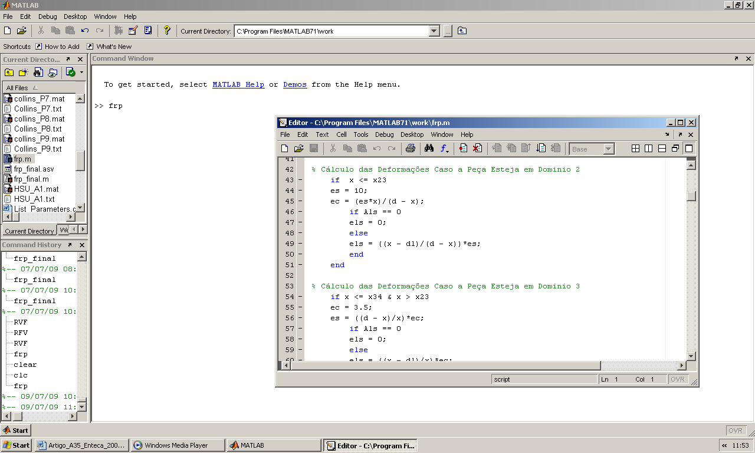
Figure 7 –MATLAB Command Window and M-File created for calculating the strengthening

Basically the calculation routines presented in the previous sections have been programmed into a M-file (“frp.m”), in order to achieve greater productivity in the iterative process, needed for determining the area of carbon fiber reinforcement for reinforced concrete beam with flexural deficiency.
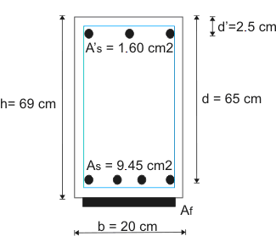 | Input data  Beam height = 69.00 cm  Beam width = 20.00 cm  Negative reinforcement = 1.60 cm²  Effective height of the negative reinforcement = 2.50 cm  Positive reinforcement = 9.45 cm²  Effective height of the positive reinforcement = 65.00 cm  Characteristic strength for concrete (f_{ck}) = 2.00 kN/cm²  Characteristic strength for steel (f_{yk}) = 50.00 kN/cm²  Modulus of elasticity for steel = 21,000 kN/cm²  Modulus of elasticity for fiber = 22,800 kN/cm²  Limit strain for carbon fiber = 14.00 º/_{oo}  Characteristic bending due to self weight = 29.00 kN.m  Characteristic bending required = 206.00 kN.m
**** INITIAL RESULTS OF PROCESSING ****  Neutral axis between Domains 2 and 3 (cm)= 16.84  Neutral axis between Domains 3 and 4 (cm)= 40.82  Ultimate Limit State in Domain 3  Neutral axis depth at ELU(cm)= 17.52  Maximum strain in concrete (o/oo)= 3.5000  Strain in the negative reinforcement (o/oo)= 3.0006  Strain in the positive reinforcement (o/oo)= 9.4840  Ultimate characteristic bending (kN.m) = 172.07  Ultimate characteristic bending (kN.m) required = 206.00  Difference between traction and compression's resultants (kN) = 0.90  Analysis Status: The beam needs to be strengthened. | ******** RESULTS FOR THE EFFORTS CAUSED BY SELF WEIGHT ********  Neutral axis depth for self weight (cm) = 2.330  Neutral axis depth in Domain 2 for self weight  Strain in the positive reinforcement (o/oo) = 0.2281  Strain in the negative reinforcement (o/oo) = -0.0006  Maximum strain in concrete (o/oo) = 0.0085  Initial strain in the carbon fiber (o/oo) = 0.2426  Tensile force in the positive reinforcement (kN) = 45.26  Tensile stress in the positive reinforcement (kN/cm2) = 4.79
*************** RESULTS RELATIVE TO THE CARBON FIBER REINFORCEMENT ************
Iteration Number = 1.00  Required FRP reinforcement (cm2) = 4.29  Estimated height for the neutral axis (kN) = 40.82  Resultant of compressed concrete (kN) = 793.07  Resultant of the negative compressed reinforcement (kN) = 69.57  Resultant of the positive tensile reinforcement(kN) = 410.89  Resultant of the stress on the reinforcement (kN) = 212.42  Total strain in concrete (o/oo) = 3.50  Strain in the negative reinforcement (o/oo) = 3.29  Strain in the positive reinforcement (o/oo) = 2.07  Total strain in the carbon fiber (o/oo) = 2.42  Effective strain in the carbon fiber (o/oo) = 2.17  Maximum strain allowed for the fiber (o/oo) = 14.00  Final height obtained for the neutral axis (kN) = 28.50  Internal moment (kN.m) = 380.11  External moment (kN.m) = 288.40  Percentage of error between moments = 31.80 | Iteration Number = 10.00  Required FRP reinforcement (cm2) = 0.54  Estimated height for the neutral axis (kN) = 22.13  Resultant of compressed concrete (kN) = 429.88  Resultant of the negative compressed reinforcement (kN) = 69.57  Resultant of the positive tensile reinforcement (kN) = 410.89  Resultant of the stress on the reinforcement (kN) = 88.57  Total Strain in concrete (o/oo) = 3.50  Strain in the negative reinforcement (o/oo) = 3.10  Strain in the positive reinforcement (o/oo) = 6.78  Total strain in the carbon fiber (o/oo) = 7.41  Effective strain in the carbon fiber (o/oo) = 7.17  Maximum strain allowed for the fiber (o/oo) = 14.00  Final height obtained for the neutral axis (kN) = 22.13  Internal moment (kN.m) (kN.m) = 288.40  External moment (kN.m) (kN.m) = 288.40  Percentage of error between moments = 0.00
Figure 8 – Details of the flexural strengthened beam by Machado (2002) and results obtained using the program developed in MATLAB.

Then, we present the numerical results obtained by using MATLAB software, and the results obtained were compared with those described by Machado (2002) for a reinforced concrete beam strengthened with carbon fibers and shown in more details in Figure 8. It is noteworthy that we intended to show only the results of the first and the last iteration, aiming to describe briefly the iterative process.
As one can see by the processing, the area of reinforcement required provided by the program created is 0.54 cm², while the amount specified by Machado (2002) was 0.58 cm². In this way, it is observed a good performance of the program created, with the advantage that the process is faster, accurate and provides all the information necessary about the forces and strains acting on the materials.

CONCLUSIONS

The carbon fiber strengthened composites have become an optimal alternative for the reinforcement of structural elements undergoing resistance deficiencies. When compared with other options for reinforcement, such as addition of bars or plates of steel, the carbon fibers present several advantages like economy, ease of application, lower weight and higher durability. Nevertheless, there is some difficulty on the required procedures for the due design of the reinforcement using this material.

Considering the difficulties, the present study aimed to present the main characteristics of the carbon fiber and the process of design of the reinforcement using this material for reinforced concrete beams with flexural deficiency. In addition, we develop a specific program implemented in the MATLAB package, in order to optimize the iterative processes usually required for this type of analysis.

The program developed has some shortcomings, since it is a work still preliminary. One of the problems to be solved, for example, refers to the formulation of security to be applied on carbon fibers, a subject without consensus in literature. For the program in question, it was adopted a unit coefficient, i.e., there was no reduction in the characteristic resistance of the fiber due to a security factor. BYARS et alli (2003), for instance, present a summary table of existing assessments in some codes, where it is possible to see the lack of consensus on the subject.

Another problem refers to the shear resistance at the interface between the concrete substrate and the carbon fibers. In the case of bent beams there may be a premature detachment of the carbon fiber, in view of problems of adherence. Moreover, the beam resistance to shear force should always be checked, with the danger this simple effort become determinant, once the flexural strength was enhanced by introducing carbon fibers.

Despite the evidenced deficiencies, our initial results are very encouraging, regarding the obtaining of a tool versatile and simple to use, attractive to increase the use of carbon fibers as an alternative reinforcement. At last, it should be observed that the developed program will be further improved, through creating additional routines to evaluate the detachment at the interface of the carbon fibers with the concrete substrate, with the creation of routines for shear and torsion, as well as with the creation of a graphical interface for a more attractive interaction with the users.

REFERENCES

ASSOCIAÇÃO BRASILEIRA DE NORMAS TÉCNICAS. “NBR6118: Projeto de Estruturas de Concreto - Procedimento”, Rio de Janeiro, 2003.

AMERICAN CONCRETE INSTITUTE. “Guide the Design and Construction of Externally Bonded FRP Systems for Strengthening Concrete Structures”. ACI Committee 440, Detroit, EUA, 2001.

AMERICAN CONCRETE INSTITUTE. “Guide for the Design and Construction of Concrete Reinforced with FRP Bars”. ACI Committee 440, Detroit, EUA, 2001.

AMERICAN CONCRETE INSTITUTE. “State-of-The Art Report on Fiber Reinforced Plastic (FRP) Reinforcement for Concrete Structures”. ACI Committee 440, Detroit, EUA, 1996.

BEBER, A. J.. “Comportamento Estrutural de Vigas de Concreto Armado Reforçadas com Compósitos de Fibra de Carbono”. Doctoral Thesis, Universidade Federal do Rio Grande do Sul, Porto Alegre, 317p, 2003.

BYARS, E.A.; WALDRON, P.; FEJKE, V.; DEMIS, S.; HEDDADIN, S.. “Durability of FRP in Concrete – Current Specifications and a New Approach”. International Journal of Materials & Product Technology, Volume 10, n.1/2, 2003.

CHAPMAN, S. J.. “Programação em MATLAB para Engenheiros”. Editora Thomson, São Paulo, 2003.

De LORENZIS, L.; NANNI, A.; LA TEGOLA, A.. “Flexural and Shear Strengthening of Reinforced Concrete Structures with Near Surface Mounted FRP Rods”. In: 3a International Conference on Advanced Composite Materials in Bridges and Structures, Ottawa, Canada. J. Humar and A. G. Razaqpur, Editors, p.521-528, 2000.

FÉDÉRATION INTERNATIONALE DU BÉTON. “FIB 2000: Bond of Reinforcement in Concrete - State-of-the-Art Report”. Lausanne, 2000.

FERRARI, V. J.. “Reforço à Flexão de Vigas de Concreto Armado com Manta de Polímero Reforçado com Fibras de Carbono (PRFC) Aderido a Substrato de Transição Constituído por Compósito Cimentício de Alto Desempenho”. Doctoral Thesis, Escola de Engenharia de São Carlos da Universidade de São Paulo, São Carlos, 2007.

FORTES, A. S.. “Estruturas de Concreto Submetidas à Flexão Reforçadas com Laminados de CFRP Colados em Entalhes”. Doctoral Thesis, Universidade Federal de Santa Catarina, Florianópolis, 2004.

GANGARAO, H. V. S.; TALY, N.;. VIJAY, P. V.. “Reinforced Concrete Design with FRP Composites”. CRC Press, Boca Raton, United States, 2006.

HULSE, R.; MOSLEY, W. H.. “Reinforced Concrete Design by Computer”. MacMillan Eduacation Ltda, London, 1986.

JUVANDES, L.F.P.. “Reforço e Reabilitação de Estruturas de Betão Usando Materiais Compósitos de CFRP”. Doctoral Thesis, Faculdade de Engenharia da Universidade do Porto (FEUP), Departamento de Engenharia Civil, Porto, Portugal, 400p., 1999.

JUVANDES, L.F.P.; MARQUES, A.T.; FIGUEIRAS, J.A.. “Materiais Compósitos no Reforço de Estruturas de Betão”. Technical Report, Faculdade de Engenharia da Universidade do Porto, Porto, Portugal, 112p, 1996.

MACHADO, A. P.. “Reforço de Estruturas de Concreto Armado com Fibras de Carbono”. Editora Pini, São Paulo, 2002.

MARCHAND, P.; HOLLAND, O. T.. “Graphics and GUIs with MATLAB”. Editora Chapman & Hall/CRC, Boca Raton, EUA, 2002.

RIBEIRO, P. T. P.. “Uma Abordagem Sobre o Modo de Dimensionamento do Reforço do Concreto Armado com Elementos Compósitos de Carbono – Mitos e Verdades”. In: 47° Congresso Brasileiro do Concreto, Recife, 2005.

SOUZA, R. A.; TRANALLI, P. P.; MARTIN, G. G.; BITTENCOURT, T. N.. "Análise Experimental e Analítica de Consolos Curtos de Concreto Armado Reforçados com Fibras de Carbono". In: 48° Congresso Brasileiro do Concreto, Rio de Janeiro, 2006.

