**CONSERVAÇÃO PÓS-COLHEITA DE RABANETE**

**POSTHARVEST OF RADISH**

**RESUMO**

A um aumento de consciência da qualidade de produtos hortícolas e no setor de saúde com forte demanda em pesquisas para a manutenção da qualidade até a comercialização, integrando as mesmas aos processos produtivos. Com isto o objetivo deste trabalho foi avaliar a conservação pós-colheita de rabanetes cv. Crimson giant em duas condições. Armazenados com e sem folhas à temperatura ambiente (20 ± 2 °C) e de 75% UR, exeperimento 1. E com e sem folhas e minimamente processados, armazenados em temperatura de refrigeração de 5 ºC e 90% de UR, experimento 2. Avaliações foram feitas em 0, 1 e 3 dias de armazenamento em temperatura ambiente devido a rápida detereioração do produto, e em 0, 1, 3 e 6 dias de armazenamento refrigerado. As variáveis avaliadas foram a perda de peso, firmeza da polpa, sólidos solúveis, pH, e acidez titulável. Em temperatura ambiente (20 ± 2 °C; 75%), bulbos de rabanete com e sem folhas apresentaram perdas de peso superiores a 5% após um dia de armazenamento, o que os torna não-comercializáveis. Bulbos de rabanete minimamente processados ​​podem ser armazenados por mais de seis dias a uma temperatura de 5 ºC, enquanto os rabanetes não processados, armazenados com e sem folhas na mesma temperatura, não devem exceder um dia de armazenamento.

**Palavras-chave:** *Raphanus sativus* L., refrigeração, processamento mínimo.

**ABSTRACT**

Increased awareness of quality, particularly in horticultural crops and in the health sector, strongly demands research to be focused on the maintenance of product quality until the product reaches the market and on the integration of these quality improving factors into production processes. The aim of this work was to ascertain the post-harvest preservation of Crimson Giant radishes with the following conditions: 1) stored at room temperature (20 ± 2°C and 75% relative humidity; RH) with or without leaves; or 2) stored at a refrigeration temperature of 5ºC and 90% RH with leaves, without leaves or minimally processed. For radishes stored at room temperature, evaluations were made at 0, 1 and 3 days. For radishes stored at a refrigeration temperature, evaluations were made at 0, 1, 3 and 6 days. The parameters evaluated included weight loss, pulp firmness, soluble solids, pH, and titratable acidity. At room temperature (20 ± 2°C and 75% RH), the radish bulbs with and without leaves had weight losses exceeding 5% after one day of storage, which rendered these radishes unmarketable. Minimally processed radish bulbs can be stored for more than six days at a temperature of 5ºC, and non-processed radishes stored with and without leaves at the same temperature should not be stored for more than one day.

**Keywords:** *Raphanus sativus* L., refrigeration, minimum processing

**INTRODUCTION**

There is an increasing awareness of quality, particularly in horticultural crops and in the health sector, which strongly demands research to be focused on the production of a product with a defined quality, preservation of quality during marketing, evaluation of quality parameters and integration of this into production processes (Valero & Serrano, 2010).

The radish (*Raphanus sativus* L.), which belongs to the Brassicaceae family, originates from the Mediterranean region, and its root is a red-colored edible bulb with a spicy flavor. Radishes can be used as a crop of rapid economic return because they have a growth cycle of 25 to 40 days. The peak harvest season of radishes is spring, but most varieties are available year-round. Although radish is a crop that occupies small planted areas, radish crops are important for small farms with greater crop diversity (Minami & Netto, 1997).

Radishes are considered a good source of calcium, iron, phosphorus, vitamins (C, B1, B2 and nicotinic acid) and fiber, which has diuretic, antiscorbutic and stimulant activities. Moreover, radishes contain sulfur compounds, and they have anticarcinogenic activity (Marques & Santos, 2005; Lopes, 2008).

Appearance is vital factor for consumers in deciding the purchase of fresh produce. Consumers expect fresh products to have a near perfect visual appearance (Valero & Serrano, 2010).

Preharvest conditions largely affect horticultural crop quality, chemical composition, texture, and postharvest moisture loss (Gómez-Galindo et al., 2004). The percentage of water that can be lost before quality is markedly reduced varies among produce (Acked, 2002). The rate of postharvest water loss is dependent primarily on external vapor pressure deficits, although others factors influence postharvest water loss. Products with a large surface-to-volume ratio, such as leaf crops, lose a greater percentage of water (Valero & Serrano, 2010).

Radishes are usually sold in bundles with their leaves still attached, which make them more prone to dehydration. If the total water loss exceeds 5%, radishes lose their turgidity, thereby reducing their shelf life and quality (Luengo & Calbo, 2001).

Minimally processed vegetables should be submitted to one or more procedures, such as washing, peeling or slicing, but still be in a fresh state and metabolically active (Moretti, 2007). The marketing of radishes has increased due to a growing demand for food considered convenient or easy to prepare (Aguila et al., 2007).

Quality measures commonly used to characterize radishes include weight loss, total acidity, hydrogenic potential, soluble solids and firmness. Total acidity is related to the levels of organic acids in the juice or pulp and is a common feature in the evaluation of postharvest quality of vegetables (Chitarra & Chitarra, 2005). In recent years, however, the perception of taste by consumers has not only been related to the content of sugars but also to total acidity, which is becoming an important factor. Therefore, the ratio between soluble solids and total acidity is now used as a criterion for product acceptance (Valero & Serrano, 2010).

This study aimed to evaluate the post-harvest preservation of radishes stored at room temperature with or without leaves as well as radishes stored at a refrigeration temperature with leaves, without leaves or minimally processed.

**MATERIAL AND METHODS**

The first experiment was carried out in a completely randomized design (2x3 factorial design) with six treatments (two storage forms: bulbs with leaves and bulbs without leaves; and three storage times: 0, 1 and 3 days) and storage at room temperature (20 ± 2ºC and 75% RH). Three replications were performed, and each replicate consisted of three radishes. The second experiment was carried out in a completely randomized design (3x4 factorial design with twelve treatments (three storage forms: bulbs with leaves, bulbs without leaves and minimally processed bulbs; and four storage times: 0, 1, 3 and 6 days) and storage at a refrigeration temperature of 5°C with 90±5% humidity. Three replications were performed, and each replicate consisted of three radishes.

The harvested Crimson Giant radishes were selected, and those that showed physical damage, mechanical damage or visible infection were discarded. Radishes were washed in running water to remove impurities adhered to the product.

In preparation for minimum processing, the leaves and roots were removed. The radishes were then washed in running water, immersed in a sanitizing solution (200 mg L-1 sodium hypochlorite for 10 minutes), rinsed in distilled water, dried with absorbent paper and packaged in polystyrene trays wrapped in polyethylene film.

The following variables were evaluated: weight loss, which was determined by weighing the radishes on a semi-analytical balance (Mettler Toledo, AB204-S); pulp firmness, which was measured with a fruit pressure tester (FT**-**327, Italy) with an 8-mm diameter tip by pressing it perpendicular to the equatorial surface of the radish; soluble solids, which were evaluated from juice extracted from the bulbs using a manual refractometer (Digit); pH, which was measured with a digital pH meter (HI 22, HANNA Instruments); and titratable acidity, which was measured by titrating with a solution of 0.1 N NaOH up to a pH of 8.1 (Carvalho *et al.*, 1990). Titratable acidity was expressed as the percentage of malic acid, and the SS/AT ratio was calculated as the relationship between the soluble solids and total titratable acidity.

The data were subjected to a variance analysis (F-test), and the means were compared by Tukey’s test at a 5% probability. After the comparison, the means were subjected to a polynomial regression using STATS™2.0 statistical software (Kronka & Banzato, 1995).

**RESULTS AND DISCUSSION**

The first experiment showed a significant interaction between the storage form and storage time factors but only in terms of weight loss percentage (Table 1). With regard to the storage form, the weight loss of radishes stored with leaves was greater than that of radishes stored without leaves, except on day zero of storage. This result was attributed to the leaves hastening the dehydration process.

**Table 1.** Weight loss percentage of radish bulbs with and without leaves as a function of storage time when stored at a temperature of 20±2ºC and 75% RH.

|  |  |  |
| --- | --- | --- |
| Storage time (days) | Weight loss (%) | |
| Without leaves | With leaves |
| 0 | 0.00 Acª | 0.00 Ac |
| 1 | 22.63 Bb | 41.40 Ab |
| 3 | 52.96 Ba | 67.63 Aa |
| CV (%) | 0.03 | |

ªMeans followed by the same uppercase letter in the row and lowercase letter in the column do not differ from each other according to Tukey’s test (*P* ≤ 0.05).

With regard to the storage forms of the radishes, only the titratable acidity showed a significant effect (Table 2).

**Table 2.** Titratable acidity, firmness, soluble solids and pH of juice extracted from radish bulbs with and without leaves when stored at a temperature of 20±2°C and 75% RH.

|  |  |  |  |  |
| --- | --- | --- | --- | --- |
|  | Acidity (%) | Firmness (N) | Soluble solids (°Brix) | pH |
| Without leaves | 0.42 Bª | 65.38 A | 3.27 A | 6.18 A |
| With leaves | 0.47 A | 63.35 A | 3.54 A | 6.23 A |
| CV (%) | 10.75 | 10.85 | 8.86 | 1.75 |

ªMeans followed by different letters in the column differ from each other according to Tukey’s test (*P* ≤ 0.05).

A comparison of the storage times revealed a significant difference in all characteristics of the radish bulbs except for firmness (Table 3). Compared to the condition at harvest, the soluble solids increased in the first days of storage due to dehydration, but the soluble solids decreased by the third day in response to the consumption of sugars by respiration (Table 3). The reduction of pH with storage time was attributed to increasing acidity.

**Table 3.** Titratable acidity, firmness, soluble solids and pH of juice extracted from radish bulbs as a function of storage time when stored at a temperature of 20±2°C and 75% RH.

|  |  |  |  |  |
| --- | --- | --- | --- | --- |
| Storage time (days) | Acidity (%) | Firmness (N) | Soluble solids (°Brix) | pH |
| 0 | 0.34 Bª | 65.92 A | 3.43 B | 6.32 A |
| 1 | 0.41 B | 60.80 A | 4.07 A | 6.12 B |
| 3 | 0.58 A | 66.36 A | 2.72 C | 6.17 AB |
| CV (%) | 10.75 | 10.85 | 8.86 | 1.75 |

ªMeans followed by different letters in the column differ from each other according to Tukey’s test (*P* ≤ 0.05).

The estimated SS/AT ratio of 7,6 during storage at 20ºC was not influenced by the presence or absence of leaves. However, the SS/AT ratio decreased from 10,08 during the first storage day to 4,68 after two additional days of storage. The SS/AT ratio in vegetable crops is considered to be an indicator for flavor. Increased SS/AT ratios normally indicate a good flavor, and this ratio can also be used as a ripening indicator (Pinto et al., 2003).

In the second experiment, there was a significant interaction between storage forms and storage times, which affected the characteristics of weight loss, soluble solids and total titratable acidity of the radish juice.

The minimally processed radish bulbs showed acceptable levels of weight loss for marketing during the 6 days of storage. However, the other treatments presented fresh mass weight losses greater than 5%, which rendered the radishes receiving these treatments unmarketable (Luengo & Calbo, 2001) (Figure 1).

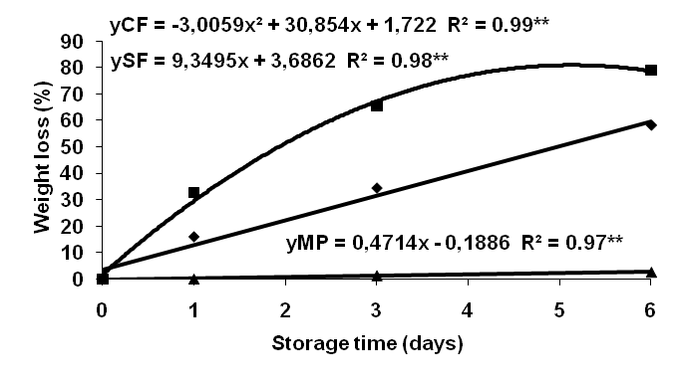

**Figure 1.** Weight loss percentage of radish bulbs stored with leaves (■ CF), radish bulbs stored without leaves (♦SF), and minimally processed radish bulbs (▲MP) as a function of storage time.

The soluble solid content decreased independently of the storage form (with leaves, without leaves and minimally processed), increasing from the third day of storage (Figure 2).

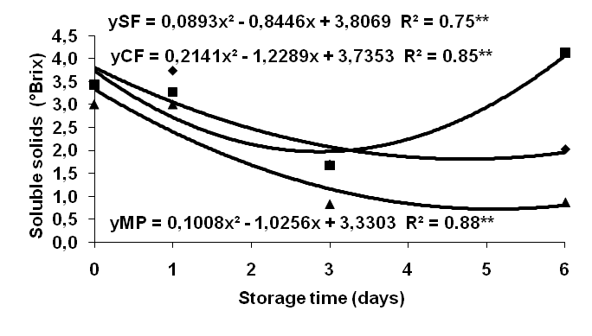

**Figure 2.** Soluble solids (ºBrix) of juice from radishes stored with leaves (■ CF), radishes stored without leaves (♦ SF) and minimally processed radishes (▲MP) as a function of storage time.

These results corroborated the bulb weight loss results, namely that greater water losses resulted in higher soluble solid contents.

During the storage period, the titratable acidity increased in radishes stored with and without leaves, showing maximum acidity on the sixth day of storage. In the minimally processed radish bulbs, the maximum acidity was obtained on the third day of storage, which then declined to 29% on the sixth day of storage (Figure 3).

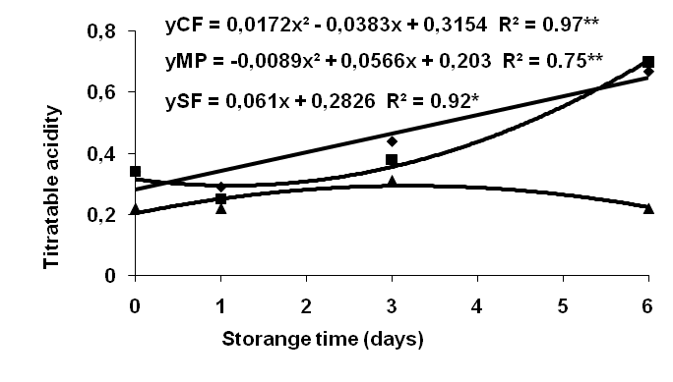

**Figure 3.** Titratable acidity of juice from radishes stored with leaves (■ CF), radishes without leaves (♦ SF) and minimally processed radishes (▲MP) as a function of storage time.

Even at a temperature of 5±2ºC, the SS/AT ratio decreased with storage time (Table 4). The decreased SS/AT ratio was attributed to sugar consumption during respiration (Kassat *et al*., 2007), which was accompanied by an increase in acidity. In general, this ratio increases during maturation because the content of SS increases and acidity decreases (Cavalini, 2004). Reductions in acids and phenolics improve flavor (Chitarra & Chitarra, 2005). However, the present study disagreed with this generalization because the low ratio indicated the beginning of the radish perishability due to extended storage.

**Table 4**. The SS/AT ratio of radishes stored without leaves (SF), radishes stored with leaves (CF) and minimally processed radishes (MP) stored at a temperature of 5± 2ºC and 90% RH.

|  |  |  |  |
| --- | --- | --- | --- |
| **Days** |  | **Treatment** |  |
|  | **SF** | **CF** | **MP** |
| **1** | 8,97 | 9,37 | 9,6 |
| **3** | 4,52 | 5,62 | 4 |
| **6** | 3,06 | 5,8 | 3,62 |

The pH and firmness of the radish bulbs did not fit the polynomial equation with averages of 6.23 and 66.49 N, respectively.

Radish bulbs with and without leaves showed increasing weight loss over time, and the acceptable weight loss value for marketing was exceeded on the first day. According to Luengo & Calbo (2001), the acceptable weight loss value is 5%. The relative humidity (RH) contributed to dehydration during storage because this vegetable requires more than 90% relative humidity during storage (Luengo & Calbo, 2001).

The lower percentage of malic acid in radishes stored without leaves may have been caused by the consumption of acids immediately after the leaves were cut off because acids serve as substrates for the respiratory process (Aguila *et al.*, 2006b).

The titratable acidity was highest on the third day of storage, which was similar to the result reported by Aguila *et al.* (2006a) in minimally processed and packaged radishes. Most plants show a reduction in acidity during ripening due to the consumption of acids as a source of energy (Valero & Serrano, 2010). Increases in acidity are likely due to an initial accumulation of organic acids resulting from the degradation of cellular components (Moura, 1995) and the subsequent increase in the consumption of these acid molecules during the process of respiration (Chitarra & Chitarra, 2005).

The stress caused by cutting the minimally processed samples led to a higher consumption of soluble solids due to the respiration process. The respiration process is triggered by the plant’s attempt to repair injuries because some of these soluble solids are carbohydrates, which are the principal substrates for respiration in most plants (Aguila *et al.,* 2006b). Aguila *et al,.* (2006a), who stored minimally processed and whole Crimson Giant radishes at a temperature of less than 10ºC, found a 0.43% decrease in the content of soluble solids after 10 days of storage. This decrease in soluble solids can be partially attributed to the consumption of carbohydrates through respiration in an attempt to repair injury (Aguila *et al.*, 2006a).

The reduction of titratable acidity likely resulted from the consumption of acids in the plant’s respiration process, which increases during minimal processing (Aguila *et al.*, 2006b).

The pH level is indicative of the flavor of vegetables, and it has an inverse relation to the acidity. However, the buffering capacity of some juices allows large variations to occur in acidity with no appreciable change in pH (Chitarra & Chitarra, 2005).

Aguila *et al.* (2006b) reported similar trends when studying Crimson Giant radishes stored at a temperature of 10ºC, which showed a weight loss of 2 to 5% after 10 days of storage.

Radish samples with and without leaves stored for only 1 day showed a weight loss exceeding the 5% limit acceptable for marketing (Luengo & Calbo, 2001).

Nicola *et al.* (2005) found that the storage of radish bulbs wrapped in macro-perforated film results in a final weight loss of 33% and that the weight loss of radishes wrapped in polyethylene film is reduced over time, reaching a final reduction of 3%. These results indicate that the type of packaging directly influences the quality of the product whether or not the product is minimally processed.

**CONCLUSIONS**

Radish bulbs should not be stored at room temperature (20±2°C and 75% RH) because the radishes lose their fresh appearance due to shriveling. Minimally processed and packaged radish bulbs can be stored for six days at a temperature below 5°C, and non-processed radish bulbs stored with or without leaves at this temperature should not be stored for more than one day.

**REFERENCES**

ACKED J. Maintainig the post-hatvest quality of fruits and vegetables. In **Fruit and Vegetable Processing,** ed. W. Jongen, 2002. p. 121-149.

*AGUILA JS; SASAKI FF; HEIFFIG LS; ORTEGA EMM; JACOMINO AP; KLUGE RA. Quality of fresh cut radish stored in a passive modified atmosphere under refrigeration. **Brazilian Journal of Food Technology 9**. 2006a. p.19-24.

*AGUILA JS; SASAKI FF; HEIFFIG LS; ORTEGA EMM; JACOMINO AP; KLUGE RA. Fresh-cut radish using different cut types and storage temperatures. **Postharvest Biology and Technology 9**. 2006b.p.149–154.

AGUILA JS; SASAKI FF; HEIFFIG LS; ORTEGA EMM; JACOMINO AP; KLUGE RA. Alteration of the respiratory metabolism in whole and fresh cut radishes. **Ciência Rural**, 37(2). 2007. p.565-568.

*CARVALHO CRL; MANTOVANI DMB; CARVALHO PRN; MORAES RMN. **Análises químicas de alimentos**. Campinas: ITAL (Manual Técnico) 1990. p.121 .

CAVALINI, F. C**. Índices de maturação, ponto de colheita e padrão respiratório de goiabas 'Kumagai' e 'Paluma'.** Dissertação (Mestrado em Fisiologia e Bioquímica de Plantas) – Escola Superior de Agricultura "Luiz de Queiroz". Piracicaba. 2004.

*CHITARRA MIF; CHITARRA AB. **Pós-colheita de frutos e hortaliças:** fisiologia e manuseio. 2 ed. UFLA, Lavras. 2005. p 785.

GÓMEZ-GALINDO, F., HERPPICH, W., GEKAS, V., and SJÖHOLM, I. **Factors affecting quality and postharvest properties of vegetables:** Integration of water relations and metabolism. Critical Review in Food Science and Nutrition. 2004, p.139-154.

KASSAT, GF; MATTIUZ, B; OGASSAVARA FO; BIANCO MS; MORGADO CMA; CUNHA LC. Injúrias mecânicas e seus efeitos em pêssego ‘Aurora-1’. Revista Barsileira de Fruticultura. Jaboticabal: 2. 2007. p..318-322.

KRONKA SN; BANZATO DA. **Estat:** Sistema para análise estatística versão 2.0. 3 ed. Jaboticabal: FUNEP. 1995.p. 247.

*LOPES MAJBM. **Incorporação de lodo de esgoto e seus efeitos sobre alguns atributos do solo cultivado com rabanete (*Raphanus sativus* L.).** Recife, Master’s Dissertation, Universidade Católica de Pernambuco. 2008. p. 99.

*LUENGO RFA; CALBO AG. **Armazenamento de hortaliças.** Brasília: Embrapa Hortaliças. 2001. p. 242.

*MARQUES PAA.; SANTOS ACP. **Efeito de diferentes níveis de irrigação baseadas em frações do tanque classe sobre a produção de rabanete (*Raphanus sativus* L.).** *Colloquium Agrariae* 1. 2005. p.23-27.

*MINAMI K; NETTO JT. **Rabanete: Cultura rápida, para temperaturas amenas e solos areno-argilosos.** Piracicaba: ESALQ. 1997.p. 27.

MORETTI CL;. Panorama de processamento mínimo de frutas e hortaliças. In: MORETTI CL. **Manual de processamento mínimo de frutas e hortaliças**. Brasília: Embrapa Hortaliças. 2007, 25-39p.

MOURA MA. **The wrapping and storage effect at zero degree during the persimmon fruit (*Diospyros kaki* L.) Taubaté ripening**. Master’s Dissertation. Universidade Federal de Viçosa, Viçosa. 1995.

*NICOLA S; FONTANA E; HOEBERECHTS J; SAGLIETTI D. ***Raphanus sativus* production in soilless or traditional culture systems and postharvest packaging**. *Acta Horticulturae* 682. 2005. p. 1303-1310.

PINTO W. da Silva.; DANTAS ACVL.; FONSECA AAO.; LEDO CA. da S.L.; JESUS SC. de; CALAFRANGE PLP.; ANDRADE EM. **Caracterização física, físico-química de frutos de genótipos de cajazeira.** Pesquisa Agropecuária Brasileira, Brasília, v.38, n.9, p.1.059-1.066, 2003.

VALERO DB; SERRANO M. Changes in fruit quality attributes*.* In: VALERO DB; SERRANO M. **Postharvest biology and technology for preserving fruit quality**. 2010. p.269.