Genetic variability in Oligosarcus paranensis (Teleostei: Characiformes) from the São Francisco River, Ivaí River Basin - Paraná, Brazil
Michele Rocha dos Santos¹
Erasmo Renesto²

¹ michele.roch@hotmail.com
² Departamento de Biologia Celular e Genética. Universidade Estadual de Maringá, Universidade Estadual de Maringá, Av. Colombo-5790, 87020900, Maringá, Paraná, Brasil. erenesto@hotmail.com

Resumo

A variabilidade genética de Oligosarcus paranensis foi estimada a partir de uma população coletada no rio São Francisco, município de Prudentópolis no Estado do Paraná (Brasil) utilizando a técnica de eletroforese em gel de amido. Onze sistemas enzimáticos foram analisados: Aspartato aminotransaminase (AAT; E.C. 2.6.1.1), Álcool desidrogenase (ADH; E.C. 1.1.1.1), Esterase (EST; E.C. 3.1.1.1), Glicose-6-fosfato isomerase (GPI; E.C. 5.3.1.9), Glicerol-3-fosfato desidrogenase (G3PDH; E.C. 1.1.1.8), Isocitrato desidrogenase (IDH; E.C. 1.1.1.42), L-Lactato desidrogenase (LDH; E.C. 1.1.1.27), Malato desidrogenase (MDH; E.C. 1.1.1.37), Malato desidrogenase NADP+ (ME; E.C. 1.1.1.40), Fosfoglicomutase (PGM; E.C. 5.4.2.2) e Sorbitol desidrogenase (SORB; E.C. 1.1.1.14). Foram identificados vinte loci por eletroforese em gel de amido de milho 15% dos quais nove (45%) foram polimórficos. A heterozigosidade média esperada foi estimada em 0,1229±0,1728, e a observada foi de 0,0586±0,1069, indicando uma alta variabilidade genética. O valor médio de F_{IS} = 0,5145 indica excesso de homozigotos.

Palavras-chave: Alozimas, Variabilidade Genética, Heterozigosidade, Polimorfismo, Peixes.
Título resumido: Genetic variability in Oligosarcus paranensis.

Abstract

The genetic variability of Oligosarcus paranensis was estimated from a population collected in São Francisco River, Prudentópolis county in Paraná State (Brazil) using the electrophoresis in starch gel technique. Eleven enzymatic systems were analyzed: Aspartate aminotransaminase (AAT; E. C. 2.6.1), Alcohol dehydrogenase (ADH; E. C. 1.1.1.1), Esterase (EST; E. C. 3.1.1.1), Glucose-6-phosphate isomerase (GPI; E. C. 5.3.1.9), Glycerol-3-Phosphate dehydrogenase (G3PDH; E. C. 1.1.1), Isocitrate dehydrogenase (IDH; E. C. 1.1.1.42), L-lactate dehydrogenase (LDH; E. C. 1.1.1.27), Malate dehydrogenase (MDH; E. C. 1.1.1.37 ), Malate dehydrogenase NADP (ME; E. C. 1.1.1.40), Phosphoglucomutase (PGM; E. C. 5.4.2.2) and Sorbitol dehydrogenase (SORB; E.C. 1.1.1.14). Twenty loci were identified through 15% corn starch gel electrophoresis of which nine (45%) were polymorphic. The average expected heterozygosity was estimated as 0.1229 ± 0.1728, and the observed was 0.0586 ± 0.1069, indicating high genetic variability. The average value of F_{IS} = 0.5145 indicates homozygote excess.

Key-words: Allozyme, Genetic Diversity, Heterozygosity, Polymorphism, Pisces.
Running title: Genetic variability in Oligosarcus paranensis.

Introduction

Fish are important for human consumption, however this importance are preventing many species to go through the extinction process. Fishes are also indicators of environmental pollution (Nelson, 2006). They play a key role as components of the ecosystem, participating in the nutrient cycling and energy flow, such as staple food for many birds and animals. Due to their impressive diversity of species, the fish fauna is a valuable gene bank, strategy for future applications.
The fish that have a great diversity of shapes, sizes and habitats. Of the 54,711 known species of vertebrates, fish are 27,977 of which 11,952 are freshwater ones (Nelson, 2006). South America is dominated by the order Characiformes, with comprises approximately 1,200 species and by the Siluriformes, with 1,300 species (Agostinho et al., 2007). Despite the prevalence of these two orders, the composition and number of species among different basins varies considerably (Agostinho et al., 2007).
The São Francisco River is a tributary of the Ivaí River, that is, in turn, a tributary of the Paraná River. The fish fauna of the Paraná River basin is estimated in 310 species (Langeani et al., 2007), but this number may be much higher (Agostinho et al., 2007). Although many species are not yet described, the antropogenic changes in aquatic environments in recent decades have been threatening the perpetuation of natural populations. To accomplish its conservation, the true value of the fish fauna needs to be urgently better appreciated in the economic, scientific and ecological fields (Agostinho et al., 2007).
The Genus Oligosarcus represents 16 species, characterized as agile predators, preying on small fish and insects (Rubert and Margarido, 2007). They can be found in the river basins of the Paraná and Paraguay rivers and in the coast of south and southeastern Brazil (Menezes, 1969). They occur predominantly in shaded water rapids with approximately 40 cm deep, surrounded by riparian vegetation, with rocky and sandy riverbeds (Caramaschi, 1986).
The species Oligosarcus paranensis Menezes and Géry, 1983, reaches the standard length of 20.5 cm (Oliveira et al., 2002), and has a diploid number of 2n = 50 (Rubert and Margarido, 2007). Despite of its small size and low commercial value it is of great ecological importance because it is a predator of smaller animals.
Abundance is a way to measurethe species adaptedness - the state of being adapted to their environment (Fisch-Muller, 2003), as well as adaptability (ability to survive and reproduce in different environments), which are closely linked to genetic variability of the species. The future of a species diversity depends upon the genetic diversity of that species (Vida, 1994). The greater the genetic diversity maintained the greater adaptability, and thus, the probability of survival in an unstable environment. It is important to estimate the genetic diversity degree in this species to support conservation programs.
The objective of this study was to estimate the genetic variability of Oligosarcus paranensis in São Francisco River of the Paraná River basin and compare it with other species from the upper Paraná River basin to support preservation programs.

Material and methods

Thirty specimens of Oligosarcus paranensis (Figure 1) were collected just above the São Francisco falls (25° 8’ 21.27’’ S/51° 18’4.81’’ W) an approximately 190 meters high waterfall, in São Francisco River, located at Prudentópolis (Paraná State) as shown in Figure 2. The São Francisco River is a tributary of the Ivaí River, that is, in turn, a tributary of the Paraná River. The individuals were collected in February 2007 and were immediately frozen in liquid nitrogen, transported to the laboratory and stored in liquid nitrogen.
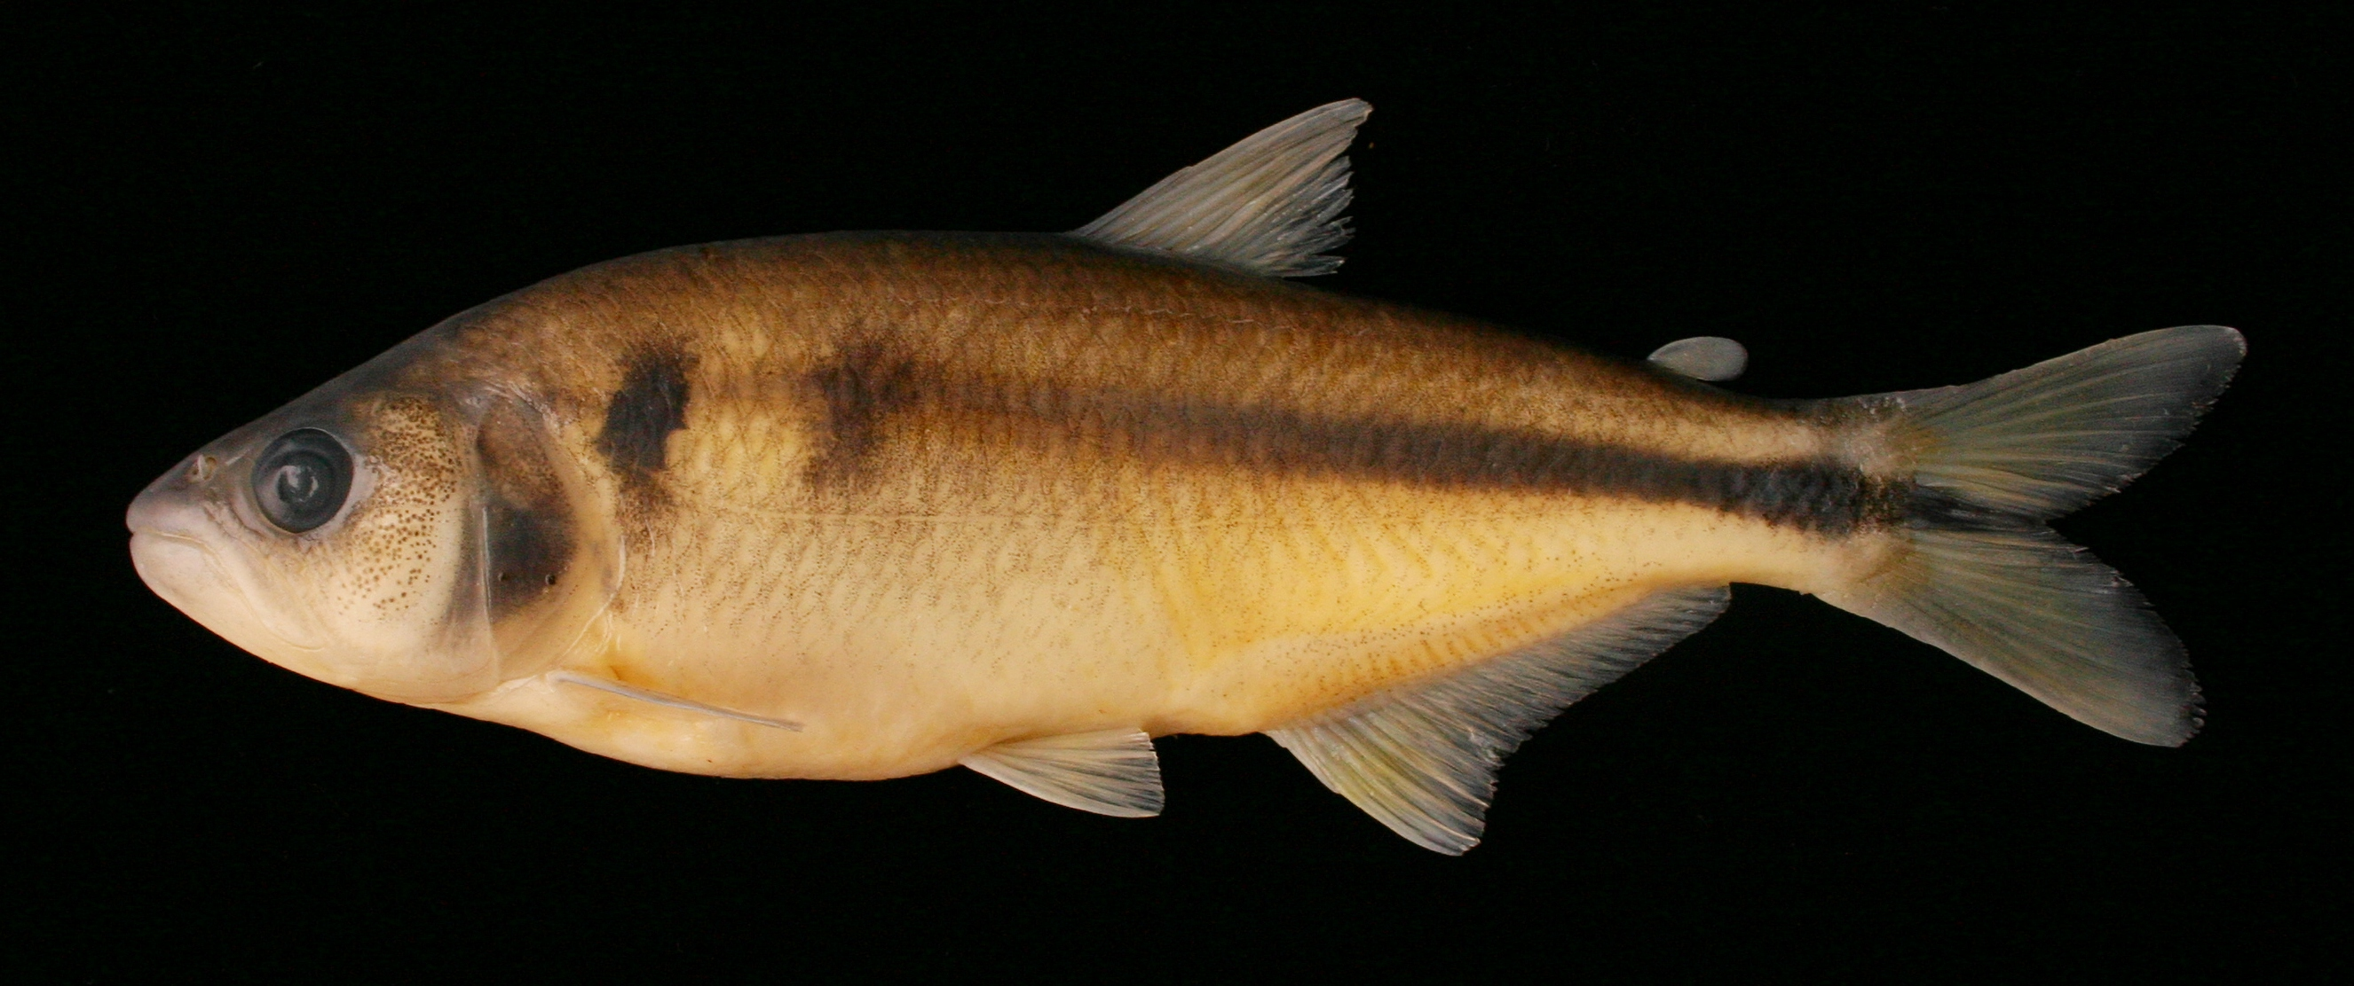
Figure 1. Oligosarcus paranensis collected in the São Francisco River, located at Prudentópolis (Paraná state). Standard Length = 120.10 mm

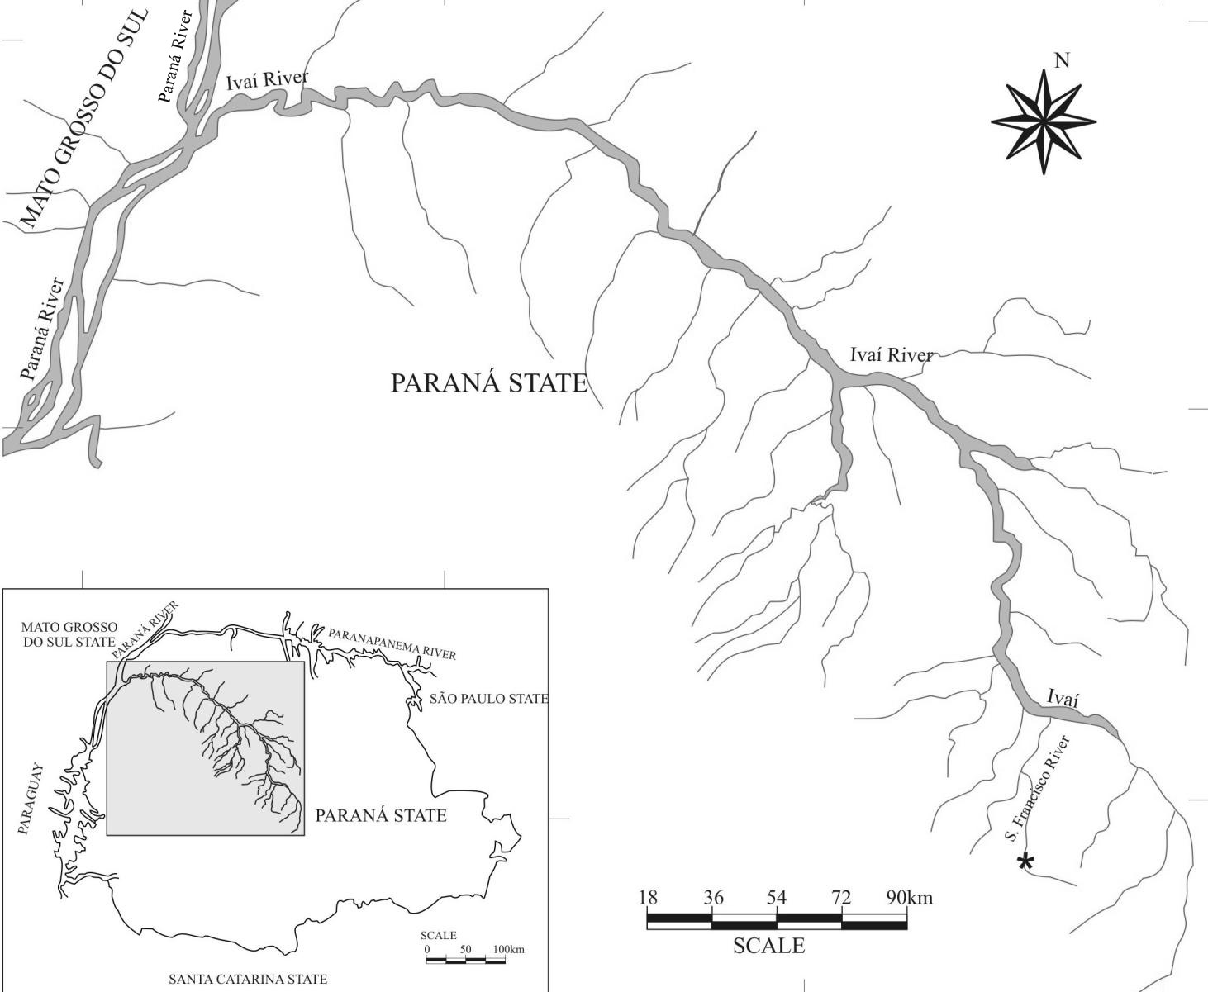

Figure 2. Geographic representation of the Ivaí River basin showing the location of collection (*) of Oligosarcus paranensis in the São FranciscoRriver.

Samples were homogenized with plastic sticks in 1.5 ml Eppendorf tubes with 100 µl of Tris / HCl 0.02 M, pH 7.5 buffer, in order to be analyzed. Since the liver has a lot of fat, carbon tetrachloride was added to liver samples at a ratio of 1:2 (tissue: tetrachloride).
The starch gel was prepared by making a solution of 15% corn starch (Penetrose 50) in buffer solution (Val et al., 1981). The solution was heated to boiling and then poured into a glass plate with 0.6 cm edges. After cooling, the solution was consistent with 0.7 cm thick gel. The gel remained in the refrigerator for 24 hours.
Samples from each fish were loaded onto the gel through strips of paper filter 3MM and subjected to horizontal electrophoresis with a continuous current of 200V and 50V at source, measured at the ends of the gel. The starch gels were sliced horizontally and revealed to the desired enzyme. Tissues of gills, white muscle, heart, liver and kidney were subjected to electrophoresis in Tris 0.0135 M/0.043 M citrate, pH 7.0 (diluted 15 times in the gel) and 0.18 M Tris/0.1 M borate / EDTA 0.004 M, pH 8.7 (diluted 4 times in the gel) to visualize the expression patterns of enzyme and choose the most suitable tissue for the analysis population. Since there were no major differences in the expression of enzymes in the two buffers, we used only Tris / citrate for the population analysis. The loci and alleles were named according to Murphy et al. (1996). The data were analyzed by PopGene 1.31 (Yeh et al., 1997).

Results

Through the starch gel electrophoresis technique, 11 enzyme systems of Oligosarcus paranensis, collected in São Francisco River, were analyzed. Twenty loci were detected, with a total of thirty alleles.
The enzyme systems tested were aspartate aminotransaminase (AAT, EC 2.6.1.1), Alcohol dehydrogenase (ADH, EC 1.1.1.1), Esterase (EST, EC 3.1.1.1), Glucose-6-phosphate isomerase (GPI, EC 5.3. 1.9), Glycerol-3-phosphate dehydrogenase (G3PDH, EC 1.1.1.8), Isocitrate dehydrogenase (IDH, EC 1.1.1.42), L-lactate dehydrogenase (LDH, EC 1.1.1.27), Malate dehydrogenase (MDH, EC 1.1. 1.37), Malate dehydrogenase NADP + (ME, EC 1.1.1.40), Phosphoglucomutase (PGM, EC 5.4.2.2), and Sorbitol dehydrogenase (SORB, EC 1.1.1.14).
AAT - This enzyme showed expression in all tissues. The dimeric structure is recognized by the presence of two to four bands. The phenotype was interpreted as a result of the expression of two loci, one monomorphic (Aat-1) and a polymorphic one with two alleles (Aat-2).
ADH - This enzyme showed a pattern of several bands with a higher expression in the liver. EST - The expression of this monomeric enzyme was detected in the liver with TBE 8.7 and in the gills by TC 7.0 buffer, with a greater expression of these tissues.
G3PDH – A dimeric enzyme, with expression of three monomorphic loci Gpd-1, Gpd-2 and Gpd-3 (allele a), expressed in the liver of all individuals, while in muscle tissue, only two loci Gpd-2 and Gpd-3 were expressed.
GPI – A dimeric enzyme encoded by two loci Gpi-A and Gpi-B expressed in all tissues, with the presence of heterodimers between them.
IDH - This dimeric enzyme showed differential expression among tissues. A polymorphic locus with three alleles was expressed in gill and liver, while another monomorphic locus was detected in heart and white muscle. Both (Idh-1 and Idh-2) were expressed weakly in the kidney.
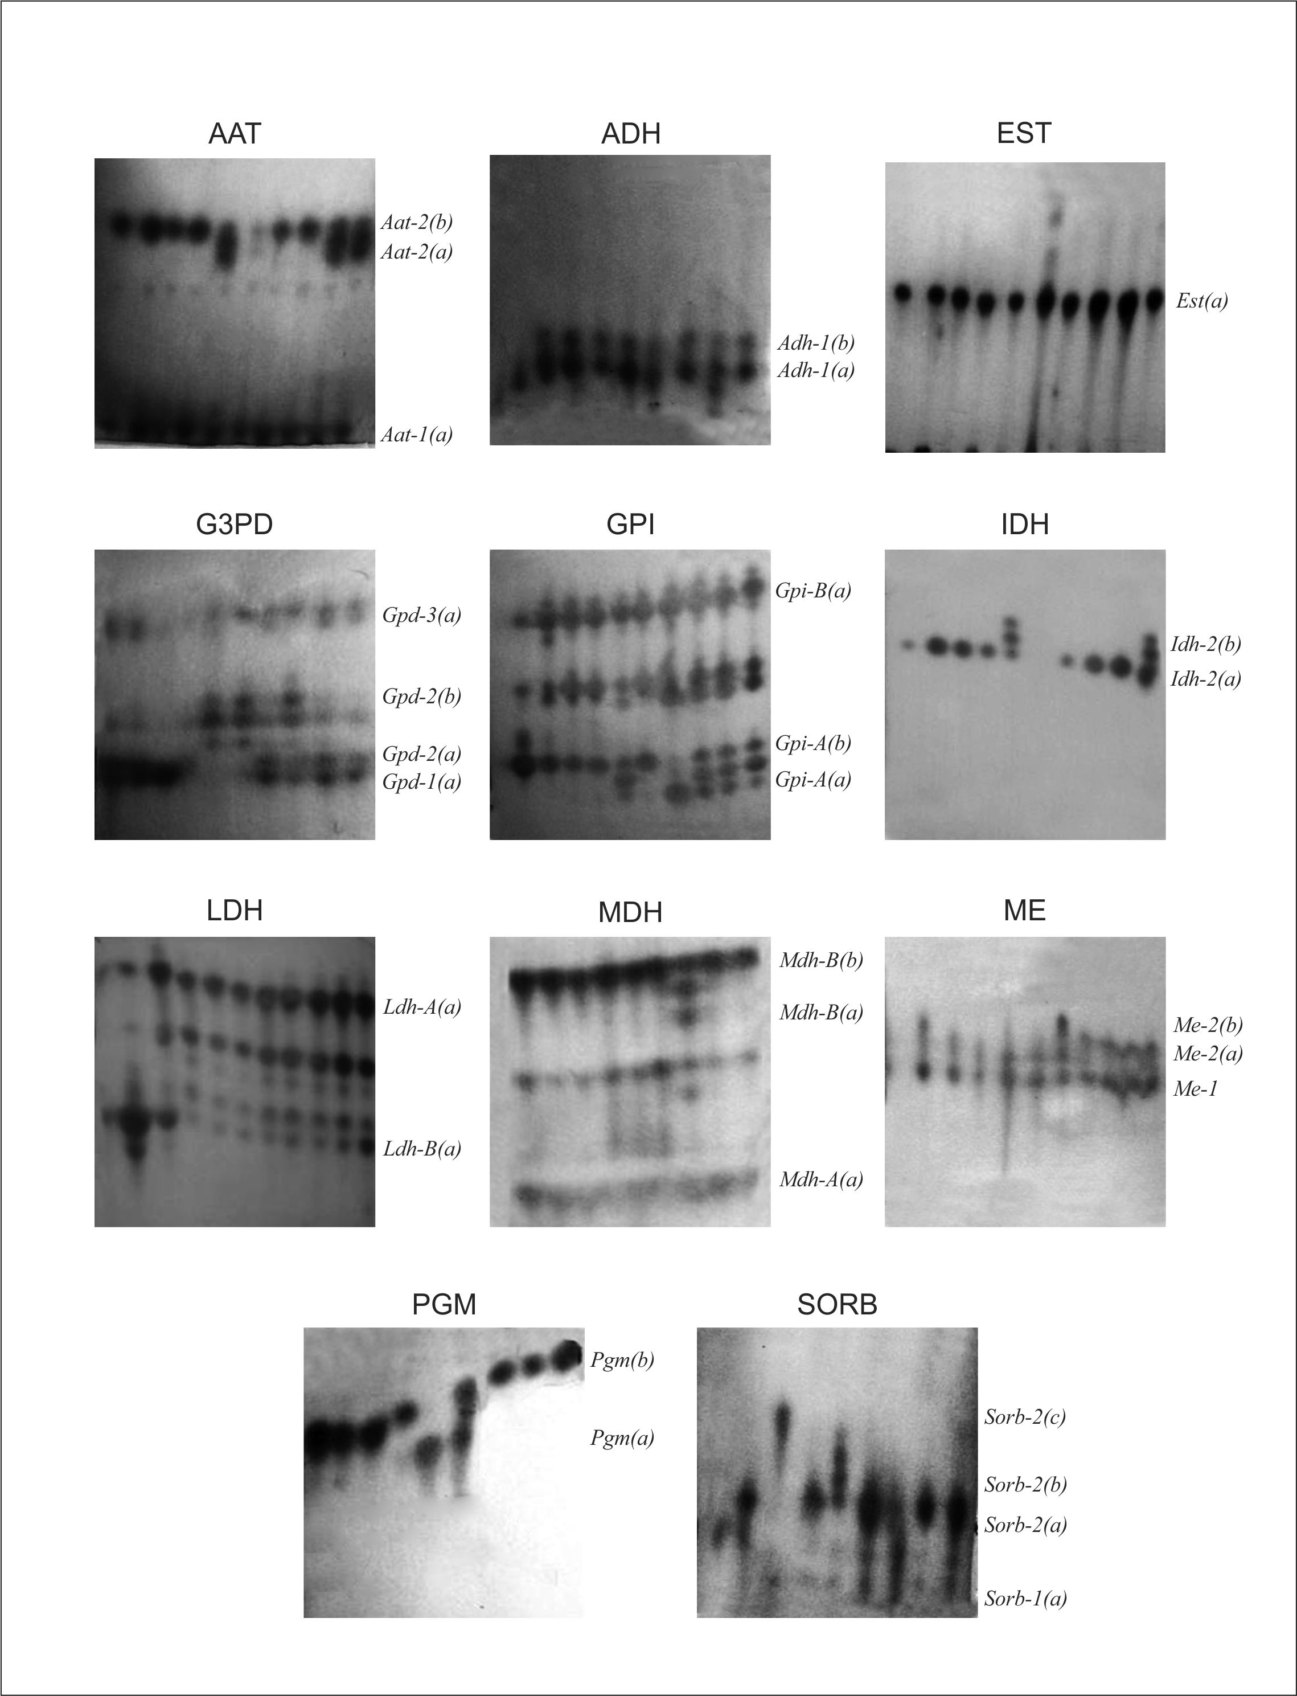
Figure 3. Gel photos of 11 enzymatic systems showing the loci and alleles detected in a population of Oligosarcus paranensis from São Francisco River, Prudentópolis county, Ivaí River basin (Paraná, Brazil).

LDH - This tetrameric enzyme was detected as the result of the expression of two homozygous loci. The two loci are expressed in all tissues, but Ldh-B is best expressed in muscle tissue.
MDH - This dimeric enzyme showed four bands of activity in the gills, heart and white muscle. This pattern was interpreted as the expression of two loci, Mdh-a and Mdh-b.
ME - This tetrameric enzyme showed a pattern of bands with two loci in the two buffers used.
PGM - A single-banded pattern was observed for all individuals inliver and muscle; typical of a monomeric enzyme encoded by a polymorphic locus with two alleles.
SORB – This enzyme is presented as encoded by two polymorphic loci, presenting greater intensity in the liver. This enzyme system was not tested in TBE buffer.
Figure 3 shows the electrophoretic patterns of 11 enzyme systems in Tris / citrate pH 7.0 and also the designation of the detected loci and alleles. Table 1 shows the allele frequencies for each detected locus and Table 2 measures the genetic variability. Nine (45%) loci (Aat-2, Adh, Gpd-2, Gpi-A, Gpi-B, Idh-2, Mdh-B, Pgm-1, Sorb-2) were polymorphic. Five loci (Adh, Idh-2, Me-2, Pgm-1, and Sorb-2), are not in Hardy-Weinberg equilibrium (Table 2).
Table 1. Allele frequencies at 20 loci detected by electrophoresis in starch gel in a population of Oligosarcus paranensis from São Francisco River, Prudentópolis county, Ivaí River basin (Paraná, Brazil).
Locus | Allele | Frequency
Aat-1 | A | 1.0000
Aat-2 | A | 0.1250
Aat-2 | B | 0.8750
Adh | A | 0.6897
Adh | B | 0.3103
Est-1 | A | 1.0000
Gpd-1 | A | 1.0000
Gpd-2 | A | 0.9667
 | B | 0.0333
Gpd-3 | A | 1.0000
Gpi-A | A | 0.2667
 | B | 0.7333
Gpi-B | A | 0.9667
 | B | 0.0333
Idh-1 | A | 1.0000
Idh-2 | A | 0.7222
 | B | 0.2778
Ldh-A | A | 1.0000
Ldh-B | A | 1.0000
Mdh-A | A | 1.0000
Mdh-B | A | 0.1333
 | B | 0.8667
Me-1 | A | 1.0000
Me-2 | A | 1.0000
Pgm-1 | A | 0.0500
 | B | 0.9500
Sorb-1 | A | 1.0000
Sorb-2 | A | 0.2593
Sorb-2 | B | 0.6852
Sorb-2 | C | 0.0556

Table 2. Observed heterozygosity (Ho) and expected heterozygosity (He), standard deviation (SD), probability of chi-square test for Hardy-Weinberg (PHW), fixation index (F_{IS}) for loci detected by electrophoresis in starch gel in a population of Oligossarcus paranensis from São Francisco River, Ivaí River basin (Paraná, Brazil).
Locus | Ho | He | PHW | F_{IS}
Aat-1 | 0,0000 | 0,0000 | ------- | -------
Aat-2 | 0,2500 | 0,2227 | 0,4874 | - 0,1429
Adh | 0,0000 | 0,4356 | 0,0000 | 1,0000
Est-1 | 0,0000 | 0,0000 | ------- | -------
Gpd-1 | 0,0000 | 0,0000 | ------- | -------
Gpd-2 | 0,0667 | 0,0655 | 0,8946 | - 0,0345
Gpd-3 | 0,0000 | 0,0000 | ------- | -------
Gpi-A | 0,3333 | 0,3977 | 0,3622 | 0,1477
Gpi-B | 0,0000 | 0,0000 | -------- | -------
Idh-1 | 0,0000 | 0,0000 | ------- | -------
Idh-2 | 0,1852 | 0,4088 | 0,0034 | 0,5385
Ldh-A | 0,0000 | 0,0000 | ------- | -------
Ldh-B | 0,0000 | 0,0000 | ------- | -------
Mdh-A | 0,0000 | 0,0000 | ------- | -------
Mdh-B | 0,2667 | 0,2350 | 0,4338 | - 0,1538
Me-1 | 0,0000 | 0,0000 | ------- | -------
Me-2 | 0,0000 | 0,1266 | 0,0000 | 1,0000
Pgm-1 | 0,0333 | 0,0966 | 0,0000 | 0,6491
Sorb-1  Sorb-2 | 0,0000  0,0370 | 0,0000  0,4689 | -------  0,0000 | -------  0,9195
Média  SD | 0,0586  0,1069 | 0,1229  0,1728 | -------  ------- | 0,5145  ---------

Discussion
The population of Oligosarcus paranensis analysed in this work presents high genetic variability, 45% of polymorphic loci and mean He = 0.1229 when compared whit other species from the same river basin.
The heterozygosity values presented in Table 2 show variations among the loci. The Ho values ranged from 0 to 0.3333 with an average of 0.0586 ± 0.1069. He values ranged from 0 to 0.4356 with an average of 0.1229 ± 0.1728. The average value of He was larger than the average 0.050 for all fish species studied so far (Lassala and Renesto, 2007).
There are few studies of genetic variability in Characiformes. So far only ten species have been genetically analyzed. Chiari and Sodré (1999) estimated the genetic variability of five species of anostomids: Schizodon intermedius, S. nasutus, Leporinus friderici, L. elongatus and L. obtusidens collected in Tibagi River (Paraná, Brazil). The values of expected heterozygosity estimates were 0.072 ± 0.038 for S. intermedius, 0.092 ± 0.040 for S. nasutus, 0.132 ± 0.046 for L. friderici, 0.142 ± 0.054 for L. elongatus and 0.090 ± 0.042 for L. obtusidens. Peres et al. (2002) estimated the genetic variability of two populations of H. malabaricus from upper Paraná River and found a value of expected heterozygosity of 0.14 ± 0.045. And Peres and Renesto (2005) studied the genetic variability of Leporinus lacustris from Carão lagoon, upper Paraná River, and found an estimated value of expected heterozygosity of 0.0806 ± 0.0313.
Peres et al. (2005) found expected heterozygosity values of 0.1518 ± 0.0493 for a population of Astyanax altiparanae from upper Paraná River and 0.0905 ± 0.0464 for a population from Ribeirão Ficha (tributary of Piquiri River).
Lassala and Renesto (2007) estimated the genetic variability of nine species of Characiformes and Siluriformes from Paraná River. They estimated heterozygosity values of 0.084 ± 0.025 for Roeboides paranensis and 0.045 ± 0.020 for Serrasalmus marginatus. Thus, the values for the10 species studied so far range from 0, 045 in R. paranensis to 0.152 in Astyanax altiparanae. The value of expected heterozygosity estimated in this study (0.123) is consistent with the variation found for other species of Characiformes South America.
Zawadzki et al. (2005) estimated the genetic variability of 15 species of Loricariidae (Siluriformes) from Paraná River and found expected heterozygosity values ranging from 0.019 to 0.107.

Conclusion

The F_{IS} values show that there was an excess of heterozygous loci Aat-2, Gpd-2 and Mdh-B and a deficiency for the heterozygous at loci Adh, Gpi-A, Idh-2, Me-2, Pgm-1 and Sorb -2. The average value of F_{IS} indicates that in this population there is an excess of homozygotes. These results can be due to many causes for this excess, such as inbreeding, natural selection, fragmentation of the population, and assortative mating. The results of this work, through the enzyme electrophoresis in starch gel technique, showed that Oligosarcus paranensis is a species with high genetic variability and deserves proper environmental management attention in order to be preserved.

References

AGOSTINHO A. A; GOMES, L. C; PELICICE, F. M. Ecologia e Manejo de Recursos Pesqueiros em Reservatórios do Brasil. Maringá:EDUEM, 2007. 501p.
BIZERRIL, C. R. S. F; PRIMO, P. B. S. Peixes de Águas Interiores do Estado do Rio de Janeiro. Rio de Janeiro: FEMAR – SEMADS, 2001. 417p.

CARAMASCHI, E. P. Distribuição da ictiofauna de riachos das bacias do Tietê e do Paranapanema, junto ao divisor de águas (Botucatu, SP). Doctorate thesis, Universidade Federal de São Carlos, São Carlos, Brasil, 1986.

CHIARI, L. & SODRÉ, L. M. K.. Genetic variability in five species of Anostomidae (Ostariophysi – Characiformes). Genet. Mol. Biol. v.22, p.517-523, 1999.

FISCH-MULLER, S. Family Loricariidae: Subfamily Ancistrinae. In: REIS, R.E.; KULLANDER, S.O.; FERRARIS JR., C.J. Check List of the Freshwater Fish of South America. Porto Alegre: Edipucrs, 2003. p. 373-400.

LANGEANI, F; CASTRO, R.M.C; OYAKAWA, O.T; SHIBATTA, O.A; PAVANELLI, C.S. & CASATTI, L. Diversidade da ictiofauna do Alto Rio Paraná: composição atual e perspectivas futuras. Biota Neotrop. Sep/Dez 2007.

LASSALA, M. D. P; RENESTO, E. Reproductive strategies and genetic variability in tropical freshwater fish. Genetics and Molecular Biology, v. 30, n. 3, 2007. p.690-697.

MENEZES, R.S. de. Incubação labial de ovos pelo macho de Loricaria typus Bleeker, da Lagoa do Peixe, Piauí, Brasil (Actinopterygii, Loricariidae, Loricariinae), 9(3): 381-387. 1969.

MURPHY, R.W.; SITES, J.W.; BUTH, D.G.; HAUFLER, C.H. Proteins: Isozyme. Electrophoresis. In: HILLIS, D.M.; MORITZ, C.; MABLE, B.M. (eds). Molecular. 2rd Systematics ed. Massachusetts: Sinauer Associates, 1996. p. 51-120.

NELSON, J. S. Fishes of the world. 4th edition. New Jersey: John Wiley & sons Inc., 2006. 601 p.

OLIVEIRA, A. V.; PRIOLI, A. J; PRIOLI, S. M. A. P; PAVANELLI, C. S;
JULIO H. F. & PANARARI, R. S. Diversity and genetic distance in populations of Steindachnerina in the upper Paraná River floodplain of Brazil. Genética, 2002.

PERES, M. D; RENESTO, E; LAPENTA, A. S; ZAWADZKI, C. H. Genetic variability in Hoplias malabaricus (Osteichthyes: Erythrinidae) in fluvial and lacustrine environments in the upper Paraná River floodplain (Paraná state, Brazil). Biochemical Genetics, 2002.

PERES, M. D; RENESTO, E. Genetic variability in a Leporinus lacustris Campos, 1945 (Osteichthyes: Anastomidae) population from Lagoa do Carão (Upper Paraná River floodplain), Brazil. Acta Scient. Biol., 2005.

RUBERT, M; MARGARIDO, V. P. Cytogenetic studies in three species of the Genus Oligosarcus. Braz. Arch. Biol. Technol., 2007.

VAL, A. L. A. R. SCHWANTES, M. L. B. SCHWANTES & P. H. de LUCA. 1981. Amido hidrolisado de milho como suporte eletroforético. Ciência e Cultura, 33: 737-741.

VIDA, G. Global issues of genetic diversity. In: Loeschcke V, Tomiuk J and Jain SK, (eds), Conserv Genet, Basel, Birkhauser Verlag. 1994.

YEH, FC; YANG, R-C; BOYLE, TBJ; Ye, Z-H; and MAO, JX. 1997. POPGENE, the user-friendly shareware for population genetic analysis. Molecular Biology and Biotechnology Centre, University of Alberta, Canada. http://www.ualberta.ca/~fyeh/faq.htm (April 29th, 2009).

ZAWADZKI, C.H; RENESTO, E; REIS, R.E; MOURA, M.O; MATEUS, R. P. Allozyme relationships in hypostomines (Teleostei: Loricariidae) from the Itaipu Reservoir, Upper Rio Paraná basin, Brazil. Genetica 123, 2005.

