SUPPLEMENTARY MATERIAL

Appendix S1. Geographical range’s boundaries used for calculate the richness of species with contrasting dispersal ability.
Range Group | Range size | Description
Narrow-Ranged 1 (NR1) | < 20% | Species occupying until 20% of South American area
Narrow-Ranged 2 (NR2) | < 25% | Species occupying until 25% of South American area
Narrow-Ranged 3 (NR3) | < 30% | Species occupying until 30% of South American area
Narrow-Ranged 4 (NR4) | < 35% | Species occupying until 35% of South American area
Intermediary (IT) | 35% - 60% | Species occupying between 35%-60% of South American area
Wide-Ranged 1 (WR1) | > 60% | Species occupying more than 60% of South American area
Wide-Ranged 2 (WR2) | >65% | Species occupying more than 65% of South American area
Wide-Ranged 3 (WR3) | >70% | Species occupying more than 70% of South American area
Wide-Ranged 4 (WR4) | > 75% | Species occupying more than 75% of South American area

Appendix S2. Spatial correlations (Pearson’s r) of GWR slopes of the contemporary (lower triangle) and historical climates (upper triangle) among all range intervals. Note that meaningful coefficients occur, preferentially, within each range groups (narrow or wide). For range interval codes, see table 1. TR refers to Total Richness. Correlations between contemporary and historical climates in each range class (the diagonal line) are not presented. Asterisks denote statistical significance (*: p<0.05; **: p<0.01; ***p<0.001).
 | Range Intervals
Range Interval | NR1 | NR2 | NR3 | NR4 | IT | WR1 | WR2 | WR3 | WR4 | TR
NR1 |  | 0.930*** | 0.846*** | 0.836*** | 0.173 | 0.001 | 0.004 | 0.011 | 0.015 | 0.408***
NR2 | 0.981*** |  | 0.927*** | 0.917*** | 0.199*** | 0.001 | 0.004 | 0.011 | 0.016 | 0.455***
NR3 | 0.958*** | 0.994*** |  | 0.968*** | 0.217*** | <0.001*** | 0.003 | 0.007 | 0.010 | 0.484***
NR4 | 0.978*** | 0.985*** | 0.997*** |  | 0.229** | <0.001 | 0.003 | 0.008 | 0.012 | 0.492***
IT | 0.436 | 0.512 | 0.564 | 0.615 |  | 0.386*** | 0.292** | 0.165 | 0.088 | 0.708***
WR1 | 0.329 | 0.329 | 0.366 | 0.410 | 0.893* |  | 0.892*** | 0.73*** | 0.529*** | 0.242**
WR2 | 0.315 | 0.356 | 0.391 | 0.434 | 0.89* | 0.996*** |  | 0.749*** | 0.573*** | 0.181
WR3 | 0.340 | 0.378 | 0.413 | 0.456 | 0.897* | 0.996*** | 0.994*** |  | 0.726*** | 0.140
WR4 | 0.383 | 0.406 | 0.433 | 0.473 | 0.863* | 0.951** | 0.956** | 0.976** |  | 0.100
TR | 0.587 | 0.660* | 0.473 | 0.748* | 0.972*** | 0.873* | 0.877* | 0.886* | 0.862*

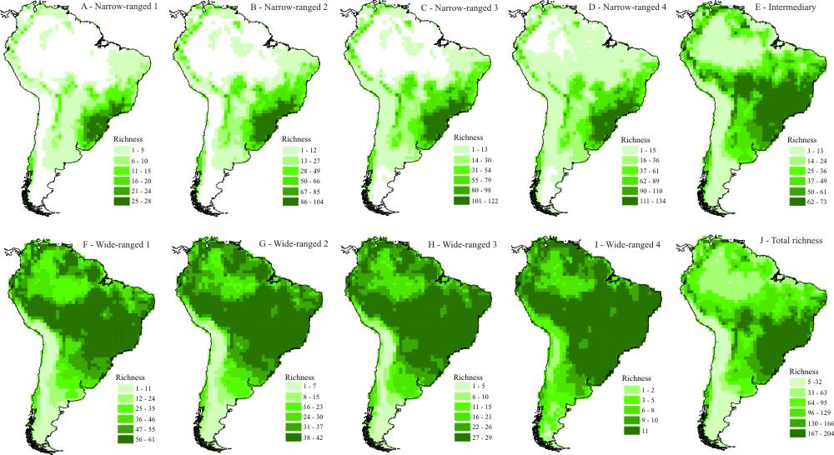
Appendix S3. Deconstructed species richness patterns of the 217 South American tree species analyzed in the present study. See Table 1 for range size group codes.

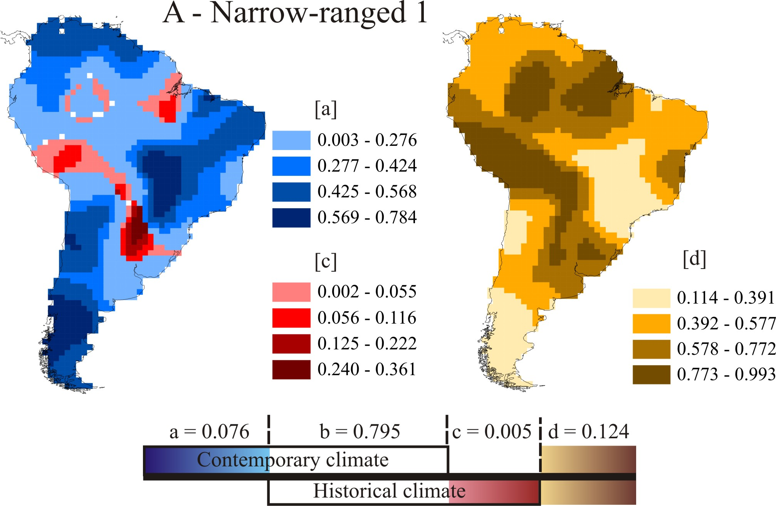

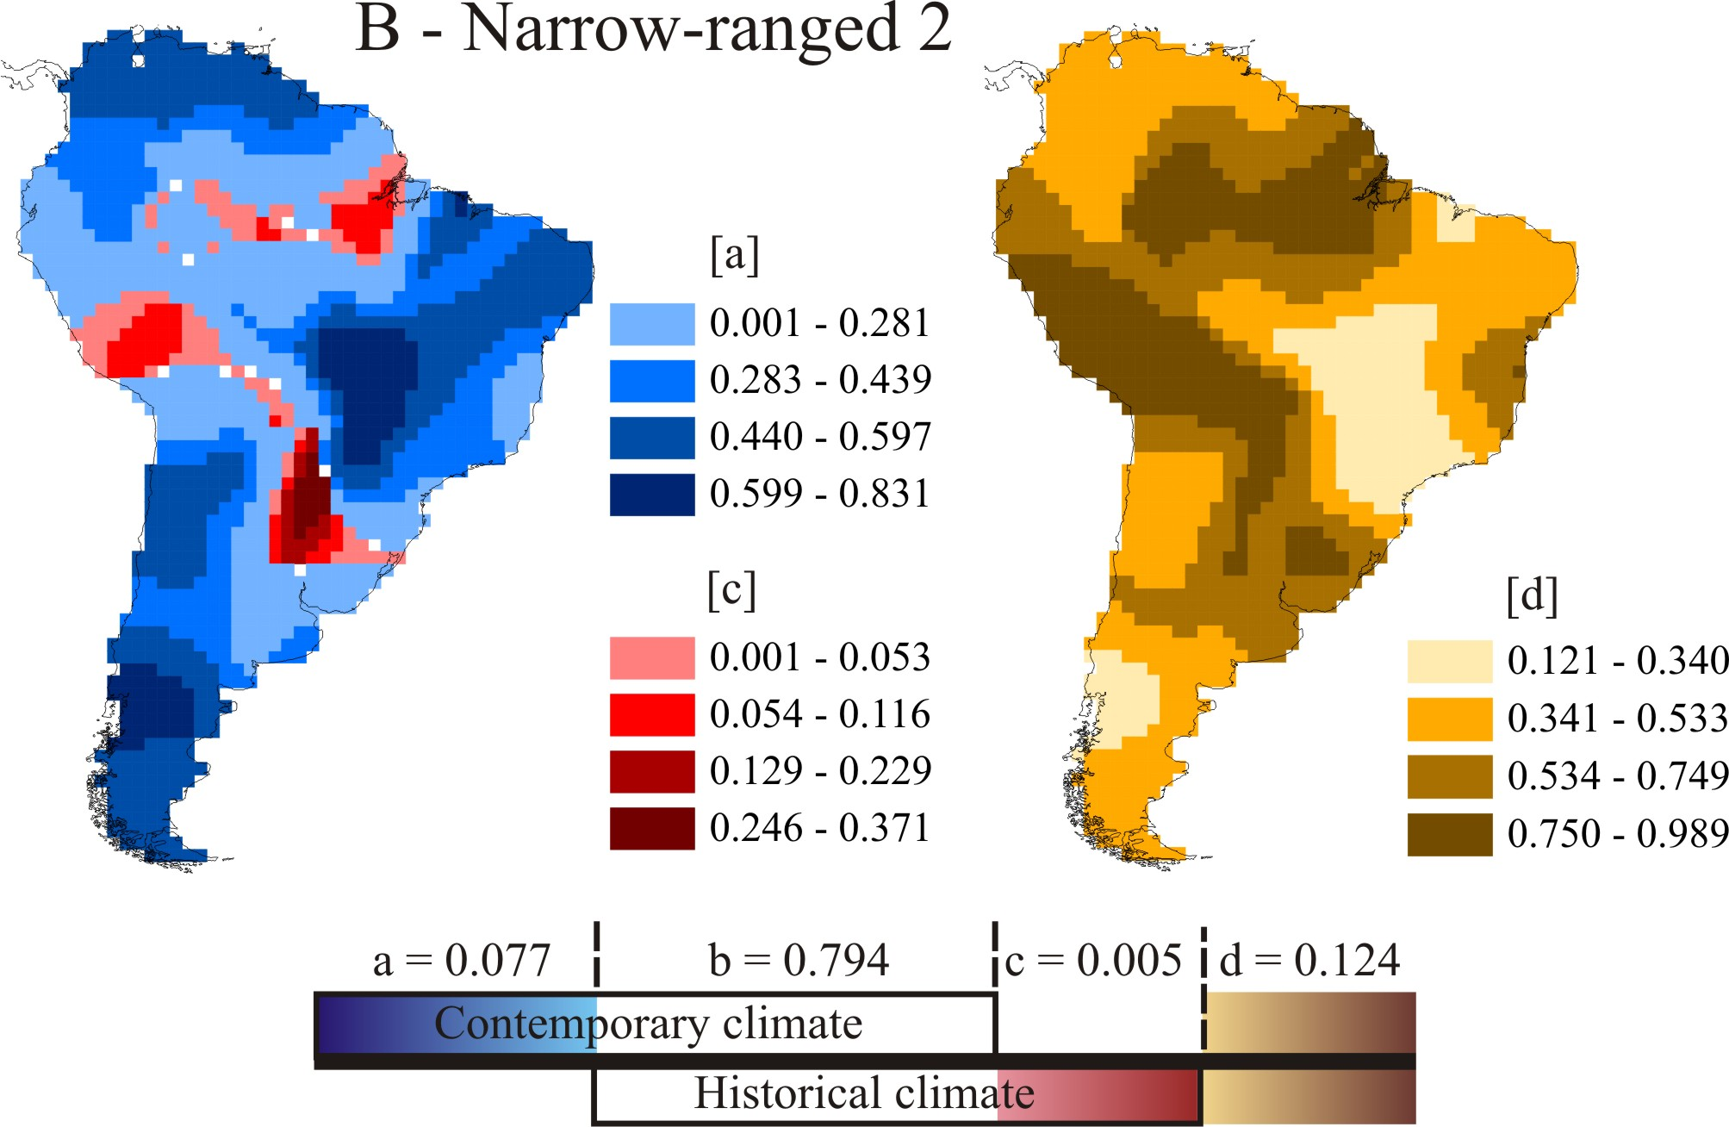

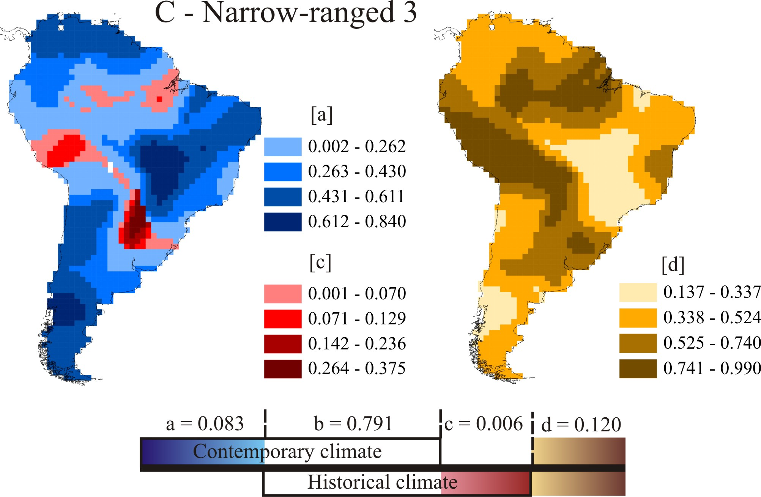

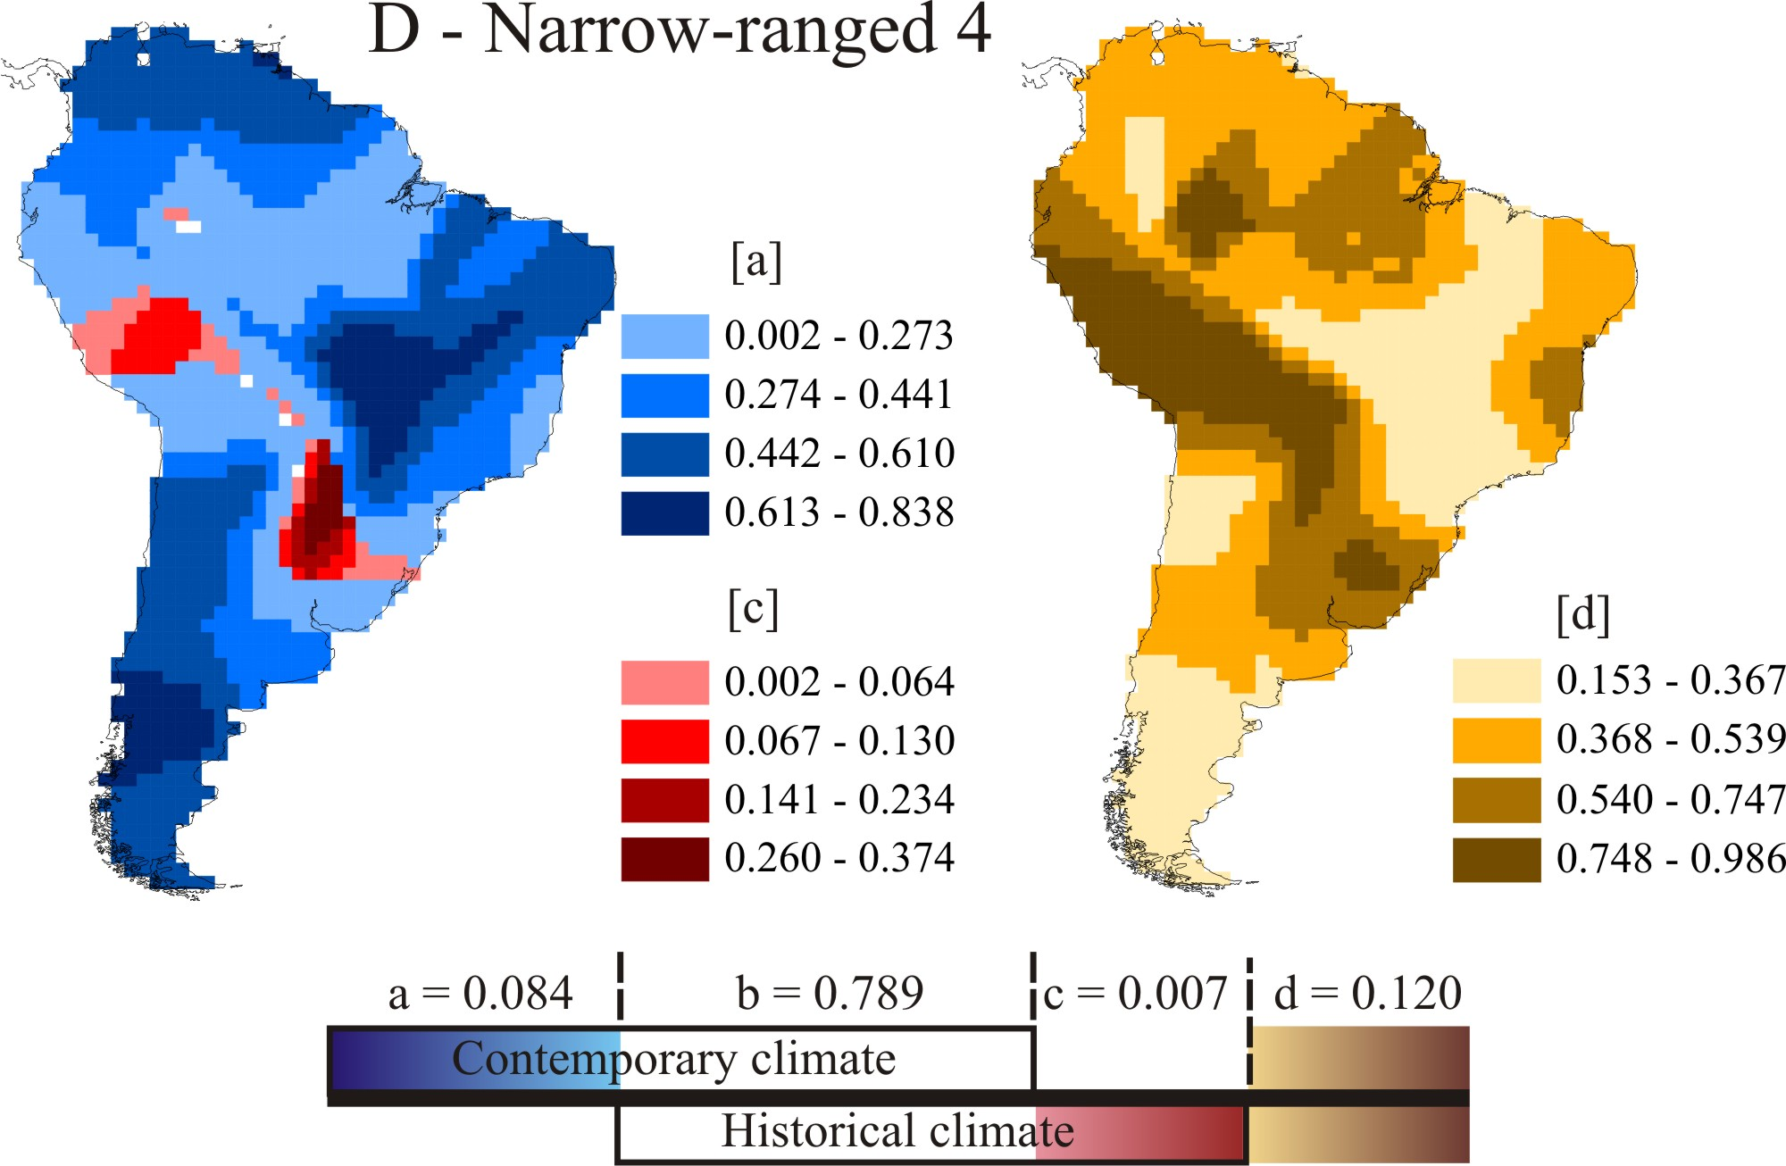

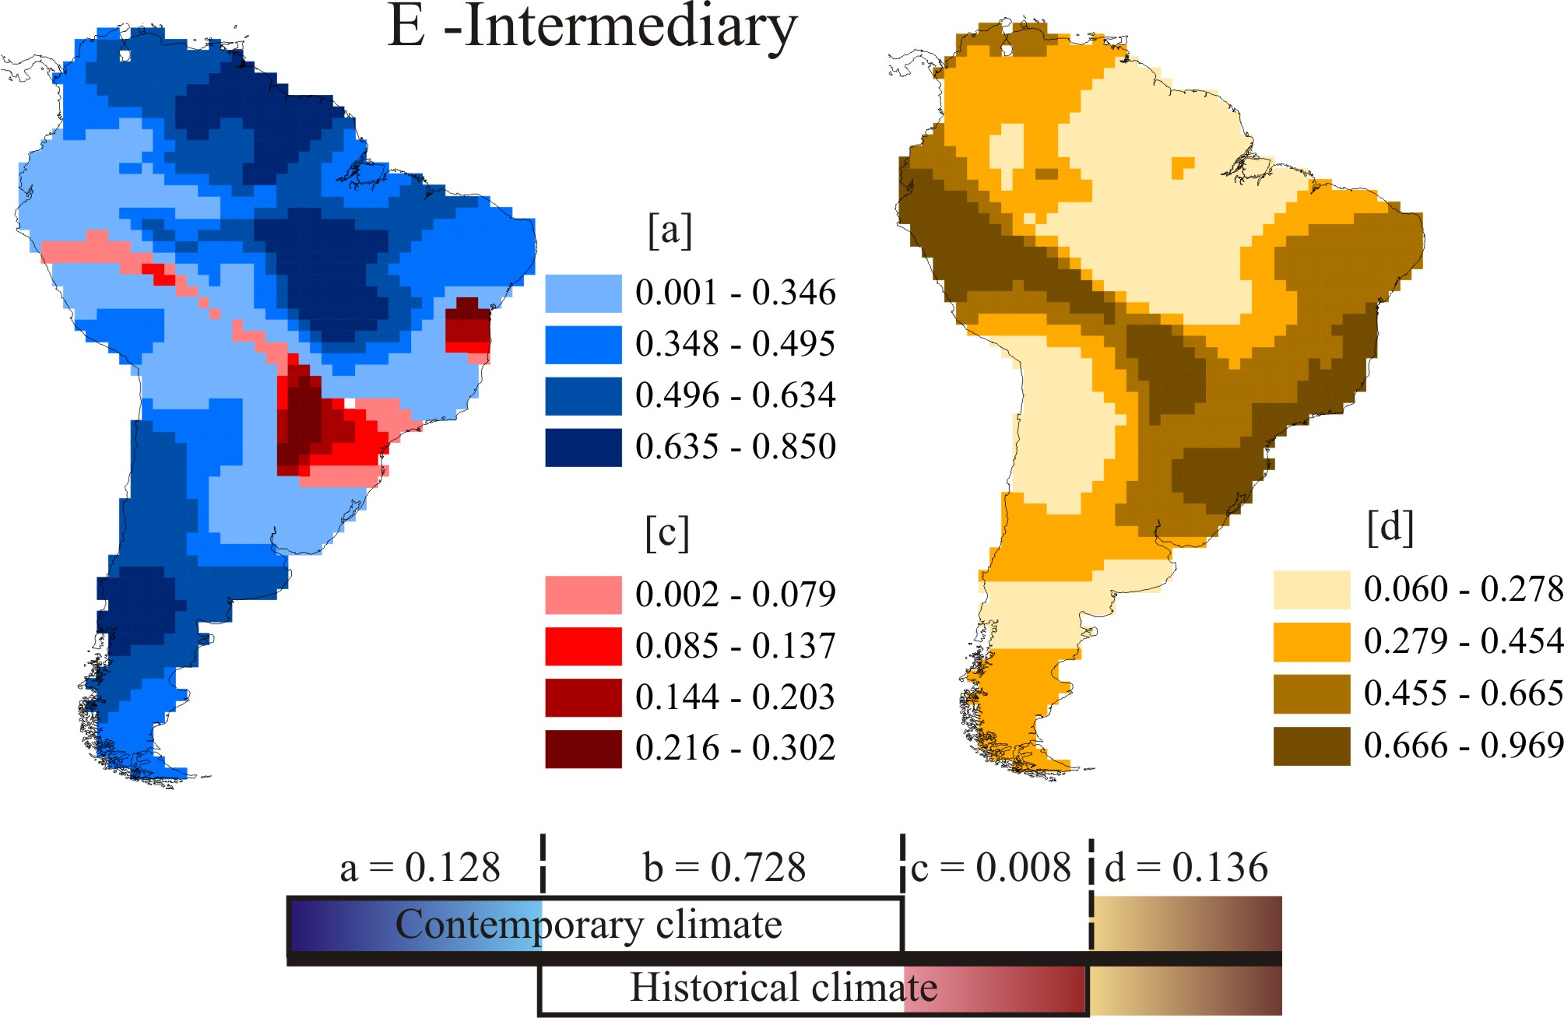

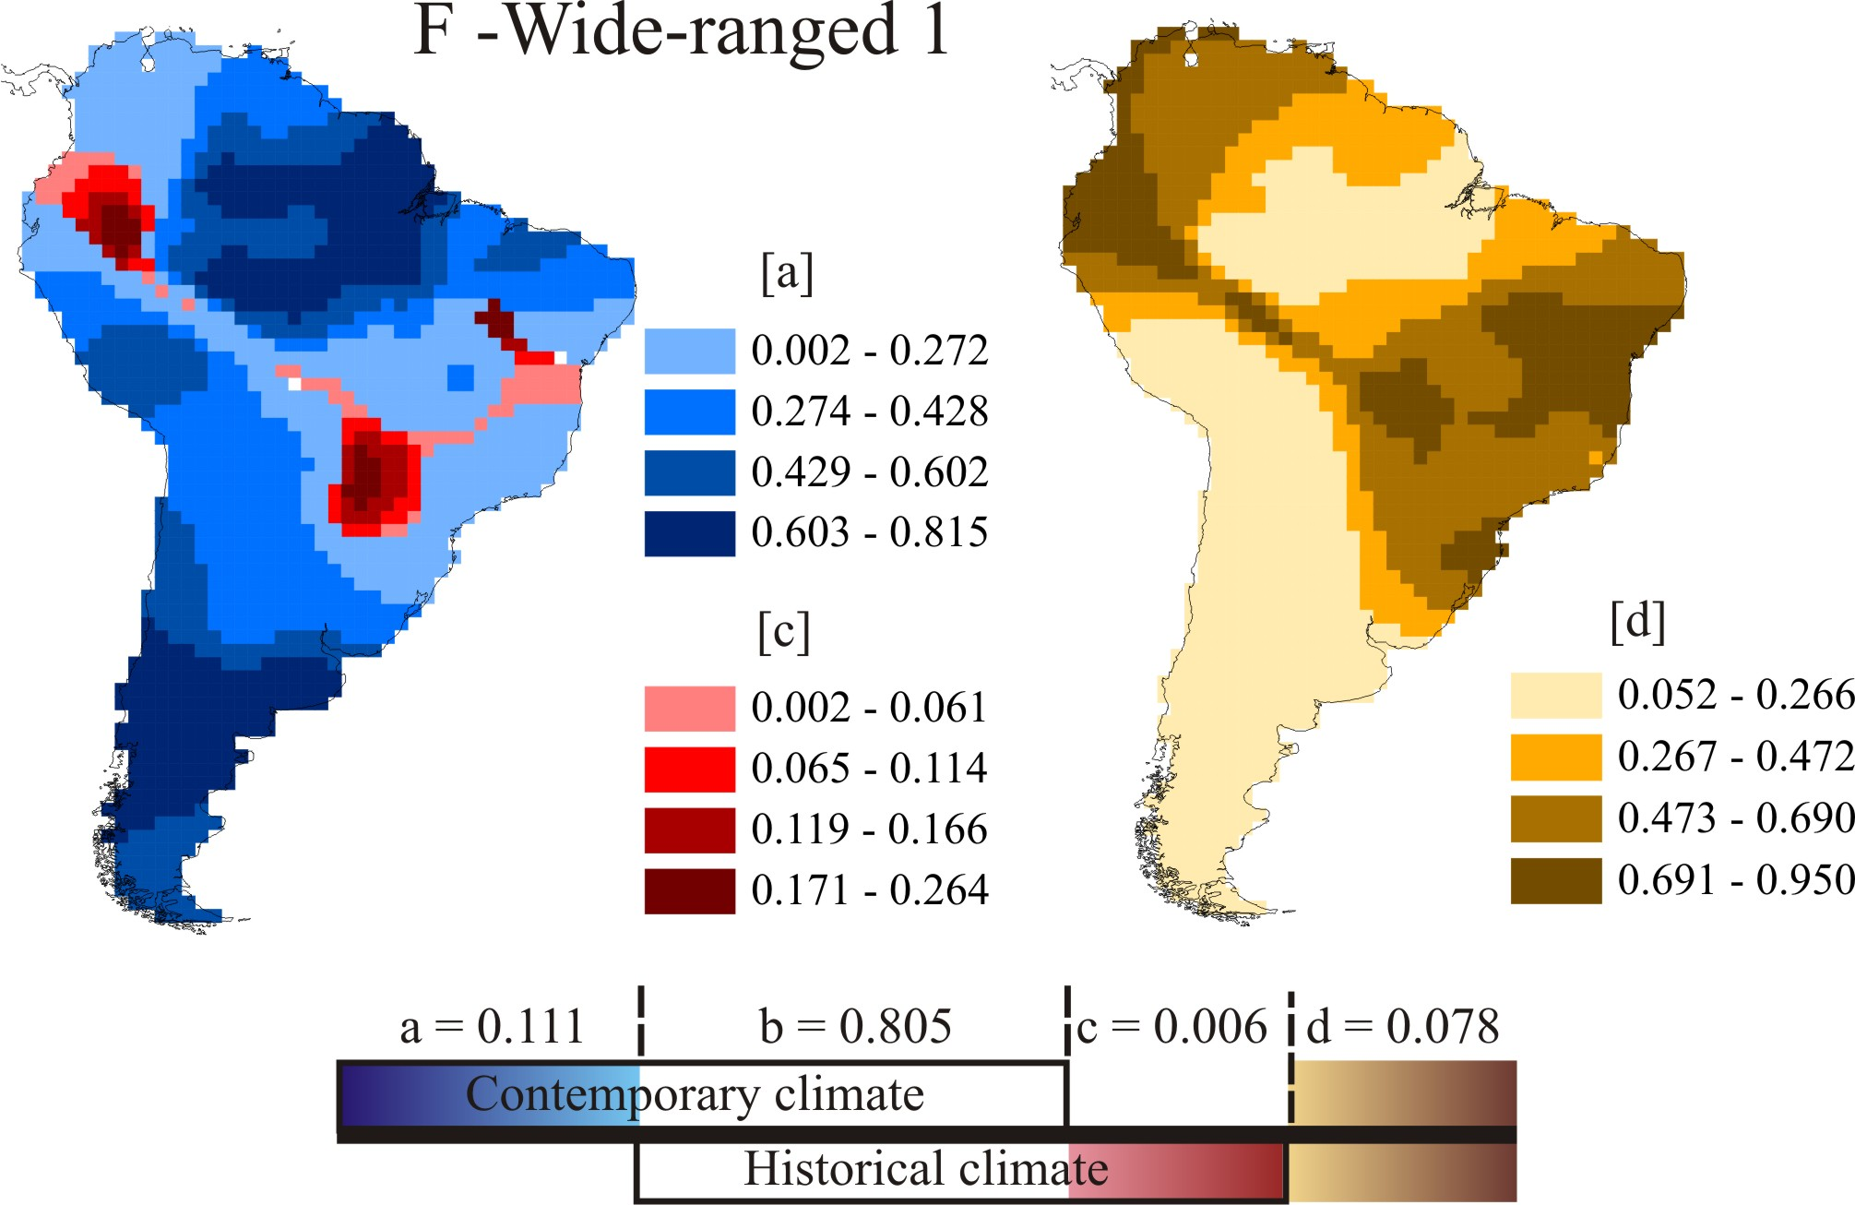

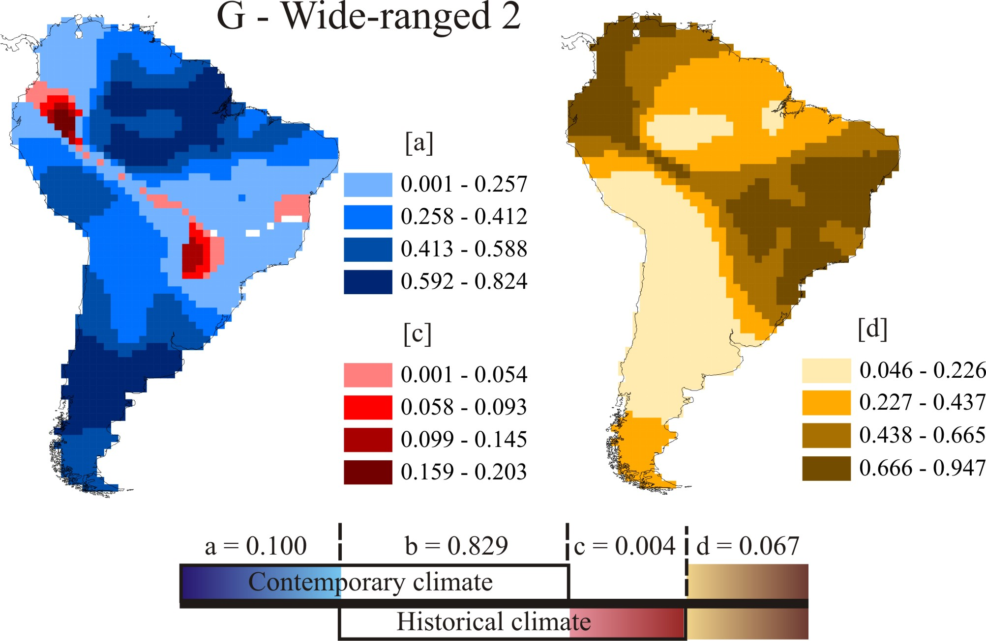

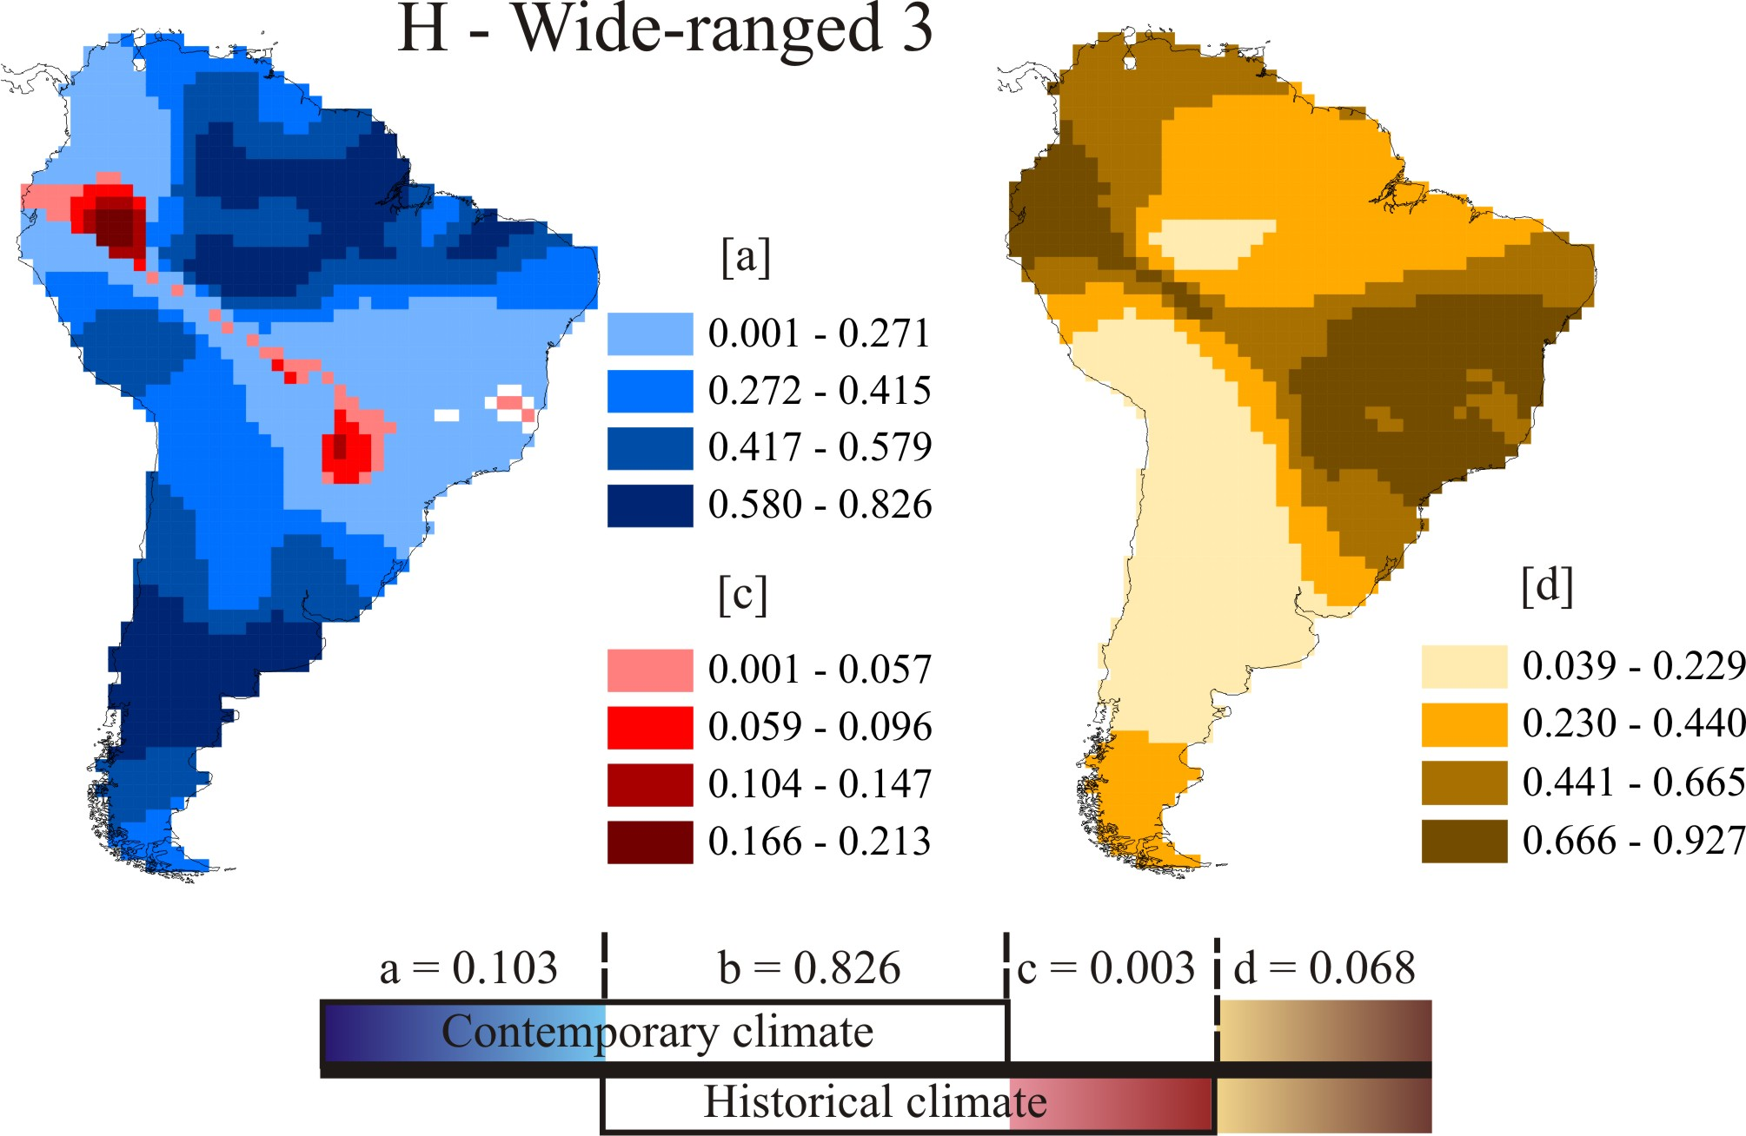

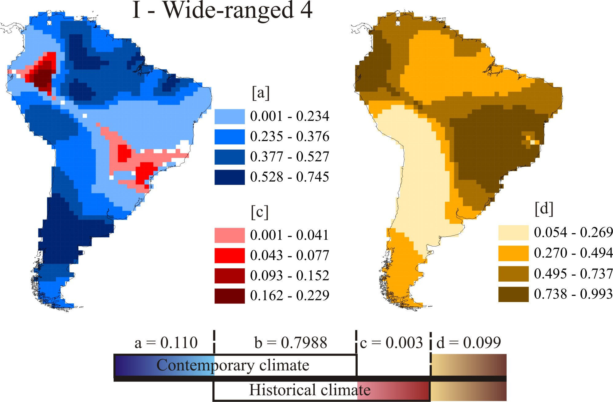

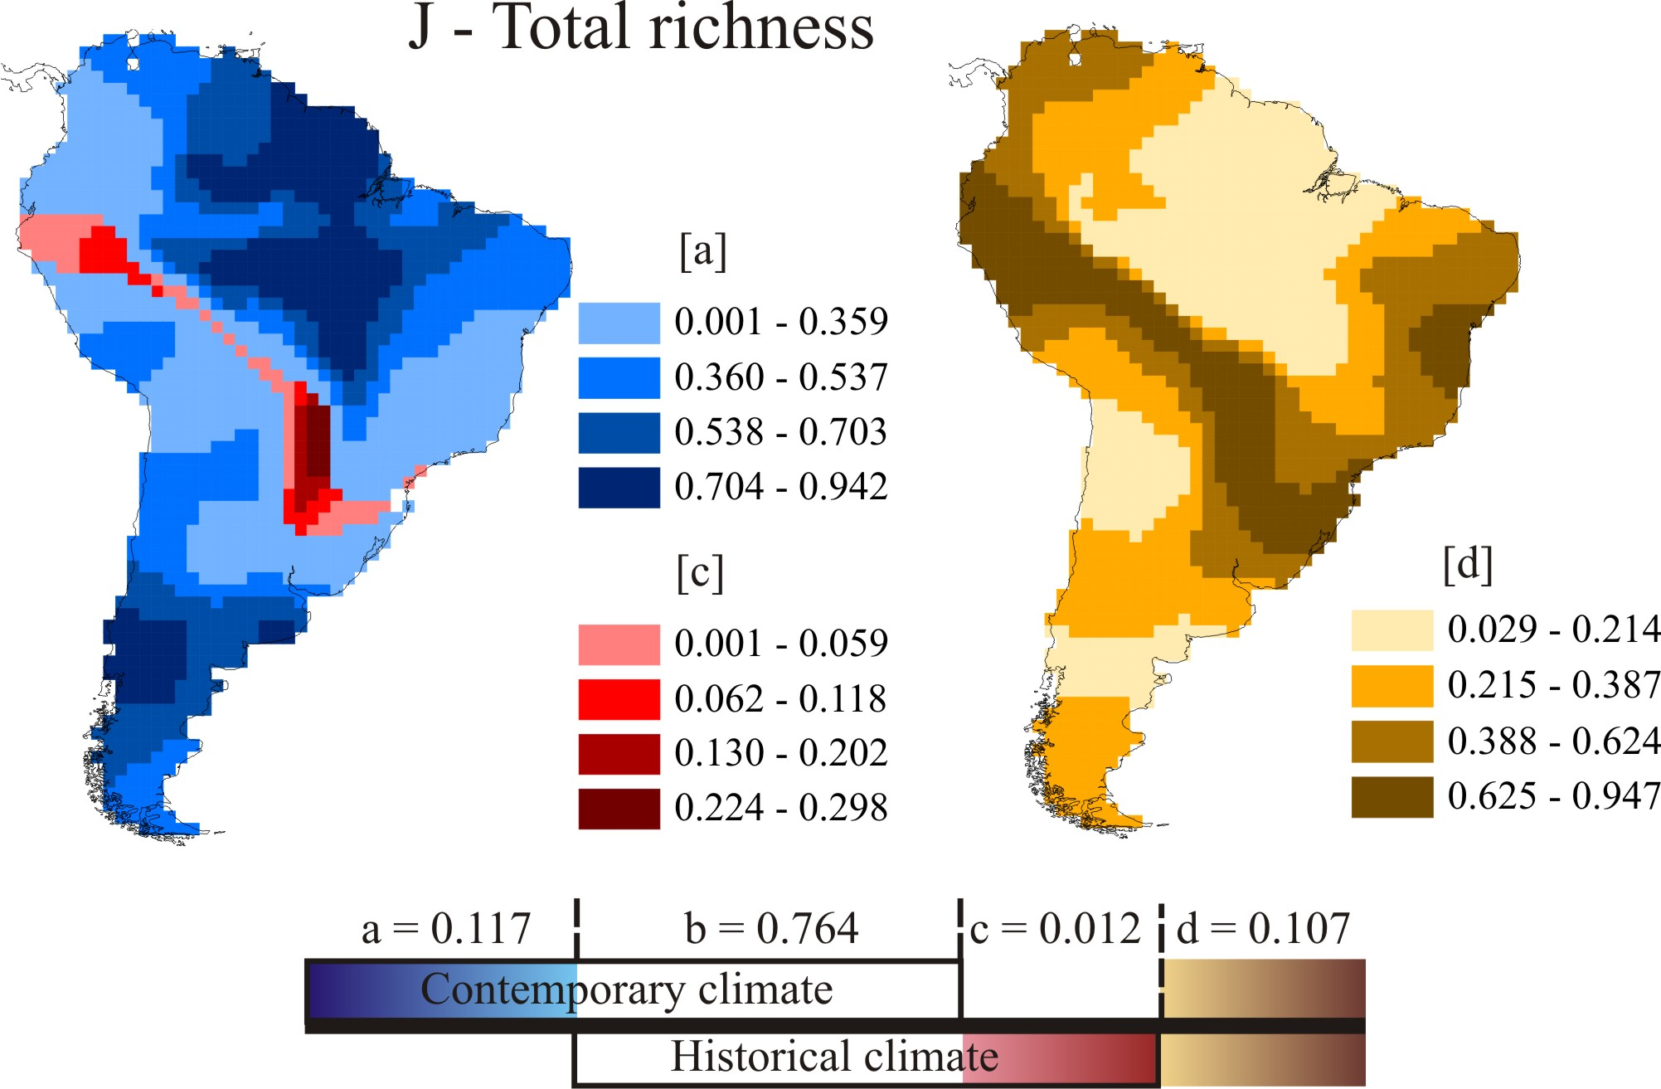

Appendix S4. Spatial pattern of richness variance explained only by contemporary ([a]fraction, blue) and historical climate ([c] fraction, red), as well as unexplained variance ([d] fraction, brown) according the variance partitioning from GWR analyses. In the left maps, the areas in blue correspond to cells where the contemporary climate component ([a] fraction [a]) explains a higher amount of richness variance than historical climate ([c] fraction[c]) as obtained by variance partitioning. Similarly, the red cells indicate the areas where the historical climate component ([c] fraction) explains a higher amount of richness variance than contemporary climate ([a] fraction). White areas correspond to cells where contemporary and historical coefficients are equally predictive. The intersection of the contemporary and historical climates components is not shown in maps. The variance partitioning bar below each map shows the results of partial regression analyses using the global R² of the GWR analyses (relationship between observed and estimated richness from GWR analyses). Note that the bars lengths are not in the same proportion than partition factors values. Each map corresponds to a geographical range size and the R² partitions values are given in the figures. See Table 1 for range size groups’ codes and deconstruction criteria.

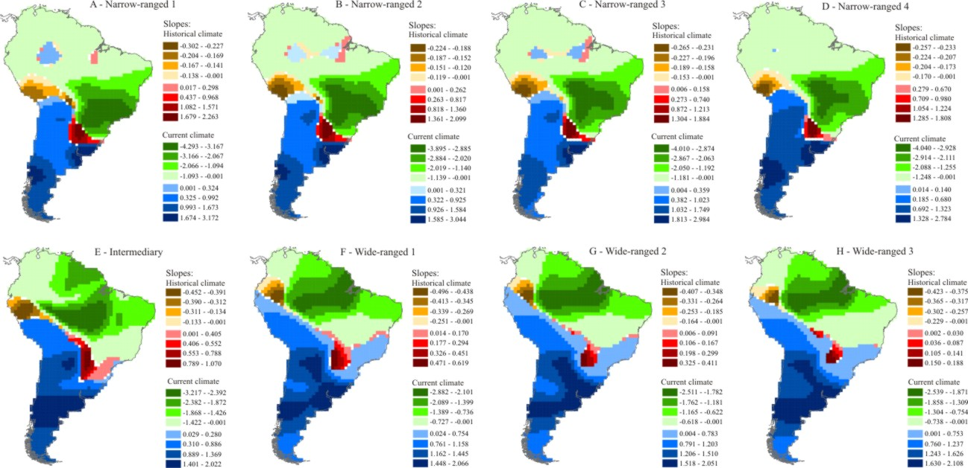

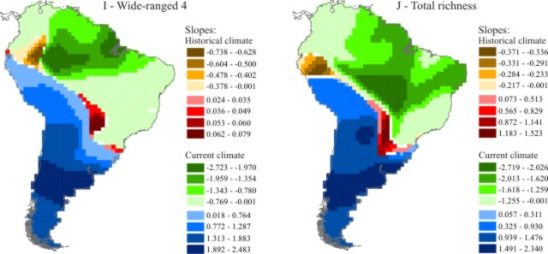
Appendix S5. Spatial variation in standardized coefficients (slope-b) from GWR analyses of tree species richness against the explanatory variables. Areas in blue and green correspond to cells where the contemporary climate coefficient was higher than historical climate coefficient. In blue cells the relation of the contemporary climate against tree species richness is positive, and in green, negative. Red and brown-yellowish areas correspond to cells where the historical climate coefficient was higher than current climate coefficient. Similarly, in red cells the relation between historical climate against tree species richness is positive, and in brown-yellowish cells, negative. White areas correspond to cells where contemporary and historical coefficients are equally predictive. Each map corresponds to a geographical range size, which is described above all maps. The standardized coefficients are given in the figures. See Table 1 for range size group codes.

