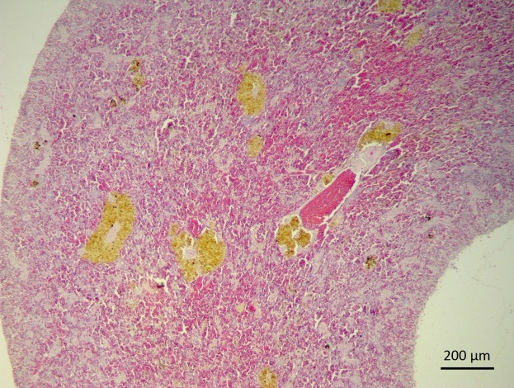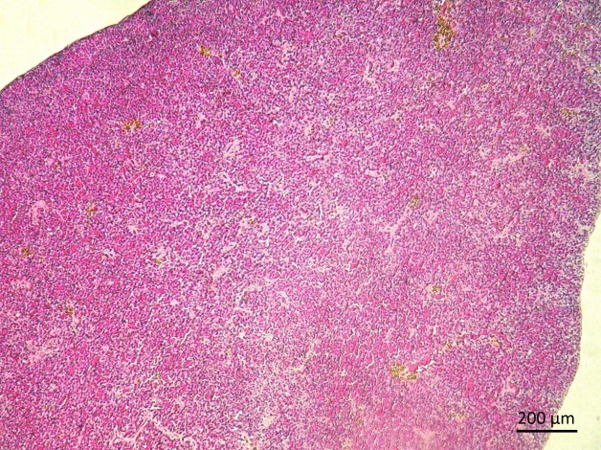
(B))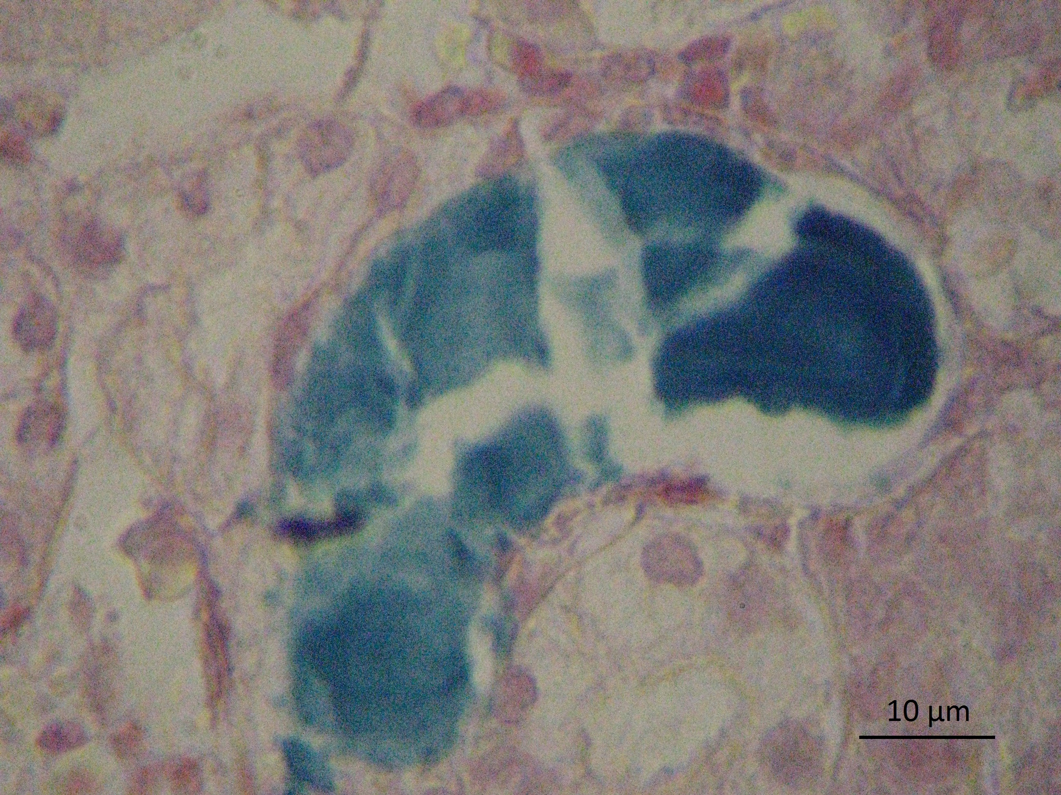
(A))
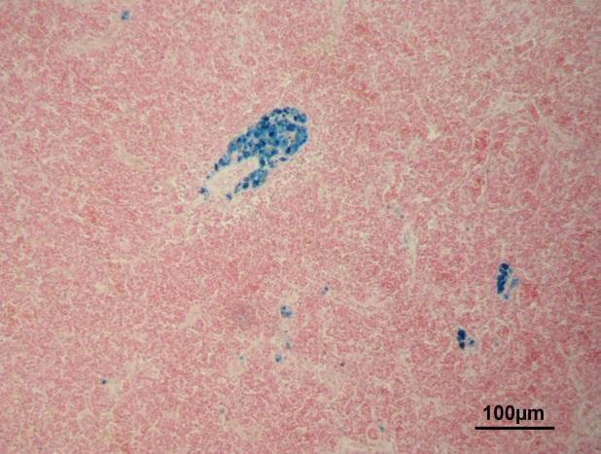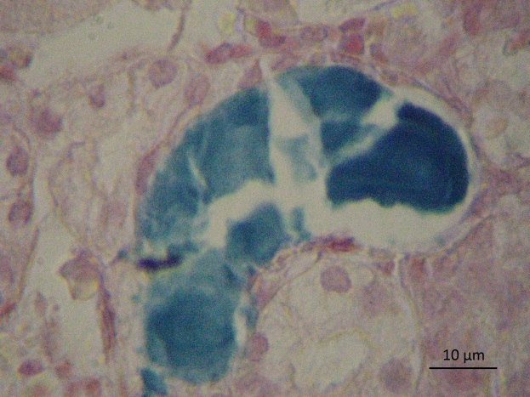
(D)
(C)
Figure 1. Melanomacrophage center photomicrographs (arrow) stained with Harris hematoxylinin tilapia´s spleen fed with 2% propolis supplemented diet (A) and non-supplemented (B). Melanomacrophages centers containing hemosiderin in the spleen (arrow) stained by the method of Perl (C); Hemosiderinuria in kidney stained by Perl method (D).

