Ultrastructural Aspects of the Tongue in Magellanic Penguins, Spheniscus magellanicus (Forster, 1781)
Abstract
The tongue of birds presents diversified morphologic characteristics, related directly their feeding habits and may be adapted to food capture. Penguins of the Spheniscidae family are pelagic birds that are totally adapted to the marine environment. The objective of this study was to describe the morphology of the tongue in Magellanic penguins (Spheniscus magellanicus). In order to investigate these caracteristics, six tongues of juvenile S. magellanicus were collected and analyzed by macro and microscopic analysis, as well as scanning electron microscopy. The tongue of the Magellanic penguin has a fusiform shape with a round apex that is narrower than the root, following the shape of the beak. The epithelium of the tongue of the Magellanic penguin showed to be stratified and very keratinized, with the presence of lingual papillae that showed a caudally inclined apex. The neighboring connective tissue showed absence of mucous glands. The cartilaginous skeleton was observed in the medial region of the tongue, extending from the base to the apex. The structure of the tongue of the Magellanic penguin showed to be similar to that of other penguin species, but also showed peculiar characteristics that were not observed in other bird families.
Keywords: lingual papillae, lingual structure, Spheniscidae, ultrastructure.

Resumo

A língua das aves apresenta características morfológicas diversificadas, relacionados diretamente com seus hábitos alimentares e pode ser adaptado para a captura de alimentos. Os pinguins da família Spheniscidae são aves pelágicas totalmente adaptadas ao ambiente marinho. O objetivo deste estudo foi descrever a morfologia da língua de pinguins de Magalhães (Spheniscus magellanicus). Para investigar tais características, seis línguas de S. magellanicus juvenis foram coletados e analisados ​​por meio de análise macro e microscópica, bem como a microscopia eletrônica de varredura. A língua do pinguim de Magalhães tem formato fusiforme com ápice arredondado e mais estreito em relação à raiz, acompanhando o formato do bico. O epitélio da língua do pingüim de Magalhães mostrou-se estratificado e muito queratinizado, com a presença de papilas linguais, com ápices voltados caudalmente. O tecido conjuntivo adjacente mostrou ausência de glândulas mucosas. Um esqueleto cartilaginoso, formado por cartilagem hialina, foi observado na região mediana da língua se estendendo da base até ápice. A estrutura da língua do pinguim Magellanic mostrou ser semelhante ao de outras espécies de pinguins, mas também apresentou características peculiares que não foram observados em outras famílias de aves.

Palavras-chave: papila lingual, estrutura lingual, ultraestrutura, Spheniscidae.

Introduction

In consideration the characteristics of the various phylogenetic groups of vertebrates, locomotion and feeding has featured for having a great influence on the evolution of adaptations and subsequent patterns of evolutionary process. Changes in eating habits reflect the phylogeny to some degree, so that detailed studies of these changes may elucidate the selective factors responsible for various adaptive events. What determines prey and habitat strongly influence, through natural selection, on feeding behavior and, ultimately, the function and morphology of feeding mechanisms (ÖZETI; WAKE, 1969).
Comparative studies on the tongue of different vertebrate species suggest morphological adaptations throughout the evolutionary process. These evolutionary changes are considered the bases for the progress in food intake and occupation of different habitats (IWASAKI, 2002; EMURA et al., 2009; 2010).
The development of the upper and lower jaws of birds into beaks and the absence of teeth, lips and cheeks limit the manipulation of foods (REECE, 1996). The lingual apparatus is responsible for the regulation of these functions, consists of various elements that influence one another mechanically, such as cartilaginous and bony skeletal elements, muscles and salivary glands (HOMBERGER; MEYERS, 1989)
The tongue of birds show highly diversified morphology in terms of size, shape and structure (McLELLAND, 1989; ERDOĞAN et al., 2012), and may reflect the type of diet and the mode of feeding in these animals. Harrison (1964) grouped the tongue of birds in five categories according to the adaptive characteristics: adapted to capture, handling and swallowing of food, gustation and touch, and nest building.
Morphophysiological studies on the structure of bird tongues demonstrate that, in general, the tongue is found in the lower jaw and has, many times, the shape of the beak. It is divided into apex, body and root (CAMPBELL; LACK 1985; McLELLAND 1990; VOLLMERHAUS; SINOWATZ 1992; KOENING; LIEBIG 2001; EMURA et al. 2008, 2009; GUIMARÃES et al., 2009; ERDOĞAN; IWASAKI, 2013).
Penguins of the Spheniscidae family are pelagic birds that are totally adapted to the marine environment. They make up a group of birds that lost the ability to fly and, in order to find their food in the sea, they are adapted to swimming and diving (HILDEBRAND, 1974; BANNASCH, 1986). However, like all the birds, they come back to land to lay and incubate their eggs (SILVA-FILHO; RUOPPOLO, 2007).
The Magellanic penguins (Spheniscus magellanicus) inhabit the cold regions of the coasts of Argentina and Chile (BINGHAM, 2002). During their reproductive period, they migrate to the north of the continent in the search for greater availability of food (STOKES et al., 1998; PÜTZ et al., 2000), reaching the southern and southwestern coastal areas of Brazil (SILVA-FILHO; RUOPPOLO, 2006; ROOS, 2008) It is the most abundant penguin species in temperate regions, with a world population estimated in 1,300,000 of couples (MADER et al., 2010). However, according to the IUCN (2011), this species is considered near threatened of extinction.
Among the food preferences of this species are mainly the fish, cephalopods and shellfish (SCHIAVINI et al., 2005; YOFRE et al., 1983). According to Kobayashi et al (1998), the tongue of the penguins generally presents adaptations to this type of food, with rigid and sharp papillae that enable the capture of the slippery prey. Considering the adaptive morphological characteristics of the penguins, the objectives of the present study were to describe the morphology of the tongue of Magellanic penguins, considering the importance of the adaptation of this organ in the collection of food, and to compare these data with descriptions of other bird species in the literature.

Material and Methods
Six tongue ​​of juveniles Magellanic penguins (Spheniscus magellanicus), the collection of veterinary anatomy laboratory of the Faculty of Veterinary Medicine and Animal Science of the University of São Paulo, were analyzed. After being removed from the oral cavity, tongues were photographed and sent to macroscopic analysis, to light microscopy and scanning electron microscopy.
For light microscopy, tongues were fixed by immersion in formaldehyde 10%. After that, they were washed in running water, dehydrated in increasing concentrations of alcohol to 100%, diaphanized in xylol and embedded in Paraplast®. Samples were cut in sections of 5-μm in thickness, and were stained by Hematoxylin-Eosin (HE), Masson’s Trichrome, and Picrosirius techniques.
For the scanning electron microscopy, samples were fixed in modified Karnovsky’s fixative, containing 2.5% glutaraldehyde and 2% paraformaldehyde, according to Watanabe and Yamada (1983). After fixation, they were washed in distilled water and immersed in tannic acid 1% (MURAKAMI, 1974). For the analysis the epithelium-connective tissue interface, they were treated with NaOH 10% for 3-6 days at room temperature (OHTANI, 1987) in order to remove the epithelial layer and expose the surface of the lamina. Then, they were washed and submitted to post-fixation with osmium tetroxide 1% aqueous solution, washed in distilled water and immersed in tannic acid 1%.
After that, all samples were dehydrated in serial baths of alcohol from 60% to 100%, and dried in a critical point dryer. Later on, samples were mounted in metallic stubs, covered with gold, and analyzed and photographed in a MEV LEO 435VP electron microscope.

Results
The tongue of the Magellanic penguin has a fusiform shape with a round apex that is narrower that the root (Figs. 1A, 1B and 1C), following the shape of the beak. As for size, it was observed that the tongue presented mean apex-root length of 4cm, occupying almost all the lower jaw.
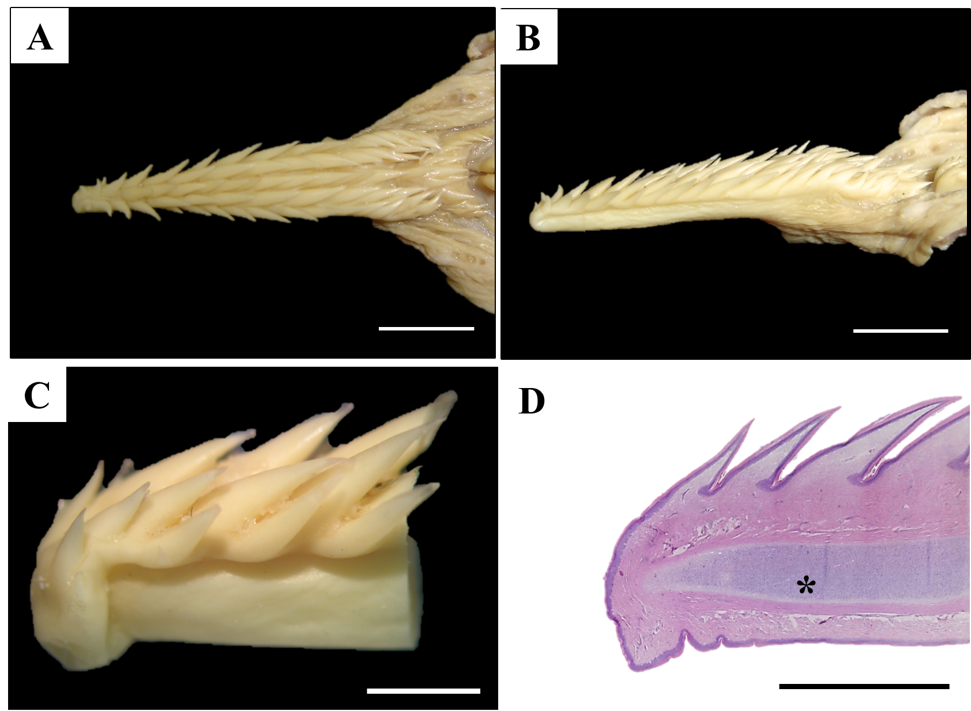
Figure 1 - Tongue of juvenile Magellanic penguin (Spheniscus magellanicus). Dorsal (A) and lateral (B) view of the dorsal surface of the tongue with filliform papillae of different heights. Bar: 1cm; C. Under greater magnification, the apex of the tongue and the distribution of the papillae toward the back of the mouth may be seen. Bar: 1cm; D. Photomicrograph of the lingual papillae of the dorsal surface, cartilage (*), and smooth ventral surface. HE. Bar: 370 µm

All the dorsal surface of the tongue was composed only the filiform papillae distributed in longitudinally arranged rows. It was possible to observe a variation in the size of these papillae, with larger ones in the medial region, not in the root and apex. Although filiform papillae were caudally inclined, papillae located in the rows in the lateral margins of the tongue (right and left) were inclined latero-caudally (Figs. 1 and 2C).
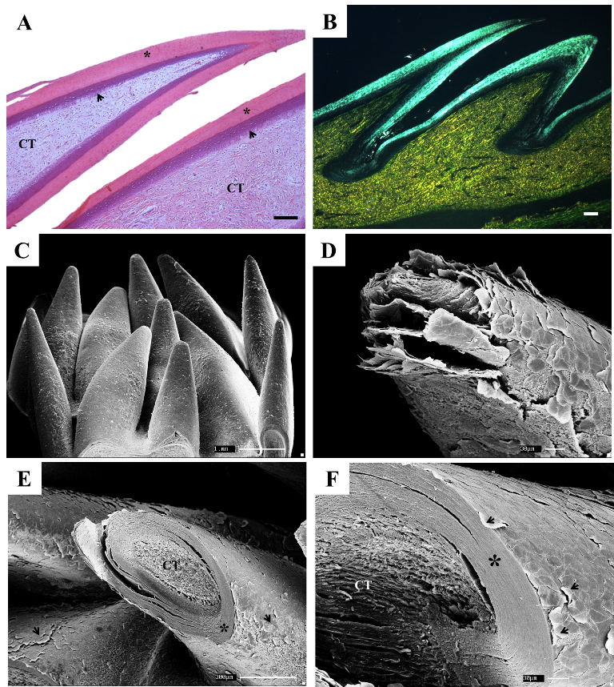
Figure 2 - A: Photomicrograph of a transversal section of the tongue of the Magellanic penguin. The epithelium (arrow) and thick keratin layer (*), and thick layer of connective tissue may be observed (CT). HE, Bar: 100µm; B: Under polarized light, the predominance of type III collagen fibers may be observed (in green). Picrosirius. Bar: 100µm; C: SEM showing filliform papillae; D: SEM showing the apex of one filliform papilla and the occurrence of sloughing. E: SEM showing connective tissue (CT) and the epithelium layer (*) with the occurrence of sloughing (arrow); F: Under greater magnification, connective tissue, epithelium (*) and keratin (arrows) may be seen.

The epithelium of the tongue of the Magellanic penguin is stratified, with a thick keratin layer and presence of sloughing (Figs. 2A, 2E, 2F and 3A). It was noted that the apex of the papillae was the region where most of the sloughing was found (Figs. 2D, E and F), when compared with the body and base of the papillae and the floor of the tongue. No taste buds were observed in these papillae, which were characterized as mechanical papillae.
Below the thick epithelium of the lingual papillae, connective tissue rich in type I and III collagen fibers was observed, with predominance of type III fibers (Figs. 2B and 3B) and absence of mucous glands. After the epithelium was removed, the floor of the tongue presented narrow parallel rows of longitudinally arranged connective papillae. The arrangement of the connective papillae followed the distribution of the epithelial papillae (Figs. 3D, E and F). It was observed the presence of salivary glands in the whole extension of the tongue dorsal surface.
The ventral region did not show lingual papillae or connective papillae, but small cavities in the epithelium close to the apex of the tongue were observed (Figs. 3G and H).
The cartilaginous skeleton, formed by hyaline cartilage, was observed in the medial region of the tongue, extending from the base to the apex. Striated skeletal muscle fibers were observed around the tongue cartilage (Figs. 3A, C, G and H).
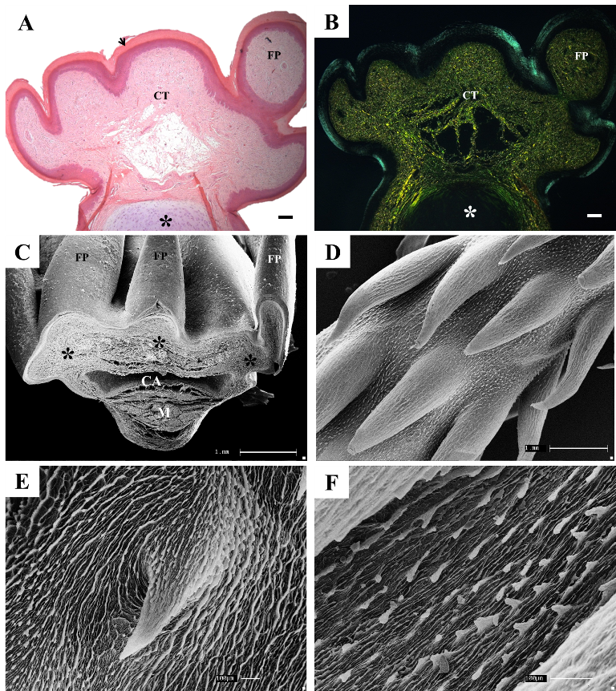
Figure 3 - A: Photomicrograph of a transversal section of the tongue of the Magellanic Penguin. Keratinized epithelium (arrow), thick layer of connective tissue (CT) and cartilaginous tissue (*) may be seen. HE. Bar: 100µm; B: Under polarized light, the predominance of type III collagen fibers may be observed (in green). Picrosirius. Bar: 100µm; C: SEM showing filliform papillae (FP), connective tissue (*), cartilage (CA) and muscle (M); D: SEM showing the thin connective papillae of the filliform papillae; E: SEM showing connective papilla (highlighted); F: Under greater magnification, the presence of small projections of connective tissue may be seen on the floor of the tongue.
Discussion
The avian tongues exhibit adaptations specific for the collection, manipulation and swallowing of foods (STURKIE, 2000; ERDOĞAN; IWASAKI, 2013). The diversity of feeding adaptations among birds is reflected in the form and function of their feeding apparatus, and morphological adaptations of avian tongues are also closely associated with discrete eating habits and lifestyle in different environments (NICKEL et al., 1977; EMURA et al., 2008a,b; PARCHAMI et al., 2010a,b).
Studies on the adaptive morphology of the tongue of vertebrates, such as the keratinization of the tongue epithelium during the adaptation to moist to dry conditions or to seawater, suggest an important role of this organ during the migration of vertebrates from freshwater to seawater or land (IWASAKI, 2002).
The tongue of the Magellanic penguin showed a highly keratinized epithelium both in the dorsal and ventral regions, as it was observed with other penguin species (KOBAYASHI et al., 1998) and in other birds, such as the white-tailed eagle (HOMBERGER; BRUSH, 1986), the cormorant (JACKOWIAK, 2006), the oriental scops owl, and the Japanese pigmy woodpecker (EMURA et al., 2009), whose feeding habits depend on a more rigid and resistant tongue structure. In ratites, such as emus and ostriches, the tongue epithelium is not keratinized (GUIMARÃES et al., 2009; CROLE; SOLEY, 2010; SANTOS et al., 2011). To compensate for this absence of the keratinized epithelium, saliva or mucous secretion is produced by the numerous salivary glands on both the dorsal and ventral parts of the tongue to protect the tongue in case of mechanical irritation (CROLE; SOLEY 2009; SANTOS et al., 2011).
The structure of the tongue in birds has a direct correlation with the morphology of the beak (CAMPBELL; LACK, 1985; VOLLMERHAUS; SINOWATZ, 1992), and characteristics such as the epithelial cover and tongue skeleton are correlated with way food is captured and the feeding habits of the bird (McLELLAND, 1989).
The triangular shape of the tongue of the Magellanic penguin showed a direct relationship with the shape of the lower jaw, taking up the whole cavity. This characteristics was also observed by Oliveira et al. (2011) in Spheniscus magllanicus and Kobayashi et al. (1998) in other four species of penguins: Spheniscus demersus, Pygoscelis papua, Spheniscus humboldti, and Eudyptes chrysolophus. The triangular shape with the pointed apex is considered the standard in omnivorous birds (GARDNER, 1927).
In birds such as ratites, which swallow the whole food, the tongue is rudimentary, taking up only 1/3 of the oral cavity, and does not follow the shape of the beak (JACKOWIAK; LUDWIG, 2008; GUIMARÃES et al., 2009; SANTOS et al., 2011).
The presence of the cartilage in the tongue of the Magellanic penguin suggests that, besides having the structural function of maintaining the shape of the tongue (McLELLAND, 1979), it makes up the hyobranchial system, which aids in the capture of the food, acting as a lever, pushing the food towards the back of the mouth for quick swallowing. This hyobranchial system in birds is not articulated with the cranium, enabling wide mobility, and it is the main contributor to the movement of the tongue (KING; McLELLAND, 1984; BONGA, 2000).
In the tongue of the Magellanic penguin, as described in other penguin species (KOBAYASHI et al., 1998) it was possible to observe thin papillae with keratinized epithelium spread all over the surface of the organ. As the diet of the Magellanic penguins is mainly based on slippery animals, such as fish, cephalopods and shellfish (SCHIAVINI et al., 2005; YOFRE et al., 1983) lingual papillae have an important role in these animals, as they aid the apprehension of the food (MacLELLAND, 1989).
The presence of lingual papillae was already reported in other birds, such as the white-tailed eagle, the cormorant (HOMBERGER; BRUSH, 1986), oriental scops owl, and the Japanese pygmy woodpecker (EMURA et al., 2009). However, the absence of these papillae was described in ratites, such as ostriches (JACKOWIAK; LUDWIG, 2008; GUIMARÃES et al., 2009) and emus (CROLE; SOLEY, 2010; SANTOS et al., 2011).
In the tongue of the Magellanic and other penguin species (KOBAYASHI et al., 2006), only one type of lingual papillae was found, whose morphology is similar of filiform papillae described in aquatic mammals (KOBAYASHI et al., 1994; 2002). In this study, no gustative papillae were found, as has been reported for other species of penguins. However, when present in birds, these papillae may be spread not only in the tongue epithelium, but also in other regions of the oral cavity (GANCHROW; GANCHROW, 1985; REUTTER; WITT, 1993).
In our study the presence of salivary glands was not observed, as Kobayashi et al. (2006) in several species of penguins. However, Samar et al. (1995 and 1999) observed the presence of salivary glands in the back of the tongue in the transition region with oropharynx and palate, in this same species. Thus, one may suggest that humidification of food commences from the oropharynx, which facilitates swallowing of food, which in penguins is swallowed whole.
In our study the presence of salivary glands was not observed, as Kobayashi et al. (2006) in several species of penguins. However, Samar et al. (1995 and 1999) observed in this species the presence of salivary glands in the back of the tongue, in the transition region with oropharynx and palate. Thus, one may suggest that humidification of food commences from the oropharynx, which facilitates swallowing of food, which in penguins is swallowed whole.
Scanning electron microscopy results showed the sloughing of the epithelium in the dorsal surface of the tongue, which was more intense in the apex of the lingual papillae, due to the direct friction with the food. Sloughing of the epithelium was also observed in the dorsal surface of the tongue in emus (SANTOS et al., 2011; CROLE; SOLEY, 2010) and ostriches (GUIMARÃES et al., 2009).
It was possible to observe, based on the results obtained in this study, that the tongue of the Magellanic penguin presented morphological similarities with other penguin species (Spheniscidae) (KOBAYASHI et al., 1998). In spite of sharing common characteristics with ratites (ostrich, rheas, emus, etc.), such as wings adapted to propulsion, the morphology of the tongue of these groups of birds were very different and adapted to the way of life and way food is captured in each species.

References
BANNASCH, R. Morphologic-functional study of the locomotor system of penguins as a general model of movement in under-water flight. Gegenbaurs Morphologisches Jahrbuch, v.132, p. 645-679, 1986.
BINGHAM, M. The decline of Falkland Islands penguins in the presence of a commercial fishing industry. Revista Chilena de História Natural, v. 75, p.805-818, 2002.
BONGA, C.A. Feeding in paleognathous birds, in Feeding: form, function, and evolution in tetrapod vertebrates, edited by K. Schwenk. San Diego: Academic Press, 2000.
CAMPBELL, B.; LACK, E. A Dictionary of Birds. Calton T. AD. Poyser, 1985.
CROLE, M.R.; SOLEY, J.T. Surface morphology of the emu (Dromaius novaehollandiae) tongue. Anatomia, Histologia Embryologia, v. 39, n. 4, p. 355-365, 2010.
CROLE, M.R.; SOLEY, J.T. Morphology of the tongue of the emu (Dromaius novaehollandiae). II. Histological features. Onderstepoort Journal Veterinary Research, v. 76, p. 347-361, 2009.
ERDOĞAN, S.; SAĞSÖZ, H.; AKBALIK, M.E. Anatomical and histological structure of the tongue and histochemical characteristics of the lingual salivary glands in the Chukar partridge (Alectoris chukar, Gray 1830). British Poultry Science, v. 53, n. 3, p. 307-315, 2012.
ERDOĞAN, S.; IWASAKI, S. Function-Related Morphological Characteristics and Specialized Structures of the Avian Tongue. Annals of Anatomy. v. 24, 2013.
EMURA, S.; OKUMURA, T.; CHEN, H. Scanning electron microscopic study of the tongue in the oriental scops owl (Otus scops). Okajimas Folia Anatomica Japonica, v. 86, p. 1-6, 2009.
EMURA. S.; OKUMURA, T.; CHEN, H. Scanning electron microscopic study of the tongue in the Japanese pygmy woodpecker (Dendrocopos kizuki). Okajimas Folia Anatomica Japonica, v. 86, p. 31-35, 2009.
EMURA, S.; OKUMURA, T.; CHEN, H. SEM studies on the connective tissue cores of the lingual papillae of the Northern goshawk (Accipiter gentilis). Acta Anatomica Nippon, v. 83, p. 77-80, 2008a.
EMURA, S.; OKUMURA, T.; CHEN, H. Scanning electron microscopic study of the tongue in the peregrine falcon and common kestrel. Okajimas Folia Anatomica Japonica, v.85, n.1, p.11-15, 2008b.
EMURA S, OKUMURA T, CHEN H. Comparative studies of the dorsal surface of the tongue in three avian species by scanning electron microscopy. Okajimas Folia Anatomica Japonica, v. 86, n. 4, p. 111-115, 2010.
GARDNER, L.L. On the tongue in birds. The Ibis, v. 3, p.185-196, 1927.
GUIMARÃES, J.P.; MARI, R.B.; CARVALHO, H.S.; WATANABE, I. Fine structure of the dorsal surface of ostrich's (Struthio camelus) tongue. Zoological Science, v. 26, p. 153-156, 2009.
HARRISON, J.G.. Tongue. In: A new dictionary of birds, edited by A.L. Thomson. London: Nelson, 1964.
HILDEBRAND, M. Analysis of vertebrate structure. J. Wiley and Son, New York, p. 584, 1974.
HOMBERGER, D.G..; BRUSH, A.H. Functional morphological and biochemical correlations of the keratinized structure in the African Grey parrot, Psittaccus erithacus. Zoomorphology, v. 106, p. 103-114, 1986.
HOMBERGER, D.G..; MEYERS, R.A. Morphology of the lingual apparatus of the domestic chicken, Gallus gallus, with special attention to the structure of the fasciae. American Journal of Anatomy, v. 186, p. 217-257, 1989.
IWASAKI, S. Evolution of the structure and function of the vertebrate tongue. Journal of Anatomy, v. 201, p. 1-13, 2002.
JACKOWIAK, H.; ANDRZEJEWSKI, W., GODYNICKI, S. Light and scanning electron microscopic study of the tongue in the cormorant Phalacrocorax carbo (Phalacrocoracidae, Aves). Zoological Science, v. 23, p. 161−167, 2006.
JACKOWIAK, H.; LUDWIG, M. Light and scanning electron microscopic study of the structure of the ostrich (Strutio camelus). Zoological Science, v. 25, p.188–194, 2008.
KING, A.S.; MCLELLAND, J. Digestive system, in Birds - their structure and function, 2nd ed. London: Bailliere Tindall, 1984.
KOBAYASHI, K.; KUMAKURA, M.; YOSHIMURA, K. Stereo structure of the connective tissue cores of the lingual papillae in the steller sea lion. Journal of Electron Microscopy, v. 43, 246, 1994.
KOBAYASHI, K., KUMAKURA, M.; YOSHIMURA, K.; INATOMI, M.; ASAMI, T. Fine structure of the tongue and lingual papillae of the penguin. Archivum Histologicum Cytologicum,v. 61, p.37-46, 1998.
KOENIG, H.E.; LIEBIG, H.G. Anatomie und Propädeutik des Geflügels. Lehrbuch und Farbatlas für Studium und Praxis. Schattauer Stuttgart, New York, 2001.
MADER. A.; SANDER, M.; CASA, J.R. Ciclo sazonal de mortalidade do pinguim-de-magalhães, Spheniscus magellanicus influenciado por fatores antrópicos e climáticos na costa do Rio Grande do Sul, Brasil. Revista Brasileira de Ornitologia, v.18, n.3, p.228-233, 2010.
McLELLAND, J. Digestive system. In: Form and function in birds, Vol. 1, edited by King, A.S. and McLelland, J. London: Academic Press, 1979.
McLELLAND, J. Digestive system. In: Form and Function in Birds. vol 2 Ed by King, A.S.; McLelland, J. Academic Press, London, p.69-181, 1989.
McLELLAND, J. Digestive system. In: A color atlas of avian anatomy. Aylesbury, England: Wolfe Publishing Ltd., 1990.
MURAKAMI, T. A revised tannic-osmium method for noncoated scanning electron microscope specimens. Archivum Histologicum Japonicum, v. 36, p. 189-193, 1974.
NICKEL, R.; SCHUMMER, A.; SEIFERLE, E. Anatomy of the Domestic Birds. Verlag Paul Parey, Berlin, Hamburg, p. 44-46, 1977.
OHTANI, O. Three dimensional organization of the connective tissue fibers of the human pancreas: a scanning electron microscopy study of NaOH treated tissues. Archivum Histologicum Japonicum, v.50, p.557-566, 1987.
OLIVERA, R.P.N.; SANTOS, B.G.; DUARTE, B.R.; NOGUEIRA, C.H.O.; SILVEIRA, L.S.; BARBOSA, L.A.; RODRIGUES, A.B.F. Morfologia, topografia e distribuição das papilas linguais em pinguim-de-magalhães (Spheniscus magellanicus). PUBVET, v.5, n.7, 2011.
PARCHAMI, A.; DEHKORDI, R.A.F.; BAHADORAN, S. Fine structure of the dorsal lingual epithelium of the common quail (Coturnix coturnix). World Applied Sciences Journal, v.10, p. 1185-1189, 2010a.
PARCHAMI, A.; DEHKORDI, R.A.F.; BAHADORAN, S. Scanning electron microscopy of the tongue in the golden eagle Aquila chrysaetos (Aves: Falconiformes: Accipitridae). World Journal of Zoology, v.5, p. 257-263, 2010b.
REECE, W.O. Physiology of Domestic Animals. 2nd ed., Williams & Wilkins, Baltimore, Philadelphia, London, Paris, Bangkok, Buenos Aires, Hong Kong, Munich, Sydney, Tokyo, Wroclaw, p. 321-323, 1996.
REUTTER, K.; WITT, M. Morphology of vertebrate taste organs and their nerve supply. In: (ed. by) SIMON, S. A. and ROPER, S. D.: Mechanisms of taste transduction, CRC Press, Boca Raton-Ann Arbor-London-Tokyo, p. 29-82, 1993.
SAMAR, M.E.; AVILA, R.E.; FABRO, S.P.; CENTURION, C. Structural and cytochemical study of salivar glands in the Magellanic penguin Spheniscus magellanicus and the kelp gull Larus dominicanus. Marine Ornithology, v. 23, p. 153-157, 1995.
SAMAR, M.E.; AVILA, R.E.; FABRO, S.P.; PORFIRIO, V.; ESTEBAN, F.J.; PEDROSA, J.A.; PEINADO, M.A. Histochemical study of magellanic penguin (Spheniscus magellanicus) minor salivary glands during postnatal growth. The Anatomical Records, v. 254, p.298-306, 1999.
SANTOS, T.C.; FUKUDA, K.Y.; GUIMARÃES, J.P.; OLIVEIRA, M.F.; MIGLINO, M.A.; WATANABE, I. Light and scanning eléctron microscopy study of the tongue in Rhea americana. Zoological Science, v. 28, n. 1, p.41-46, 2011.
SILVA-FILHO, R.P.; RUOPPOLO, V. Sphenisciformes (Pingüim). In: Cubas ZS, Silva JCR, Catão-Dias JL. Tratado de Animais Selvagens - Medicina Veterinária. São Paulo, SP: Roca, p. 309-323, 2006.
STOKES, D.L.; BOERSMA, P.D.; DAVIS, L.S. Satellite tracking of Magellanic Penguin migration. Condor, v. 100, p. 376-38, 1998.
STURKIE, P.D. Sturkie's Avian Pysiology. 5th Ed., Academic Press, San Diego, London, Boston, New York, Sydney, Tokyo, Toronto, p. 300-302, 2000.
VOLLMERHAUS, B.; SINOWATZ, F. Verdauungsapparat. In: Nickel, R.; Schummer, E.; Seiferle, E. (Eds.) Anatomie der Vogel Bd. 5. Lehrbuch der Anatomie der Haustiere, Parey, Berlin, 1992.
WATANABE, I.; YAMADA, E. The fine structure of lamellated nerve endings found in the rat gingiva. Archivum Histologicum Japonicum, v. 46, p. 173-182, 1983.
YOFRE, A.E.; NAROVSKY, T.; PALERMO, M.A.; MARCHETTI, B. El pingüino de Magallanes. Fauna Argentina 1. Buenos Aires: Centro Editor de América Latina, p.10-14, 1983.

