Behavior of lateral buds of Hancornia speciosa after cryopreservation by encapsulation-vitrification

Cryopreservation of Hancornia speciosa by encapsulation-vitrification

**DÉBORA DE OLIVEIRA PRUDENTE¹ deboraoprudente@outlook.com - Universidade Federal de Lavras, Departamento de Biologia, Av. Doutor Sylvio Menicucci, 1001, Kennedy, Lavras, MG, Brasil, CEP 37200-000

RENATO PAIVA¹ renpaiva@dbi.ufla.br - Universidade Federal de Lavras, Departamento de Biologia, Av. Doutor Sylvio Menicucci, 1001, Kennedy, Lavras, MG, Brasil, CEP 37200-000

FERNANDA CARLOTA NERY¹ fernanda.nery@dbi.ufla.br - Universidade Federal de Lavras, Departamento de Biologia, Av. Doutor Sylvio Menicucci, 1001, Kennedy, Lavras, MG, Brasil, CEP 37200-000

WESLEY PIRES FLAUSINO MÁXIMO² wesleypfm@gmail.com - Universidade Federal de Lavras, Departamento de Química, Av. Doutor Sylvio Menicucci, 1001, Kennedy, Lavras, MG, Brasil, CEP 37200-000

LUCIANO COUTINHO SILVA³ lucoutsilva@yahoo.com.br - Universidade Federal da Paraíba, Centro de Biotecnologia, Campus I, Castelo Branco, João Pessoa, PB, Brasil, CEP 58051-900

** Autor para correspondência

Behavior of lateral buds of Hancornia speciosa after cryopreservation by encapsulation-vitrification

Cryopreservation of Hancornia speciosa by encapsulation-vitrification

RESUMO
Comportamento de gemas laterais de Hancornia speciosa após criopreservação por encapsulamento-vitrificação. Hancornia speciosa é uma frutífera do Cerrado com elevado potencial econômico. Entretanto, o extrativismo desordenado causou a redução populacional em sua área endêmica. Além disso, a recalcitrância da semente afeta negativamente sua conservação convencional. Buscando alternativas de conservação para essa espécie, objetivou-se avaliar a regeneração das gemas laterais após a técnica de encapsulamento-vitrificação. Cápsulas de alginato de sódio contendo gemas laterais foram pré-cultivadas em meio WPM acrescido de 1,0 M de glicerol e, posteriormente, imersas em diferentes concentrações de sacarose (0,3; 0,75 e 1,0 M) por 24 ou 48 h. As cápsulas foram submetidas à desidratação em sílica gel ou em fluxo laminar por 0, 1, 2 e 3 h antes de sua incubação em diferentes tempos de PVS2 (0, 15, 30, 60 e 120 minutos). Elevada porcentagem de regeneração de gemas laterais foi observada após a criopreservação de cápsulas tratadas com 0,75 M de sacarose + 1,0 M de glicerol por 24 h, associado com a desidratação em fluxo laminar (1 h) e imersão em PVS2 (15 minutos). O encapsulamento-vitrificação é eficiente para a conservação de longo prazo e permite a obtençao de altas taxas de sobrevivência após a criopreservação de explantes sensíveis (gemas laterais) de Hancornia speciosa.
Palavras-chave: Mangabeira, espécie recalcitrante, conservação em longo prazo, desidratação

ABSTRACT
Cryopreservation of Hancornia speciosa by encapsulation-vitrification. Hancornia speciosa is a fruitful species from Cerrado biome with high economic potential. However, the intense and disordered extractivism have caused a reduction of its population in its endemic area. In addition, seed recalcitrance negatively affects the conventional conservation of the species. Aiming to find alternatives that enable the long-term conservation of this species, the study’s objective was to assess the behavior of lateral bud’s regrowth after cryopreservation procedures by encapsulation-vitrification technique. Sodium alginate capsules containing lateral buds were pre-cultured in liquid WPM supplemented with 1.0 M glycerol, and subsequently exposed to different concentrations of sucrose (0.3; 0.75 and 1.0 M) for 24 or 48 h. The capsules were subjected to dehydration in silica gel or airflow hood for 0, 1, 2 and 3 h before different incubation times in PVS2 (0, 15, 30, 60 and 120 minutes) at 0 °C. A high regeneration percentage of lateral buds was observed after cryopreservation of capsules treated with 0.75 M sucrose plus 1.0 M glycerol (24 h), associated with dehydration in an airflow hood (1 h) and immersion in PVS2 (15 minutes). Encapsulation-vitrification allowed the long-term conservation, and provided high plant material survival rates after cryopreservation of Hancornia speciosa sensitive explants.
Keywords: Mangabeira, recalcitrant species, long-term conservation, dehydration

INTRODUCTION
Cerrado is a complex Brazilian biome with great diversity of habitats. This rich biodiversity occupies an area over 2 million km², and represents about 23% of the Brazilian national territory (Klink & Machado, 2005). Several plant species of economic importance are found in this biome and many of them, if exploited consciously, have potential for the sustainable production of food and medicine (Machado et al., 2004).
The species Hancornia speciosa Gomes, popularly known as “Mangabeira”, is a native fruitful tree of the Brazilian cerrado, belonging to Apocynaceae, and is widely distributed throughout the country, from Amapá to the state of São Paulo (Silva Júnior et al., 2007). Among the attractive characteristics of the species are its fruits that, due to its pleasant flavor, stimulate fresh consumption and can also be used in the production of syrups, juices, candy, ice cream and jams (Soares et al., 2011). Since it is an iron-rich fruit and a vitamin C source, the mangaba fruit occupies a prominent position among functional foods (Silva Júnior et al., 2007). For all these characteristics, this species has been the target of predatory extraction, which has led to a decline in H. speciosa population in its native areas (Soares et al., 2011). In addition, the recalcitrance of its seeds is another detrimental factor for the availability of the species, since it prevents conventional storage and its later use (Barros et al., 2006).
Aiming to overcome the obstacles imposed by the natural characteristics of each species, germplasm conservation strategies have been used in order to prevent the extinction of these species and allow multiple genotypes to remain available for future applications (Flores et al., 2013). Among the current germplasm conservation forms, cryopreservation, known to be a method for long-term conservation, ensures the viability of the biological material, with no modifications or genetic alterations for an indefinite period (Engelmann, 2011). Recently, some effort has being done to increase the conservation of H. speciosa germoplasm by means of cryopreservation using different techniques. A protocol using droping vitrification technique (Panis et al., 2005) was successfully performed using shoot tips as explants (Santos et al., 2015). Conversely, the encapsulation-dehydration technique was unsussessfuly applied on lateral buds (Sartor et al., 2012), showing that more studies are needed to increase the number of cryopreservation protocols of this tissue.
There are different cryopreservation techniques, and the choice of which is most appropriate will depend on the explant to be cryopreserved (Sakai & Engelmann, 2007). Encapsulation-vitrification is one of these cryopreservation techniques, which was developed based on the production of encapsulated units in the alginate matrix. This method can protect sensitive explants against harmful conditions, for example, the exposure to potentially toxic substances present in cryoprotectants used during the procedure (Subramaniam et al., 2013).
During cryopreservation, the samples survival will depend on the glassy state of explants, that is, the direct transition of water from liquid to an amorphous or glassy solid (Engelmann, 2011). This process is dependent on the viscosity increment of the solution, which occurs when the solutes become more concentrated, a characteristic considered essential to prevent intracellular crystallization and membrane rupture (Fahy et al., 1984). Thus, the determination of the dehydration degree necessary to prevent the onset of these effects appears to be a promising strategy for the success of cryopreservation techniques and subsequent establishment of germplasm banks (Raven & Havens, 2014).
Given the above, the aim of this study was to establish an efficient long-term conservation method through cryopreservation protocol using the encapsulation-vitrification technique for lateral buds of Hancornia speciosa.

MATERIAL AND METHODS
Plant material - Hancornia speciosa shoots with 60 days of in vitro culture were used as a source of explants. These explants were grown in culture medium composed by Wood Plant Medium (WPM) basal salts (Lloyd & Mccown, 1980) supplemented with 8.87 μM 6-benzylaminopurine (BA), 30 g L⁻¹ sucrose and gelled with 7 g L⁻¹ agar, as established by Soares et al. (2011).
Encapsulation and dehydration of lateral buds - Lateral buds, with approximately 1.0 mm², were excised from shoots and immersed in sodium alginate matrix (2.5% w/v). Subsequently, with the aid of an automatic pipette, the individual encapsulated units were retrieved and dripped into calcium chloride solution (CaCl₂.2H₂O) (100 mM), remaining for 20 minutes for complexation procedure. The encapsulated units, individually formed by a lateral bud wrapped in sodium alginate matrix, were subjected to three washes with autoclaved distilled water to remove the excess of CaCl₂. Sequentially, the encapsulated units were immersed in potassium nitrate solution (KNO₃) (100 mM) for 15 minutes for decomplexation, and then washed again with autoclaved distilled water. Capsules containing the lateral buds were immersed in pre-culture liquid WPM medium added with sucrose at different concentrations (0.3; 0.75 and 1.0 M) and supplemented with 1.0 M glycerol for different incubation times (24 or 48 h) under constant stirring of 150 rpm. Subsequently, the capsules were inoculated in regeneration medium (WPM added with 0.2 µM BA) and maintained in a growth chamber with a 16-h photoperiod, irradiance of 36 μmol m⁻² s⁻¹ and temperature of 25 °C ± 2 °C. Each treatment consisted of ten Petri dishes containing five encapsulated units per plate, randomly. After 30 days in culture, the regeneration percentage of encapsulated buds was evaluated. After the determination of sucrose optimal concentration in the pre-culture medium and the best incubation time, the capsules were subjected to two dehydration procedures: the first in an airflow hood, and the second on silica gel, both for 0, 1, 2 and 3 h. After dehydration, the capsules were inoculated in regeneration medium (WPM supplemented with 0.2 µM BA) and maintained in a growth room chamber with a 16-h photoperiod, irradiance of 36 μmol m⁻² s⁻¹ and temperature of 25 °C ± 2 °C. Each treatment consisted of ten Petri dishes containing five encapsulated units per plate, randomly. After 30 days in culture, the regeneration percentage of encapsulated buds was evaluated.
Encapsulation-vitrification - Encapsulated lateral buds were pre-cultured in liquid WPM supplemented with 0.75 M sucrose and 1.0 M glycerol, under constant stirring of 150 rpm for 24 h, with subsequent dehydration in an airflow hood for 1 h. The capsules were treated with Loading Solution (LS) (2.0 M glycerol + 0.4 M sucrose) for 20 minutes before immersion in Plant Vitrification Solution number 2 (PVS2), composed by 30% glycerol, 15% ethylene glycol, 15% Dimethyl sulfoxide (DMSO) and 0.4 M sucrose (Sakai et al., 1990) at 0 °C for different incubation times (0, 15, 30, 60 and 120 minutes). After the PVS2 treatment, the capsules were inserted into 2.0-mL cryovials and plunged into liquid nitrogen (LN), remaining for 90 minutes. Rewarming was performed in a water bath at 40 °C for three minutes. Following, the capsules were then treated in a Petri dish containing Recovery Solution (RS), also known as Unloading Solution (1.2 M sucrose) at 25 °C for 15 minutes. After cryopreservation, the capsules were inoculated in post-culture medium, consisting of WPM basal salts supplemented with 0.3 M sucrose for 24 h in the absence of light. Subsequently, the capsules were inoculated in bud regeneration medium (WPM supplemented with 0.2 µM BA). The explants were maintained in a growth room chamber with a 16-h photoperiod, irradiance of 36 μmol m⁻² s⁻¹, at a temperature of 25 °C ± 2 °C. Each treatment consisted of ten Petri dishes containing five encapsulated units per plate, entirely at random. The variables evaluated after 30 days in culture were the percentage of survival and the percentage of shoot formation.
Statistical analysis - The collected data were statistically analyzed using SAS (Statistical Analysis System, Cary, NC, 2001), and the means were compared by Fisher's exact probability test (p< 0.05).

RESULTS AND DISCUSSION
Encapsulation-dehydration - After pre-culture of sodium alginate capsules containing the explants in liquid WPM media with different sucrose concentrations, the highest percentage of regeneration was obtained in treatment with 0.75 M sucrose after 24 h of pre-culture (Figure 1).
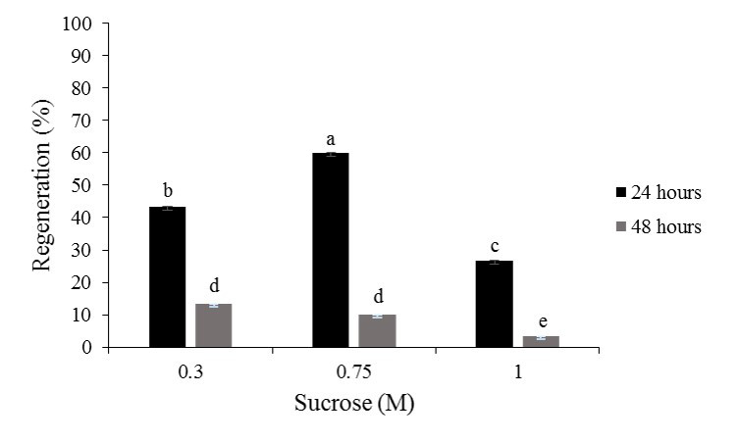
Figure 1. Regeneration percentage of lateral buds encapsulated in sodium alginate matrix subjected to pre-culture treatments in liquid WPM media supplemented with 0.3, 0.75 and 1.0 M sucrose for 24 or 48 h. Means followed by the same letter do not differ between each other according to Fisher's exact test (p≤0.05).

The different dehydration conditions of alginate capsules, both in silica gel and airflow hood, showed significant differences among treatments. The highest survival percentage (78%) was observed in the explants exposed to dehydration in an airflow hood for 1 h, where the capsules had a water content of 34% (Table 1).

Table 1. Percentage of water content and recovery of encapsulated units of Hancornia speciosa subjected to drying, either in silica gel or airflow hood, for different times.
Time (h) |  | Water content (%) |  | Recovery (%)
 |  | Airflow | Silica | Airflow | Silica
Control |  | 99.7 | 99.4 | 85.0 aA | 82.0 aA
1 |  | 34.0 | 33.9 | 78.0 bA | 69.0 bB
2 |  | 23.5 | 9.5 | 16.5 cA | 0.0 cB
3 |  | 11.8 | 8.4 | 0.0 dA | 0.0 cA
*Means followed by the same lowercase letter in the column and uppercase letter in the row do not differ between each other by Fisher's exact test (p ≤ 0.05).

Among pretreatment techniques described for the plant tissues cryopreservation, encapsulation-dehydration has numerous advantages, such as easy handling of the explants and a large storage capacity for fragile tissues (Sakai & Engelmann, 2007). The importance of dehydration protocols is related to reduce the water content of the plant material (Silva et al., 2014), in order to enable tissue cooling, and prevent injuries caused by the expansion of frozen water and the formation of extra- and intracellular ice crystals (Sakai & Engelmann, 2007). Therefore, dehydration acts alleviating these critical steps and is considered one of the key points for the success of cryopreservation. Thus, the optimum water content after dehydration ranges from 20 to 30% of the total water content in the tissues (Vertucci & Farrant, 1995).
The highest recovery rate of encapsulated lateral buds after dehydration occurred at a water content around 34% (Table 1), which is considered viable for the capsules hydration levels to be cryopreserved. However, H. speciosa lateral buds seems to be more sensitive to dehydration. Successful cryopreservation was observed in shoot apices of Rabdosia rubescens encapsulated and precultured in MS culture medium with 0.4 M sucrose, in combination with 2.0 M glycerol and dehydrated for 1 h in silica gel, reaching a water content of 21% and a recovery rate of 85% (Ai et al., 2012). Encapsulation-vitrification of apical meristems of date palm (Phoenix dactylifera L) in PVS2 for 15 minutes and immersion in LN, ensured increased survival and recovery of explants (40%) (Fki et al., 2012). Shoot apices of Vitis vinifera encapsulated were pre-cultured in half-strength MS medium supplemented with increasing concentrations of sucrose (0.25-1.0 M) and then dehydrated in an airflow hood for different periods, in order to determine the optimum capsules dehydration time (Wang et al., 2000). These authors found that only the shoot apices with water content lower than 22.5% survived. Wang et al. (2005) observed that sodium alginate capsules containing apical buds of Rubus idaeus L., pre-cultured in MS medium containing sucrose, had an initial moisture content of 66%, and the water content decreased to 22.2% in the first 4 h in an airflow hood, and to 14.3% after 8 h of dehydration. According to these authors, the highest recovery rates of the apical buds were obtained by dehydration for at least 3 h in an airflow hood.
Similar to the observed in the present study, the encapsulation-dehydration technology has been successfully applied in the cryopreservation of different species, such as Beta vulgaris (Vandenbussche & Proft, 1998), Apple (Malus x domestica Borkh.) (Paul et al., 2000) and Citrus (Wang et al., 2002). One of the advantages of this method is that the recovery of cryopreserved buds occurs directly, quickly and usually without callus formation.

Encapsulation-vitrification - The cryopreservation of lateral buds was successfully obtained with the encapsulation-vitrification technique, using PVS2 incubation for 15 minutes before plunge into LN. On average, it was possible to observe 67% of explants survival (Figure 2A) and 89% of shoot formation (Figure 2B). In addition, after 15 days from the beginning of the dehydration and cryopreservation treatment, a disruption of the capsule occurred and shoots start to grow (Figure 3A-B). At the end of 60 days of cultivation, normal plants, which means possessing shoot and roots as well, were formed from encapsulated-vitrified lateral buds (Figure 3 C-E).

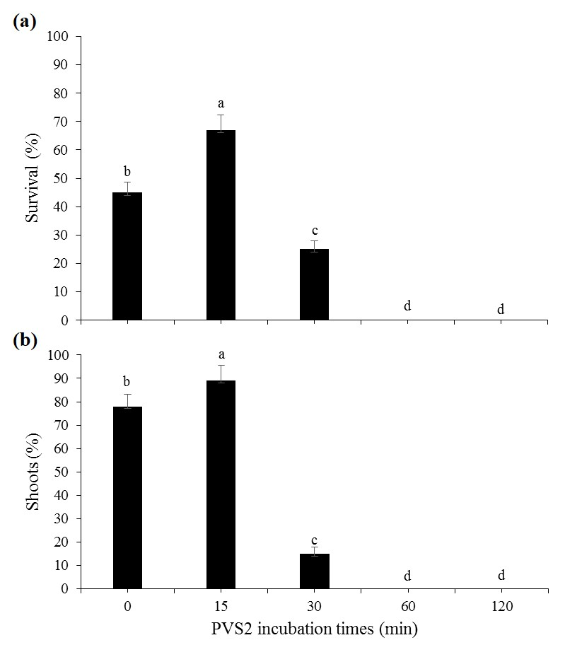
Figure 2. Explants survival percentage (a) and percentage of shoot formation (b) from lateral buds encapsulated in sodium alginate matrix after 30 days in culture, after incubation in PVS2 cryoprotectant solution for different times (0, 15, 30, 60 and 120 minutes), before immersion in LN. Means followed by the same letter on the bars do not differ between each other according to Fisher's exact test (p≤0.05).

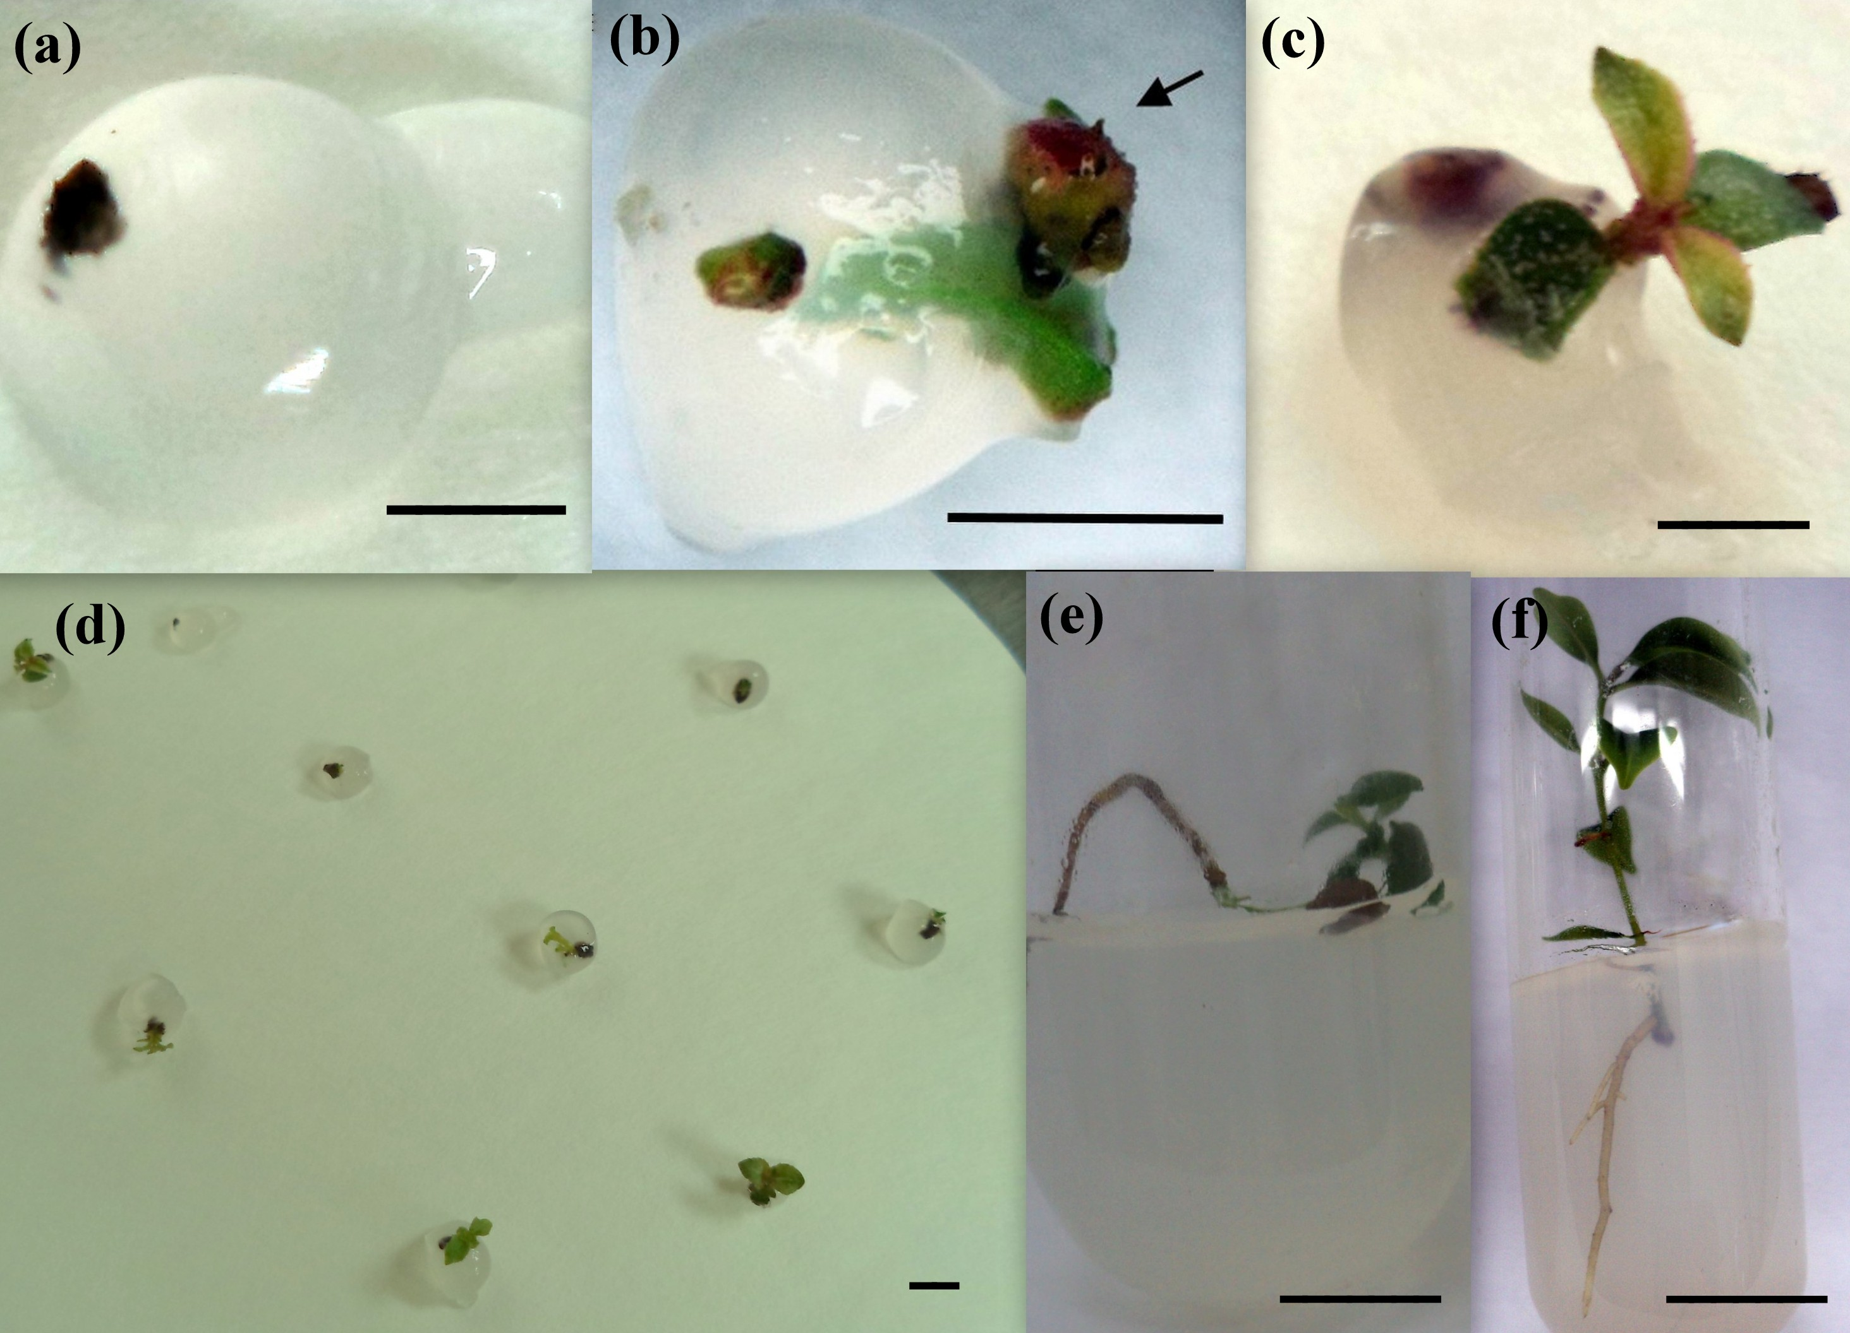
Figure 3 - Morphological aspects of Hancornia speciosa lateral buds after cryopreservation and regeneration of plants during in vitro culture. (a) Encapsulated lateral buds and pre-cultured in liquid WPM medium supplemented with 0.75 M sucrose and 1.0 M glycerol for 24 h (Bar = 1.0 cm); (b) Capsule disruption (arrow) of encapsulated-vitrificated lateral bud after 15 days in culture medium (Bar = 0.5 cm); (c) Shoot regeneration after at 30 days in culture medium (Bar = 0.5 cm); (d) General aspect of different capsules starting regrowth at 30 days after cryopreservation (Bar = 0.5 cm); (e) Regenerated shoot cultivated in WPM medium after 60 days of cryopreservation (Bar = 1.0 cm); (f) Elongation of rooted shoot on WPM medium (Bar = 1.0 cm).

In the last few years, the encapsulation-vitrification technique has stood out in the cryopreservation of several species of tropical and temperate plants (Sakai & Engelmann, 2007). However, like other cryopreservation techniques, some limiting factors reduce the efficiency of this process. Osmotic stress and chemical toxicity promoted by cryoprotectants are two major problems associated with the low efficiency of this technique. One of the ways to obtaining better results is optimizing the cryoprotectant concentration before the explants immersion in LN, aiming to increase survival after the application of cryopreservation techniques (Papadopoulos et al., 2002; Castro et al., 2011).
Amongthe results obtained by this study, the incubation in PVS2 for 15 minutes was good enough to lead to cryoprotection in the encapsulated explants, not interfering in the capsules structure. After 30 minutes of incubation in PVS2, the capsules had a gelatinous aspect and disrupted spontaniously, which may be the probable cause of the recovery failure (Figure 2).
Recent cryopreservation studies with Hancornia speciosa lateral buds by encapsulation-dehydration technique indicated unsuccesfully regrowth rates (Sartor et al., 2012). In this case, the absence of satisfactory results may be due to the lack of adequate procedures for vitrification, combined with the wrongly rewarming of encapsulated explants at room temperature. Both mistakes may have led to intracellular ice formation by means of crystallization during cooling, and recrystallization during reawarming (Fahy, 1984). Vitrification procedures must be used, instead only dehydration, for sensitive tissues as Hancornia speciosa lateral buds. In this article, it was proved that encapsulation-vitrification is an adequate procedure for cryopreservation of this kind of tissue. Moreover, several studies have shown that the encapsulation-vitrification technique is quite efficient for different explants and species (Wang et al., 2000; Sakai & Engelmann, 2007: Ai et al., 2012; Fki et al., 2012).

CONCLUSION
This protocol describes an efficient method for cryopreservation of Hancornia speciosa germplasm by encapsulation-vitrification technique. The optimized parameters here reported enabled to obtain cryopreserved lateral buds and plants regeneration up to 67%. These results also emphasized the importance to investigating the acclimatization phase and material genetic stability after cryopreservation and ex vitro development. Besides, this study is a promising approach for cryopreservation using sensitive explants produced under in vitro conditions, and may facilitate the conservation of many other recalcitrant species.

ACKNOWLEDGEMENTS
The authors are grateful to the Conselho Nacional de Desenvolvimento Científico e Tecnológico (CNPq; Brasília, DF— Brazil), Fundação de Amparo à Pesquisa de Minas Gerais (FAPEMIG; Belo Horizonte, MG—Brazil) and Coordenação de Aperfeiçoamento de Pessoal de Nível Superior (CAPES; Brasília, DF—Brazil) for financial support.
REFERENCES
Ai, P.F., Lu, L.P., & Song, J.J. (2012) Cryopreservation of in vitro grown shoot-tips of Rabdosia rubescens by encapsulation-dehydration and evaluation of their genetic stability. Plant Cell, Tissue and Organ Culture, 108(3), 381-387. http://dx.doi.org/10.1007/s11240-011-0049-x.

Barros, D.I., Bruno, R.D.L.A., Nunes, H.V., Cabral, G.C., Pereira, W.E., & Mendonça, R.M.N. (2006) Método de extração de sementes de mangaba visando à qualidade fisiológica. Revista Brasileira de Fruticultura, 28(1), 25-27.

Castro, S.V., Carvalho, A.D.A., da Silva, C.G., Faustino, L.R., de Figueiredo, J.R., & Rodrigues, A.R. (2011) Intracellular cryoprotant agents: Characteristics and use of ovarian tissue and oocyte cryopreservation. Acta Scientiae Veterinariae 39(2), 957-974.

Engelmann, F. (2011) Use of biotechnologies for the conservation of plant biodiversity. In Vitro & Developmental Biology 47(1), 5-16. http://dx.doi.org/10.1007/s11627-010-9327-2

Fahy, G.M., MacFarlane, D.R., Angell, C.A., & Meryman, H.T. (1984) Vitrification as an approach to cryopreservation. Cryobiology 21(4), 407-426.

Fki, L., Bouaziz, N., Chkir, O., Benjemaa-Masmoudi, R., Rival, A., Swennen, R., ... & Panis, B. (2013) Cold hardening and sucrose treatment improve cryopreservation of date palm meristems. Biologia Plantarum 57(2), 375-379. http://dx.doi.org/10.1007/s10535-012-0284-y.

Flores, R., Uliana, S.C., Pimentel, N., & Garlet, T.M.B. (2013) Sacarose e sorbitol na conservação in vitro de Pfaffia tuberosa (Spreng.) Hicken (Amaranthaceae). Journal of Biotechnology and Biodiversity 4(3), 192-199.

Klink, C.A., & Machado, R.B. (2005) Conservation of the Brazilian cerrado. Conservation biology 19(3), 707-713. http://dx.doi.org/10.1111/j.1523-1739.2005.00702.x.

Lloyd, G., Mccown, B. (1980) Use of microculture for production and improvement of Rhododendro spp. HortScience 15(3), 416-420.

Machado, L., Ramos, M.L.G., Caldas, L.S., & Vivaldi, L.J. (2004) Seleção de matrizes e clones de mangabeira para o cultivo in vitro. Pesquisa Agropecuária Brasileira 39(5), 431-435.

Panis, B., Piette, B. & Swennen, R. (2005) Droplet vitrification of apical meristems: a cryopreservation protocol applicable to all Musaceae. Plant Science 168(1), 45-55. http://dx.doi.org/10.1016/j.plantsci.2004.07.022

Papadopoulos, S., Rizos, D., Duffy, P., Wade, M., Quinn, K., Boland, M.P., & Lonergan, P. (2002) Embryo survival and recipient pregnancy rates after transfer of fresh or vitrified, in vivo or in vitro produced ovine blasstocysts. Animal Reproduction Science 74(1), 35-44. http://dx.doi.org/10.1016/S0378-4320(02)00162-8.

Paul, H., Daigny, G., & Sangwan-Norreel, B. S. (2000) Cryopreservation of apple (Malus × domestica Borkh.) shoot tips following encapsulation-dehydration or encapsulation-vitrification. Plant Cell Reports 19(8), 768-774. http://dx.doi.org/10.1007/s002990000195
Raven, P., & Havens, K. (2014) Ex situ plant conservation and cryopreservation: Breakthroughs in tropical plant conservation. International Journal of Plant Sciences 175(1), 1-2. http://dx.doi.org/10.1086/674030.

Sakai, A., Kobayashi, S., & Oiyama, I. (1990) Cryopreservation of nucellar cells of navel orange (Citrus sinensis Osb. var. brasiliensis Tanaka) by vitrification. Plant Cell Reports 9(1), 30-33.

Sakai, A., & Engelmann F. (2007) Vitrification, encapsulation-vitrification and droplet- vitrification: a review. CryoLetters 28(3), 151-172.

Santos, P.A.A., Paiva, R., Silva, L.C., Souza, A.C., Santana, M.C. & Silva, D.P.C. (2015) Cryopreservation of the mangaba tree (Hancornia speciosa GOMES): a protocol for long-term storage. Acta Scientiarum. Agronomy 37(3), 289-296. http://dx.doi.org/ 10.4025/actasciagron.v37i3.19573

Sartor, F.R., de Moraes, A.M., & Almeida, F.D.A.C. (2012) Técnicas para criopreservação de gemas de mangabeira. Revista Agrotecnologia 3(1), 31-39. http://dx.doi.org/10.12971/agrotec.v3i1.339

Silva Junior, J.F., Xavier, F.R.S., Silva Lédo, C.A., Santos Musser, R., & Silva Lédo, A. (2007) Variabilidade em populações naturais de mangabeira do litoral de Pernambuco. Magistra 19(1), 373-378.

Silva, L.C., Paiva, R., Swennen, R., Andrè, E., & Panis, B. (2014) Cryopreservation of Byrsonima intermedia embryos followed by room temperature thawing. Acta Scientiarum Agronomy 36(3), 309-315. http://dx.doi.org/10.4025/actasciagron.v36i3.19688.

Soares, F.P., Paiva, R., Alvarenga, A.D., Nery, F.C., Vargas, D.P., & Silva, D.R.G. (2011) Taxa de multiplicação e efeito residual de diferentes fontes de citocinina no cultivo in vitro de Hancornia speciosa Gomes. Ciência e Agrotecnologia 35(1), 152-157.

Subramaniam, S., Sinniah, U.R., Khoddamzadeh, A.A., Periasamy, S., & James, J.J. (2013) Fundamental concept of cryopreservation using Dendrobium sonia protocorm-like bodies by encapsulation-dehydration technique. African Journal of Biotechnology 10(19), 3902-3907. http://dx.doi.org/10.5897/AJB10.2265.

Vertucci, C.W., & Farrant, J.M. (1995) Acquisition and loss of desiccation tolerance. In Seed Development and Germination (Kigel, J. and Galili, G., eds), pp. 237–271, Marcel Dekker.

Wang, Q., Batuman, Ö., Li, P., Bar-Joseph, M., & Gafny, R. (2002) A simple and efficient cryopreservation of in vitro-grown shoot tips of Troyer'citrange [Poncirus trifoliata (L.) Raf.× Citrus sinensis (L.) Osbeck.] by encapsulation-vitrification. Euphytica 128(1), 135-142. http://dx.doi.org/10.1023/A:1020683305690.

Wang, Q., Laamanen, J., Uosukainen, M., & Valkonen, J.P. (2005) Cryopreservation of in vitro-grown shoot tips of raspberry (Rubus idaeus L.) by encapsulation–vitrification and encapsulation–dehydration. Plant Cell Reports 24(5), 280-288. http://dx.doi.org/10.1007/s00299-005-0936-x.

Wang, Q., Tanne, E., Arav, A., & Gafny, R. (2000) Cryopreservation of in vitro-grown shoot tips of grapevine by encapsulation-dehydration. Plant Cell, Tissue and Organ Culture 63(1), 41-46. http://dx.doi.org/10.1023/A:1006411829738.

