Florianópolis, October 27th, 2016

**Dear Editor**

**Dr. Ricardo Massato Takemoto**

Acta Scientiarum. Biological Sciences

Universidade Estadual de Maringá, Maringá, Paraná, Brazil

Avenida Colombo, 5790 87020-900 Maringá, Paraná, Brasil

Telefone: +55 44 30114253

Fax: +55 44 30114253, e-mail: [actabiol@uem.br](mailto:actabiol@uem.br)

We would like to submit the manuscript entitled "**First record of** *Hamaticolax scutigerulus* **(Copepoda) in Brazil, ectoparasite of the spotted goatfish** *Pseudupeneus maculatus*" for your consideration as a Brief Communication in *Acta Scientiarum. Biological Sciences*.

Few studies have been performed on the parasitic fauna of spotted goatfish in South America. This study presents new locality for the Copepoda *Hamaticolax scutigerulus* and a review about the species of the genus.

The manuscript provides original and accurate data and is not under consideration elsewhere. The authors are prepared to assume public responsibility for its content.

Thank you for receiving our manuscript and considering it for review. We appreciate your time and look forward to your response.

The manuscript idiom was revised by David Elliff as letter attached.

Please e-mail me if you have any questions.

Suggested reviewers:

Dr. Jorge C. Eiras (Porto, Portugal) – (parasitology) Email: jceiras@fc.up.pt

Dr. Marcos Tavares-Dias (EMBRAPA, AM, Brazil) - (parasitology, aquaculture, water quality, hematology, treatment, histology, immunology). Email: [marcostavares@cpafap.embrapa.br](mailto:marcostavares@cpafap.embrapa.br)

Dr. Rodrigo Yudi Fujimoto (EMBRAPA, SE, Brazil) - (parasitology, aquaculture, water quality, hematology). Email: [ryfujim@hotmail.com](mailto:ryfujim@hotmail.com))

Yours sincerely,

Lucas Cardoso, Msc.

Aquaculture Engineer – Federal University of Santa Catarina

Os seguintes autores estão cientes e de acordo com a submissão do manuscrito:

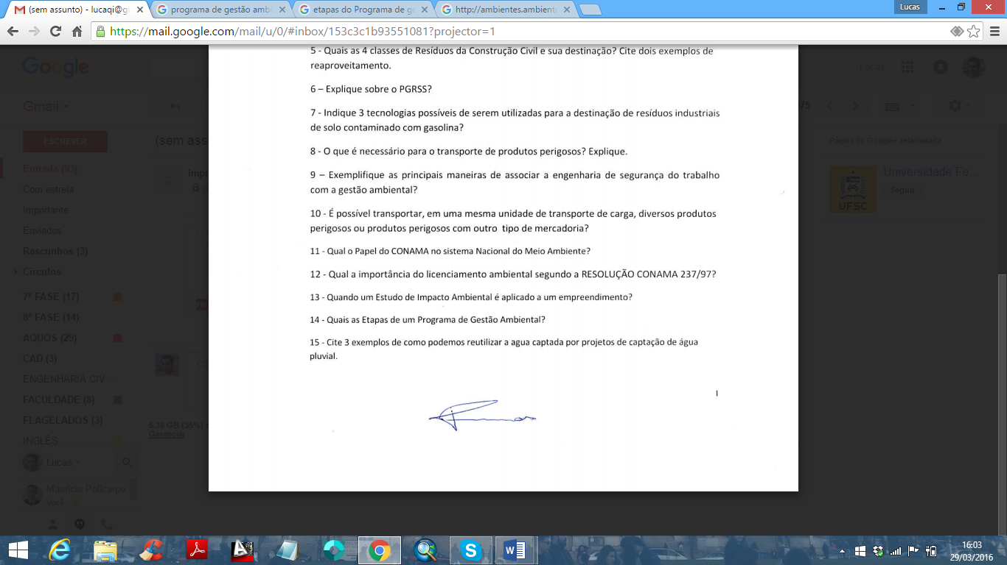

____________________________

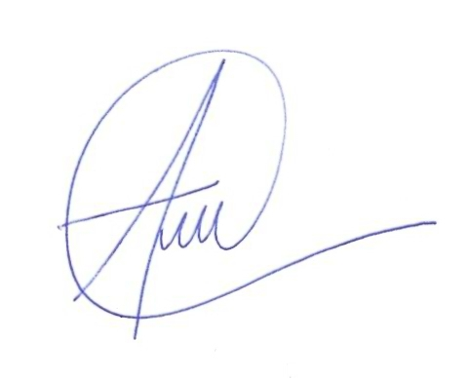**Lucas Cardoso**

**____________________________**

**Ana Carolina Figueiredo Lacerda Sakamoto**

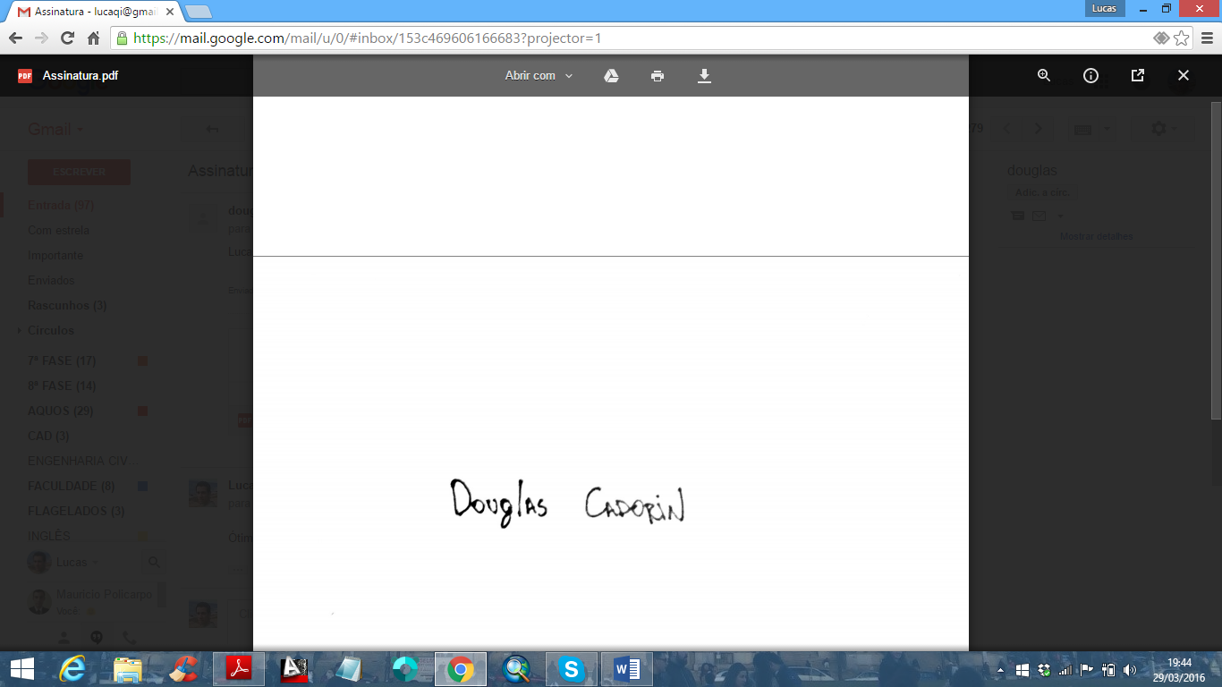

**____________________________________________**

**Douglas Ismael Cadorin**



**____________________________________________**

**Carolina Nunes Costa Bonfim**

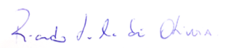

**____________________________**

**Ricardo Luís Mendes de Oliveira**

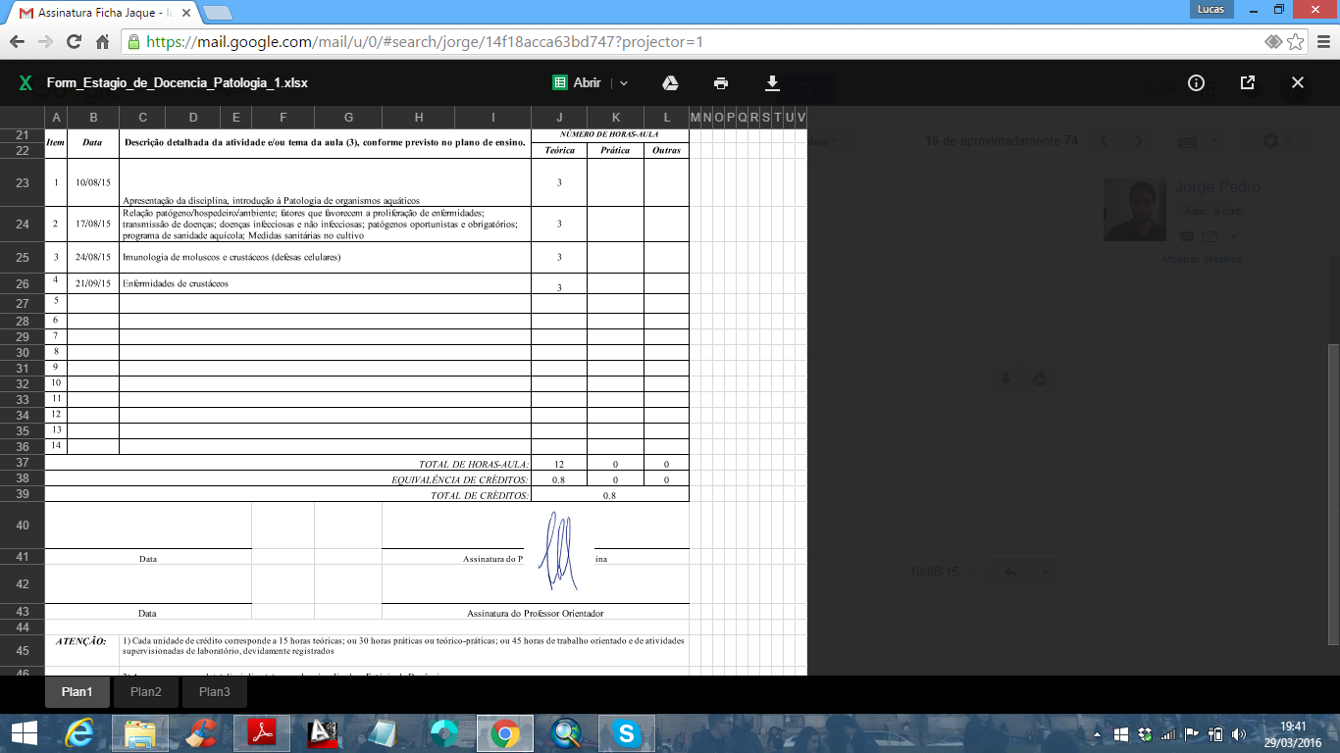

**____________________________________________**

**Mauricio Laterça Martins**