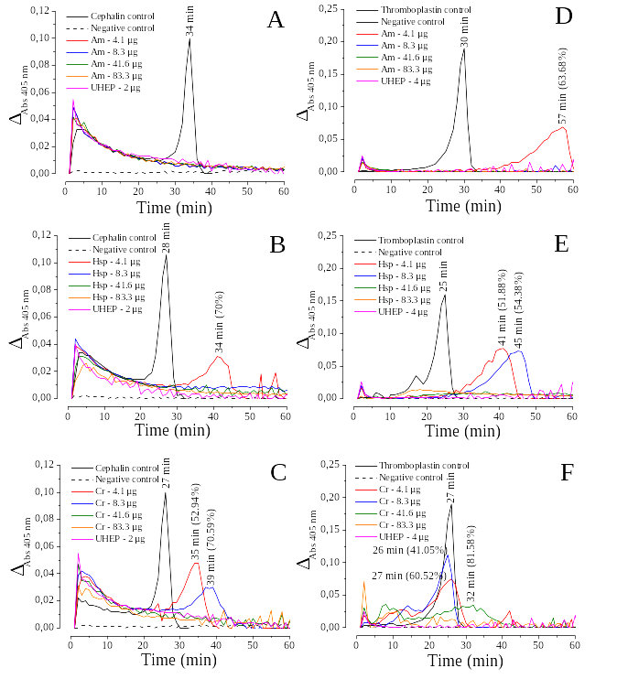

Figure 3. Effect of different concentrations of crude SPs extracts from the Rhodophyta A. muscoides (Am) (A and D) and Halymenia sp (Hsp) (B and E); and from the Chlorophyta C. racemosa (Cr) (C and F) on cephalin-activated or thrombolplastin-activated TG systems in 60-fold diluted human plasma using chromogenic method by a continuous detection system (405 nm).

