**Mammary gland morphology in the northern Amazon red squirrel (*Sciurus igniventris*)** **Short Communication**

**Running Title:**

**Mammary gland morphology in red squirrel**

**RESUMO**

*Sciurus igniventris* é um esquilo com distribuição na América do Sul. Nós examinamos uma fêmea adulta que foi doada após morte por atropelamento. O objetivo do trabalho foi descrever as características morfologicas da glândula mamária de um exemplar da espécie. O animal foi fixado utilizando solução aquosa de formoldeído a 10%. Os tecidos foram processados e lâminas foram preparadas seguindo protocolos histológicos padrões. A análise morfológica da glândula mamária revelou similaridades com o que temos descrito na literature para animais domésticos e selvagens. No entanto, foi distinguido nas características macroscópicas um par de glândulas torácicas, seguidas por três pares de glândulas abdominais e, uma característica microscópica abundante foi a presença de tecido conectivo dividindo as glândulas túbulo alveolares.

**PALAVRAS-CHAVE:** Morfologia; glândula mamária; esquilo

**SUMMARY**

*Sciurus igniventris* is a squirrel with broad distribution in South America. We examined one female adult specimen which was donated after death by trampling. The aim of this work was describe the morphological characteristics of mammary gland of one specimen. The body was fixed using 10% aqueous formaldehyde. Tissues were processed and slides prepared following standard histological protocols. Morphological analysis of the mammary glands revealed similarities to those described in the literature for domestic and wild mammals. However, there were distinguishing macroscopic features including a pair thoracic glands following by three pairs of abdominal glands, and one distinguishing microscopic character which was abundant connective tissue dividing the alveolar-tubular glands.

**KEYWORDS:** Morphology; mammary gland; squirrel.

**INTRODUCTION**

S*ciurus igniventris* (Mammalia: Rodentia) is a squirrel species in the family Sciuridae (Emmons, 1990). This species builds nests in trees that are used as resting places and shelter from inclement weather, as well as for protection against predators and provision of offspring, which require parental care from 3 to 5 years (Yahner, 1980; Carey, Wilson, Maguirre, Biswell, 1997).

Breastfeeding is performed via the mammary glands, which in females develop during the embryonic period. Mammary glands constitute a system of ducts filled with connective and adipose tissues. Each mammary gland complex contains a glandular functional body and a mammary papilla, which is an excretory system (Gurtler, Kertz Kolb, Shroder, Seidel, 1987). There are few descriptions of macro and microscopic features of squirrel mammary glands, and such knowledge is critical for an understanding of the physiological process of lactation in these animals and the perpetuation of the species. Thus, we present here a description of *Sciurus igniventris* mammary gland morphology*.*

**MATERIALS AND METHODS**

One adult, female *Sciurus igniventris* from the Municipality of Paragominas (PA - Bauxite Mine Area) was donated after death by trampling to the Animal Morphology Research Laboratory (LaPMA) at the Federal Rural University of Amazonia (UFRA). under authorization SEMA-PA N° 455/2009.

The corpse was fixed and preserved using 10% aqueous formaldehyde solution, after which thoracic mammary glands and abdominal glands were removed by incision. The glands were dehydrated and soaked in paraffin using standard histological protocols, after which tissues were sliced using a microtome (LEICA 2165) to 5µm thickness and subsequently stained with hematoxylin-eosin (HE). The histological slides were analyzed and photographed using a microscope with camera attachment (LEICA E – 400).

Tissues were prepared for Scanning Electron Microscopy (SEM) by washing in distilled water, post-fixation in osmium tetroxide 1% (OsO4) for 2 hours, and dehydration using ethanol solutions with increasing concentrations (from 50%) until reaching the critical point (QUORUM/K850). Mammary gland tissues were then mounted on aluminum base and metalized with Gold + Paladium (QUORUM/SC7620) for analsis (SEM model VEGA 3 LMU/TESCAN).

**RESULTS AND DISCUSSION**

Macroscopically, the distribution and quantity of *S. igniventris* mammary glands match the location and pair organization, i.e., on the thorax and abdomen. We found a pair of thoracic glands followed by three pairs of abdominal glands (cranial, caudal and inguinal) (Figure 1). In general, domestic carnivores have 10 mammary glands arranged in 5 pairs, which are then arranged in 2 series. The two series are divided into 2 pairs in the thoracic region (2 cranial thoracic and 2 caudal thoracic) and 3 pairs in the abdominal region (2 cranial abdominal, 2 caudal abdominal, 2 inguinal) (Ellenport, 1981). Casals et al. (2013) in a study with mammary glands of coati (*Nasua nasua*) and Bellatine et al. (2010) in a study with the "crab-eating racoon" (*Procyon cancrivorus*) both reported abdominal region glandular quantity and organization similar to that of *S. igniventris*.

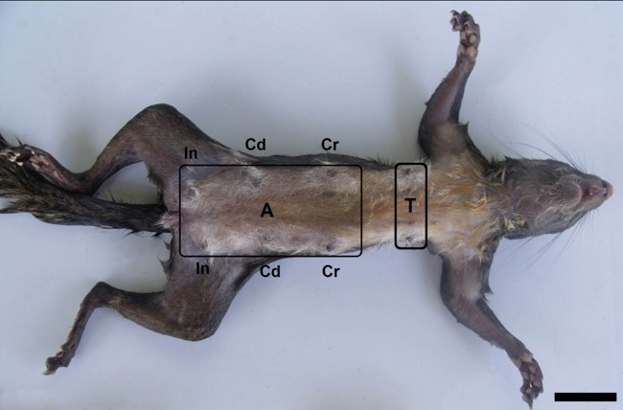

**Figure 1-** Microscope images of *Sciurus igniventris* mammary glands *in situ*. Thoracic region mammary glands (pair) (T). Abdominal region (A) with a pair of cranial (Cr), caudal (Cd) and inguinal (In) mammary glands. Scale Bar: 3cm.

Microscopic evaluation revealed layering of mammary glands, including the epidermis, dermis, muscle tissue, and more internally, a layer of connective tissue (Banks, 1992; Samoto et al., 2006; Lima et al., 2008). The same cell composition was found in domestic specimens (Banks, 1992). The epidermis had typical characteristics, being composed of keratinized, stratified, squamous epithelial tissue, covered by a layer of loose connective tissue with some visible hair follicles. Just below the epithelial tissue is a thinner layer of muscle tissue that gradually increases in thickness, giving rise to a layer of connective tissue septa between the cells of the mammary gland complex (Figure 2A), as described by Banks (1992). The same pattern was observed by Casals et al., (2013) in a study of *Nasua nasua*. The presence of sebaceous glands in the dermis at the level of the tegmentum is generally common in mammals (e.g., coati, mocó, and raccoons) (Lima et al., 2008; Bellatine et al., 2010; Casals et al., 2013). In contrast, we did not find these glands in *S. igniventris*. These glands were also absent in the rodent *Kerodon rupestres* (Lima et al., 2008). In the nipple region, the outermost layer of epithelial tissue was squamous, stratified, thicker and not pilous. Internally, microscopy revealed the presence of alveolar-tubular glands, also chambered by connective tissue and near the ducts (Figure 2 B).

Upon deeper examination we discovered muscle fibers in the periphery of the mammary gland showed variation in size, initially thinner and then thicker. According to Fanzo (2010), these constitute anatomical barriers against invading microorganisms, and act in the physical protection of the gland itself (Banks 1992; Samoto et al. 2006; Lima 2008).

In *Kerodon rupestres*, the connective tissue is intermingled with the gland, forming trabeculae in the cells (Lima, 2008). The interior of the mammary gland in *S. igniventris* is divided by connective tissue septa, and this feature is more pronounced than in *Kerodon rupestres*. This pattern of septation reported in squirrels is also found in wild animals such as the raccoon (Bellatine et al., 2010), and some domestic animals (Banks, 1992; Goana et al., 1999). However, this septation was not reported by Franzo (2010) in a study of mammary glands in ruminants and coati. Further, there have been reports in the literature that the presence or absence of this structure could influence physiology.

Histological analysis of thoracic mammary glands indicated that for females in the lactation period, cells constituents present abundant parenchyma and reduced connective tissue (Figure 2 C). Cellular patterns of mammary glands in the abdominal region indicated a period of late lactation, in which cells had a higher amount of stroma compared to parenchyma, in addition to abundant connective tissue (Figure 2 D); we have not yet found similar reports in the literature.

SEM showed epithelial follicles lining the tissue around the nipple region, followed by connective tissue that continues into the adjacent layers within a connective septum, intermingling with the glandular lobules. The longitudinal exposed in the center of the region in which are located the glandular lobules, which consist of a set of acini connective tissue covering (Figure 2E and F). Although myoepithelial cells have been described and clearly identified in SEMs of female rat (*Rattus norvegicus*) mammary glands (Wigley, 2011), we did not find these cells in *S. igniventris*.

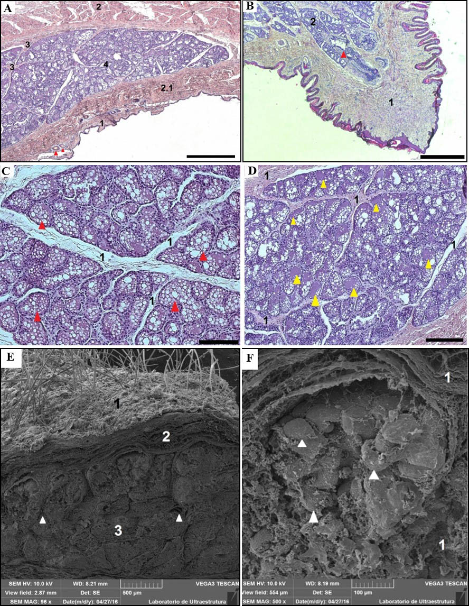

**Figure 2-** Photomicrographs of *Sciurus igniventris* mammary glands. **A:** keratinized stratified squamous epithelium (1). Layer of thick striated muscle (2). Layer of thin striated muscle (2.1). Connective tissue dividing the glands (3). The alveolar duct (4). Hair follicles (red arrows). Scale Bar: 500µm. **B:** Non-pilous, stratified squamous epithelium (1). The alveolar duct (2). Ducts (red arrow). Scale Bar: 500µm. **C:** A small quantity of connective tissue dividing the glands (1). Cells with a large quantity of parenchyma along the gland (red arrows). Scale Bar: 100µm. **D:** Large quantity of connective tissue dividing the gland (1). Cells with large quantity of stroma (yellow arrows). Scale Bar: 200µm. Color: Hematoxylin-eosin. **E and F**: Electromicrographs of *S. igniventris* mammary gland. **E:** Pilous tegument lining the outside of the gland (1). Connective tissue (2). The glandular region (3). Continuity of connective tissue dividing the glandular lobes (white arrows). Scale Bar: 500µm. **F:** Connective tissue around the glandular lobules (1). Glandular lobules with acini present along the entire structure (white arrows). Scale Bar: 100µm.

**CONCLUSION**

Mammary glands morphology in this specimen was similar to that described for other domestic and wild mammals in in terms of the numbers of layers and the general structural composition of cells. However, we highlight the distinguishing macroscopic characteristic of only one pair of glands in the thoracic region, and the presence of abundant connective tissue at the microscopic level.

**REFERENCES**

Banks, W.J. (1992). *Histologia Veterinária Aplicada*. São Paulo: Manole.

Bellatine, T., Mançanares, C., Franciolli, A. F., Ambrósio, C. E., Martins, D. S., Miglino, M. A., & Carvalho, A. F. (2010). Estudo morfofuncional das glândulas mamárias de Mão Pelada, *Procyon cancrivorus*, *Pesquisa Veterinária Brasileira,* 30, 689-695.

Carey, A. B., Wilson, T. M., Maguirre C. C., & Biswell, B. L. (1997) Dens of Northern flying squirrel in the Pacific Northwest. *Journal of Wildlife Management.* 61, 684-699.

Casals, J. B., Mançanares, C. A., Pieri, N. C. G., Miglino, M. A., Ambrósio C. E., & Carvalho, A. F. (2013). Morfologia da glândula mamária do quati (*Nasua nasua*). *Pesquisa Veterinária. Brasileira.* 33, 1371-1378.

Ellenport, C. R. (1981). Aparelho Urogenital do Carnívoro. In: R. Getty (Ed.), *Sisson/Grossman Anatomia dos Animais Domésticos.* (p.1481 - 1493). Rio de Janeiro: Interamericana.

Emmons, L. H. (1990). *Neotropical Rainforest Mammals: A Field Guide.* Chicago: University of Chicago Press.

Franzo, V. S. (2010). Aspectos Morfológicos Relacionados com o Controle da mastite. *Revista Científica Eletrônica de Medicina Veterinária*, 15, 11.

Gurtler H., Ketz Kolb, H. A., Schröder L., & Seidel, H. (1987). *Fisiologia Veterinária.* Rio de Janeiro: Guanabara Koogan.

Lima, M. C., Bonatelli, M., Oliveira, M. F., Miglino, M. A., Goiozo, P. F. I., Martins, S.M.M.K., & Carvalho, A. F. (2008). Glândula mamária do mocó (*Kerodon rupestris -*Wied Neuwied, 1820): aspectos morfológicos. *Brazilian Journal of Veterinary Research and Animal Science,* 45, 88-93.

Samoto, V.Y., Miglino, M. A., Ambrósio, C. E., Pereira, F. T. V., Lima M. C., & Carvalho, A. F. (2006). Morfologia da glândula mamária de gambás da espécie *Didelphis* sp associada ao modelo marsupial. *Biota Neotropica*. 6, 1-12.

Wigley, C. (2011) Células, tecidos e sistemas. *In:* Gray’s anatomia para estudantes. Rio de Janeiro: Elsevier.

Yahner, R. (1980). Burrow system use by red squirrel. *The American Midland Naturalist.* 103, 409-411.