RENAL ARTERY IN TUFTED CAPUCHIN MONKEY: STRUCTURE,
MORPHOMETRY AND HISTOPHISYOLOGIC CONSIDERATION

ARTÉRIA RENAL DO MACACO PREGO: ESTRUTURA,
MORFOMETRIA E MORFOFISIOLOGIA

MORFOLOGIA DA ARTÉRIA RENAL DO MACACO PREGO

RESUMO: O objetivo foi descrever a estrutura da artéria renal no macaco prego ao nível dos segmentos arteriais proximal e distal. Uma análise morfométrica foi realizada, tendo como parâmetros a espessura e a quantificação dos elementos constituintes da túnica média da parede vascular, nos dois segmentos. Foram coletadas as artérias renais de oito macacos pregos adultos para estudos histológicos dos dois segmentos, sendo o segmento proximal a parte originária da aorta abdominal e o segmento distal a parte arterial junto ao hilo renal. A quantificação de células musculares lisas e de elementos conjuntivos da matriz extracelular foi realizada em secções transversais dos dois segmentos, sendo empregadas para a túnica média as densidades de volumes (DV), dos componentes musculares e das fibras elásticas e colágenas. Tendo por base estas DV obtidas para cada segmento arterial verificou-se que o segmento proximal apresentou estrutura mioconjuntiva marcante, enquanto que o segmento distal foi caracterizado como uma artéria muscular padrão. Aparentemente, a arquitetura parietal mista do segmento proximal estaria relacionada com o controle de fluxo sanguíneo na emergência aórtica da artéria renal, garantindo um direcionamento prioritário de fluxo de plasma sanguíneo enriquecido para dentro do parênquima renal.
PALAVRAS-CHAVE: anatomia e histologia, vasos sanguineos, mamíferos.

ABSTRACT: The objective was to describe the structure of the renal artery in capuchin the level of the proximal and distal arterial segments. Morphometric analysis was performed referring to the thickness and quantification of tissue elements of the renal artery medial tunica in both the segments focused. Renal arteries of eight adult monkeys were collected and studied in the two segments characterized, being the proximal part branched from the abdominal aorta, and the distal part localized next to the renal hilus. The quantification of smooth muscle cells and connective elements was carried out in transversal sections of the two segments, employing from the medial tunica the volume densities of smooth muscle cells, collagen and elastic fibers. On the base these volume densities obtained from each segment it was verified that the proximal segment showed marked myoconnective architecture, while the distal segment was characterized as a single muscular artery. Perhaps, the mixed architecture of the proximal segment could be related to a blood flow control at the aortic emerging of the renal artery which helped to guarantee a prior flow of enriched plasma from the kidney parenchyma.
KEYWORDS: anatomy e histology, blood vessels, mammals.

INTRODUCTION

The renal artery had been mainly characterized as a typical muscular artery, similarly to the other visceral branches branched from the abdominal aorta. It was known that their distributive role of specific parts of the blood stream for the internal organs presented histophysiologic compatibility with a mural muscular architecture (MELBIN; DETWEILER, 2007; MC GRATH et al., 2005; TORTORA; GRABOWISKY, 2012).
On the medial tunica structure of the muscular arteries occurred concentric layers of smooth muscle cells assuming helical disposition (GARTNER; HIATT, 2007), being mainly intermingled by variable amounts of extracellular matrix elements, such as elastic and collagen lamellae and fibers (MC GRATH et al., 2005). The muscular arteries also presented two limiting elastic laminas, marking the inner elastic lamina the transition between the end of the medial tunic and the beginning of the loose connective adventitial tunica (GARTNER; HIATT, 2007).
Although, between the elastic and muscular arterial types (GARTNER; HIATT, 2007; TORTORA; GRABOWISKY, 2012), it was observed an intermediary arterial type whose medial tunica presented a myoconnective architecture. This building pattern was verified in the abdominal segment of aorta in some mammals (VIEGAS, ORSI, SIMÕES, DOMENICONI, e NATALI, 2004; ORSI, STEFANINI, CROCCI, SIMÕES, RIBEIRO, 2015; MELLO, ORSI, PADOVANI, MATHEUS, ELEUTÉRIO 2004; 2007), including the own tufted capuchin monkey (MELLO, ORSI, DOMINGUES, MOLINARI, ARAUJO, 2009). According to these authors in distal aortic wall a minor amount of extracellular matrix components was found, having a proportional equilibrium with the smooth muscle cells occurrence. Perhaps, it could be associated with a lesser diameter of the aorta in this distal segment (ORSI, DOMENICONI, MELLO, SPILLA, 2015).
Theoretically, other visceral distributive arteries could be formed by an intermediary mural building, but seemed to be affirmative for these vessels a muscular composition at the medial layer, as was previous described. However, concerning the renal artery architecture had a motivation to analysis this vessel in the tufted capuchin which was the aim of this study. Apparently, the capuchin monkey showed restrict geographic distribution (COSTA, LEITE, MENDES, DITCHFIELD, 2005; ALVES et al., 2007), which among other factors perhaps had been restrictive for knowledge of some anatomic characteristics in this species. Also, the terminal anatomic renal artery exerted, through the renal hemodynamic, several roles such as: dialysis of the blood; control of the body arterial pressure; ionic and water balances and other functions related with the homeostasis (MELBIN; DETWEILER, 2007; KOEPPEN; STANTON, 2009).

MATERIAL AND METHODS

The right renal artery was collected from 8 adult tufted capuchin monkeys (Cebus apella), without specific sexual distinction. The monkeys provided from the “Nucleus of Tufted Capuchin Monkeys Breeding”, localized at the UNESP Campus of Araçatuba, Sao Paulo, Brazil. The primates were euthanatized by anesthetic saturation using previously an intravenous injection of ketamine hydrochloride® (15mg/kg), followed by barbiturate salt™ (30mg/kg), injected into the peritoneal cavity.
All the monkeys suffered initially arterial perfusion with an adequate volume of neutral saline solution followed by perfusion with buffered formalin (sodium borate buffer 0.1 M, pH 9.5) at 4º C. The arterial tree perfusion occurred throughout a continuous flow in all the monkeys. Afterwards, were collected the proximal and distal segments of the right renal artery, which were destined for light microscopy studies. The proximal segment of the renal artery was characterized by fragments collected from the arterial part branched from the abdominal aorta. The arterial distal segment was represented by fragments collected from the renal artery localized next to the renal hilus.
The histological routine was followed with embedding of the arterial fragments in paraplast™, obtaining transversal and semi serial histological sections with 5 to 7 µm thickness. The slides were stained by the methods of Weigert-Van Gieson and Masson trichromes (LILLIE, 1965). Four histological sections per monkey, stained by Masson’s trichromes, were considered in all the renal arteries specimens whose data were submitted at random measurement of the thickness from the couple medial plus inner coats and counting of medial elastic lamellae. The coats thickness were established in transverse histological sections using a 10x micrometer ocular and a 20x objective under an Olympus BX 50® and also using an Image Pro Plus® software. The present research was approved by the Animal Research Ethics Committee of the Prego Monkeys Procreation Center of the Faculty of Odontology of Araçatuba - FOA 087/95.

RESULTS AND DISCUSSION

The general structure of the right renal artery of the tufted capuchin monkey presented a thin inner tunica which was separated from the larger medial tunica by a circumferential inner elastic lamina (Figures 1 and 3). At the medial tunica architecture were found smooth muscle cells mainly disposed circularly, except near the adventitial coat whose medial smooth muscle cells were arranged longitudinally (Figs. 1 to 4). Fibrous and lamellar collagen of the medial tunica was seen intermingled with the smooth muscle cells and the elastic lamellae (Figures 2 and 4). The adventitial tunica (AT) appeared close related to the medial coat architecture. AT was mainly formed by loose connective tissue with some sparse smooth muscle cells and extracellular matrix elements. They appeared scarce when the adventitial limits were more distant from the medial cot, and an outer elastic lamina surrounded the limiting border of the adventitial tunica (Figures 1 to 3). This general renal arterial architecture was similar to that described in histological texts (GARTNER; HIATT, 2007; JUNQUEIRA; CARNEIRO, 2013).

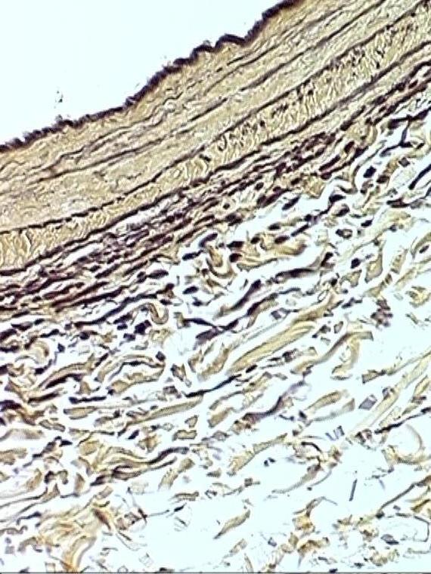  1  *  TM  TA  L | 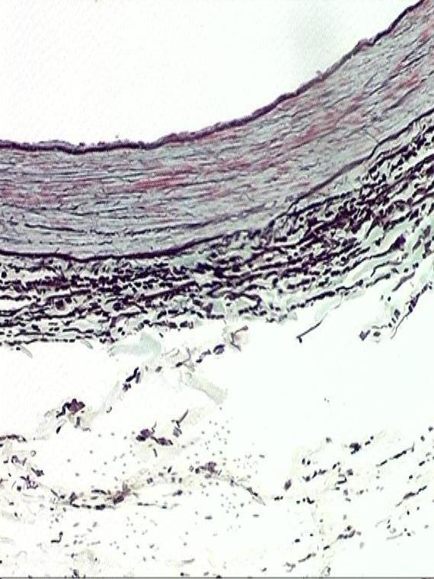  *  2  TA  TM  L
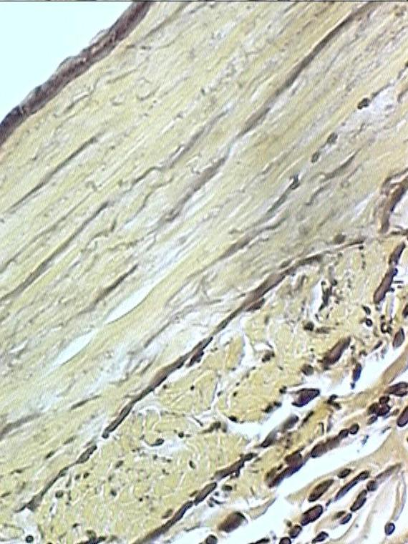  TA  3  *  TM  L | 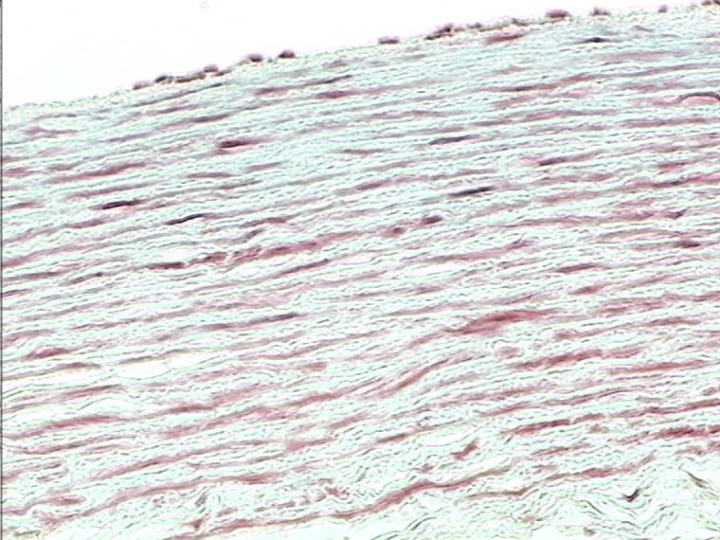  4  TMM  L
Figs 1 a 4: Architecture of the wall of the renal artery of Cebus apella monkey. 1 and 2: proximal segment (ad aortic)- (1–fucsina 100x, 2 – tricrômico de Masson 100x); 3 and 4: distal segment (ad renal hilus)- (3 –fucsina 400x, 4– tricrômico de Masson 200x). Are indicated: vascular lumen (L), tunica media (TM), tunica adventitia (TA), internal limiting elastic membrane (*), elastic lamina of the tunica media (arrow), smooth muscle fibers of the tunica media ( ∆ ), collagen fibers of the tunica media (stars).

Concerning the proper architecture of the proximal segment and distal segments of the right renal artery were verified some differences in parameters such as: number of elastic lamellae; volume density (%) of collagen elements; volume density (%) of smooth muscle cells and volume density (%) of elastic materials, showed in table 1.

Table 1: Quantitative analysis of the medial tunica of the right renal artery focused in the proximal segment (ad aortic), and in the distal segment (ad renal hilus) of the right renal artery of Cebus apella monkey.
Medial tunica components (Measures) | Segment Proximal | Segment  Distal
Number of elastic lamellae¹ | 4 a 5 | 2 a 4
Volume density (Vv%) of collagen² | 36,01 | 30,64
Volume density (Vv%) of smooth muscle²  Volume density (Vv%) of elastin² | 33,32  30,67 | 46,68  22,86
Observation: median numeric values¹, arithmetic media numeric values².

On the base the numeric values showed in the Table 1 was verified some differences between the median values of elastic lamellae presented in the proximal (ad aortic), and distal (ad hilus) segments of the right renal artery of the tufted capuchin monkey. Also, the arithmetic media from the densities of volumes verified between the smooth muscle tissue and the extracellular matrix components, formed by collagen and elastin fibers and lamellae (MC GRATH et al, 2005), showed small differences in both the segments (see Table 1).
It was verified a major number of elastic lamellae in the proximal segment whose architecture of the arterial wall showed a numeric equilibrium from densities of volumes observed for smooth muscle and extracellular matrix components (see Table 1). These observations allow classifying this ad aortic part of the right renal artery as a mixed, or myoconnective, type. This arterial pattern was somewhat similar to the abdominal aorta parietal building, as was described in some mammals (VIEGAS et al., 2004 a, b; MELLO et al., 2004; 2007; 2009; ORSI et al., 2004; 2015), obviously regarding the dimension and extension of the each vessel.
Also, in terms of vascular histophysiology the ad aortic segment of the Cebus apella renal artery could be related to a blood flow control at the aortic emerging of the renal artery. Similarly to a small functional “valve”, main formed at the medial tunica level, it guarantees a prior flow of enriched plasma from the kidney parenchyma. It is a fundamental role in terms of the renal circulation dynamic, and had support in a physiological text (MELBIN; DTEWEILLER 2007), referring on the presence of a preferential enriched blood plasma flow destined from the abdominal aorta to the renal parenchyma. This plasmatic flow was made by the renal artery (YOUNG, LOWE, STEVENS, HEATH,2007
Another ended consideration could be made from the muscular structure of the distal (ad renal hilus), of the right renal artery, whose medial coat composition presented marked smooth muscle density of volume (Vv = 46.68%, see Table 1). The general building of the distal segment wall presented some similarity to that observed in the left vertebral artery of the dog. The distributive role of part of the blood stream to the neural system throughout the vertebral artery was discussed (ORSI et al., 2015). Theoretically, the distal segment of the right renal artery, being a muscular distributive vessel, assured the continuous plasmatic inflow to the renal parenchyma supporting the hemodynamic base for the renal dialysis, and other renal functional roles.

CONCLUSION

Based on the volume of densities volume densities obtained from each segment it was verified that the proximal segment showed marked myoconnective architecture, while the distal segment was characterized as a single muscular artery. Perhaps, the mixed architecture of the proximal segment could be related to a blood flow control at the aortic emerging of the renal artery which helped to guarantee a prior flow of enriched plasma from the kidney parenchyma.

Acknowledgment: The authors thank very much the professor Dr. Rogerio Leone Buchain for assured the ethical procedure to utilize the tufted capuchin monkeys.

REFERENCES

Alves F. R., Costa F. B., Arouche M. M. S., Barros A. C. E., Miglino, M. A., Vulcano, L. C., & Guerra, P. C. (2007). Avaliação ultra-sonográfica do sistema urinário, fígado e útero do macaco-prego (Cebus apella). Pesquisa Veterinária Brasileira, 27(9), 377-382.

Costa, L. P., Leite, Y. L. R., Mendes, S. L. & Ditchfield, A. D. (2005). Conservação de mamíferos no Brasil. Megadiversidade, 1(1), 103-12.

Gartner, L. P., & Hiatt, J. L. (2007). Tratado de histologia em cores. (576 p). Rio de Janeiro, Guanabara Koogan.

Junqueira, L. C. U., & Carneiro, J. (2013). Histologia básica. (556 p). Rio de Janeiro,
Guanabara Koogan.

Koeppen, B. M; & Stanton, B. A. (2009). Berne & Levy Fisiologia. (844 p). São Paulo, Elsevier.

Lillie, R. D. (1965). Histopathologic technic and practical histochemistry. (715 p). New York, McGraw-Hill.

Mc Grath, J.C.; Deighan, C.; Briones, A.M.; Shafaroudi, M.M.; Mcbride, M.; Adler, J.; Arribas, S.M.; Vila, E.; & Daly, C.J. (2005). New aspects of vascular remodeling: the involvement of all vascular cell types. Experimental Physiology, 90 (4), 469-475.

Melbin, J.; & Detweiler, D. K. (2007). Sistema cardiovascular e fluxo sanguíneo. In: Swenson, M. J.; Reece, W. Dukes: Fisiologia dos animais domésticos. (p. 57-80). Rio de Janeiro, Guanabara Koogan.

Mello, J., Orsi, A., Domingues, R., Molinari, S. L., & Araujo, A. (2009). Arquitetura da parede vascular de segmentos torácico e abdominais da aorta de macaco prego (Cebus apella). Brazilian Journal of Veterinary Research and Animal Science, 46(1), 40-47.

Mello, J. M.; Orsi, A. M.; Padovani, C. R.; Matheus, S. M. M.; Eleutério, M. L. (2004). Structure of the aortic wall in the guinea pig and rat. Brazilian Journal of Morphological Sciences , 21(1), 35-38.

Mello, J. M.; Torrejais, M. M.; Matheus, S. M. M.; Domeniconi, R. F.; Simões, K.; & Orsi, A. M. (2007). Características ultra-estruturais do segmento abdominal da aorta de rato albino. Acta Scientiarum. Biological Sciences, 29 (4), 343-348.

Orsi, A. M. Stefanini, M. A.; Crocci, A. J.; Simões, K.; & Ribeiro, A. A. C. M. (2004). Some segmental features on the structure of the aortic wall of the dog. Anatomia, Histologia, Embryologia, 33 (3), 131-134.

Orsi, A. M; Domeniconi, R. F; Mello, J. M.; & Spilla, C. S. G. (2015). Structure and histophysiological considerations on the arterial wall of the dog. International Journal of Morphology, 33(3), 883-887.

Tortora, G. J.; & Grabowsky, S. R. (2012). Corpo humano: fundamentos de anatomia e fisiologia. (574 p). São Paulo, Artmed.

Viegas, K. A. S., Orsi, A. M., Simões, K., & Crocci, A. J. (2004 b). Histoarquitetura das artérias subclávia e vertebral esquerdas no cão (Canis familiaris). Bioscience Journal, 20 (2), 163-169.

Viegas, K. A. S.; Orsi, A. M.; Simões, K.; Domeniconi, R. F., & Natali, M. R. M. (2004 a). Características estruturais da parede das artérias renal e femoral de coelhos (Oryctolagus cuniculus). Acta Scientiarum. Biological Sciences 26 (2), 227-234.

Young, B., Lowe, J. S., Stevens, A., & Heath, J. W. (2007). Wheater histologia funcional. (448 p). Rio de Janeiro, Elsevier.

