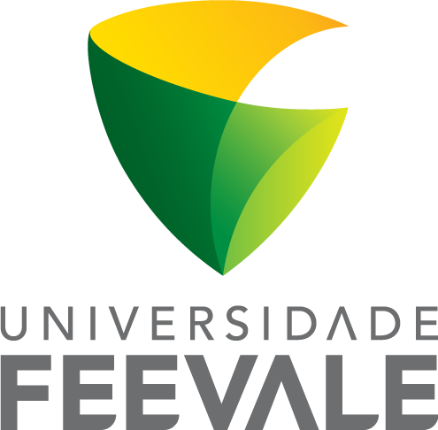
Universidade Feevale
Novo Hamburgo, RS, Brazil
July 17th, 2018
Dr.,

Editor-in-Chief
Acta Scientiarum Health Sciences

Dear Dr. ,

The aim of this letter is to submit the manuscript entitled “Effects of bovine enterovirus and streptozotocin-induced diabetes on liver and kidney pyruvate kinase activity in an animal model” to publication in Toxicology Reports.
This manuscript presents an original work regarding the effects of induced-diabetes and ingestion of contaminated water with bovine enterovirus on the liver and kidney pyruvate kinase activity in rats. This work is important since there are conflicting data in the literature related to the role of these enzymes in diabetes. In addition, several studies have suggested the involvement of enteroviral infections in triggering type 1 diabetes. Nonetheless, this association is mostly demonstrated in studies using genetically susceptible rats receiving and intraperitoneal infection of enterovirus, not comprising the way which the infection occurs in humans – oral route.
Therefore, the present manuscript aimed to investigate the effects of exposure to enterovirus (oral route) in non-susceptible rats on biochemical parameters and enzymatic activities to better understand the mechanism involved in the type 1 diabetes development.

Please, do not hesitate to contact me, in case you have any questions.

Kind regards,
Dr. Thaís Dalzochio
E-mail: tdalzochio@gmail.com

