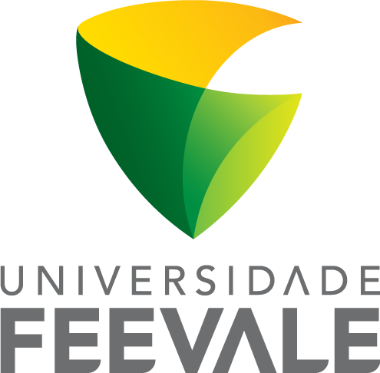
Universidade Feevale
Novo Hamburgo, RS, Brazil
July 18th, 2018

DECLARATION OF IMPORTANCE

This manuscript presents an original work regarding the effects of induced-diabetes and ingestion of contaminated water with bovine enterovirus on the liver and kidney pyruvate kinase activity in rats. This work is important since there are conflicting data in the literature related to the role of these enzymes in diabetes. In addition, several studies have suggested the involvement of enteroviral infections in triggering type 1 diabetes. Nonetheless, this association is mostly demonstrated in studies using genetically susceptible rats receiving and intraperitoneal infection of enterovirus, not comprising the way which the infection occurs in humans – oral route. Therefore, we investigated the effects of exposure to enterovirus (oral route) in non-susceptible rats on biochemical parameters and enzymatic activities.

