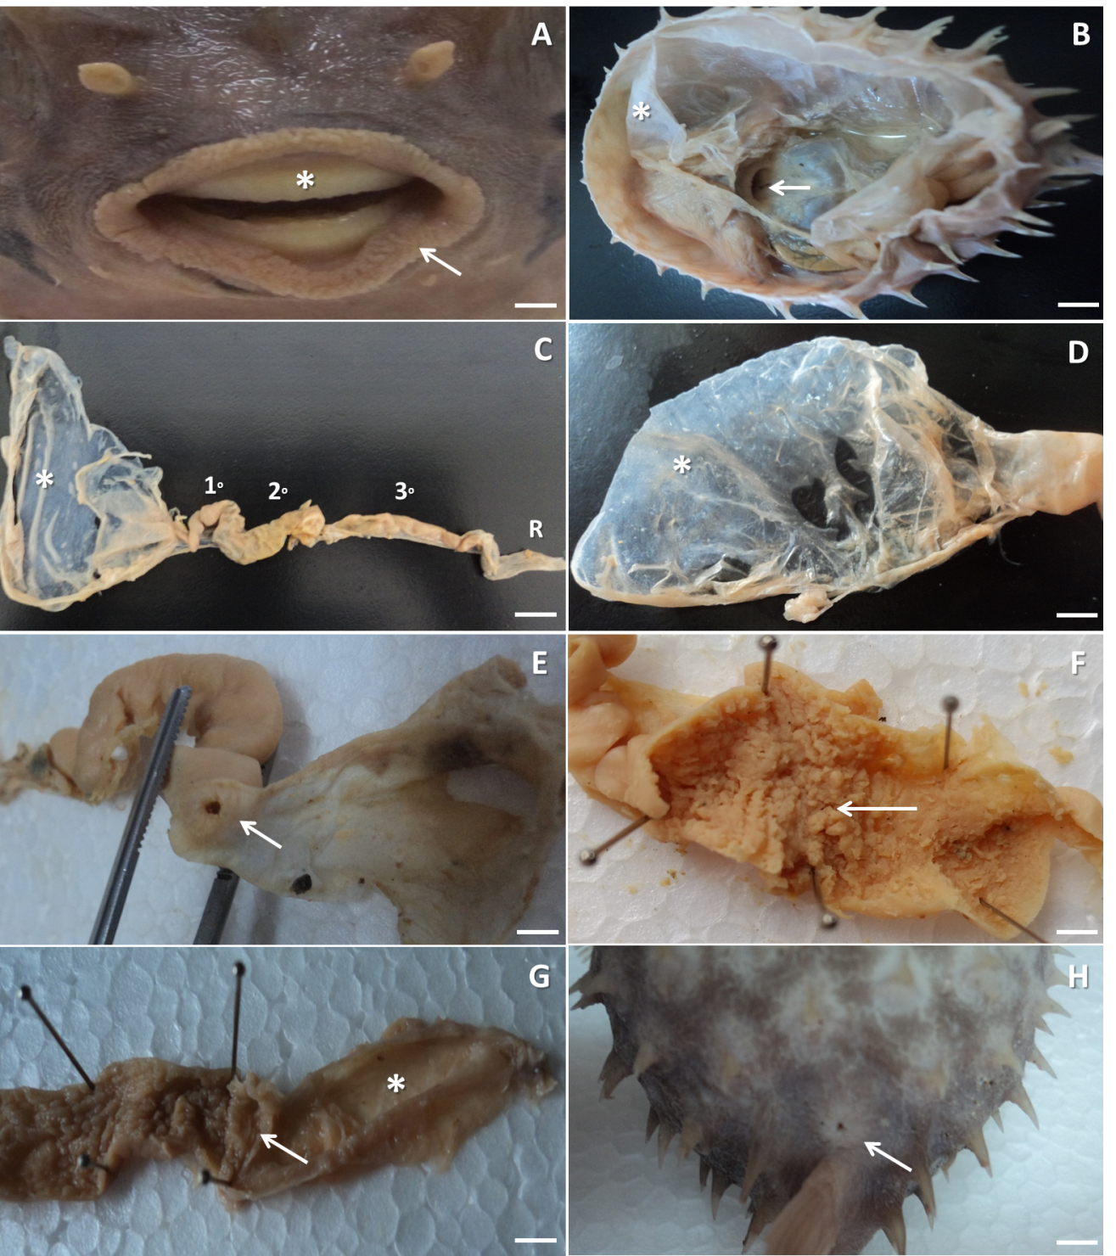

FIGURE 1: Photographs of the anatomical structures present in the digestive system of the pufferfish (Chilomycterus spinosus spinosus). (A) oral vestibule with the presence of papillae on the lips (arrow) and teeth in the form of plaques (asterisk). (B) ventral view of the digestive system, evidencing the arrangement of the abdominal pouch in the peritoneal cavity (asterisk) and the distal portion of the esophagus (arrow). (C) segments of the digestive system, showing the abdominal pouch (asterisks), intestinal loops (1ₒ, 2ₒ and 3ₒ) and rectum (r). (D) abdominal pouch showing the absence of gastric folds in the mucosa (asterisk). (E) details of the pyloric sphincter (arrow), responsible for separating the abdominal pouch from the midgut. (F) details of the first midgut loop demonstrating the large amount of villi (arrow). (G) ileorectal valve (arrow) that separates the last portion of the midgut from the rectum (asterisk). (H) ventral view showing the anal orifice (arrow). Bar scale = 100 μM.