Thermal Structure of the Poraquê Lake, Central Amazonian - Brazil

Short title: Thermal Structure in Central Amazonian lake

Fabio M. Aprile

Laboratório Max Planck, Instituto Nacional de Pesquisas da Amazônia – INPA, Brazil
*Correspondence to F. M. Aprile - Rua Doralice P. Teixeira 48 # 05417-070 Brazil. E-mail address:aprilefm@hotmail.com

ABSTRACT. Thermal gradient of a Central Amazonian Lake was studied to establish a link between seasonal variations in the water level, temperature, suspended particulate matter (SPM) and thermal stratification. Bimonthly measurements of temperature and PAR radiation were made at 0.25 m intervals from the surface to bottom from February 2004 to July 2006. Daily occurs full vertical mixing of the water column, and classic thermal stratification was not observed in the period. The effect of the winds associated to flood-pulse and the penetrative convection, transported the turbulent kinetic energy (TKE) into the lake mixing the column of water. This phenomenon was more expressive in the rainfall seasons when is generally higher contributing to the circulation of the water. The limit of the euphotic zone ranged from 1.36 to 1.77 m in the period studied. The results of the transmission curves for the sampling sites showed that, in general, less than 0.01% of the surface light reached the bottom. The trend curve developed will can facilitate the understanding of the limnological and ecological processes in lentic systems of whitewaters of the Central Amazonian.
Key words: stratification, vertical mixing, hydrological cycle, TKE, tropical lake, Amazon floodplain.

RESUMO. Estrutura térmica do lago Poraquê, Amazônia Central - Brasil. Foi estudado o gradiente térmico de um lago da Amazônia Central para estabelecer uma associação entre variações sazonais no nível de água, temperatura, material em suspensão e estratificação térmica. Foram feitas medidas bimestrais de temperatura e radiação luminosa da superfície ao fundo do lago no período entre fevereiro de 2004 e julho de 2006. Ocorreu completa mistura vertical diária da coluna de água, não sendo observada estratificação térmica clássica no período. A energia cinética turbulenta (ECT) proveniente da ação dos ventos em associação com o pulso de inundação foi responsável pela mistura da coluna de água. Esse fenômeno foi mais expressivo no período chuvoso, quando a ECT é geralmente mais alta, contribuindo para a circulação da água. A extensão da zona eufótica variou de 1,36 a 1,77 m. Os resultados das curvas de transmissão para os pontos de amostragem mostraram que menos de 0.01% da luz de superfície alcançou o fundo do lago. A curva de tendência desenvolvida poderá facilitar a compreensão dos processos limnológicos e ecológicos em sistemas lênticos de águas brancas da Amazônia Central.
Palavras-chave: Estratificação, mistura vertical, ciclo hidrológico, energia cinética turbulenta, lago tropical, planície de inundação.

INTRODUCTION
Solar radiation is important to the aquatic ecosystems for several reasons as to provide the energy necessary for aquatic currents and wind-driven waves; furthermore, is responsible by the conversion of some of that energy into heat helps form the thin layer of warm water near the surface that supports the majority of aquatic life. Most significantly, the transmission of light in water column is essential to the productivity of the lakes, ponds, and reservoirs. According to Margalef (1986), light transmission is a key factor in the ecology of lakes and streams, and all life in an aquatic ecosystem is ultimately dependent upon the light and the process of photosynthesis that it initiates.
Thermal gradients are the result of the differential heating and cooling of the water column caused in great part by the attenuation of light solar radiation in water column, and by the inflows/outflows of tributaries. In whitewaters lakes at the Amazonian, the light attenuation is due to dispersion and/or absorption of solar radiation while it goes by through the water column, and is directly associated with the concentration of suspended material, mainly clay particles. Thermal stratification of the water column is a seasonal phenomenon in deep lakes and reservoirs (Margalef, 1986; Wetzel, 1993). However, in shallow lakes the thermal stratification is most often a diel process (Ganf, 1974; Idso and Foster, 1974; Young, 1975; Kersting, 1983; Lewis, 1983). It is directly related with hydrological and hydrobiological aspects including morphometric characteristics (Kling, 1988); wind-induced turbulence, convective mixing, and mixing due to inflows/outflows (Imboden and Wuest, 1995; Martin and McCutcheon, 1999); meteorological and climatic factors (Imberger, 1985; Imboden and Wuest, 1995); and concentration of phytoplankton and/or suspended material.
The thermal gradient of the Poraquê Lake has been studied in the hydrological cycle from February 2004 to July 2006, and a thermal trend curve to the whitewaters lake was developed based on heat energy balance, vertical thermal variations (ΔT), and weather conditions. The aim of this paper was to establish a link between seasonal variations in water level, solar radiation (obtained light - L_{obt} and calculated light - L_{calc}), suspended particulate matter concentration (SPM), and thermal stratification in the lake. The results can contribute for a better understanding of the functioning of tropical lakes, as well as to possibility new discussions on the dogma stating that small tropical/equatorial lakes are polimitic lakes.

MATERIAL AND METHODS
Study area
Solimões River basin has great importance for oil and natural gas Brazil production and transport. Oil produced at Urucu region, the major terrestrial petroliferous province of the country, is transported from Petrobrás Solimões Terminal – TESOL through the Solimões River to Manaus city. Poraquê Lake (03º57’S and 63º10’W) is located 18.5 km away from Coari City and 2.5 km upstream at the TESOL (see Figure 1). The lake is situated in the flooded forest at the Solimões River basin, and is formed by various “igarapés-of-forests” (igarapé or creek = a narrow and natural channel smaller than a river connecting the flooded forest with a river or lake) and connected with Solimões River by “paranás” (paraná or armlet = channel connecting two rivers or a river and lake).
In the morphologic aspect, Poraquê Lake is a small and shallow lake of whitewaters and shape elongate, an area of approximately 230 thousand m² and annual average depth of 2.5 m at the central site (P2). It is a young lake of quaternary origin (Sioli, 1984), with processes and materials associated to transport and deposition by running water.
The paranás and igarapés both have a very important participation in the hydrological processes in the Amazon floodplain or “várzea” controlling the ictiofauna (Junk et al., 1989, 1997). The floodplains extension associated to the Amazon River is expected to alter the transport of water from upland watersheds through river systems to the sea (Junk et al., 1989). During the rising water stage, river floodwaters temporarily fill wetlands connected to the paraná of the river, inundating an immense area for the whole basin (Junk, 1982). The seasonality is very evident in the region, with strong spatial and temporal variations of the level water in the lake. Amazon lakes are strongly influenced by periodic supplying of organic matter (Darwich, 1995) of dissolved and particulate forms from rivers and paranás. This supply is responsible by deposition of nutrients in surface sediments of the lake. According to Köppen classification, the climate is equatorial hot and wet.

Methodological proceeding
Temperature was measured bimonthly at 0.25 m intervals from the surface to bottom in three sampling sites of the lake (Figure 1) with a WTW OXI-197 thermistor electrode of accuracy ± 0.1 ºC, from February 2004 through July 2006. PAR radiation measurements were made with a Quantum Radiometer LI-COR Li-250 and sensor sub-aquatic LI-COR Li-192SA in the water column. The data were reported as means ± SD, and the results were utilized to calculate the transparency (Z_{ds}), euphotic zone (Z_{eu}) and attenuation coefficient (K).
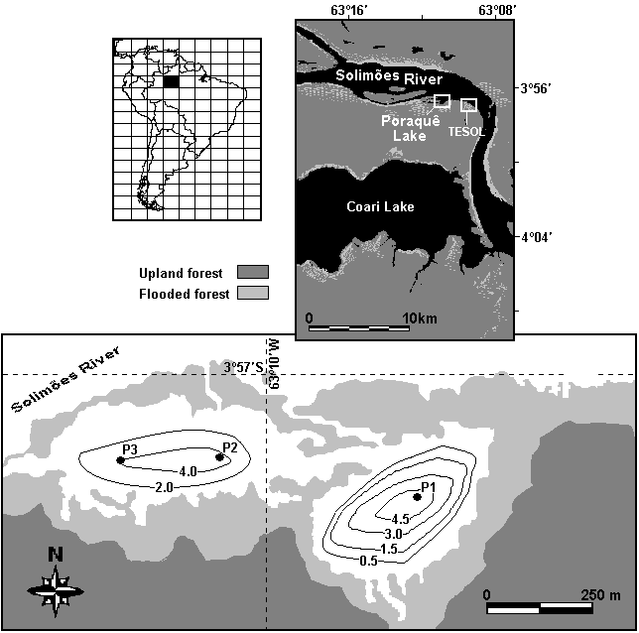
Figure 1. Location of the Poraquê Lake with the sampling sites in the floodplain.

Wind speed (U_{w} m.s⁻¹) dates were obtained in Petrobrás TESOL 2.5 km downstream at the Poraquê Lake. Water level dates were obtained from a weather station of the Petrobrás located at the Urucu River basin and in the meteorological databank at the Manaus Harbor between 1990-2006. The vertical thermal variations (ΔT) were studied for the hydrological cycle (flood, flood-crest or high water, low water, and dry) in association with morphometric and hydrological dates. Density of water (D_{z}) due to temperature (T) was calculated according to Martin and McCutcheon (1999) for each 1 m depth at each sampling period:
$D_{z} = \left[1− \frac{T+\text{288}\text{.}\text{9414}}{\text{508929}\text{.}2 (T+\text{68}\text{.}\text{12963})}(T−3\text{.}\text{9863})^{2}\right]$ Were, D_{z} is density of water in a depth (g.cm⁻³).
A correlation analyzes between temperature and PAR radiation has been made in order to express the temperature association with the seasonality in the region. Obtained light (L_{obt}) was determined directly with the Quantum Radiometer in the water column, as long as the calculated light (L_{calc}) profiles were obtained applying the fundamental decay of the solar radiation - the Lambert-Beer Law (Stefan et al., 1983; Cathcart, 1987):
$I_{z}= I_{0} \text{.} e^{−\text{kz}}$ Were, I_{o} (μE.m⁻².s⁻¹) is the light radiation in the air near the surface water; K is the attenuation coefficient and Z is the depth.
Suspended particulate matter concentration (SPM) was determined by gravimetric method with vacuum pump. All determinations followed methodological procedures described in the literature (Wetzel and Likens, 2000). Based on the thermal and light profiles, differential equations were calculated, and a thermal trend to the shallow whitewaters lake was developed.

RESULTS AND DISCUSSION
Thermal gradient
The warmer of the water layers in the lake cause a typical condition of structure of whitewaters lakes, which is presented in the Figure 2. The thermal profile of the hydrological cycle is represented with the respective standard deviations. The water temperature in the flood period (between February and March) ranged from 27.6 to 28.3 ºC (average 28.0 ± 0.49 ºC) at the surface layers, and keeping on 26.0 ºC at the bottom. Temperature levels in the flood-crest (June-July) ranged from 26.3 to 27.5 ºC (average 26.9 ± 0.85 ºC) in the surface, and ranged from 25.2 to 25.6 ºC (average 25.4 ± 0.28 ºC) between 4 and 6 meters. The higher variations of the temperature were found in this period, with a maximum difference between surface and bottom at 2.3 ºC. During September to October, in the low water period, the water temperature ranged of 27.7 - 27.9 ºC (average 27.8 ± 0.14 ºC) in the surface, and stayed stable in 26.1 ºC at the bottom. The water temperature in the dry period (November – December) ranged from 28.6 to 28.8 ºC (average 28.7 ± 0.14 ºC) in the surface, and ranged of 27.7 - 27.8 ºC (average 27.8 ± 0.07 ºC) at the bottom (Figure 2). Pearson correlation was determined to the temperature and PAR radiation profiles with base on 76 samples and 3 sampling sites, and significance at p < 0.004. Temperature correlation was mean to high for obtained light (L_{obt} r² = 0.7607) and for calculated light (L_{calc} r² = 0.7228) profiles. The stronger correlation between L_{obt} and L_{calc} profiles (r² = 0.9868 to p < 0.0001) showed a confidence in the calculated data. The difference of temperature between surface and bottom never exceed 2.3 ºC in all study period, including the flood-peak phase when is winter in the South Hemisphere, and rainfall period in Amazonian. A mean profile to the temperature was as given in Figure 4A. Weak thermal stratification in the flood period was observed but it was not observed in the other periods. Stratification presented in Figure 2, with more than 2ºC in 4 meters, should have important consequences for the vertical heat and mass exchange in the lake. However, this is not a typical permanent thermal stratification, and daily occurred complete vertical mixing of the water column. In fact, shallow tropical lakes of whitewaters are permanently heated by a diffuse radiation that occurs very slowly due to the high concentration of suspended matter from geological processes.
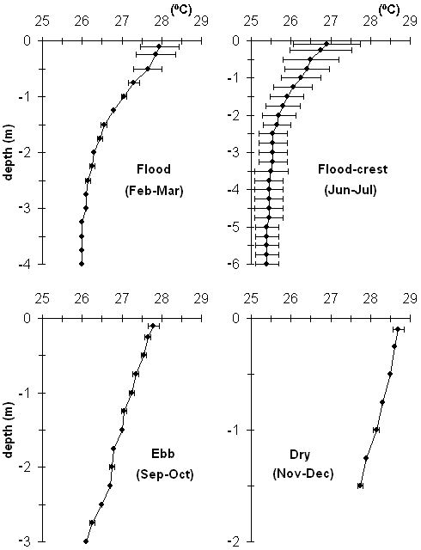
Figure 2. Temperature profiles for the hydrological cycle February 2004 – July 2006.

Turbulent kinetic energy (TKE) from action of winds and of the flood-pulse mixes the masses of water homogenizes the temperature, and this process occurs in almost whole lake. When thermal stratification is weak or inputs of TKE are high, sufficient work is available to overcome the buoyant forces due to stratification and mix the water column. During periods of stronger stratification when natural mechanics are not able to mix completely the water column, the lower portion of the water column becomes isolated from the atmosphere and gradients in the biological and chemical properties can develop (Wetzel, 2001). TKE at the water surface in consequence of the wind friction and penetrative convection creates a well-mixed surface layer whose depth is determined by the balance between this TKE and the variation in potential energy of the well-mixed layer. The lake shape (bathymetric conditions) associated with its position favorable to the action of the winds, and the high concentrations of the rainfall contributed to the circulation/perturbation of the water and high turbulent kinetic energy (TKE). Precipitation in the Poraquê Lake and surrounding areas (mean annual of 2600 mm.y⁻¹) is irregularly distributed throughout the year, with winter storms associated to strong winds. According to meteorological databank, the wind speed changes in average between 3 ± 1 m.s⁻¹ in the dry and 15 ± 5 m.s⁻¹ in the flood periods. However, eventually was observed strong river breeze associated with intense rainfall in the flood periods. The large standard deviations in the average wind speeds arise from the pronounced diurnal variation in wind speeds that are close to 0 m.s⁻¹ in the early morning hours and climax in the afternoon, generally between 1 and 3 PM. Changes in water supply in Amazon floodplain occur over diverse time scales, associated with daily and seasonal variations precipitation. The water level lake is associated with flood-pulse at the Solimões River, and its flood-peak occurs between June and July with 6.2 m, and maximum dry between December and January with 0.5 m (both at the P2 site). Water level obtained to Solimões River from July 1990 to July 2006, near Coari City, showed a variation of more than 14 meters between flood and dry periods (Figure 3). According to Imberger (1985), meteorological factors play a dominant role in lake mixing processes and thermal stratification. Therefore, in future researches are decisive to have meteorological data, if possible hourly, for wind speed comparing meteorological conditions in the study area.

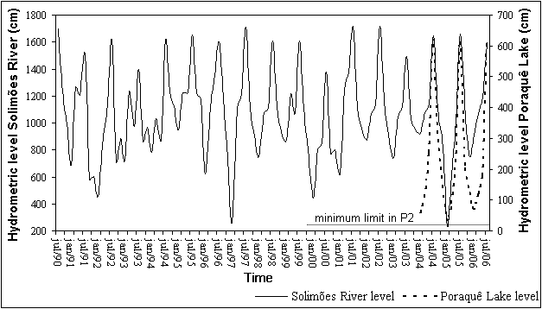
Figure 3. Hydrometric level for Poraquê Lake and Solimões River near Coari City during July 1990 and July 2006.

The absence of a significant different in thermal gradient to indicate that there is not a typical stratification, common in lakes of black-waters of the Amazonian (Rai and Hill, 1981; Darwich et al., 2005). Therefore, the water temperature in the hypolimnion is higher in whitewaters lakes than that in black-water lakes. Studies have been suggested that many shallow tropical lakes stratify and mix on a daily basis (Lewis, 1983; Lampert and Sommer, 1997). However, in the Amazon region stratification and mixing events in floodplain lakes vary throughout the year mostly because of the seasonal changes in depth and lake morphology (MacIntyre and Melack, 1984). The depth and area of the lakes change according to the flood-pulse of the main rivers (Melack, 1984; Lesack and Melack, 1995; Junk et al., 1997). The thermal structure is an important parameter to identify the degree of eutrophication and its effects in a lake (Chandler, 1942; Henry, 1999; Wetzel and Likens, 2000; Wetzel, 2001).
The transition between flood and flood-crest periods showed higher transparency (Table 1). The limit of the euphotic zone ranged from 1.36 to 1.77 m (average 1.55 m) in the study period. The compensation level that usually occurs at the depth of Z_{1%} light penetration and forms the lower boundary of the Zone of Net Metabolic Production (ZNMP) was more pronounced between flood and flood-crest periods. The most of the bottom receives relatively a very low percentage of the light that reaches the surface. The results of the transmission curves for the three sampling sites (see Figure 1) show that less than 0.01% of the surface light reached the bottom, exception to the dry period when the lake is shallow. These results approach a typical exponential curve (see Figure 4B), what means that the water was optically heterogeneous from top to bottom. Changes in transparency may alter the depth of the euphotic zone, affecting the primary production of phytoplankton and activities of diverse organisms, including benthonic organisms (e.g. phytobenthos and zoobenthos). In fact, the distribution of the organisms in water column depends on this submarine daylight and conceivably its spectral quality (Margalef, 1986; Wetzel, 1993). Light penetration and short-wave radiation inputs to surface waters are dependent upon the transparency of water (Wetzel, 2001); changes in transparency can thus alter the heat budget and thermal properties of the water column.

Thermal trend to whitewaters lakes
Mathematical models of limnological series are used for sequential generation of physical, chemical, and biological data for simulation purposes. Mathematical models are commonly considered by contain a deterministic and a stochastic element. The deterministic element may be composed of a trend and/or a periodic component. The trend curve was recognized using polynomial regression. The periodic component may be modeled using different methods (e.g. Euler, Runge-Kutta, Milne, or Series of Fourier). In this research were used differential equations (1st and 2nd), where a number of harmonics represents the means and standard deviations of the limnological variables (temperature and PAR radiation). Based

Table 1. Variables obtained for the hydrological cycle (February 2004 – July 2006) in Poraquê Lake, Central Amazonian.
 | 2004-2005 |  |  |  | 2005-2006
 | flood | flood-crest | low water | dry | flood | flood-crest | low water | dry
Z_{ds} (m) | 0.50 | 0.65 | 0.55 | 0.50 | 0.65 | 0.60 | 0.60 | 0.50
Z_{eu} (m) | 1.36 | 1.77 | 1.50 | 1.36 | 1.77 | 1.63 | 1.63 | 1.36
K (m⁻¹) | 3.40 | 2.62 | 3.09 | 3.40 | 2.62 | 2.83 | 2.83 | 3.40
U_{w}* (m.s⁻¹) |  | 16 ± 4 |  | 4 ± 1.5 |  | 18 ± 4 |  | 3 ± 2
D₀⁺ (g.cm⁻³) | 0.99628 | 0.99657 | 0.99632 | 0.99605 | 0.99626 | 0.99656 | 0.99630 | 0.99606
D_{M}⁺ (g.cm⁻³) | 0.99673 | 0.99689 | 0.99661 |  | 0.99670 | 0.99685 | 0.99662
D_{H}⁺ (g.cm⁻³) | 0.99681 | 0.99697 | 0.99679 | 0.99633 | 0.99680 | 0.99694 | 0.99676 | 0.99632
SPM₀ (mg.l⁻¹) |  | 83 |  | 42 |  | 87 |  | 48
SPM_{H} (mg.l⁻¹) |  | 142 |  | 76 |  | 144 |  | 78
* Averages over the entire summer and winter period (2003-05); ⁺D₀ = density in the surface, D_{M} = metalimnion (2 m), and D_{H} = hypolimnion (>4 m); SPM₀ = in surface, and SPM_{H} = in hypolimnion.

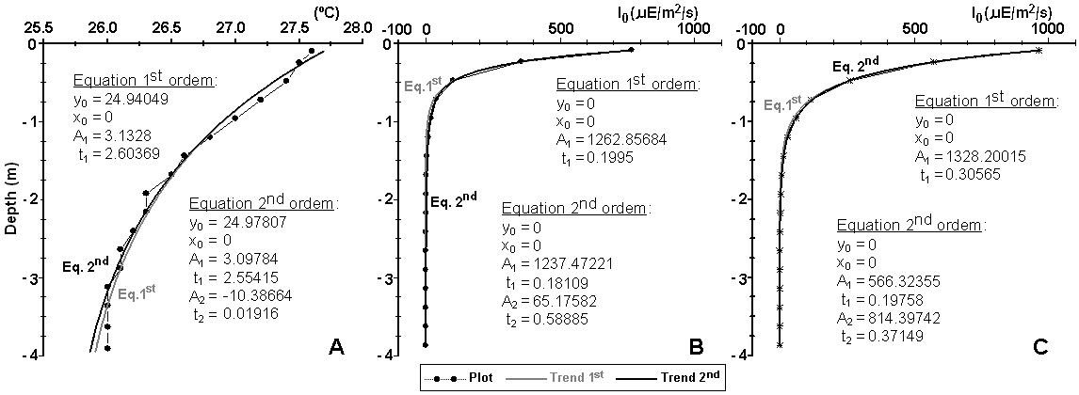
Figure 4. Mean temperature (A), light obtained (B) and light calculated (C) profiles with the respective differential equation coefficients for the hydrological cycle February 2004 – July 2006.

on the continuous observations of the natural conditions a periodic component was modeled. Results were based on the period equivalent to hydrological cycle from February 2004 to July 2006. Stochastic elements were considered dependents, because the direct relation between temperature in the water column and the seasonality. The application of mathematical equations or trends in the Amazon ecosystems is not usual yet. Lesack (1995) presented an empirical seepage model for a floodplain lake of whitewaters further up the Solimões River. This model accounts for seepage flux rates and describes the dynamics in detail. Furch (1999) developed a theoretical model for estimation of groundwater input and ionic flux to a floodplain lake in the Solimões River. Based on the light obtained (Figure 4B) and calculated (Figure 4C) profiles differential equations to the trend were developed. Thermal gradients were explained by an equation of first order and light trend was explained by an equation of second order. The condition to the validation of the light trend is that the light obtained (L_{obt}) and light calculated (L_{calc}) profiles would be equivalent (y_{obt} ≈ y_{calc}).
$$\begin{aligned} \text{Temperature}: N(z)=A \text{.} e^{k\text{.}z} \\ \text{Equation} 1\text{st} \text{order:} y = y_{0}+A_{1} \text{.} e^{−\frac{(x−x_{0})}{t_{1}}}⇒ \text{Model} \text{validated} \\ y_{\text{temp}}= \text{24}\text{.}\text{94} + 3\text{.}\text{13} e^{−\frac{x}{2\text{.}\text{60}}} \\ \\ \text{Light}: N(z)=A \text{.} e^{k\text{.}z} \\ \text{to} I_{z } =I_{0} \text{.} e^{−k\text{.}z} \text{and} y_{\text{obtained}} ≈ y_{\text{calculated}} \\ \text{Equation} 1\text{st} \text{order:} y = y_{0}+A_{1} \text{.} e^{−\frac{(x−x_{0})}{t_{1}}}⇒ \\ y_{\text{obt}}=y_{\text{calc}} ⇔ \text{1262}\text{.}\text{86} e^{−\frac{x}{0\text{.}\text{20}}} = \text{1328}\text{.}\text{20} e^{−\frac{x}{0\text{.}\text{31}}} ⇔ e^{−\frac{x}{0\text{.}\text{20}}} \text{.} e^{\frac{x}{0\text{.}\text{31}}} = e^{0\text{.}\text{05}} \\ \\ \text{Equation} 2\text{nd} \text{order:} y=y_{0}+A_{1} \text{.} e^{−\frac{(x−x_{0})}{t_{1}}} + A_{2} \text{.} e^{−\frac{(x−x_{0})}{t_{2}}}⇒ \text{Model} \text{validated} \\ y_{\text{obt}}=y_{\text{calc}} ⇔ \text{1237}\text{.}\text{47} e^{−\frac{x}{0\text{.}\text{18}}} + \text{65}\text{.}\text{18} e^{−\frac{x}{0\text{.}\text{59}}}= \text{566}\text{.}\text{32} e^{−\frac{x}{0\text{.}\text{20}}} + \text{814}\text{.}\text{40} e^{−\frac{x}{0\text{.}\text{37}}} ⇔ \\ \\ \begin{aligned}| e^{x} \left[\text{1237}\text{.}\text{47} e^{−6\text{.}6x} + \text{65}\text{.}\text{18} e^{−2\text{.}7x}− \text{566}\text{.}\text{32} e^{−6\text{.}0x} − \text{814}\text{.}\text{40} e^{−3\text{.}7x}\right]=0 \\ | \text{to} e^{x}0\end{aligned}\end{aligned}$$
Daily the radiation flux reaching the lake increases and the upper layers become warmer. The effect of the winds associated to flood-pulse and the penetrative convection, transport the TKE into the lake mixing the column of water (Figure 5). This phenomenon is more expressive in the rainfall seasons (flood-crest period) when is generally higher contributing to the circulation of the water. In shallow whitewaters lakes of the Amazonian, the mixing is almost complete, although, there are a small parcel of the lake, corresponding to the deeper zones, where the mixing is impeded. Limnological results no published about others whitewaters lakes at the Solimões River basin (e.g. Preto, Anana, Araçá, Maracá and Aruã lakes) confirm the trend of mix of the various layers of water. Studies on physical processes in association with nutritional fluxes in floodplain of whitewaters lakes at the Solimões/Amazon River basin have been described (Schmidt, 1973; Rai and Hill, 1980; Furch et al., 1983; Furch, 1984; Junk et al., 1989; Piedade et al., 1991; Furch and Junk, 1997; Cullmann et al., 2006). There is a strong correlation between the limnological/ecological processes of areas permanently inundated and of areas temporarily connected by a channel or “parana” (Figure 5). The fluvial transport and storage of nutrients and sediments within channel-floodplain systems, and oxygen distribution to the more deep layers of the lake are examples of this important connection between river and lake.
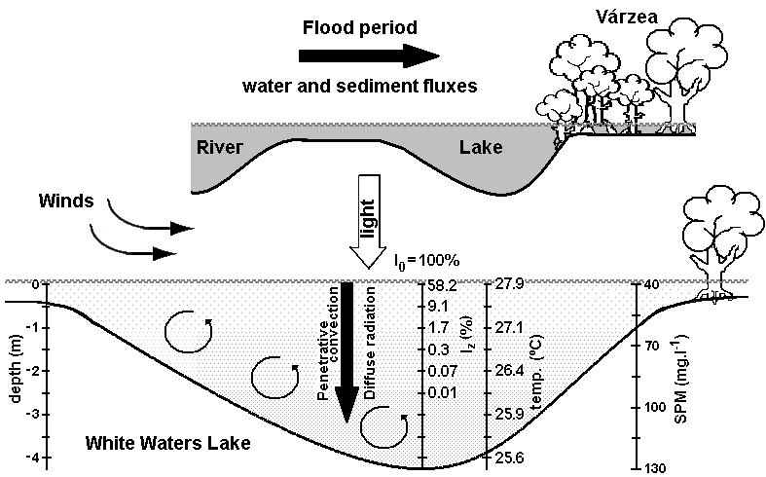
Figure 5. Light radiation and warmer trend to the Poraquê Lake (Central Amazonian).

The distribution of suspended particulate matter (SPM) is not homogeneous in the water column. In whitewaters lakes of the Amazonian, the lower layers contained higher amounts of SPM (average of 110 mg.l⁻¹) than the upper layers (average of 65 mg.l⁻¹). The concentration of suspended particulate matter in water column varies also seasonally, influenced by flood and dry periods (Table 1). These facts explain the variation of the extinction coefficient (K) in the hydrological cycle (Table 1). The K confirmed the heterogeneity in the optical quantity observed in the light profile (Figure 4B). A certain amount of incoming light is reflected away when it reaches the water surface, depending upon the state of the water itself. If it is turbulent with high TKE and many waves, more light will be reflected. The light that penetrates the surface is refracted, and once it is within the water, light may be scattered or absorbed by solid particles. Greater abundances of solid particles in the water will decrease the depth of light penetration. Therefore, water near the littoral zone that is more turbid due to particles and plants in decomposition will show a decrease in light transmission, even in shallow water. This is due to large numbers of particles brought in by the Solimões River and biological production by microorganisms, as well as waves, tides, and other water movement picking up debris on the lake floor.
The Solimões/Amazon River basin is formed by many floodplain lakes, with physical and chemical characteristics very similar to the Poraquê Lake. Thus, the understanding of thermal trend can offer valuable contribution to the ecological studies in the Solimões/Amazon River basin, in particular to lentic systems.

CONCLUSIONS
In general, classic thermal stratification was not observed in the lake during the study period. Shallow tropical lakes of whitewaters are permanently heated by a diffuse radiation that occurs very slowly due to the high concentration of suspended matter from geological processes. TKE was essential to the mixture of the water column, and this phenomenon was more expressive in the rainfall seasons. The hypolimnion of the lake was the site of intermittent mixing episodes indirectly related to external forcing (winds and inflow/outflow flux) by the oscillatory phenomena of the water. The compensation level that usually occurs at the depth of 1% light penetration and forms the lower boundary of the Zone of Net Metabolic Production was more pronounced between flood and flood-crest periods. The trend curve developed in this research can facilitate the understanding of the limnological and ecological processes in lentic systems.
The results showed can contribute to much better understanding of the limnological processes of lakes at the Central Amazonian. Furthermore, that research has also an ecological relevance because the results can be utilized in studies on abundance and distribution of fishes in whitewaters lakes in Solimões/Amazon System.

ACKNOWLEDGEMENTS
The author extends his thanks to the Dr. Assad Darwich at the INPA for valuable help with the sampling and discussion, and constructive comments from anonymous reviewer significantly improved the manuscript. This research was partially supported by the Piatam Project - UFAM and CNPq/Finep (Project numbers # 301746/1996-6 and # 505085/2004-6).

REFERENCES
CATHCART, T.P.; WHEATON, F.W. Modeling temperature distribution in freshwater ponds. Aquae. Eng., v.6, p.237-257, 1987.
CHANDLER, C.O. Limnological studies of Western lake Eric. II. Light penetration and its relation to turbidity. Ecology, v.23, n.1, p.41-52, 1942.
CULLMANN, J. et al. The impact of seepage influx on cation content of a Central Amazonian floodplain lake. J. of Hydrology, v.328, n.1-2, p.297–305, 2006.
DARWICH, A.J. et al. Limnologia do lago Tupé: dinâmica espaço-temporal do oxigênio dissolvido. In: SANTOS-SILVA, E.N. et al. (Orgs.). BioTupé: Meio Físico, Diversidade Biológica e Sociocultural do Baixo Rio Negro, Amazônia Central. INPA, Manaus, 2005. cap. 3, p.35-67.
DARWICH, A.J. Processos de decomposição de Echinochloa polystachya (H. B. K.) Hitchcock (Gramineae = Poaceae), capim semi-aquático da várzea amazônica. 1995. PhD Thesis - INPA/UA, Manaus, AM, 1995.
FURCH, K. et al. Seasonal variation in the major cation (Na, K, Mg, and Ca) content of the water of Lago Camaleão, an Amazonian floodplain-lake near Manaus, Brazil. Amazoniana, v.8, p.75–89, 1983.
FURCH, K. Evaluation of groundwater input as major source of solutes in an Amazon floodplain lake during the low water period. Stuttgart, Germany, Verh. Int. Verein. Limnol. 27, 1999.
FURCH, K. Seasonal variation of the major cation content of the varzea-lake Lago Camaleão, middle Amazon, Brazil, in 1981 and 1982. Ver. Int. Verein. Limnol., v.22, p.1288–1293, 1984.
FURCH, K.; JUNK, W.J. Physiochemical conditions in floodplains. In: JUNK, W.J. (Ed.). The Central Amazon Floodplain: Ecology of a Pulsing System. Springer-Verlag, 1997. Ecological Studies 126, p. 69-108.
GANF, G.G. Incident solar irradiance and under water light penetration as factors controlling the chorophyll content of a shallow equatorial lake (Lake George, Uganda). J. Ecol., v.62, p.593-609, 1974.
HENRY, R. Heat budgets, thermal structure and dissolved oxygen in brazilian reservoirs. In: TUNDISI, J.G.; STRASKRABA, M. (Ed.). Theoretical reservoir ecology and its applications. São Carlos. International Institute of Ecology, Backhuys Publishers e Brazilian Academy of Sciences, 1999, cap. 7, p. 125-152.
IDSO, S.H.; FOSTER J.M. Light and temperature relations in a small deserts pond as infuenced by phytoplanktonic density variations. Water Resour. Res., v.10, p.129-132, 1974.
IMBERGER, J. The diurnal mixed layer. Limnol. Oceanogr., v.30, n.4, p.737–770, 1985.
IMBODEN, D.M.; WUEST, A. Mixing mechanisms in lakes. In: LERMAN, A. et al. (Eds.). Physics and Chemistry of Lakes. Springer, Berlin, 1995. p.83–138.
JUNK, W.J. Amazonian floodplains: their ecology, present and potential use. Rev. Hydrobiol. Trop., v.15, n.4, p.285–301, 1982.
JUNK, W.J. et al. The fish. In: JUNK, W.J. (Ed.). The Central Amazon Floodplain: Ecology of a Pulsing System. Springer-Verlag, Ecological Studies 126, 1997. p.385-408.
JUNK, W.J. et al. The flood pulse concept in river–floodplain systems. In: DODGE, D.P. (Ed.). International Large River Symposium. Can. Spec. Publ. Fish. Aquat. Sci., 1989. 106, p.110–127.
KERSTING, K. Bimodal diel dissolved oxygen curves and thermal stratification in polder ditches. Hydrobiologia, v.107, p.165-168, 1983.
KLING, G.W. Comparative transparency, depth of mixing, and stability of stratification in lakes of Cameroon, West Africa. Limnol. Oceanogr., v.33, n.1, p.27–40, 1988.
LAMPERT, W.; SOMMER, U. Limnoecology: the ecology of lakes and streams. Oxford University Press, Inc. Oxford, 1997.
LESACK, L.F.W. Seepage exchange in an Amazon floodplain lake. Limnol. Oceanogr., v.40, p.598–609, 1995.
LESACK, L.F.W., MELACK, J.M. Flooding hydrology and mixture dynamics of lake water derived from multiple sources in an Amazon floodplain lake. Water Resour. Res., v.31, p. 329–345, 1995.
LEWIS, W.M.JR. A revised classification of lakes based on mixing. Canadian Journal of Fisheries and Aquatic Sciences, v.40, p.1779-1787, 1983.
MACINTYRE, S.; MELACK, J. Vertical mixing in Amazon floodplain lakes. Verh. Internat. Verein. Limnol., v.22, p.1283-1287, 1984.
MARGALEF, R. Ecologia. Ediciones Omega, Barcelona, 1986.
MARTIN, J.L.; MCCUTCHEON, S.C. Hydrodynamics and Transport for Water Quality Modeling. Lewis Publications, Boca Raton, FL, 1999.
MELACK, J.M. Amazon floodplain lakes: shape, fetch and stratification. Verh. Internat. Verein. Limnol., v.22, p.1278-1282, 1984.
PIEDADE, M.T.F. et al. The productivity of the C4 grass Echinocloa polystachia on Amazon floodplain. Ecology, v.72, p.1456–1463, 1991.
RAI, H.; HILL, G. Classification of Central Amazon lakes on the basis of their microbiological and physico-chemical characteristics. Hydrobiologia, v.72, p.85-99, 1980.
RAI, H.; HILL, G. Physical and chemical studies of lago Tupé; a Central Amazonian Black Water,, Ria Lake. Int. Revue ges. Hydrobiol., v.66, n.1, p.37-82, 1981.
SCHMIDT, G.W. Primary production of phytoplankton in the three types of Amazonian Waters. II. The limnology of a tropical flood-plain lake in Central Amazonia (Lago do Castanho). Amazoniana, v.4, n.2, p.139-203, 1973.
SIOLI, H. Introduction: History of the discovery of the Amazon and of research of Amazonian waters and landscapes. In: SIOLI, H. (Ed.). The Amazon: Limnology and Landscape Ecology of a Mighty Tropical River and its Basin. Dr. W. Junk Publishers, Dordrecht, The Netherlands, 1984. Monographiae Biologicae 56, p.1-13.
STEFAN, H.G. et al. Model of light penetration in a turbid lake. Water Resour. Res., v.19, p.109-120, 1983.
WETZEL, R.G. Limnologia. Serviço de Educação Fundação Calouste Gulbenkian. Lisboa, 1993.
WETZEL, R.G. Limnology: Lake and River Ecosystems. 3rd ed., Academic Press, San Diego, CA, 2001.
WETZEL, R.G.; LIKENS, G.E. Limnolgical analysis. W. B. Saunders Co., Philadelphia, 2000.
YOUNG, J.O. Seasonal and diurnal changes in the water temperature of a temperature pond (England) and a tropical pond (Kenya). Hydrobiologia, v.47, p.513-526, 1975.

