**The *App Amplia Mente* as a digital resource enabling the development of mathematical concepts in students with intellectual disabilities**

Adriela Maria Noronha1*, Sani de Carvalho Rutz da Silva1, Elsa Midori Shimazaki2 and Alessandra Dutra1

1Universidade Tecnológica Federal do Paraná, Rua Doutor Washington Subtil Chueire, 330, Jardim Carvalho, 84017-220, Ponta Grossa, Paraná, Brasil.  2Universidade do Oeste Paulista, Presidente Prudente, São Paulo, Brasil. *Author for correspondence. E-mail: adriela.noronha@gmail.com

**ABSTRACT.** In this article, the authors analyze the contributions and the possibilities provided by the use of an educational software, named *App Amplia Mente*, in the learning process of mathematical concepts in students with the diagnosis of intellectual disabilities (ID). The study emerged by the key question: which are the contributions of *App Amplia Mente* in the process of teaching and learning of mathematical concepts to people with ID, during distance learning? Two students with ID diagnosis who frequented the mainstream education in one period and in the other the Specialized Educational Service (SES), participated the research remotely, due to the coronavirus pandemic - Covid-19, from which the data were collected. The research is characterized as qualitative by approach of pedagogical intervention in case study, underpinned by the Historical-Cultural theory. The data records, shown here, were generated by the resolution of multiplicative situations which were made available in a first moment by the software *Amplia Mente* and restarted subsequently, with the students, synchronously during the services. The data analysis occurred through the theme category denominated: evidences of conceptual assimilation, social interactions and symbolic mediations. The results indicate that: a) The *App* *Amplia Mente* contributed so the students kept motivated to perform their tasks during the distance learning; b) The social interaction and the interventions made by the teacher were necessary for the students to advance in the process of mathematical concepts’ assimilation.

**Keywords:** educational technologies; specialized educational service; distance learning.

**O App Amplia Mente como recurso digital de apoio à formação de conceitos matemáticos em estudantes com deficiência intelectual**

**RESUMO.** Neste artigo analisam-se as contribuições e as possibilidades de utilização de um aplicativo educacional, denominado *App Amplia Mente*, no processo de aprendizagem de conceitos matemáticos em alunos com diagnóstico de deficiência intelectual (DI). O estudo surgiu da questão problematizadora: quais as contribuições do *App Amplia Mente* no processo de ensino e aprendizagem de conceitos matemáticos às pessoas com DI, durante o ensino remoto? Neste estudo participaram dois alunos com diagnóstico de DI que frequentavam o ensino regular em um período e em outro o Atendimento Educacional Especializado (AEE) de modo remoto, em função da pandemia do coronavírus - Covid-19, onde os dados foram coletados. A pesquisa caracteriza-se como qualitativa com abordagem de intervenção pedagógica em estudo de caso, fundamentada na teoria Histórico-Cultural. Os registros de dados, aqui apresentados, foram gerados a partir da resolução de situações multiplicativas, disponibilizadas num primeiro momento por meio do *App Amplia Mente* e retomadas, posteriormente, com os estudantes, de forma síncrona durante os atendimentos. A análise dos dados ocorreu mediante a categoria temática denominada: *indícios de assimilação conceitual, interações sociais e mediações simbólicas*. Como resultados, apontam-se: a) o *App Amplia Mente* contribuiu para que os estudantes continuassem motivados a realizar as tarefas durante o ensino remoto; b) a interação social e as intervenções por parte da professora se mostraram necessárias para que os estudantes avançassem no processo de assimilação dos conceitos matemáticos.

**Palavras-chave:** tecnologias educacionais; atendimento educacional especializado; ensino remoto.

**El App Amplia Mente como recurso digital para apoyar la formación de conceptos matemáticos en estudiantes con discapacidad intelectual**

**RESUMEN.** En este artículo se analiza los aportes y posibilidades del uso de un aplicativo educacional denominada *App Amplia Mente* para los procesos de aprendizaje de conceptos matemáticos en estudiantes diagnosticados con Discapacidad Intelectual (DI). El estudio surgió de la pregunta problematizadora: ¿cuáles son los aportes del *App Amplia Mente* en el proceso de enseñanza y aprendizaje de conceptos matemáticos en personas con DI durante la enseñanza a distancia? En este estudio participaron dos estudiantes con diagnóstico de DI, que asistieron a la educación regular en un período y al Servicio Educativo Especializado (AEE) de forma remota debido a la pandemia de coronavirus - Covid-19, donde se recolectaron datos. La investigación se caracteriza por ser cualitativa con enfoque de intervención pedagógica en un estudio de caso, con base en la teoría Histórico-Cultural. Los registros de datos aquí presentados fueron generados a partir de la resolución de situaciones multiplicativas, disponibles en principio a través de la aplicación *Amplia Mente* y luego retomadas de forma simultánea con los estudiantes durante los atendimientos. El análisis de datos se dio a través de la categoría temática denominada: signos de asimilación conceptual, interacciones sociales y mediaciones simbólicas. Como resultado, se señala lo siguiente: a) la aplicación *Amplia Mente* contribuyó a que los estudiantes siguieran motivados para realizar tareas durante los procesos de enseñanza a distancia; b) la interacción social y las intervenciones de la docente resultaron necesarias para que los estudiantes avanzaran en el proceso de asimilación de conceptos matemáticos.

**Palabras clave:** tecnologías educativas; servicio educativo especializado; enseñanza remota.

Received on August 13, 2021.

Accepted on December 21, 2021.

Introduction

In the educational scenario caused by the SARS-CoV-2 virus, technologies were required as valuable tools to mediate pedagogical practices. This pandemic context, which generated social isolation measures, highlighted social differences and impacts imposed on students’ teaching and learning. The social inequalities that emerged in remote education refer mainly to “[...] the differences between the conditions of access to the digital world by students and their families” (Parecer n. 05, 2020, p. 3). As barriers imposed to teaching and learning, this appreciation highlights the possible “[...] setbacks in the educational and learning process for students subjected to a long period without regular educational activities [...]” (Parecer n. 05, 2020, p. 3), such as possible school dropouts.

During the pandemic, due to the need for social isolation to avoid the spread of the virus, some services offered by the school were suspended, including the use of the library and computer rooms, the participation of students in workshops, and studies of reinforcements to learning. Other pedagogical activities were rethought to meet students’ needs. The concern with ensuring that all students acquire school knowledge is evident in this aspect. Therefore, our concern is aimed at students with disabilities who have the right to appropriate school knowledge, like any other student, at any time of the year and during the suspension of face-to-face classes, whether in regular classrooms or specialized educational service, as provided for in Parecer n. 05 (2020). Regarding this specific audience, the document “Protocolos sobre educação inclusiva durante a pandemia da Covid-19” [Protocols on inclusive education during the COVID-19 pandemic] indicates that the pandemic affects “[...] disproportionately the population with disabilities, which can be considered more vulnerable than the average of the general population” (Mendes, 2020, p. 13).

Specialized educational service (SES), which aims to supplement or complement the regular schooling of students with disabilities (Política Nacional de Educação Especial na Perspectiva da Educação Inclusiva, 2008), is support that requires continuity also remotely. Regarding the provision of SES during remote teaching, Parecer n. 05 (2020, p. 18) indicates that “[...] it must also be guaranteed during the emergency period, mobilized and guided by leading and specialized teachers, in conjunction with families to organize the non-face-to-face pedagogical activities to be carried out”. These considerations are reinforced by Parecer nº 09 (2020), indicating that pedagogical activities offered remotely would consider students of all levels, stages, and modalities as “[...] it is extended to those subjected to special teaching regimes, among which are those with high abilities/giftedness, disabilities and autism spectrum disorder (ASD), covered by the special education modality” (Parecer nº 09, 2020, p. 17).

One of the SEE teacher’s challenges is providing specialized assistance to students during the pandemic and motivating them to carry out their tasks. The period in which teaching takes place through digital resources and tools is “[...] an opportunity to rethink the ways of teaching and use the crisis as a catalyst for creativity so that it is possible to produce content and materials in different formats to serve students with disabilities [...]” (Mendes, 2020, p. 23). To motivate students with disabilities to carry out tasks and enable access to school concepts during non-face-to-face teaching, an SES teacher created an educational application called *Amplia Mente* [Expand Minds] to be used as an asynchronous digital resource by students with ID. This resource was developed from a postgraduate student’s fundamental studies during doctoral research at a postgraduate course in science and technology teaching at a public university in the southern region of Paraná[1].

Through this application, we proposed several tasks involving mathematical, reading, and writing concepts. With the app in pedagogical practice, we answered the question: How did the *Amplia Mente* contribute to the teaching and learning process of mathematical concepts with people with intellectual disabilities during remote teaching? We aim, therefore, to analyze and discuss the contributions of using the educational app in learning mathematical concepts in students with ID.

When starting the development of the work, we wanted SES teachers to use applications as resources to support the teaching and learning of mathematical concepts to enable the offering of this service during remote teaching, in addition to tackling inequalities in access and learning. We also hoped to contribute to understanding the processes of mediation and social interaction made possible for students with ID.

Therefore, we organized the study description into three sections. The first section presents considerations about SES for students with ID and about scientific concepts, the second section lists the methodological procedures of the study, and the third section presents the elaboration of the *Amplia Mente* app and discusses its contributions to the process of teaching and learning mathematical concepts through a thematic category that deals with signs of conceptual assimilation, social interactions, and symbolic mediations.

Specialized educational service for students with intellectual disabilities

The National Policy for Special Education from the Perspective of Inclusive Education (Política Nacional da Educação Especial na Perspectiva da Educação Inclusiva, 2008) determines that special education pedagogically serves target students with a new conception that is not a substitute for schooling in regular education, but rather as a complement or supplement. The educational policy aims to promote access, adherence, and learning of students with disabilities, autism spectrum disorder, and high abilities/giftedness in regular education. It also aims to guide education systems regarding the transversality of special education, the provision of SES, the education of teachers in inclusive practice, and the promotion of accessibility at school and other everyday situations. To this end, the school is called upon to respond to each student’s special needs (Política Nacional de Educação Especial na Perspectiva da Educação Inclusiva, 2008). The SES identifies students’ special needs and offers pedagogical intervention to enable them to access the curriculum and meet such needs.

The activities developed by the SES teacher must be different for each student. For students with ID, activities that enable the development of intellectual processes by teaching scientific concepts are recommended. Many of those students present difficulties in understanding. However, they demonstrate the capacity for learning and progress as long as appropriate pedagogical conditions are offered and, albeit called by the same name, students with ID have individual characteristics that the forms of teaching must meet.

In the Brazilian context, an intellectual disability is defined as a long-term intellectual impairment, which, when interacting with barriers imposed by society, can obstruct the full and effective participation of the person with the disability on an equal basis with other people (Lei n. 13.146, 2015). We understand that more critical than indicating the student’s deficits is seeking possibilities to allow people with ID to learn, emphasizing their potential. Students with ID can achieve higher levels of learning if included in satisfactory learning situations that focus on their potential and offer different methodologies for appropriating scientific knowledge (Vigotski, 2008).

From this perspective, scientific concepts are necessary for students with ID to boost and develop higher mental functions (Vigotski, 2008). In this way, teachers must provide conditions for students’ zone of proximal development (ZPD) progress and consolidate the functions maturing in the individual (Vigotski, 2008). We also point out that the role of the SES teacher is to produce didactic and pedagogical materials to instrumentalize learning, for example, manipulative and technological materials or an app to support teaching and student learning. Considering the need to serve students with ID so that they learn and develop, and thinking about the difficulties encountered in making this process effective through remote teaching, we developed an app called *Amplia Mente*, a digital resource that we present in the section “The digital teaching resource *Amplia Mente.*”

Our remarks on scientific concepts

Vigotski (2008) helps us understand the process of developing scientific concepts in children. The researcher postulates that people have spontaneous and non-spontaneous or scientific concepts. The development of these two processes are related and influence each other, as they are part of a single process, since “[...] the development of concept formation, which is affected by different external and internal conditions, but which is essentially a unitary process [...]” (Vigotski, 2008, p. 107) develops simultaneously.

The theorist understands school learning as one of the child’s leading sources of concepts. Spontaneous and scientific concepts are formed under external and internal conditions in different situations. The everyday concept is formed in the various social interactions the person informally maintains. In its pedagogical actions, the school transforms routine concepts into scientific ones. It requires systematized and planned actions to intervene in people’s natural growth and development.

Scientific concepts demand the most attention because they are precisely the concepts taught at school. In this case, the relationship with objects “[...] is mediated, from the beginning, by some other concept. Thus, the very notion of scientific concepts implies a particular position concerning other concepts, that is, a place within a system of concepts” (Vigotski, 2008, p. 116). Therefore, concepts do not appear in isolation in the child’s mind, but rather related to other concepts in a network, in a defined conceptual system. For example, multiplication is a scientific concept elaborated and transmitted to the next generations through systematized situations at school. To this end, multiplicative thinking is stimulated based on mathematical situations related to the conceptual system, in which relationships between multiplication and division are demonstrated.

Vigotski (2008) highlights that when children learn multiplication, for example, the development of this concept has just begun, as “[...] the development curve does not coincide with the school learning curve; in general, learning precedes development” (Vigotski, 2008, p. 127). Based on this understanding, the author also states that “[...] the only positive type of learning is that which goes ahead of development, serving as a guide” (Vigotski, 2008, p. 130). Therefore, by considering not only the consolidated functions but also emphasizing the functions in the consolidation process, the school contributes to students’ development, considering their real development, what they do today collaboratively, and what they may do independently tomorrow. In this sense, Vigotski (2008, p. 128) argues that “[...] the discrepancy between a child’s real mental age and the level they reach when solving problems with the help of another person indicates the zone of their proximal development.

Scientific and spontaneous concepts develop in opposite directions, and evolution makes them meet (Vigotski, 2008). Thus, we assume that awareness of intuitive concepts occurs relatively late, as Vigotski (2008) indicates that the development of those concepts is ascending, while scientific concepts are descending to a more elementary level, which allows the two processes to relate. Thus, school is where children assimilate scientific concepts systematically and intentionally to appropriate the historical knowledge produced by humanity, being the main educational objective for all students, without restrictions.

In this sense, to understand the scientific concept of multiplication, we highlight that, according to Caraça (2000, p. 18), “Multiplication is defined as a sum of equal portions.” The author emphasizes that addition is the easiest operation on which all other operations depend. When adding up, the whole is the sum of the parts, while the fundamental property of multiplication is the fixed relationship between quantities (Caraca, 2000).

Although multiplication is defined as the sum of equal portions, in this operation, we perform the combination of equal groups without counting to arrive at the result, highlighting that this difference often expresses difficulties for the student in the assimilation of the concept of multiplication (Base Nacional Comum Curricular, 2017). The multiplicative conceptual system involves different ideas, as shown in Table 1, and addition in equal parts, such as division, combinatorics, and rectangular arrangement (Base Nacional Comum Curricular, 2017).

**Table 1.** Multiplicative situations worked with students.

|  |  |
| --- | --- |
| Typical situations | Mathematical situations |
| Idea of adding equal portions | 1st) At the training center, footballs are stored in boxes. Each box holds 15 balls. How many balls are there in 5 boxes? |
| Division idea | 2nd) The football team coach won 24 energy drinks and wants to divide it between 6 players. How many energy drinks will each person receive? |
| Rectangular layout idea | 3rd) A football player who collects football boots organized his football boots in 7 rows with 5 stacked boxes. How many boxes of boots did the player organize? |
| Combinatorics idea | 4th) A football team has different shirts and shorts that make up its uniform. Knowing that the team has 3 shirts, one white, one black, and one blue, and 2 shorts, one red and one green. In how many different ways does the football team choose its uniform for players to wear during matches? |

Source: The authors (2021) based on the National Common Curriculum Base (2017).

The multiplicative situations presented in Table 1 were some worked on with the students participating in the study, in remote teaching, with the help of the app to contribute to assimilating the multiplication concept. The attempted resolutions are presented in a later section, along with the results and discussions.

Methodology

We present the methodological procedures of the study and indicate the type of study carried out, the problem and objectives of the research, the description of the participants, and the production and analysis of the data registers collected. For this, we divided the description into topics:

a) Type of study: This study is characterized as qualitative through pedagogical intervention in a case study. It is of the case study type because, according to Prodanov and Freitas (2013, p. 60), “[...] its object is the study of a unit in depth, which may be a subject, a group of people, a community, etc.,” i.e., we discussed the contributions and possibilities of a pedagogical intervention, using a digital resource, with two students with ID who attended the SES in the opposite shift to regular schooling;

b) Research question and objectives: The study aims to analyze and discuss the contributions and possibilities of using an educational application in learning mathematical concepts in students with ID. Thus, we seek to answer the question: How did *Amplia Mente* contribute to the process of teaching and learning mathematical concepts with people with intellectual disabilities during remote teaching?

c) Participants: We conducted the study with two students diagnosed with intellectual disabilities. One is taking higher education studies in information systems, and the other is an agricultural technician integrated into high school at a public institution in south Brazil. Students attend SES remotely once a week. To preserve their identities, they are called Student 1 and Student 2. One of the authors of this text works as a teacher in the special educational service, and will be called Teacher. Students present the non-appropriation of the concepts of multiplication and, consequently, the concept of division, as special needs;

d) Data production: Initially, the link to the *Amplia Mente* was made available to students by WhatsApp, with an explanatory video on how it works. During the week, students were informed about new tasks posted on the app they should perform. For tasks related to multiplicative situations, students should use the app asynchronously, watch videos about the history of football, and play the football trail, which are situations that would trigger the topic of problems with their families. They would then solve the proposed mathematical situations, posting a photograph on the app with the effective resolutions. In a subsequent service, which occurred synchronously through the platform Google Meet, the participating students explained the solutions found and discussed with the teacher their ways of thinking about the process carried out;

e) Data analysis: We analyzed the learning situations proposed with the support of the digital resource. We considered the registers of resolution of multiplicative situations carried out both asynchronously and during synchronous SES care. We also used the transcription of the dialogues that occurred between the teacher and students during the service. The data are discussed using the thematic categories of signs of conceptual assimilation, social interactions, and symbolic mediations. Such categories are indicated due to their coherence with the cultural-historical theory adopted as a theoretical scope, making it possible to seek an answer to the question proposed for the study;

f) Ethical issues: During the study stages, the identity of the participants and the school in which they were enrolled was kept confidential. The students agreed to participate in the multiplicative situations and to publish the resolutions of the tasks, signing a free and informed consent to participate in all stages of the research. This study is part of the research project “Linguagem em interação: ensino, letramento e diversidade” [Language in interaction: teaching, literacy, and diversity], with approved registration at COPEP-UEM under number 48128521.1.0000.0104.

The digital teaching resource *Amplia Mente*

During the period of remote teaching, one of the possibilities to continue offering the SES to students with ID “[...] was to make use of technological tools, especially those to which students have greater access, the computer and cell phone” (Silva, Alves, & Fernandes, 2021, p. 3). Mendes (2020, p. 23) highlights that during the pandemic, the SES teacher should guarantee, together with school managers, the reduction of barriers “[...] that may prevent the student from reaching the learning expectations stipulated by the teacher and agreed between the parties.”

Silva et al. (2021) argue that teachers, due to social isolation, sought different alternatives to continue teaching during this period. In this way, “Technological resources became essential to continue studies, which until then were offered in person” (Silva et al., 2021, p. 13). Digital resources and accessible teaching materials are fundamental for inclusive education in remote learning (Mendes, 2020). When we considered such assumptions, we created an educational app, *Amplia Mente*, that the SES teachers could use in pedagogical practice with students with ID.

*Amplia Mente* was produced by one of the co-authors of this text to motivate students to solve the asynchronous tasks proposed by SES during remote teaching, access the concepts studied, and have synchronous moments with the teacher. Therefore, *Amplia Mente* is an asynchronous digital resource to support teaching and learning. In this aspect, the possibility of creating a digital resource to be used with students allows teachers to play the main role in creating their own teaching material. We created this digital resource to use with students based on their specific and individual needs in the study process.

The application *Amplia Mente* (Figure 1) was produced through the website FabApp, an online platform for creating apps for educational purposes without the need for specific programming knowledge. Its creation took place through a few steps, described here:

1) We registered on the FabApp platform ;

2) -After entering the app production page, we clicked on the icon *Create New*;

3) We choose the template: *Blank App*;

4) We recorded general information about the app, such as name and description, as shown in Figure 1.

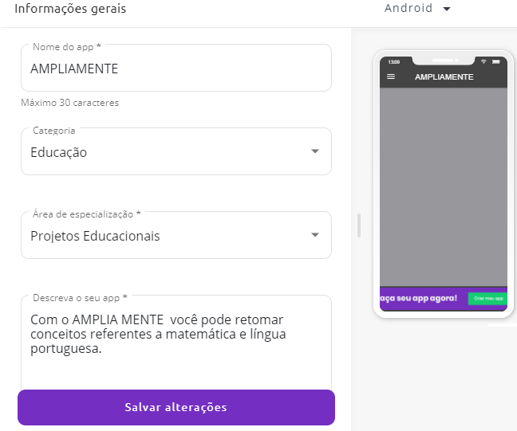

**Figure 1.** General information about the app.

Source: The authors (2021)

5) From this screen, we navigated to the icons *App Content* and *Visual Editor*. In App Content, we produced the tabs; we added icons and forms created in Google Forms; we added videos with stories and web pages. We also added podcasts, photographs, and audio, among others, according to the teacher’s objective.

6) We planned that the *Amplia Mente* would have three tabs: *Mathematics*, *Portuguese Language*, and *Comments*;

7) We clicked on the Tab Group button (on the left side of the application image) and dragged it to the application image. Next, we entered the tab title, in this example: *Mathematics*. We added the image of the tab icon, as shown in Figure 2. The images of all icons were made exclusively by the authors for use in the app.

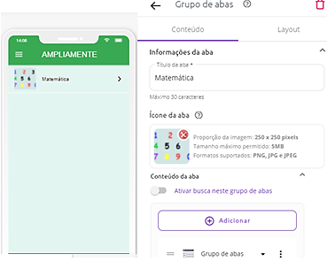

**Figure 2.** Information from the Mathematics tab.

Source: The authors (2021)

8) Still on this screen (Figure 2), in Tab Content, we clicked on Add and included another Tab Group icon within the Mathematics tab.

9) After clicking on the Tab Group (within the Mathematics tab), we filled in the information in the first icon, Numbers and Operations, as shown in Figure 3. We provided the tab title and the icon image, and in Tab Content, we added the Web Page tab.

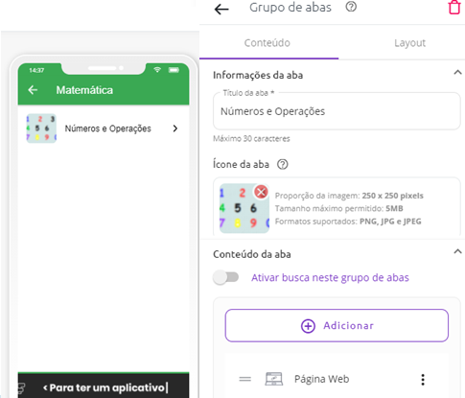

**Figure 3.** Information from the Numbers and Operations tab.

Source: The authors (2021)

10) When we click on the Web Page tab, we fill in the information (Figure 4): Tab Title – *Problems* and add an image to the tab icon; in addition, in tab content, we inform the link of the form produced in the Google Forms, with the mathematical tasks available. The Google Forms form with the tasks was planned, and its address was made available in the URL, as shown in Figure 4. We emphasize that each time the teacher wishes, they can change the problems by introducing a new Google form.

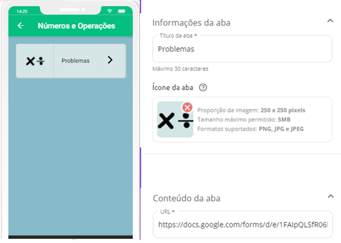

**Figure 4.** Problems tab information.

Source: The authors (2021)

11) By clicking on the Problems tab, we are directed to Google Forms. Figure 5 shows the beginning of the Football Trail, one of the situations that trigger the multiplicative concepts addressed in this study.

12) This process of creating tabs was carried out with each icon (Mathematics, Portuguese Language, and Comments) according to our objective.

13) In the Visual Editor icon, we customized the app layout, chose the colors, images, and format of the icons;

14) Upon completion of production, we publish the app with an access link made available by the platform;

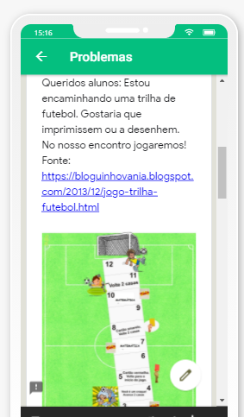

**Figure 5.** Google Forms with the Football Trail.

Source: The authors (2021)

15) In its complete mode (Figure 6), on the first screen, the app has the home page with the title *Amplia Mente* [Expand Mind]; the second screen contains three icons: Portuguese Language, Mathematics, and Comments. From this screen, with one touch, you can access the Portuguese Language tab, which has four icons, the Mathematics tab with five icons, and then, the Comments tab.

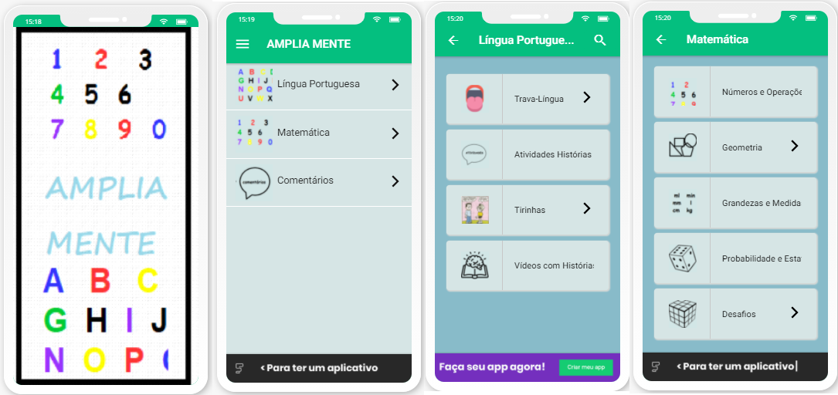

**Figure 6.** Application *Amplia Mente*.

Source: The authors (2021)

Using the Comments icon, students leave messages for the teacher and other users of the application. In the Portuguese Language icon, students have access to content, such as tongue twisters, comic strips, and stories narrated and made available through videos with related activities, which are produced by Google Forms and made available through the application. Such activities are modified and deleted, and new study situations are added.

Using the Mathematics icon, one can access five tabs that contain concepts and problems related to numbers and operations, geometry, quantities and measurements, probability and statistics, and mathematical challenges. This icon allows the teacher to correct the tasks students perform on the instrument Google Forms, modifying the tasks according to their pedagogical objective.

Students who attended SES remotely received several tasks under the Portuguese Language and Mathematics icons. In this study, we particularly discuss the tasks presented in the Numbers and Operations icon relating to multiplicative problem situations. We asked students to create strategies to solve situations, write down their hypotheses, indicate a means of solution, take a photo of the resolution, and attach the task to the app. The multiplicative situations were stimulated through a trail game called *Trilha do Futebol* [Football Trail], with narrated stories about football, also made available through the app under the Portuguese Language icon. Subsequently, the students discussed their hypotheses and proposed resolutions with the teacher in a synchronous session.

Evidence of conceptual assimilation, social interaction,s and symbolic mediations

We will now discuss the analysis category of signs of conceptual assimilation, social interactions, and symbolic mediations.

Student 1 used the *Amplia Mente* app asynchronously satisfactorily, as he could access it, watch the stories narrated, and solve the proposed mathematical situations. Firstly, he tried to carry out the proposed tasks without the teacher’s help, photographing the resolutions and posting them on *Amplia Mente*. After receiving the solutions, the teacher verified that, of the four multiplicative situations, only one was correct. This contributed to the analysis of the student’s errors, and the teacher could intervene in difficulties so that the student could learn the concept in question. Figure 7 shows Student 1’s solution to the first multiplicative situation, which involved the idea of adding equal portions:

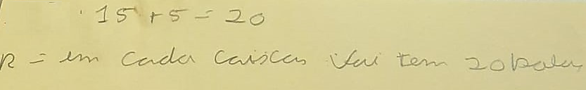

**Figure 7.** Student 1’s Solution.

Source: The authors (2021)

We verified that the student interpreted the problem based on the addition algorithm. As there were two pieces of information about the quantities of balls and boxes, he knew he would need to do some calculations, so he used the addition operation. During synchronous service, we asked him to access the app to reflect on the solutions together. Using his cell phone, the student accessed the app *Amplia Mente* and rechecked multiplicative situations. Likewise, the teacher also accessed the application and read the first situation. For understanding, we checked this interaction in the transcribed dialogue:

(1) Teacher: Let’s look at this problem: At the training center, footballs are kept in boxes, big boxes, okay!? Each box has 15 balls inside. How many balls are there in 5 boxes? How can we solve it? (The teacher reads the mathematical situation, while the student follows it on the app)

(2) Student 1: (The student remains silent)

(3) Teacher: You can draw it if you want... think of a box that holds 15 balls inside. If I have 5 of these boxes, how many balls will there be in total?

(4) Student 1: Ah! Is it a times count, or…. a sum, or… a subtraction, I don’t know.

(5) Teacher: How can we solve it?

(6) Student 1: (The student remains silent)

(7) Teacher: Think a little! There are 15 balls in 1 box, how many are there in the second box?

(8) Student 1: There are fifteen.

(9) Teacher: And then, in the first one, there are 15; in the second, there are 15; in the third....

(10) Student 1: Ah! 15 times 5. (The student solves the mathematical situation and shows it to the teacher)

(Dialogue between teacher and Student 1)

With the teacher’s intervention, Student 1 organized his ways of thinking. The register of the resolution of the multiplicative situation is found in Figure 8.



**Figure 8.** Student 1’s resolution after the teacher’s intervention.

Source: The authors (2021)

After being questioned by the teacher (lines 1, 3, 5, 7, and 9), Student 1 concludes that it would be necessary to multiply the number of boxes by the balls. Thus, the student initially sought to understand which operation he would perform (line 4). Figure 8 reveals that the student draws five boxes and represents the information that there are 15 balls in each one. From this action, he concluded that it was necessary to multiply 15 balls by 5 boxes. The student registered and posted a photograph of the resolution on the app again. We found that multiplicative thinking began to show signs of development, as the student could already formalize the multiplication operation through an algorithm despite still needing representation through drawings to understand the multiplicative situation.

Using the *Amplia Mente* app made the pedagogical intervention dynamic, engaging the student in solving the tasks. Oliveira and Silva (2018, p. 202) argue that mobile technologies, such as applications, are resources that the teacher would use to make classes “[...] more creative and have a result with significant value in each student’s learning.” In this sense, we infer that Student 1 demonstrated enthusiasm in using the digital resource, as evidenced by his involvement with the tasks.

Student 1, individually and without interactions with the teacher, did not understand the meanings of the multiplicative situation, as observed in the description in Figure 7. Only with the teacher’s intervention, during synchronous sessions, could he demonstrate conceptual assimilation advances. In this case, the student still did not carry out the proposed task alone; however, with assistance in interaction, he demonstrated that he was capable. This conclusion proves that the student is assimilating the multiplication concept since the student’s independent solving of the problem would be considered a level of potential development.

Vigotski (2010) says that only through interactions can the individual transform external social relationships into higher psychological functions. This transformation occurs in the social and collective through culturally determined instruments and symbols. Thus, student-teacher interaction is essential for the student to assimilate culturally and socially accepted concepts because knowledge always crosses other people until appropriation, as taught by the cultural-historical theory perspective.

Regarding the second multiplicative situation, Student 1 accessed the mathematical situation through the app. When asked how he thought about the resolution, he stated that he knew how to do it, as it was a division (line 14). Let us observe an excerpt from the dialogue established between the student and the teacher:

(13) Teacher: Let’s look at the next one: The coach of a football team won 24 energy drinks and wants to divide it between 6 players. How many energy drinks will each person receive? How do we resolve this?

(14) Student 1: I know that! It’s a division.

(Dialogue between teacher and Student 1)

Figure 9 presents the resolution of the multiplicative situation by Student 1:

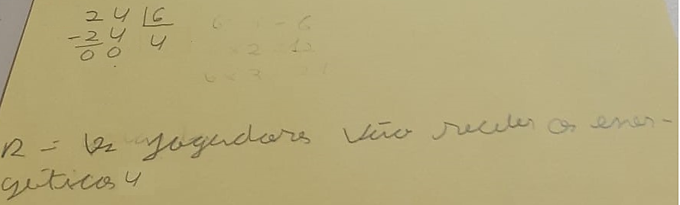

**Figure 9.** Student 1’s resolution.

Source: The authors (2021)

This mathematical situation refers to division problems traditionally taught in school. The student knew which operation to perform; the problem situation is described with the word divide. Some pedagogical practices are aimed at allowing students to discover, based on keywords in the problem statement, which operation to perform. For example, the terms join, gain, lose, give, and divide, among others, allow for more accurate identification. Therefore, this strategy contributes little to the development of mathematical thinking.

From teaching the proposed mathematical situation with the identification of keywords, thinking, and reasoning are only trained to discover the calculations, but not to understand the meaning in the situation, which could be solved in different ways, without necessarily using the operation algorithm. Understanding the algorithm is vital, as it formalizes the mathematical operation. However, it would be related to the meaning so that the operation could be done (Pacto Nacional pela Alfabetização na Idade Certa, 2014). In the SES teacher’s pedagogical practice aimed at students with ID, it makes no sense to train them to solve mathematical problems because the objective is to stimulate their mental processes to understand the concepts involved. The intention is precisely the opposite, i.e., to lead the student to understand the mathematical meaning involved in the multiplicative situation and the algorithm used.

Student 1 used the *Amplia Mente* app and successfully located the posts of the narrated stories, the trial game, and the multiplicative situations. Thus, he enjoyed using the app during the synchronous moment and felt motivated to solve the tasks. Ramos et al. (2017, p. 486) argue that digital resources help motivate students and provide “[...] teachers with the opportunity to transform teaching practice with dynamic and motivating activities.” For students with ID, simply manipulating the application and navigating the tabs represents something significant in their development, as it highlights and contributes to their autonomy and independence, skills that many people with ID lack precisely because of the scarce social interactions they are provided with.

Regarding the third multiplicative situation, we report the resolution and forms of thoughts of Student 2. Like Student 1, Student 2 also used the application positively, as he had it on his cell phone, which allowed him access at different times and places. Therefore, we consider that “[...] mobile learning allows accessibility and adaptability for users to seek knowledge anytime and anywhere” (Oliveira & Silva, 2018, p. 204). After watching the narrated story, he solved the problem and posted a photo of the resolutions on the *Amplia Mente* app.

Student 2 solved most situations using mathematical operations algorithms. Nevertheless, he has difficulties in oral language, as his speech is difficult to understand. In this way, when communicating, he uses gestures or isolated words, not articulating them properly in a sentence. When writing, he also uses isolated words because he cannot yet write a complete sentence. His characteristics demonstrated that he had not consolidated the literacy process and needed the help of a reader to carry out tasks in remote teaching. His younger sister, who has no intellectual disability, took on this role. Student 2 solved simple problems satisfactorily when receiving help. At the synchronous moment, the teacher questioned his way of thinking. In the interaction described below, we observe how the third multiplicative situation is solved:

(13) Teacher: Let’s look at this situation: A football player, who collects football boots, organized his football boots in 7 rows with 5 stacked boxes. How many boxes of boots did the player organize? How did you think to solve this problem?

(14) Student 2: 1 row. (The student shows the sheet with the solution, runs his finger along the first row) 5 boxes. (Swipes his finger over the stacked boxes)

(15) Teacher: Right! There are 5 boxes in a row, and in total? In the 7 rows, how many boxes are there?

(16) Student 2: 35! (The student counts the boxes 5 by 5 and then answers)

(Dialogue between teacher and Student 2)

Student 2, despite solving the problem satisfactorily, did not perform the multiplication operation because, when counting by 5, he performed the addition operation. In this situation, it is necessary to advance students’ development, so that they can become aware of multiplication as an option for resolution, showing that more pedagogical interventions are required. Vigotski (2010) highlights that as the individual interacts with others, in this case, the student with the teacher, and is offered clues for solving a given situation that is beyond their momentary capacity, they will, little by little, organize their ways of thinking to solve the problem alone. By solving the problem independently, the student demonstrates assimilation of the concept and advances in development; however, for such ideas to become real knowledge, assistance, interventions, interactions, and symbolic mediations are required, i.e., the presence of the interaction of others, of the social and collective, so that there is progress in learning and development.

In the following dialogue, we present the combinatorial reasoning presented by Student 2, referring to the fourth multiplicative situation:

(17) Teacher: This question is a little different. Now, we must think: A football team has different shirts and shorts that make up its uniform. Knowing that the team has 3 shirts, 1 white, 1 black, and 1 blue, and 2 shorts, 1 red and 1 green. In how many different ways does the football team choose its uniform for players to wear during matches? How can we manage it? How can we create these combinations between t-shirts and shorts?

How did you think?

(18) Student 2: 6.

(19) Teacher: Right! Six! I need you to show me your reasoning. How did you arrive at this result? Can you show me by writing how you got to number 6…

(20) Student 2: (The student sends a photo with the solution in written form, the same one already attached to the app.) He points to the word red, then to white (The red shorts with a white shirt), then, he points to red and black, then to red and blue... then, he repeats it with the green shorts (Figure 10).

(Dialogue between teacher and Student 2)

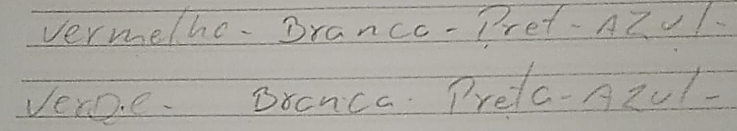

**Figure 10.** Student 2’s Solution.

Source: The authors (2021)

Through registers and gestures, we verified that the student understood the idea of combination. In his studies, Vigotski (2018) presents the concept of social compensation for disability, a process in which the primary (organic) deficiency can be compensated through social interaction. In the specific case of Student 2, we observed the replacement of oral communication by other forms of communication, such as using drawings, gestures, and writing isolated words.

Despite needing assistance with reading, the student showed understanding in navigating the *Amplia Mente*, demonstrating autonomy and independence in using it*.* Possibly, the images available on the application icons helped him manipulate it, as each image refers to the meaning of the tasks that are posted. For example, the Mathematics icon has an image of numbers, and the Portuguese Language icon, an image of letters, as seen in Figure 6.

As the SES aims for student autonomy inside and outside school (Ropoli et al., 2010), we concluded that using the app stimulated students’ independence. In this sense, “The use of new methodologies and the handling of technological tools as a didactic resource in the student’s daily life contribute to increasing participation in the teaching-learning process, encouraging them to develop their autonomy [...]” (Silva et al., 2021, p. 8). In turn, Gomes, Poulin, and Figueiredo (2010) argue about the importance of the SES teacher promoting diverse situations using different methodologies and materials, such as digital resources; as they state: “[...] they influence the development of autonomy and student independence in the face of different learning situations” (Gomes, Poulin, & Figueiredo, 2010, p. 15).

The *Amplia Mente* app, as a support resource created by the teacher herself for use in asynchronous moments, enabled the students served by the SES to remain motivated to solve tasks during remote teaching as they engaged in the posted activities, saw the videos, and listened to the stories. In this process, we highlight that just using the application is not enough for the student to advance in the assimilation of concepts, as, to acquire scientific knowledge, the person would need mediation through signs and instruments, together with another person, in the process of social interaction.

The teacher’s intervention is necessary since, without the teacher, learning school content becomes more difficult. Based on this observation, we return to Vigotski (2008) when arguing that the interactive process is central to the educational process, as it is through social interaction that knowledge is transmitted to the child. Therefore, the teaching process at school occurs through social interactions between the teacher and students, together with symbolic mediation through language, so that the student turns external actions into internal actions to assimilate the scientific concepts taught by the teacher.

Final considerations

The study aimed to analyze the contributions and possibilities of using an educational application with students with ID for learning mathematical concepts during specialized service that occurred remotely due to the COVID-19 pandemic. The results were positive regarding the use of the resource in an asynchronous way, specifically related to multiplicative thinking since the students watched the videos and listened to the stories presented, built and played the proposed *Trilha do Futebol* [Football Trail] game, and tried to solve the proposed multiplicative situations, which were later, synchronously, resumed with the teacher’s intervention.

We emphasize the importance of teachers seeking assorted possibilities to stimulate the learning processes of students targeted in special education during remote teaching, including using technological resources. However, we highlight that the interaction between students and the teacher, synchronous interventions, and questions were necessary for students with ID to progress in assimilating the concept of multiplication explored in the application.

We highlight that the *Amplia Mente* app is a mediating instrument that can be used in face-to-face tuition. In a future study, we intend to verify the contributions of the application in regular inclusive classes attended by students with and without disabilities. We also intend to use the application with students with other disabilities to adapt the *Amplia Mente* app to their needs.

References

*Base Nacional Comum Curricular*. (2017). Brasília, DF: MEC.

Caraça, B. J. (2000). *Conceitos fundamentais da matemática*. Lisboa, PT: Gradiva.

Gomes, A. L. L., Poulin, J.-R., & Figueiredo, R. V. (2010). *A Educação Especial na Perspectiva da Inclusão Escolar: o atendimento educacional especializado para alunos com deficiência intelectual*. Brasília, DF: Ministério da Educação/Secretaria de Educação Especial. Recuperado de http://www.repositorio.ufc.br/handle/riufc/43221

*Lei nº 13.146, de 6 de julho de 2015*. (2015, 6 julho). Institui a Lei Brasileira de Inclusão da Pessoa com Deficiência (Estatuto da Pessoa com Deficiência). Diário Oficial da União, Brasília. Recuperado de http://www.planalto.gov.br/ccivil_03/_ato2015-2018/2015/lei/l13146.htm

Mendes, R. H. (2020). *Protocolo sobre educação inclusiva durante a Pandemia da Covid-19. Um sobrevoo por 23 países e organismos internacionais*. Instituto Rodrigo Mendes. Recuperado de https://fundacaogrupovw.org.br/wp-content/uploads/2020/07/protocolos-educacao-inclusiva-durante-pandemia.pdf

Oliveira, C. A., & Silva, J. L. (2018). Possibilidades pedagógicas do uso das tecnologias móveis no ensino de matemática na perspectiva da m-learning. *Boletim Online de Educação Matemática, 6*(11), 200-221. DOI: https://doi.org/10.5965/2357724X06112018200

*Pacto Nacional pela Alfabetização na Idade Certa. Operações na resolução de problemas*. (2014). Brasília: MEC/SEB. Recuperado de: http://pacto.mec.gov.br/materiais-listagem/item/download

*Parecer nº 05, de 28 de abril de 2020*. (2020, 28 abril).Reorganização do Calendário Escolar e da possibilidade de cômputo de atividades não presenciais para fins de cumprimento da carga horária mínima anual, em razão da Pandemia da COVID-19. Diário Oficial da União, Brasília. Recuperado de http://portal.mec.gov.br/component/content/article/33371-cne-conselho-nacional-de-educacao/90771-covid-19.

*Parecer nº 09, de 8 de junho de 2020*. (2020, 8 junho). Reexame do Parecer CNE/CP n.º 5/2020, que tratou da reorganização do Calendário Escolar e da possibilidade de cômputo de atividades não presenciais para fins de cumprimento da carga horária mínima anual, em razão da Pandemia da COVID-19. Diário Oficial da União, Brasília. Recuperado de http://portal.mec.gov.br/component/content/article/33371-cne-conselho-nacional-de-educacao/90771-covid-19

*Política Nacional de Educação Especial na Perspectiva da Educação Inclusiva*. (2008). Grupo de Trabalho da Política Nacional de Educação Especial. Brasília: SEESP/MEC. Recuperado de http://portal.mec.gov.br/arquivos/pdf/politicaeducespecial.pdf

Prodanov, C. C., & Freitas, E. C. (2013). *Metodologia do trabalho científico: métodos e técnicas da pesquisa e do trabalho acadêmico* (2a ed.). Novo Hamburgo, RS: Feevale.

Ramos, L. W. C. et al. (2017). A construção de um aplicativo interativo como recurso didático para conceitos termodinâmicos. *ACTIO: Docência em Ciências, 2*(1), 474-492. DOI: http://dx.doi.org/10.3895/actio.v2n1.6792

Ropoli, E. A. et al. (2010). *A educação especial na perspectiva da inclusão escolar. A escola comum inclusiva*. Brasília, DF: Ministério da Educação/Secretaria de Educação Especial. Recuperado de http://www.repositorio.ufc.br/handle/riufc/43213

Silva, E. A. P., Alves, D. L. R., & Fernandes, M. N. (2021). O papel do professor e o uso das tecnologias educacionais em tempos de pandemia. *Cenas Educacionais, 4*(10), 1-17. Recuperado de https://revistas.uneb.br/index.php/cenaseducacionais/article/view/10740

Vigotski, L. S. (2008). *Pensamento e linguagem*. São Paulo, SP: Martins Fontes.

Vigotski, L. S. (2010). *A Formação social da mente*. São Paulo, SP: Martins Fontes.

Vigotski, L. S. (2018). Acerca dos processos compensatórios no desenvolvimento da criança mentalmente atrasada. *Educação e Pesquisa, 44*, e44003001. Recuperado de https://www.scielo.br/j/ep/a/JvycVmnwS39xrXQbCXgCycw/?format=pdf&lang=pt

**INFORMATION ABOUT THE AUTHORS**

**Adriela Maria Noronha:** PhD student in Science and Technology Teaching at the Federal Technological University of Paraná (UTFPR). Professor at the Instituto Federal Catarinense (IFC), Concórdia, SC, Brazil.

ORCID: https://orcid.org/0000-0001-9537-1223

Email: adriela.noronha@gmail.com

**Sani de Carvalho Rutz da Silva:** PhD in Materials Science from the Federal University of Rio Grande do Sul (UFRGS). Professor at the Federal Technological University of Paraná (UTFPR), Ponta Grossa, PR, Brazil.

ORCID: https://orcid.org/0000-0002-1548-5739

Email: sani@utfpr.edu.br

**Elsa Midori Shimazaki:** PhD in Education from the University of São Paulo (USP) and post-doctorate in Literature from the State University of Maringá (UEM). Professor of the Postgraduate Program in Education at the Universidade do Oeste Paulista (Unoeste). Presidente Prudente, SP, and the State University of Maringá. Maringá, PR, Brazil.

ORCID: https://orcid.org/0000-0002-2225-5667

Email: emshimazaki@uem.br

**Alessandra Dutra:** PhD in Linguistics and Portuguese Language from UNESP/Araraquara. Permanent professor of the Postgraduate Programs in Human, Social, and Natural Sciences Teaching and Science and Technology Teaching at the Federal Technological University of Paraná.

ORCID: https://orcid.org/0000-0001-5119-3752

Email: alessandradutra@utfpr.edu.br

**Note**:

The authors were responsible for data conception, analysis, and interpretation; writing and critical review of the content of the first draft; and approval of the final version to be published.

1. The professor who invented the application is one of the co-authors of the research and is a doctoral student in the Postgraduate Program in Science and Technology Teaching.