Viçosa, August 20, 2017.
To: Editor Acta Scientiarum Health Sciences

From: Josefina Bressan

Departamento de Nutrição, Universidade Federal de Viçosa, Av/ PH Rolfs, CCBII. 36570-000. Viçosa, Brazil.

E-mail: jbrm@ufv.br

Dear Editor,
We are submitting the manuscript “Prediction of body image dissatisfaction in university students by multivariate statistical methods” by Vinícius Rodrigues Arruda Pinto, Laura Fernandes Melo and Josefina Bressan. This paper arrives as a result from the research project developed during Pinto VRA master degree. The corresponding author is Bressan J, from Universidade Federal de Viçosa, Departamento de Nutrição e Saúde. Av/ PH. Rolfs, 36570-000 Viçosa, Brazil. E-mail: jbrm@ufv.br. Phone number: +55 31 3899-2692. Fax number: +55 31 3899-2541.
All authors have reviewed the manuscript and approved its submission to Acta Scientiarum Health Sciences and if accepted it will not be later published in the same or similar form in any language without the consent of the publishers. The material has not been submitted for publication elsewhere, while under consideration for Acta Scientiarum Health Sciences and none portion of the manuscript has been published or posted on the Internet.
The manuscript does not infringe any other person's copyright or property rights and the ethical guidelines were followed by the all investigators in performing this study.
The authors declared no conflict of interest.

Sincerely,
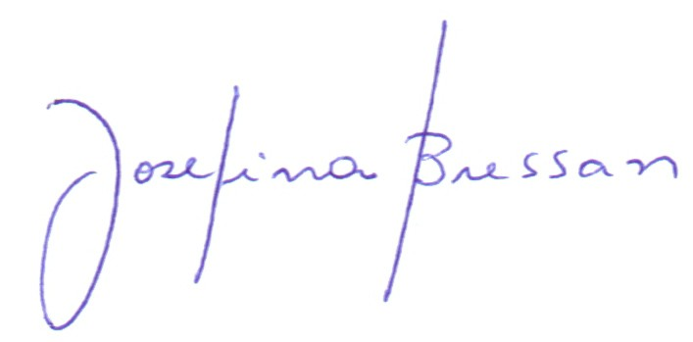
Prof. Josefina Bressan

