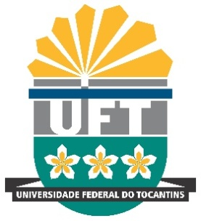 | Gustavo Cunha de Araújo  PhD Candidate in Education at UNESP/Marília, SP. He is a Professor at the Federal University of Tocantins  Helena Quirino Porto Aires  PhD Candidate in Education at UFSCAR/São Carlos, SP. She is a Professor at the Federal University of Tocantins

COVER LETTER

Tocantinópolis, February 9th, 2018.

To the Editorial Committee of Journal Acta Scientiarum. Human and Social Sciences

Dear Editor,

We wish to submit to you the Editorial Committee of Journal Acta Scientiarum. Human and Social Sciences for appreciation a copy of the manuscript entitled What is being a teacher in the countryside? Conceptions of Brazilian peasant higher education students about the Supervised Curricular Internship. We declare that the present article is original and unpublished, is not being submitted to any other journal for publication, does not present conflicts of interest, meets all the ethical procedures of scientific research and has our authorization to be published. We further declare that we transfer the copyright and co-author of this article to the Journal Acta Scientiarum. Human and Social Sciences.
The reasons why we believe we deserve to publish comes from the following points:
- To our knowledge, the data of this manuscript, in consonance with the methodology used, can contribute to discuss and think about new public policies for the training of teachers for the countryside, which is still incipient in Brazilian education. From this, the contribution will also be broadening studies on this subject in other international educational contexts that deal with this topic in scientific investigations, contributing to the advancement in the area of study and, consequently, to the history of education.
- The relevance of this study is justified by the fact that there is little research in the Brazilian scientific literature regarding the curricular internship supervised in the rural education. Because it refers to the training of teachers for rural areas, we understand that the study can contribute to broaden the debate about teacher training for the field in Brazilian and international educational research.
Therefore, we believe that the manuscript has relevance to be published in the Journal Acta Scientiarum. Human and Social Sciences.

Best regards,

Gustavo Cunha de Araújo
Author

Helena Quirino Porto Aires
Co-author

