**IMPLEMENTATION OF NURSING CONSULTATION AT AN ENDOSCOPY CENTER**

**IMPLANTAÇÃO DA CONSULTA DE ENFERMAGEM NUM CENTRO ENDOSCÓPICO**

**RESUMO**

Objetivou-serelatar a experiência de implantação da Consulta de Enfermagem no serviço de endoscopia do Hospital Universitário da Universidade Federal de Santa Catarina. Desde que enfermeiros foram lotados exclusivamente no setor do Centro Endoscópico da instituição, percebeu-se a necessidade de formular diretrizes que caracterizassem e documentassem o papel desse profissional no setor. Nesse quesito, várias providências foram tomadas pela gerência de enfermagem ambulatorial em parceria com os enfermeiros do setor, dentre as quais a implantação da consulta de enfermagem, com o intuito de contribuir para aperfeiçoar o registro da assistência prestada e melhorar a comunicação entre os membros da equipe de enfermagem daquele setor. Instituído o processo de enfermagem, notou-se maior segurança para o paciente e equipe de enfermagem durante todos os procedimentos realizados. A conscientização e o conhecimento sobre a relevância da atuação profissional do enfermeiro nesse tipo de serviço devem ser pautados na qualidade da assistência prestada e no diferencial que a enfermagem traz para a qualidade do atendimento ao usuário.

**Descritores:** Endoscopia. Cuidados de enfermagem. Processos de enfermagem.

**ABSTRACT**

The objective of this study was to report the experience of implementing Nursing Consultation into the endoscopy service at the Federal University of Santa Catarina’s University Hospital. Ever since nurses have been assigned an exclusive place at the institution’s Endoscopy Center, there has been a need to elaborate guidelines so as to characterize and document the role of this professional at the sector. In this regard, several actions have been taken by the outpatient nursing management in partnership with nurses at the sector, including implementation of nursing consultation aimed at enhancing the registering of provided assistance and improving communication between nursing team members of that sector. Once the nursing process was instituted, both patient and nursing team were provided greater security during all procedures performed. Awareness and knowledge about the relevance of a nurse’s professional practice at this type of service should be based on the quality of the provided assistance and on the difference nursing makes to the quality of user service.

**Keywords**: Endoscopy. Nursing care. Nursing processes.

**INTRODUCTION**

Technological progress in the field of endoscopy exams over recent years has caused a leap in the quality and quantity of this type of exam in hospital and outpatient areas, requiring from nursing enhancement and adaptation to the new reality in a welcoming, secure and humanized way. The growth of nursing in Gastrointestinal Endoscopy has been constant at different centers in Brazil, reason for which these professionals are increasingly seeking to deepen their knowledge and qualification in the area(1).

At endoscopy services, although quick procedures and the short time users stay in the place hinder the establishment of bonds with nurses, patients and their family members, this factor should not prevent a planned, customized and humanized nursing care(2). The Nursing Process can be a tool to evidence the triggering of thoughts and judgements developed during the provision of care. In addition, it integrates, organizes and ensures the continuation of information for the nursing team, thus enabling an assessment of its efficiency and efficacy(3).

In Brazil, the Federal Council of Nursing [*Conselho Federal de Enfermagem*] (COFEN) sets forth that the Nursing Process must be performed in a deliberate and systematic manner at all environments where professional nursing care is provided, through a public or private service. The concepts of Nursing Care Systematization [*Sistematização da Assistência de Enfermagem*] (SAE) and Nursing Process have been widely used in an ambiguous way. If on one hand, there are those who use these concepts as synonymous, on the other hand, some people have the perception that the SAE operationalized and clarified the Nursing Process(4,5).

However, COFEN Resolution 358/2009, of October 2009, corroborates this last understating, stating that Nursing Care Systematization organizes professional work as to method, staff and instruments, enabling the operationalization of the Nursing Process, methodological instrument that guides professional Nursing care and the documentation of professional practice. The resolution reiterates, additionally, that, when performed in an outpatient environment, the Nursing Process corresponds to what is commonly called Nursing Consultation(4,5).

The aim of this study is to report the experience of implementing Nursing Consultation into the Endoscopy Service at the Federal University of Santa Catarina’s Professor Polydoro Ernani de São Thiago University Hospital (HU/UFSC).

**THE CONTEXT OF THE EXPERIENCE**

Until 2009, upper gastrointestinal endoscopy exams used to be performed at the HU/UFSC for more 25 years, but without the constant presence of a nurse at the sector. Due to changes arising at the service over the years, the presence of a nursing professional assigned exclusively to the sector was consolidated, based on demands that emerged with the acquisition of more complex equipment, new legal requirements for their high-level cleansing and disinfection, increased number of exams performed every year and ever more common utilization of conscious sedation for users to undergo procedures.

Currently, the Endoscopy Center counts with a staff composed of two nurses, two nursing technicians, two health assistants and one UFSC undergraduate student with a scholarship, responsible for the reception of the service. Moreover, five nurses from other sectors at the hospital help as backups during weekends, on on-call shifts.

Ever since the assignment of an exclusive nurse to the Endoscopy Center in 2009, it was possible to notice that, despite the wide range of this professional’s responsibilities and his contribution to the organization of the service, the management and supervision of the nursing technicians team, besides assistance to users, the service did not count with guidelines that characterized and documented this professional’s role at the sector. A gap was, then, evidenced in the communication process not only between nurses and users, but also between members of the nursing team itself.

Thus, over recent years, the nursing management of the hospital’s outpatient service, in partnership with nurses from the Endoscopy Center, prepared manuals on nursing norms and routines for the sector, a protocol on how to welcome users(6), an explanatory leaflet with instructions to be followed before the exam and necessary preparation, an informed consent form model, resulting in the implementation of nursing consultation, inexistent at the sector until then.

In this context, the implementation of nursing consultation at the service’s Endoscopy Center aimed to improve the quality of nursing care provided there, in addition to enhancing the service as a whole, mainly when it comes to health orientations and education to patients and their families. Besides, by implementing consultation, nursing in that sector would begin to act in a systematized manner, contemplating Nursing Process stages, aiming to contribute to improving the registering of provided assistance and communication between nursing team members of that sector.

**BUILDING THE INSTRUMENT**

The process of nursing consultation implementation was built with the engagement of both nursing assistants that worked at the Endoscopy Center and the sector’s heads. At the meetings, which were held in September and October of 2012, based on a literature review and on experience acquired with practice, the three nurses prepared an instrument to carry out the nursing consultation.

During those meetings, the group sought to develop a practical instrument that was adequate to the institution, employing a language accessible to all members of the nursing team and that could be updated whenever necessary. The group also decided that, due to the short time the patient stays in the sector, it would be easier to synthetize, on a single document, the registering of all nursing care stages performed in the pre, trans and post-exam moments.

In this way, simultaneously to the implementation of nursing consultation, a unified instrument was built for Nursing Care Systematization performed at the Endoscopy Center. This instrument first records data on nursing consultation, comprehended in the Nursing History and the Physical Exam, both carried out by a nurse. Then, the monitoring and nursing care performed by the team during the procedure are registered; finally, the patient’s progress after the exam, in addition to the care provided and the orientations given when the patient is sent home, are registered as well.

The items contained in the instrument were based on the Nursing Process that already existed at the institution, but were duly adapted to the needs of the sector, emphasizing information that is relevant to exams performed there. The first part of the instrument, applicable to the pre-exam phase, contemplates nursing consultation. When the user arrives at the sector and is welcomed by the receptionist, he is first taken to a nurse, who collects data to compose the Nursing History and performs the physical exam. This moment comprehends the collection of information that is relevant to the performance of these exams, with emphasis on the patient’s safety, and that contributes to a higher-quality assistance.

Relevant aspects to be assessed by the nurse at this stage are illustrated in Figure 1.

**ENDOSCOPY CENTER: ( ) Bronchoscopy ( ) Endoscopy ( ) Colonoscopy**

**Name: Record:**

**Date:________/ _____/ _______**

**NURSING HISTORY**

1) Has the patient ever undergone this exam? ( ) No ( ) Yes. Reason: ______________________________________________________________________________________________________________________________________________________

If he has done so, what is the result? ________________________________________( ) Does not remember

2) Why has the doctor requested this exam? _________________________________________________________________________________________________________________________________________________________________________________________________________________________________

3) Has the patient ever been treated for Bacteria H. Pylon? ( ) No ( ) Yes. When: _________

4) Medications in use: _________________________________________________________________________________________________________________________________________________________________________________________________________________________________

5) Latest exams performed: ____________________________________________________

6) Allergic: _________________________________________________________________

**PHYSICAL EXAM**

1) Neurological Status:

( ) Oriented ( ) Anxious (..) Active (..) Calm ( ) Agitated

( ) Other:__________________________

2) Movement:

( ) Walking ( ) Bedridden ( ) Wheelchair user

( ) Other findings:____________________________________________________

3) Weight: _________ Kg

4) Height: __________m

____________________________________

Nurse’s signature – COREn

Figure 1 – Document for the registering of Nursing Consultation data. Florianópolis, SC. Prepared by the author.

Still during the nursing consultation, after composing the History and performing the Physical Exam, the nurse takes the opportunity to carry out a health education activity, providing the user all information that is relevant to the exam to be performed, such as: what the exam is, the sedation that will be used and possible effects, the need for medical certificate for the day, how the medical report will be delivered and how the post-procedure recovery will be. Besides, one also verifies whether all preparation for the exam has been done properly.

In order to make this moment more didactic, the nurse began to use an instrument that had been built before the implementation of the nursing consultation at the sector, the explanatory leaflet with instructions to be followed before the exam and necessary preparation. Duly illustrated, this leaflet contemplates relevant information about the exam to be performed, including: professionals that compose the team; what the upper gastrointestinal endoscopy exam is; what the doctor can see during the exam; what an endoscope is(1).

Since its preparation, the leaflet began to be distributed at Basic Health Units [*Unidades Básicas de Saúde*] (UBS) and handed in to every user when they were scheduling the exam. When the patient is hospitalized at the institution itself, the nurse from the Endoscopy Center goes to the hospitalization unit to visit the patient and hand it in to him and his companion, going through all information contained in it. During the nursing consultation at the Endoscopy Center, this material began to be another instrument to be used to clarify doubts about the procedure.

For the registering of nursing actions during the exam (trans) and after the exam, the group sought to build an instrument that encompassed records relating to the monitoring of the patient, especially concerning data on vital signs, which began to be collected first by the nurse soon at the nursing consultation, in the pre, then in the trans and also in the post-exam phases, before the patient is discharged. Thus, pre-exam vital signs data are now a parameter to trans and post-exam moments, resulting in greater security and reliability to the registering of data as the procedure progresses.

The instrument began to allow as well the registering of capillary blood glucose monitoring and the type of sedation used during the procedure, in addition to making space for the registering of the nursing conduct adopted in each situation. The end of the instrument brings registered data referring to the patient’s neurological and motor assessment after the and to his release from the sector, as seen in Figure 2.

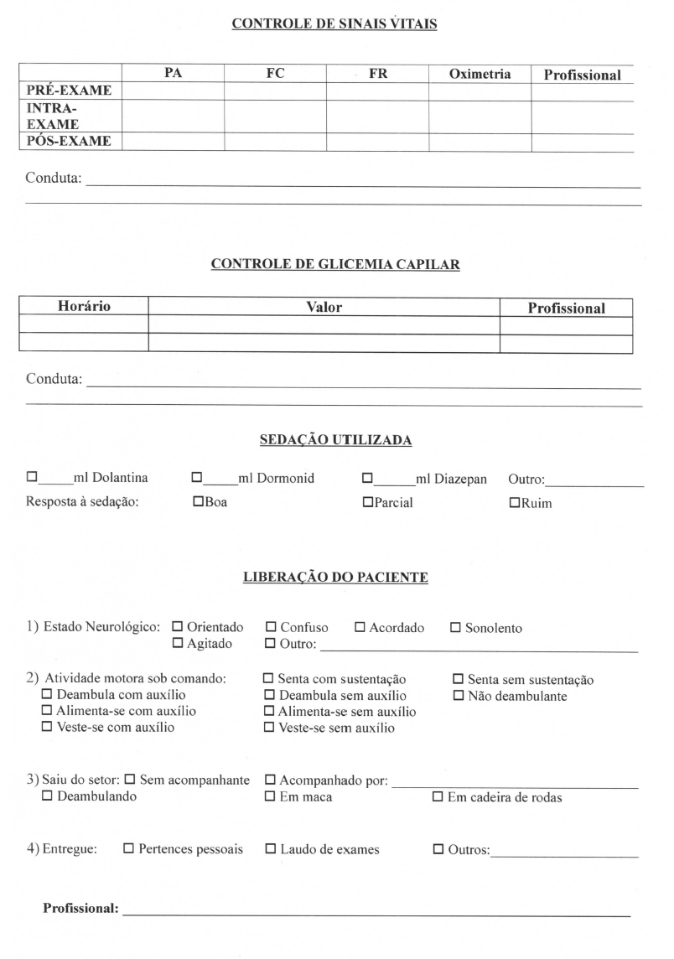

Figure 3 – Document for the registering of trans and post-exam data.

Florianópolis, SC. Prepared by the author.

**THE CONTRIBUTION OF THE EXPERIENCE**

The implementation of nursing consultation at the service and the building of an instrument to enhance the registering of nursing actions in pre, trans and post-exam moments at the HU/UFSC Endoscopy Center brought many contributions.

The performance of the nursing consultation validated the assistance provided by the nurse at the sector and began to enable the assessment of the user that he and the team of nursing technicians will be taking care of during a procedure with several eventual risks, since it is highly invasive and very commonly used under sedation. With the implementation of nursing consultation, the nurse has become able to assess the user in search of information that is relevant to the exam and that can point potential complications, possible drug interactions, risks of allergic reaction, in addition to indicating the user’s particularities that allow the nurse to assess and decide on the best way to welcome, mobilize and take care of him during the procedure.

In this way, the nursing service achieved what is set forth in the Nursing Process: that assistance should be based on an assessment of the patient, because it provides data that direct the definition of goals to be achieved and that serve as a basis to select interventions that meet the patient’s specific situation. From this perspective, the Nursing Process is then an instrument to guide the nurse’s clinical decisions and, as such, refers to intellectual and cognitive processes within the nursing practice(7).

With the implementation of nursing consultation, the user began to be provided an welcoming moment(8) prior to the consultation, in which he is assisted by a professional prepared to guide him, which can significantly contribute to minimizing anxiety, clarifying doubts and preventing complications, increasing security in the procedure, the quality of the assistance and the humanization of care. Welcoming is classified as a care technology with the establishment of a bond between health professional and user, with the former approaching the latter warmly, listening to him and understanding him so as to voice his individual and collective demands(9).

Moreover, with the building of an instrument that enhanced the registering of nursing assistance beyond the pre-exam moment, but also including trans and post-exam moments, allowed the systematization of the assistance to be registered continuously and synchronically, allowing documents on the assistance provided and the analysis of registered information to reveal important statistical data on the service and Nursing practice, in addition to drawing the clinical profile of assisted users. In this process, it is worth highlighting the importance of nursing prescription as a guiding instrument to nurses’, nursing technicians’ and nursing assistants’ actions(5). The Nursing Process methodology is used nowadays at health services all over the world, always associated with improvements in the quality of information, of the communication between professionals, and in the assessment of the performance of Nursing activity(10).Thus, just as what is found in the literature, this experience authorizes us to state that, despite the short time period in which these actions were carried out – about two years –, their effects are being evidenced already, proving to be very promising.

It is worth noting that, although, at first, there has been some resistance to the implementation of nursing consultation at the service, especially from the medical team, which alleged that it would cause delayed services, with time, this practice began to be recognized for its value in the prior assessment of the patient and in the records obtained, allowing one to know the patient better and obtain relevant information about his health-illness process.

**FURTHER CONSIDERATIONS**

This experience report is expected to provide subsidizes to reflections on the importance of a nurse’s role at endoscopy centers and a systematized nursing care in this field. Such reflection should be based on the assumption that awareness and knowledge about the relevance of a nurse’s professional practice at this type of service should be anchored on the quality of the assistance provided and on the difference nursing makes to the quality of user service.

The report of this practice is an extract from the reality experienced by nurses that works at that institution, and does not intend to end this theme here. On the contrary, the expectation is that this report motivates the conduction of new studies and that this theme is ever more approached in all its aspects and interfaces.

**REFERENCES**

1. Selhorstl, IZB, BUBL, M.B.C., GIRONDI, J.B.R. Protocolo de acolhimento para usuários submetidos à endoscopia digestiva alta e seus acompanhantes. Rev Bras Enferm. [on-line]. 2014 [citado em 2015 jul 20]; 67(4):575-80. Disponível em: http://www.scielo.br/pdf/reben/v67n4/0034-7167-reben-67-04-0575.pdf.
2. Selhorst ISB, Bub MBC, Girondi JBR. Usuário submetido à endoscopia digestiva alta e seu acompanhante: perfil e expectativas. Enferm. Foco [on-line]. 2013 [citado em 2015 jul 20]; 4(3,4) 207. Disponível em: http://revista.portalcofen.gov.br/index.php/enfermagem/article/viewFile/554/237
3. Dal-Sasso GTM, Barra, DCC, Paese F, Almeida SR, Rios GC, Marinho MM et al. Computerized nursing process: methodology to establish associations between clinical assessment, diagnosis, interventions, and outcomes. Rev.Esc Enferm USP [on-line]. 2013 [cited 2015 jul 20]; 47(1):238:45. Available from: http://www.ncbi.nlm.nih.gov/pubmed/23515827.
4. COFEN. Conselho Federal de Enfermagem. Resolução número 358/2009. Dispõe sobre a Sistematização da Assistência de Enfermagem [on-line]. Brasília; 2009 [citado em 2015 jul 15]. Disponível em: <http://www.cofen.gov.br/>. Data do acesso: 07 de julho de 2015.
5. Pimpão FD, Lunardi-Filho WD, Vaghetti HH, Lunardi VL. Percepção da equipe de enfermagem acerca da prescrição de enfermagem. Cienc Cuid Saude [on-line]. 2010 [citado em 2016 out 21[; 9(3):510-517. Disponível em: file:///C:/Users/Eduardo/Downloads/9336-47686-1-PB.pdf.
6. Selhorst ISB, Bub MBC, Girondi JBR. Protocolo de acolhimento e atenção para usuários submetidos a endoscopia digestiva alta e seus acompanhantes. Rev Bras Enferm [on-line]. 2014 [citado em 2015 jul 15]; 67(4):575-80. Disponível em: <http://www.scielo.br/scielo.php?script=sci_arttext&pid=S0034-71672014000400575>.
7. Guedes ES, Turrini, RN, Sousa RM, Baltar VT, Cruz DA. Attitudes of nursing staff related to the nursing process. Rev.Esc Enferm USP [on-line]. 2012 [cited 2015 jul 20]; 46(Esp):130-7. Available from: http://www.ncbi.nlm.nih.gov/pubmed/23250269.
8. Macedo CA, Teixeira ER, Daher DV. Possibilidades e limites do acolhimento na percepção de usuários. Rev. Enferm [on-line]. UERJ. 2011 [citado em 2015 jul 20]; 19(3):457-62. Disponível em: http://www.facenf.uerj.br/v19n3/v19n3a20.pdf.
9. Oliveira TA, Pinto KA. Acolhimento com classificação de risco e acesso em serviços de emergência: avaliação de usuários. Cien Cuid Saude [on-line]. UERJ. 2015 [citado em 2016 abr 20]; 14(2):1122-29. Disponível em: http://periodicos.uem.br/ojs/index.php/CiencCuidSaude/article/view/22897/14790.
10. Egilegor JXH, Puyadena MIE, Etxabe JMU, Herrero MVE, Iraola CA. Estudo retrospectivo da implementação do processo de enfermagem em uma área de saúde. Rev. Latino-Am. Enfermagem [on-line]. 2013 [citado em 2015 jul 25]; 21(5):[06 telas]. Disponível em: http://www.scielo.br/pdf/rlae/v21n5/pt_0104-1169-rlae-21-05-1049.pdf.