Gelo nos Trópicos: A Exportação de “Blocos de Cristais da Frieza Ianque” para Índia e Brasil.

**Abstract.** The Boston natural ice trade thrived during 1830-70 based upon Frederic Tudor’s idea of combining two useless products – natural winter ice in New England ponds and sawdust from Maine’s lumber mills. Tudor ice was exported extensively to the tropics from the West Indies to Brazil and the East Indies as well as to southern ports of the United States. In tropical ice ports, imported natural ice was a luxury product, e.g., serving to chill claret wines (Calcutta), champagne (Havana and Manaus), and mint juleps (New Orleans and Savannah) and used in luxury hotels or at banquets. In the temperate United States, natural ice was employed to preserve foods (cold storage) and to cool water (Americans’ peculiar love of ice water. In both temperate and tropical regions natural ice found some use for medicinal purposes (to calm fevers). With the invention of a new technology to manufacture artificial ice as part of the Industrial Revolution, the natural ice export trade dwindled as import substituting industrialization proceeded in the tropics. By the turn of the twentieth century, ice factories had been established in half a dozen Brazilian port cities. All that remained of the once extensive global trade in natural ice was a sailing ship which docked in Rio Janeiro at Christmas time laden with ice and apples from New England.

*“Ice is a luxury but not a necessity in the hot lands of the world…the taste for ice,*

*like that for the pickled olive, is a cultivated one” - Ice and Refrigeration, 1893*

The rich in the modern world have sought out living comfortably in cooler temperatures. In 1856, some 875 tons of natural ice cut out from ice ponds around Boston were landed at the port of Salvador (and 257 tons at Pernambuco, 1,762 tons in Rio de Janeiro).[1] The first natural ice shipment into Brazil took place in 1834 when a three-masted barque vessel, the *Madagascar* owned by Frederic Tudor, the “Ice King[2],” unloaded ice and Baldwin (bright red winter New England) apples in Rio de Janeiro. The nineteenth-century international ice trade was carried out by Boston and by Norway (which supplied the English market with ice until World War I at lower prices than could be done by Boston exports[3]). A report dated 1863, noted that “nearly $2,000,000 are invested in the ice trade of Boston and vicinity, employing about 550 ships, and giving employment to about 4,000 persons.”[4] The world trade in natural ice illustrates the intense globalization which ***took place before*** what has been termed the first wave of globalization.[5]

For centuries ice had been made by boiling water to expel air, then collecting evaporation in wetted cloths, the evaporation from which made ice during cold, winter nights.[6] In the East Indies the artificial formation of natural ice was long carried on as the only means of cooling beverages and food. The ground near Hoogly, about 40 miles from Calcutta, was a production site: pans of porous earthenware were placed on layers of straw placed over shallow troughs. Then, shortly before midnight in winter months and when the wind happened to be blowing from the northwest, a little water was poured into each earthen vessel or pan; and if all natural circumstances were favorable, a film of ice was created in each vessel by the following morning. This ice was collected and stored with utmost care and was sold in Calcutta for about 6 pence per pound.[7] Such “Hoogly ice” would be completely displaced by cheaper, higher quality imported Boston Ice. The ice works at Allahabad, India, protected from cheaper imported natural ice in coastal port cities by geographical distance, still made up to 29 tons/night of ice in 1875.[8]

Natural ice harvesting for local use in the United States had a long history going back to colonial times.[9] Artificial refrigeration was a vital element of the Industrial Revolution in the nineteenth-century which required refrigeration as in dairy products, meat-packing, breweries, and ice-making. The growth of large urban populations requiring food from outside the cities and the emergence of efficient transportation systems (railroads and ships) served to create a demand for ice. The demand was first met by the worldwide ice trade and as of 1860 with the invention by Ferdinand P. E. Carre of the ice machine based upon the modern ammonia absorption system, by factory-made ice on location.[10] Charles Tellier perfected the innovation and was first in 1876 to successfully put it into a steamship, *Le Frigorifique*, which he had purchased in Liverpool, and delivered chilled meat from Buenos Aires to Rouan, France[11]

Frederic Tudor (1783-1864) had combined two useless products – winter ice from ponds around Boston and sawdust from Maine – and created a major New England industry with significant exports.[12] The ice trade was seasonal, from November – March depending upon the severity of New England winter weather. Ice from New England coastal ponds exhibited unusual purity (making it slow to melt) and possessed an appealing crystal-like color. Tudor’s ice trade with Calcutta contributed to Boston dominating the well-established, lucrative general Calcutta traffic during 1833-67 (when New York overtook Boston in the Calcutta trade).[13] Carrying ice had the additional appeal in that it obviating the need for ballast on out-going ships from Boston.[14] The ice was packed in ships’ holds in the insulating sawdust. Tudor added apples to the cold sawdust and so started the apple trade with Brazil, South America and the ice ports of Asia. Tudor’s ships returned to Boston laden with tropical produce - transport of slave-grown sugar, fruit, and eventually much cotton for New England’s textile mills[15] - which served to keep the price of ice lower in the receiving ports.

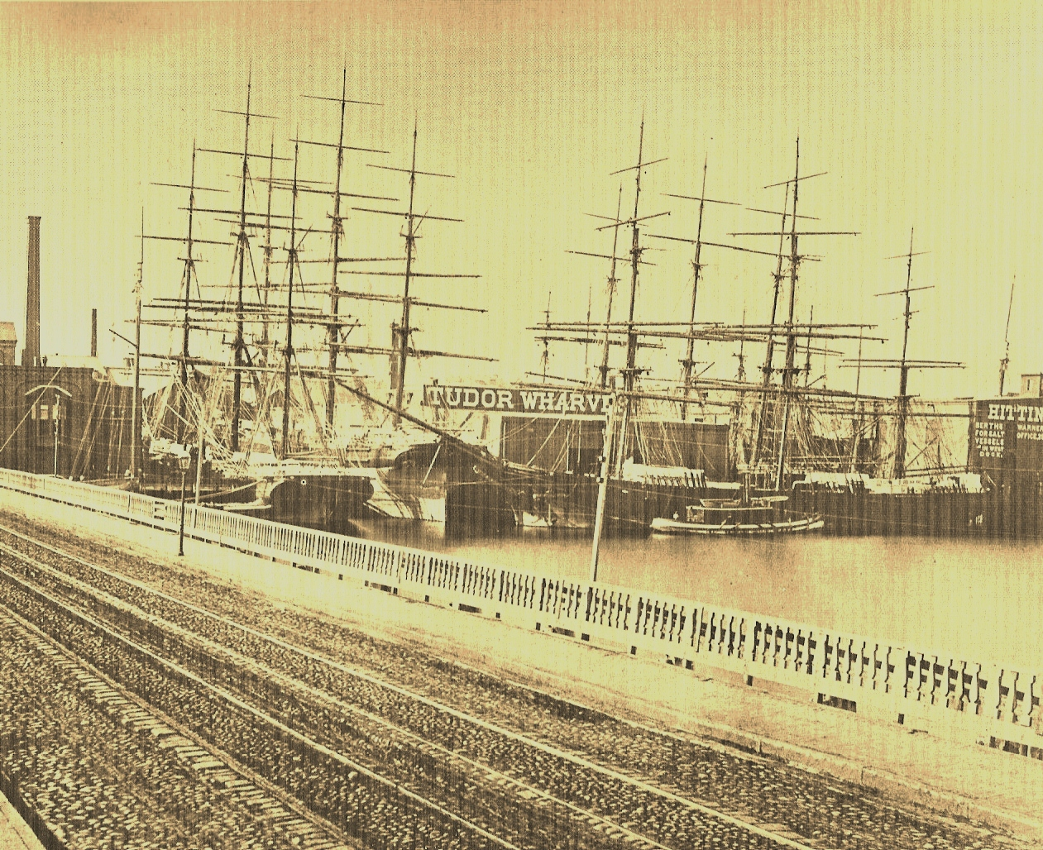

East Indiamen Loading Ice at the Tudor Wharves in Charlestown, Massachusetts (Source: Morison, op. cit.: 285)

Tudor’s first shipment of ice left his wharf in Charleston in 1805 with 130 tons destined for St. Pierre in French Martinique. The West Indian islands were being ravaged by yellow fever and the need for ice was greatly felt.[16] But for twenty years, Tudor struggled financially and it was only in the 1830s that his business took off. He shipped 240 tons of ice to Havana in 1807, secured a monopoly from Great Britain in 1812 with her colonies in the West Indies, was awarded a monopoly concession from Spain in 1815-6 with her colonies, soon followed by delivering his ice to Charleston S.C. (1817), Savannah (1818), New Orleans (1820), Jamaica and British Guiana.

In May 1833 in response to the request of English and American merchants there, he made his first shipment of 180 tons to Calcutta, a 3-4 months journey and later to Madras and Bombay, the start of a long and profitable trade with India as well as with China (Canton), Japan and Europe (Liverpool).[17] One hundred tons of Tudor’s ice were unloaded at his ice-house in Calcutta in September 1833.[18] The ice was consumed there by the westernized, Indo-Anglian, mercantile elites (to chill water and Claret wines[19]) and used for medical purposes (e.g., treating fevers, anesthesia before surgery, as an antiseptic, etc.).[20] In the Orient, ice use was chiefly limited to foreign settlements and the selected upper classes (as in South America). Oysters and (Hoogly first and later Tudor) ice were served at dinner-parties (‘assemblies’) of the European residents in Calcutta. Ice retailed there at 3 pence/pound, thus 100 tons in brought in 2,800 British pounds sterling or $13,552 in 1834 (worth in 2010 US $ 353,000) from which freight charges needed to be subtracted. In 1844, Tudor’s Boston ice was also unloaded in three Cuban ports (Havana, St. Jago, Matanzas), Oporto (Portugal), Barbados, Galveston, St. John’s, New Orleans, Savannah and Norfolk.[21]Tudor sold his ice in 1834 for 1 ½ cents/pound in New Charlestown; for 2 cents/lb. in New Orleans; in Havana for 3 cents/lb.; and in Rio de Janeiro in 1833 at 12 pounds for a Spanish dollar (or US$ .083 a pound).[22] In 1847, Tudor’s ice sold in Havana for 6 ½ cents a pound, in New Orleans for half a cent to 3 cents a pound and in Calcutta for 2 ½ cents a pound.[23] The Tudor ice in Calcutta displaced the local Hoogly ice which was both not as crystalline and priced at 6 pence per pound. Tudor had ice houses built in Calcutta (1835), Madras (1841), and Bombay (1843).[24] Tudor himself reported that in 1856 his enterprise had made exports abroad to: Aspinwall, Nassau, St. Thomas, Havana, Matanzas, St. Jago, St. Johns (San Juan, Puerto Rico), Barbados, Cardenas (Cuba), Trinidad, Martinique, Guadalupe, Kingston, Laguaira, Demerara, Bahia, Pernambuco, Buenos Aires, Rio de Janeiro, Valparaiso, Callao, Guayaquil, Ceylon, Calcutta, Bombay, Madras, Batavia or Singapore (Dutch East Indies), Manila, Penang, Canton, Mauritius and Australia.[25]

Tudor had sold his ice in Panama and the Boston and Panama Ice Company had a monopoly of its import into the two cities, Panama and Aspinwall. The ice was delivered by five ice ships a year which sailed around Cape Horn. A visitor to the cities in 1855 commented upon ice being used to “make the luxury of sherry cobbler and ice-cream, which latter is now cried nightly in the streets of Panama, in English, by Jamaica Negro women.”[26] In 1867, the Grand Hotel in Panama which had opened in 1866 advertised itself as “unequalled in elegance and comfort in South America…and is fitted with the best French furniture.”[27] The dining halls and reception rooms supplied every luxury; the best wines and liquors imported direct from France, and every evening ice cream were served. The Boston Ice Company with branches in Aspinwall and Panama furnished the ice. Imported American ice was selling in Callao, a major ice port on the west coast of South America in 1860 at 3 pence/lb. or 6 U.S cents/lb. and was deemed an expensive luxury.

A magazine catering to well-off American travellers, *Outing an Illustrated Magazine of Recreation,* published an account (in the gaze of the colonizer) of a visit to colonial Havana in 1883. The traveller commented upon the use of imported and manufactured ice: it

…Is supplied at the table with precisely the same liberality as in any first-class hotel to be found in New York. By the way, it was a strange and incongruous scene that met our gaze one afternoon while passing along the wharves of Havana. A double line of large and powerful Negroes, perfectly nude, their skin black and with the gloss of a thorough-bred, were loading a store house with ice from a large ship. The ice they carried on their heads, their arms up to steady it; and the cake that each carried was enormous.[28]

The same could have been found for unloading of ice in Calcutta, Canton, Manila, or Rio de Janeiro, etc., only the skin color and ethnicity of laborers would differ.

In 1860, New Orleans alone consumed 60,000 tons of Boston ice whereas Calcutta absorbed 8,000 tons in 1863.[29] The Calcutta trade was Tudor’s crown jewel for thirty years.[30] In 1857, about a dozen companies in Boston shipped 10-11,000 tons of ice to the East Indies; in 1860 about 20,000 tons, and in 1867 peaking at 27,000 tons.[31]

Tudor’s success attracted competitors into the natural ice export business though after his ice business began showing signs of commercial success in the 1830’s. Competition drove down the price of natural ice. An early Boston ice cutter and exporter was Addison, Gage & Co. (est. 1835) which became Gage, Harrison & Co. in 1840 (-1860) when Jacob Hittinger (1811-1875) joined the firm. The enterprise shipped ice to the West Indies, Havana, Jamaica and Rio de Janeiro (where in 1843 it established a branch house).[32] The Gage, Hittinger firm cut ice in the Spy and Fresh Ponds in east Cambridge. The enterprise tried to initiate natural ice exports to London in 1842, but the venture failed and all subsequent attempts to introduce New England ice to that market were not more fortunate.[33] In one season in the early 1840’s, the firm shipped ice outward on 101 sailing ships, regularly supplying ice to Bombay, Canton, Mauritius, Calcutta, Madras, Barbados and even Australia. A cargo in 1843 was sent to the East Indies where it was traded entirely for cotton which was brought back to Liverpool and sold.[34] In 1849, Gage Hittinger & Co’s wharf in Charleston was seen filled with boiled lobsters, packed in ice, being prepared for shipment to Barbados.[35] By 1844, sixteen companies in Boston were engaged in shipping ice to the East and West Indies, and to New Orleans and other southern ports. The principal dealers were Gage Hittinger, Frederick Tudor, and Nathaniel J. Wyeth.[36]

The Boston ice trade grew enormously during 1836-1846 and again during 1846-56. The following Table presents data for annual exports from Boston. The ice trade grew until1860 after which exports steadily decreased.

|  |  |  |
| --- | --- | --- |
| 1805 | 1 cargo | 130 tons shipped to Martinique |
| 1816 | 6 cargoes | 1,200 |
| 1826 | 15 | 4,000 |
| 1832 | n.a. | 4,352 |
| 1836 | 45 | 12,000 |
| 1838 | 140 | 30,000 |
| 1843 | n.a. | 55,000 |
| 1846 | 175 | 65,000 |
| 1847 | 353 | 74,478 (incl. coastwise @ 51,857) |
| 1852 | n.a. | 96,482 |
| 1856/7 | 363 | 125,814 (incl. coastwise @ 81,895) |
| 1859 | n.a. | 129,403 |
| 1863 | “ | 133,000 |
| 1867 | “ | 142,463 |
| 1866 | “ | 124,751 |
| 1870 | “ | 106,000 (43,000in U.S coastal trade) |
| 1872 | “ | est. 69,500 |
| 1874 | “ | 69,800 |
| 1884 | “ | 60,000 |
| 1890 | “ | 44,850 |
| 1895 | “ | 17,300 |
| 1900 | “ | 13,720 |

Source: Data for 1806-1856 from Leander Wetherell, “The Ice Trade,” *Executive Documents Printed by Order of the House of Representatives during the First Session of the Thirty-Eight Congress, 1863-64* (Washington: Government Printing Office, 1864): 440 and 449. Data for 1847 from Wyeth (1849), op. cit.: 407 and other figures from Bunting, op. cit.: 338. The figure for 1843 is from Simmonds, op. cit.: 79. Ice export data for 1850-1900 is presented in Arthur L. Hunt, “Manufactured Ice,” *Census Bulletin* No. 174 (May 22, 1902): 16. Figures for 1860-66 are from Hill (1884), op. cit.: 8. An interesting graph plotting the Massachusetts ice trade during 1806-1886 is presented in Dickason, op. cit.: 57. An 1856 figure of 146,000 tons was reported by the Boston Board of Trade in Tudor and Sawyer, op. cit.:80, but this was an error. The 1856 figure cited here is from Homans (1860: 1003)

The peak years for the *“crystal blocks of Yankee coldness”* (as Tudor’s natural ice was called in India) were 1840-70. Export shipments of natural ice began decreasing in the mid-1860’s caused by the innovation of artificial (machine-made) ice (first achieved commercially in New Orleans in 1868) and the dispersion worldwide of economical ice-making factories – a classic example of a little-noticed import substituting industrialization which occurred in India during the 1870’s.[37] The emergence of manufactured ice gradually destroyed the shipping of ice and with it the small export trade in apples. In 1874, entrepreneurs in Madras manufactured ice locally by steam processor at the International Ice Company.[38] The idea spread to Calcutta. The Bengal Ice Company, the second artificial ice maker in India, was formed in 1878.[39] But Frederic Tudor who died at age 80 in 1864 had become a multi-millionaire with a fortune then of $ 12 million (or in 2010 dollars @ 226 millions) though his millions came less from the ice trade and more from the raid appreciation in value of the lands on which his ice houses stood in major world seaport cities.[40]

Early ice plants in South America which date back to the late 1870s or early 1880’s were often pioneered by German or Swiss immigrants, being set up in connection with breweries or hotels.[41] Such immigrant-built factories follow the wider pattern across Brazil in which foreigners and first-generation immigrants (not the diversifying coffee or sugar elites) built the first factories of modern Brazil. Important immigrants in the ice trade and later ice factories in Brazil included Jacob Hittinger, Francisco Bolonha, Louis Bucher and Georg Maschke. Machinery in ice plants could be driven by steam engines and was in the early plants, but electricity proved to be far less expensive and was employed when available.[42] Rio de Janeiro had imported ice from Boston since the days of Frederic Tudor, “…but necessarily its use has been confined to the rich.”[43] The former U.S consul in Rio de Janeiro wrote about Boston’s ice entering Rio in 1836/7.[44] The Boston ice cutting and exporting enterprise of Gage, Hittinger set up a branch house in Rio in 1843. In 1848, Rio de Janeiro imported 320 tons of Boston ice, placing it in third place among foreign markets in Boston’s ice trade (behind Calcutta/Bombay with 467 tons and Havana with 450 tons).[45] In 1856, Rio de Janeiro took 1,762 tons of Boston ice placing it third (behind the East Indies, Callao and Havana).[46] The U.S exported some $8,600 – 11,000 worth of ice annually to Brazil during 1853-55.[47] In1855, 8,109 tons were exported to Brazil bringing-in $9,279 (i.e. a ton of ice was selling for a little over one U.S dollar). Ice use in Rio grew slowly.[48] In 1865, 3,319 tons of ice from Boston arrived in Rio de Janeiro.[49] The figures were 2,500 tons imported in 1872, 3,100 in 1873, and 2,400 tons in 1874, placing Rio de Janeiro second in destination of American ice exports (after Demerara).[50] Small ice plants were in operation in Rio de Janeiro in the early 1880’s.[51] Two machine-ice factories were in operation in Rio de Janeiro before 1889: one employed the sulfuric gas process and made 3,000 tons of ice annually (or a little over 8 tons/day); the other smaller one employed the ammonia method. By 1892, ice was being manufactured in considerable quantity in Rio de Janeiro in a large ice factory. [52] The Swiss immigrant Joseph Villiger had created a small brewery on rua Visconde de Sapucai in 1888, Manufacturera de Cerveja Brahma, Villiger & Cia., but it languished for half a decade until 1894 when the German, Georg Maschke acquired it. He expanded the brewery enormously by buying a second-hand ice machine in 1894 and raising its capitalization to 900 contos in 1896. In 1896, he imported a large new ice machine from Maschinenfabrik Augsburg-Nurenberg.[53] Maschke sponsored bars, restaurants, clubs and artists to expand beer consumption.

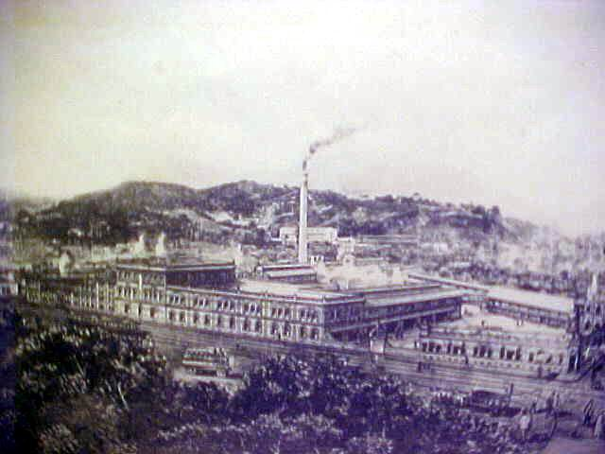

Photo of the large Brahma beer factory in the Catumbi neighborhood of Rio de Janeiro which possessed a large ice machine unit imported from Maschinenfabrik Augsburg-Nurenberg in 1896 (Source of photo dated 1908: <http://www.bairro.catumbi.nom.br/f1brahma.htm> )

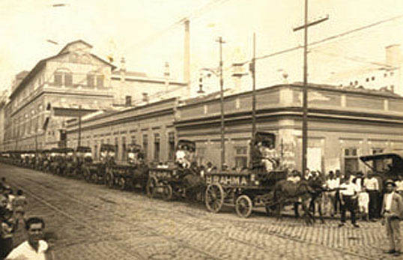

Another photo of the old Brahma factory in Catumbi (Source: <http://www.ambev.com.br/pt-br/a-ambev/institucional/historico?utm_campaign=Maio&utm_medium=Twitter&utm_source=Ambevbrasil&utm_content=Post&utm_term=Historia> accessed on June 15, 2011)

U.S Consul Anderson reported in 1907 that artificial ice in the city was still being supplied by this single factory using” outdated equipment.”[54] The ice was distributed mostly to depots in corner groceries and thence in small quantities to consumers at about 2 ½ U.S cents pound. Once a year, a sailing ship arrived at Christmas time unloading natural ice and apples in Rio de Janeiro.

Machine-ice factories operated in Sao Paulo (the Antacrtica beer factory’s ice plant in 1888), Porto Alegre and Pernambuco.[55] The Antarctica Paulista – Fabrica de Gelo e Cerveja, formed and managed by the German immigrant, Louis Bucher, began operating in 1888 in the neighborhood of Agua Branca, producing 50 tons of ice per day.[56] The enterprise partnership was a combination of an older hog slaughterhouse with a small ice plant formed by a Portuguese immigrant, Joaquim Salles, and the German brewer. The two partners incorporated in 1891, creating Cia Antarctica Paulista, which went on to become one of Brazil’s leading enterprises during the twentieth century.

U.S vice consul Krause noted that in 1899 there was one ice factory operating in Pernambuco and the citywide consumption of ice was ½ to one ton a day, being sold at 2 cents per pound. A German ice plant had been set up around 1889 in Pernambuco. The plant used a German machine able to produce 3 tons of ice every 24 hours. But ice demand proved unsatisfactory and another German purchased the machinery in 1896 and shipped it to Salvador da Bahia.[57] An ice factory in a brewery was operating in Porto Alegre since the 1880’s.[58]

In Santos, U.S. consul Girimondi noted in 1900 that the rising consumption of ice there was “due principally to the increasing demand for ice in restaurants, hotels and other public places where drinks are served. Foreigners – chiefly Americans, Englishmen and Germans – who are unaccustomed to a tropical climate, are loudest in the call for this commodity.”[59] He added that a noticeable absence of ice existed in fish, vegetable and meat markets caused by the high price of ice and the difficulty to procure it.

With a much smaller market and greater social inequality, ice consumption per capita in Bahia was smaller. One of the German Bonne brothers had opened Salvador’s first rudimentary ice plant in 1853 located at the Baixa de Graca but it only operated briefly.[60] Another small ice factory owned by Lourenco de Voto was operating by 1872 in the Sao Bento neighborhood of Salvador. An 1893 report mentioned a steam-driven ice and oils factory operating at the Praia de Preguica, owned by Jose Manuel de Araujo & C.[61] An 1892 article commented though that “the ice cart does indeed, perambulate the city of Bahia in the early evening, with ice at 5 cents per pound, when those who do use it buy small amounts for use at the evening dinner, the entire purchase being consumed at that meal.”[62] The demand for ice proved inadequate and the ice-making was abandoned. In 1896, however, a German purchased a second-hand ice machine in Pernambuco (Recife), brought it to Salvador and began ice manufacture.[63]A German publication mentioned that Brahma operated a small ice factory in Bahia at the time.[64] The factory was located along the sea front a narrow street of the lower city (Preguica). The ice was made in blocks about 3 feet long and 5 inches square, weighing about 10 kilograms. It was sold for 300 reis/block (or 4 ½ U.S cents). It was delivered at the door of a consumer by carts which made one trip a day. The U.S consul in Bahia reported in 1899 that the use of ice “was confined almost entirely to the two hotels, four foreign boarding houses and half a dozen drink shops patronized by the foreign population, two clubs, and a few foreign families.”[65] It was rarely used to preserve food, but only to cool drinks.

The artificial ice industry in Brazil at the turn of the twentieth century was most developed in Para or Belem, situated at the mouth of the Amazon River. Tremendous wealth had been generated there and upriver in Manaus by the rubber boom. The pioneer of Para’s ice industry was an Italian engineer trained in Rio de Janeiro, Francisco Bolonha (1872-1938). Along with a number of local partners Bolonha successfully established three ice plants during 1896-99 and was successful in driving out of business another factory using French machinery. An 1894 U.S. consular report from Para had referred to a small ice plant operating in Para with a capacity of 2 tons/day and ice being sold at 3 ½ cents/lb.; a high price which was limiting demand.[66] Bolonha and partners in the syndicate, Bolonha, Paiva & Cia operated the Fabrica de Gelo Paraense, the Fabrica de Gelo Crystal, and the Fabrica de Gelo Reducto. Bolonha had visited the United States to purchase ice-making equipment from the Delaware-based enterprise, Remington Machine Co.[67] A fourth plant was built by the syndicate in Manaus in 1899. U.S consul Kennedy reported from Para in August 1899, “The ice industry, under the management of Dr. Bolonha, in Para, has been exceedingly profitable. There was formerly in Para an ice plant of French construction… (but) officials of the…plant quickly discovered that it was impossible to compete in quality or quantity of ice. The owner was forced to sell to Dr. Bolonha, who now owns three different plants in Para and one in Manaus. All represent the latest American machinery, and each gets highly satisfactory dividends.”[68] The old trading firm of G. Amsinck & Co. shipped an entire ice plant capable of making 10 tons per day in 1899 from the United States to the city of Para, being the sixth such unit in Para.[69] Para’s ice plants shipped ice to various ports of Brazil. The three plants delivered ice across Para in twelve ice wagons of 2,000 pounds capacity each, built in New York City by the Kipp Wagon Works (photo below).

Ice chilled the champagne which flowed in rivers at the famed parties and in the bordellos during Manaus’ rubber boom years. Freyre commented upon the “Sardanapalian banquets” held at Para’s landmark aristocratic hotel, Hotel Globo, where luxurious food was “washed down with costly wines and Champagne Cliquot,”[70] cooled no doubt with Bolonha’s ice.

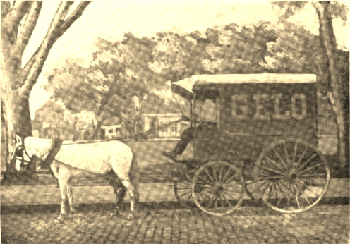

Ice delivery wagon of the Fabrica de Gelo Paraense (Source: “A Brazilian Ice Syndicate,” op. cit.: 89)

Bolonha expanded his business activities as he was building ice plants, moving into constructing kiosks in Para, a meat and fish market supplied with his ice, and even purchasing a scenic railway in New York which he shipped to Para.[71] The profitability of Bolonha’s various business activities found expression in the large, ostentatious palacete he had built for himself and family, the Palacete Bolonha of Belem.[72] Ice used in towns along the Amazon from Iquitos to Para was also manufactured on a state-of-the-art imported American ice machine (of the Remington Machine Co., Delaware) at a plant in Para operated since 1903 by the Fábrica de Cerveja Paraense.[73] The machine was shipped by G. Amsinck & Co. (NYC) and was able to produce 10 tons of ice a day.[74]

The following chart summarizes the machine-ice production in Brazil at the turn of the twentieth century. About ten ice plants were then in operation.

|  |  |  |
| --- | --- | --- |
| Rio de Janeiro | 1887 | First small ice plant as part of city’s first brewery, making Brahma beer, in 1887 founded by the Swiss immigrant, Joseph Villiger. By 1889, two factories were operating including a very large one in the Lapa district |
| Sao Paulo | 1888 | Factory in a large beer plant of Antarctica Paulista |
| Porto Alegre | 1880’s | Ice-making plant in one of city’s many breweries, the Cervejaria e Fábrica de Gelo Bopp & Irmãos |
| Pernambuco (Recife) | 1890 | German plant set up and operated for several years. Another factory established during 1890’s |
| Para (Belem) | 1890’s | Three ice plants set up using American machinery; another ice plant in operation in 1899 |
| Manaus | 1899 | Small ice factory set up |
| Bahia (Salvador) | 1880’s-90’s | Small ice factory set up before 1892 by a Brazilian but ceased operation after a few years. In 1896, a German established a modern ice plant down by the waterfront |

By 1923, ice plants had multiplied across Brazil: three plants operated in Para, two in Manaus, three in Recife, three in Bahia, seven in Rio de Janeiro, six in Sao Paulo, and several smaller cities in the State of Sao Paulo and in southern Brazil had ice plants.[75]

[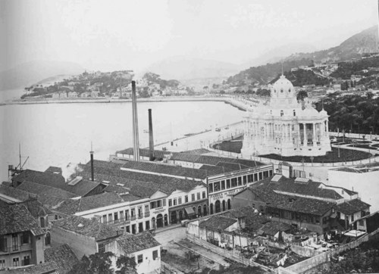](http://rioantigo-monroe.buzznet.com/user/photos/manequinho-e-o-palacio-monroe/?id=1195705#pt)

A modern ice factory in Rio de Janeiro located next to the Palacio Monroe (completed in time for the Third International Conference of the America States in 1906 (source: <http://rioantigo-monroe.buzznet.com/user/photos/palacio-monroe/?id=1196486> accessed on June 15, 2011)

**Conclusion**

Throughout the last couple thousand years, the rich have acquired goods to help them reach a condition of living comfortably: hand-held fans moved by slaves, parasols and umbrellas, wrought-iron window grills to keep out the sunshine (common in Salvador), ice, cooled drinks, refrigeration, not to mention weekends during summer by the ocean in northern Europe, etc. The use of ice could be taken as a partial index of the “degree of civilization.”[76] Certainly by the turn of the twentieth century, the standard of living was then highest in the U.S. and the per capita consumption of ice was greatest. Almost every American village had its ice house or regular ice dealer who sold ice blocks out of his canvas-covered cart. Ice use to preserve perishable produce had started in Boston and New York in the early nineteenth century. Americans took to having ice to cool drinks and to keep fresh food in larders. Innovations served to reduce the retail price of natural ice to consumers from once being $6 to 12 ½ cents per 100 pounds.[77] Per capita ice consumption in Europe was much lower but this was because of the more temperate climate there (cooler summers than in the U.S), because ice was “confined to the wine cellars of the rich and the cooling pantries of first class confectionaries,”[78] and because the pressure to save time was lesser in Europe than in the U.S. meaning that buying and cooking food daily was more culturally accepted. For example, a report dated 1892 published in a major U.S trade journal noted that in large French cities like Bordeaux and Marseilles, butchering was done every day in winter and twice a day in summer and the meat was cooked within a few hours after the slaughtering.[79] The mass of the French population used no ice, purchasing their food supplies of food once or even twice a day, consuming the total purchase at once. In the nineteenth century, natural ice harvested during winter in Europe was used as a method of cooling by brewers, meatpackers, conserving fish, and in luxury restaurants. In Germany and Italy, natural ice from the mountains was employed. The report concluded, ”from all of which it appears that the old world is far behind the United States in the application of ice to the economies of the household – a fact that is in no wise surprising, in view of the fact that the standard of living is much higher among the masses of the people in this country.”[80]

On the other hand, in the tropics with a much lower average standard of living, one finds little ice being used. Imported ice in the tropics was a luxury product – making ice cream and iced drinks (including mint juleps with crushed ice in the U.S. South). In Manila, for example, the artificial ice produced in the early 1890’s was not used to preserve food as provisions were purchased daily for immediate consumption but rather “the chief use for ice …is to cool drinks by setting the vessels in the ice.”[81] But whereas Tudor had realized that larger profits lay in the mass demand for well-preserved food and consequently in the distribution of ice to butchers, fishmongers, dairymen and ultimately to homes equipped with iceboxes, such would only occur during the twentieth century in the tropics.[82]

Ice followed the colonial and neocolonial outposts, e.g. to Havana, British Guyana, Jamaica, Barbados, India, Batavia, Manila, Aspinwall, the Chinese treaty ports, Galle (an old Portuguese, then Dutch and later British seaport in southern Ceylon), etc., e.g. the British and American community in Calcutta was an avid consumer of imported, American, natural ice. Initially, the natural ice was shipped to the tropics based upon Tudor’s brilliant idea (ice packed in sawdust) and later it was produced there using the new technology of making artificial ice – captured in a transition from *crystal blocks of Yankee coldness* to *machines as frozen spirit.[83]*

1. Isaac J. Smith Hemans, *A Cyclopedia of Commerce and Commercial Navigation* (New York: Harper & Brothers Publishers, 1860): 1003
2. ”Frederic Tudor – Ice King,” *Bulletin of the Business Historical Society* 6, 4 (September 1932): 1-8
3. Robert David, “The Demise of the Anglo-Norwegian Ice Trade,” *Business History* 37, 3 (1995): 52-69
4. Leander Wetherell, “The Ice Trade,” *Executive Documents Printed by Order of the House of Representatives during the First Session of the Thirty-Eight Congress, 1863-64* (Washington: Government Printing Office, 1864): 448
5. As in Richard E. Baldwin and Philippe Martin, *“Two Waves of Globalization: Superficial Similarities, Fundamental Differences”* (Cambridge, MA.: National Bureau of Economic Research working paper W6904, January 1999).
6. Hugh S. Cumming, “Safe Ice,” *Public Health Reports* (1896-1970) 29, no. 32 (August 7, 1914): 2066-67
7. from Charles Knight, *Cyclopedia of the Industry of All Nations* (New York and London: George P. Putnam, 1851): 1050
8. Mary Ellen Snodgrass, *Encyclopedia of Kitchen Industry* (New York: Taylor and Francis Group, 2004): 498
9. See for example Vertie Knapp, “The Natural Ice Industry of Philadelphia in the Nineteenth Century,” *Pennsylvania History* 41, 4 (October 1974): 412-421
10. The Carre machine was one amongst other innovations developed to preserve foods in order to feed the growing industrial cities but also to feed troops in wars, e.g., the Franco-Prussian war. Further details presented in Robert P. Clark, “Chapter 8. Feeding Industrial Cities,” in *Global Life Systems: Population, Food, and Disease in the Process of Globalization* (Lanham and Oxford: Rowman & Littlefield Publishers, 2000) and in C.P. Wood, “Artificial Refrigeration Systems,” *Power and the Engineer* 32, 18 (May 3, 1910): 821-23.
11. “A Father of Refrigeration,” *Ice and Cold Storage* 11, No. 128 (November 1908): 279. A photo of Tellier’s steamer may be seen at <http://museum.agropolis.fr/english/pages/expos/fresque/zm_mod13a.htm>
12. William H. Bunting, *Portraits of a Port: Boston, 1852-1914* (Cambridge: Bellknap Press, 1971): 338. Ice was harvested on the Hudson River as well but most was destined for New York City, see details in Daniel Calandro, *“Hudson River Valley Icehouses and Ice Industry”* (Poughkeepsie: Marist College, Hudson River Valley Institute, June 2005) at <http://www.hudsonrivervalley.org/library/pdfs/articles_books_essays/studentworks/NatIceIndustrydicehousepaper.pdf>
13. Further details in Hamilton Andrews Hill, *Boston’s Trade and Commerce for Forty Years 1844-1884* (Boston: American Statistical Association, Press of T.R. Marvin & Son, 1884): 7-9
14. Dickason, op. cit.: 64
15. Tamara Plakins Thornton, ”Review (untitled),” *The New England Quarterly* 78, 1 (March 2005): 148
16. From F.H. Forbes, “Ice,” *Scribner’s Monthly Magazine* 10, 4 (August 1875) at <http://www.iceharvestingusa.com/demorest/scribners1.html>
17. Details on the ice trade with India in David G. Dickason, “The Nineteenth-Century Indo-American Ice Trade: An Hyperborean Epic,” *Modern Asian Studies* 25, 1 (1991): 53-89 and in C.B. Tripathi, “The Beginning of American Ide Trade with India,” in G. S. Dikshit (ed.), *American History by Indian Historians II* (Hyderabad: American Studies Research Center, 1969) 114-138. The American merchant community in Bengal during 1790-1880 is analyzed in Ranjan Chakrabarti, “The Brown Ships in the Indian Oceab: The American Merchants and the Bengali Banians 1790-1880,” in Chittabarta Palit, Pranjal Kumar Bhattacharyya (eds), *Business History of India* (Deklhi: Kalpaz Publications, 2006): 221-234.
18. “Ice-Making in Bengal,” *The Penny Magazine for the Diffusion of Useful Knowledge* (May 27, 1837): 199
19. “On the Cooling of Wines with Ice,” *Gleanings in Science Vol. III* (Calcutta: Baptist Mission Press, 1831): 120 and especially “ Social Life in Bengal Fifty Years Ago by an Old Indian,” *The Calcutta Review* No. 146 (1881): 399
20. Dickason, op. cit.: 55, 61, 71-2, and 84
21. A listing of foreign ice ports to which 22,591 tons of Boston ice were delivered is presented in N.J. Wyeth, Esq., “The Ice Trade of the United States,” T*he Bankers’ Magazine and State Financial Register* III, 7 (January 1849): 407
22. Samuel Eliot Morison, “Chapter XVII. China and the East Indies 1820-1850,” in *The Maritime History of Massachusetts, 1783-1860* (Boston and New York: Houghton Mifflin Company, 1921): 281
23. Wetherell, op. cit.: 441
24. Dickason, op. cit.: 69
25. Tudor and Sawyers, op. cit.: 80-81
26. Robert Tomes, *Panama in 1855: An Account of the Panama Rail-Road, of the Cities of Panama and Aspinwall* (New York: Harper and Brothers Publishers, 1855): 204
27. Dr. Berthold Carl Seeman, *History of the Isthmus of Panama* (Panama: printed and published at the Office of the Star & Herald, 1867): 78-79
28. F. H. Janes, “Havana,” *Outing. An Illustrated Magazine of Recreation* Vol. 1, No. 9 (January 1883): 2
29. Wetherell, op. cit.: 449 and the Calcutta figure from Dickason, op. cit.: 74
30. Details in Gavin Weightman, *The Frozen Water Trade: A True Story* (New York: Hyperion, 2003). The reasons for Tudor’s business success in India are examined in Dickason, op. cit.: 55-56, 74.
31. Hill (1 894), op. cit.: 130 and Dickason, op. cit.: 75
32. George Washington Howard, *The Monumental City, Its Past, History and Present Resources* (Baltimore: J.D. Ehlers & Co., 1873): 498
33. Hamilton Andrews Hill, “Suffolk County. Trade, Commerce and Navigation,” in William Thomas Davis, Professional and Industrial History of Suffolk County, Massachusetts, Vol. 2. Illustrated (Boston: The Boston History Company, 1894): 130
34. P. L. Simmonds Esq., “The Ice Trade of Boston, America,” in *Simmond’s Colonial Magazine and Foreign Miscellany Vol. III* (Simmonds and Clowes, Foreign Colonial Office, Sept-Dec. 1844): 79
35. From *Gazette of the Union, Golden Rule, and Old-Fellow’s Family Companion, Vol. II* (New York: Crampton & Clark, 1849): 31
36. Simmonds, op. cit.: 80
37. The genesis of manufacturing ice is examined in Arthur L. Hunt, “Manufactured Ice,” *Census Bulletin* No. 174 (May 22, 1902): 8ff. In 1870 there were only four ice factories in the United States; there were 222 by 1890 and 787 in 1899. See also David O. Whitter and Bessie Emrick Whitter, *The Birth of Big Businesses in the United States, 1860-1914. Commercial, Extractive, and Industrial Enterprises* (Westport: Praeger Publishers, 2006): 167. Dickason (op. cit.: 80) notes such import substitution.
38. Snodgrass, op. cit.: 500
39. Dickason, op. cit.: 80-1
40. As argued in Dickason, op. cit.: 55-56. See also James Parton, “Frederick Tudor, Ice Exporter,” *Captains of Industry: Men of Business Who Did Something besides Making Money* (Middlesex: The Echo Library, 2008): 74-76
41. James Fred Rippy, *Latin America and the Industrial Age* (New York: G. P. Putnam’s Sons, 1944): 213 and for the crucial role of Germans in making ice machinery, see Mikael Hard, *Machines are Frozen Spirit: the Scientification of Refrigeration and Brewing in the 19th Century, a Weberian Interpretation* (Frankfurt am Main: Campus Verlag, 1994)
42. Rippy, op. cit.: 211
43. ”Ice in the Tropics,” *Ice and Refrigeration* 3, 6 (December 1892): 437
44. John M. Baker, *A View of the Commerce between the United States and Rio de Janeiro, Brazil* (Washington D.C.: Office of the Democratic Review, 1838): 12-15
45. Wyeth, op. cit.: 411
46. Homans, op. cit.: 1003
47. Homans, op. cit.: 1003
48. Delso Renault, *Rio de Janeiro, a Vida de Cidade Refletida nos Jornais (1850-1870)* (Rio de Janeiro: Civilizacao Brasileira, 1978): 195
49. ”Brazil,” *Report of the Commissioners from British North America Appointed to Inquire into the Trade of the West Indies, Mexico & Brazil* (Ottawa: G.E. Desbarats, 1866): 30
50. Forbes, op. cit. at <http://www.iceharvestingusa.com/demorest/scribners1.html>
51. Edgar Helmut Kob, *Die Brahma-Brauerai und die Modernisierung der Getrankenhandels in Rio de Janeiio 1888 bis 1930* (Stuttgart: Franz Steiner Verlag Unternehmungsgeschichte Band 20, 2005): 91
52. mentioned in “Ice in the Tropics,” op. cit.: 437
53. ibid: 92
54. “Ice Plants in Brazil,” *Cold Storage and Ice Trade Journal* Vol. 34, No. 3 (September 1907): 47
55. Dr, Wilhelm Michels, “A Industria no Brasil,” *Revista Agricola do Imperial Instituto Fluuminense de Agricultura* vol. 19 (Rio de Janeiro: Typografphia Laemmert & C., 1888): 203
56. Sergio de Paula Santos, *Os Primordios da Cerveja no Brasil* (Cotia: Atelie Editorial, 2004): 24. See also website at <http://www.saopauloantiga.com.br/antarctica-paulista/>
57. Consul H.W. Furniss, “Manufacture of Ice in Latin America: Brazil,” *Consular Reports on Commerce, Manufactures, Etc.* 269-271 Vol. 63, No. 238 (July 1900)
58. Consul Charles Negley, “Porto Alegre, Brazil,” *Consular Reports in Commerce, Manufactures, Etc.* No. 126 (March 1891): 373
59. Consul John J. Grimondi, “Ice Machines Wanted in South America,” *Ice and Refrigeration* 20, 2 (February 1901): 71
60. Wilhelm Overbeck, *Funfzig Jahre Deutscher Verein Germania und Deutschtum in Bahia* (Berlin: Druck von Emil Ebering, 1923): 174
61. Francisco Vicente Vianna and Jose Carlos Ferreira, *Memoria Sobre o Estado da Bahia* (Salvador: Typographia e Encadernacao do ‘Diario da Bahia’, 1893): 275
62. “Ice in the Tropics,” op. cit.: 437
63. Consul H.W. Furniss, “Manufacture of Ice in Latin America: Brazil,” *Consular Reports on Commerce, Manufactures, Etc.* 269-271 Vol. 63, No. 238 (July 1900)
64. Kob, op. cit.: 95
65. Furniss, op.cit.: 269
66. Consul George G. Mathews Jr., “United States Trade with Para,” *Consular Reports. Commerce, Manufactures, Etc.* Vol. 47, No. 175 (April 1895): 526
67. “A Brazilian Ice Syndicate,” *Ice and Refrigeration* 14, 2 (February 1898): 87
68. Consul K. K. Kennedy, “Para,” *Commercial Relations of the United States with Foreign Countries for the Year 1899* Vol. 1 (Washington: Government Printing Office, 1900): 614-616
69. *Monthly Bulletin of the International Bureau of the American Republics* 7, 2 [August 1899]: 143.
70. Gilberto Freyre and Rod William Horton, *Order and Progress: Brazil from Monarchy to Republic* (Berkeley: University of California Press, 1986): 240
71. Kennedy, op. cit.: 616 and especially Maria de Nazare Sargas, *Belem: Riquezas Produzinda a Belle-Epoque (1870-1912)* (Belem: Editora Paka-Tatu, 2002) which was originally written as a master’s thesis in 1990 at the Universidade Federal de Pernambuco.
72. see Celio Claudio de Queiroz Lobato, Eurler Santos Arruda, Andrea Helyette Gomes Ramos, *Palacete Bolonha Uma Promessa de Amor* (Belem do Para: Editora Universitaria UFPA, 2007)
73. Details in “A Brazilian Ice Syndicate A Sketch of the Empreza de Gelo Paraense of Belem, Para, Brazil – American Ice Making Machinery in Operation in the Valley of the Amazons,” *Ice and Refrigeration* XIV, 2 (February 1898): 87-90.
74. ”Ice Machine in Brazil,” *Ice and Refrigeration* vol. 26 (March 1904): 136
75. Rippy, op. cit.: 214
76. ”Ice in the Tropics,” op. cit.: 436
77. From Tom Schachtman, *Absolute Zero and the Conquest of Cold* (New York: Houghton Mifflin Company, 1999): 70. These technological advances are analyzed in Cummings, op. cit.
78. ”How Much of It is used and Where it Comes From,” op. cit.: 709
79. ”Ice in Europe,” op. cit.: 360
80. ”Ice in Europe,” op. cit.: 362
81. ”Ice in Sunny Lands,” op. cit.: 208
82. Thornton, op. cit.: 148
83. in the words of Mikael Hard, op. cit.