Dear Editor,

We are submitting the manuscript “Assessment professional competence and risk factors perception of *Toxoplasma gondii* at the Cuba National Zoo Park and Zoo Garden of Rio de Janeiro, Brazil” for possible publication in the Journal of Veterinary Science and Public Health.

We also declare that the data and results obtained in this work are original and have not been plagiarized. We accept and recognize the order of appearance of the authors after the manuscript has been published.

We declare that this work is unpublished. It strictly followed all ethical procedures and it has not been submitted to any other journal for publication. All authors contributed to the development of this manuscript, participating in all phases of the study. Moreover, we are aware that, if the manuscript is accepted for publication, copyright now belong to this journal.

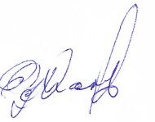Yours faithfully,

The authors

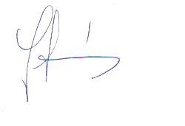**Ginette Villar Echarte:**

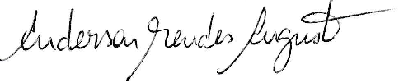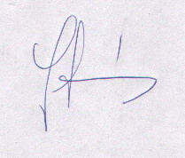**Yolanda EmiliaSuárez Fernández:**

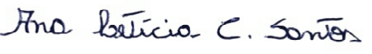**Anderson Mendes Augusto:**

**Ana Letícia Carvalho Santos:**

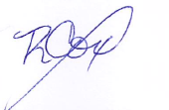**Marcia Macedo Lima Dantas:**

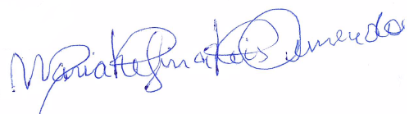**Raymundo Cox Iraola:**

**Maria Regina Reis Amendoeira:**