Nitrogen and Chlorophyll as Indicators for Dry Matter Production in Wheat in South West of Iran

* A.Bavi¹, ²M.Nabipoor, A.Shokoofar⁴, N.Sayahi³, S.Boroomand Nasab¹.
1:Department of Irrigation and Drainage, Faculty of Water Sciences Eng., Shahid Chamran University, P.code 61357-8-3151 Ahwaz, Iran. *e-mail:Abavi1@yahoo.com,phon call: +989161118307, Fax: +986113776657, boroomandsaeed@yahoo.com,
2: Faculty of Agriculture, Shahid Chamran University, P.code 61357-8-3151 Ahwaz, Iran.
3: payame nor university of Ahwaz Iran, .Nsayahi@yahoo.com,
4: Islamic Azad University, branch of Ahwaz, Iran. E-mail: ASHokoohfar@yahoo.com
Corresponding author: *Adel Bavi, e-mail:Abavi1@yahoo.com,phon call: +989161118307 fax: +986113776657
ABSTRACT
Effect of chlorophyll on dry matter production of wheat (triticum aestivum L.) by chlorophyll meter (SPAD) in 2006-2008, in agriculture field of Shahid Chamran university was studied in factorial Experiment with a completely randomized blocks design with three replication and five levels of Nitrogen (0, 25, 50, 75, 100 Percent) for production 5 ton/ha wheat in addition three places of field References that applied all of Needed of Nitrogen for production of 5 ton/ha grain Wheat. the data given in this study are averages of two year of agricultural evaluation. Lopez et al (2001) attempted to measure Nitrogen concentration (Nc) in stems and leaves of crop during flowering stage and seed Nitrogen was predicted in maturation stage, thus they could estimate the Nitrogen requirements of the crop before flowering stage. The first readings of chlorophyll in present study, by chlorophyll meter performed from the upset leaf in step 5 of the experience. Then two readings were performed and synchronizing by Reading Dry matter (DM) measuring. As shown in Fig (1) to (4), dry matter (DM) production process results finally in a higher (DM) amount for star cultivar, however higher (DM) is wasted in this cultivar). The maximum weight of (DM) in the main stem among fertilization treatments was found to be for N5 whilst the minimum weight was of N1. Differences between treatments and references was calculated the real N fertilizer to apply. The results showed a high correlation between chlorophyll production (SPAD reading) and Dry matter Production. There was a significant differences between SPAD readings of treatments in three cultivar of wheat SPAD could be used for estimating of top-dress nitrogen.
Abbreviations: Dry matter (DM), Nitrogen concentration (Nc), Nutrient fertilizers, Planting, Randomized blocks, Top-dress fertilizer.
INTRODUCTION
NITROGEN fertilizer is a fundamental input for production of corn and other grains in the grass family. Previous research has shown that optimal N fertilizer rates vary widely from field to field (Bundy and Andraski, 1995; Cerrato and Blackmer, 1991; Schmitt and Randall, 1994) as well as within fields (Mamo et al., 2003; Schmidt et al., 2002; Scharf et al., 2005). Application rates of N fertilizer ensure production of near-maximum yields but result in unused N that can move to ground and surface waters. In Western Europe, agricultural land is now by far the leading source of nitrate in rivers and aquifers (OECD, 2001). In Germany, the nonpoint pollution of surface waters caused by agriculture corresponds to 30% of the N fertilizer applied to arable land (Umweltbundesamt, 2003). The Minolta SPAD (Konica Minolta, Hong Kong) CM measures transmission of red and near-infrared light through individual leaves. Its output is in arbitrary units and has been shown to be strongly related to leaf chlorophyll concentration (Markwell et al., 1995). Chlorophyll meter readings would be much more useful for making management decisions in wheat if they could, in addition to predicting whether wheat will respond to N fertilizer, predict how much fertilizer is needed, or the size of the expected yield response, in time to make management decisions. The prediction of how much N to apply appears to be more generally useful for making management decisions, but in cases where a rescue N application is being considered (e.g., weather prevented a planned N application, or resulted in loss of previously applied N fertilizer), an assessment of the size of the yield reduction that could be expected if nothing is done would be a useful decision aid. There do not appear to be any reports regarding the relationship between relative CM readings and the amount of N needed. Scharf (2001) reported that absolute CM readings at the V6 stage were related to EONR and produced N rate recommendations that were lower than N rates used by producers in the same fields, but that performed as well or better economically than producer rates. In contrast, Bullock and Anderson (1998) concluded that absolute CM readings were not useful for predicting N fertilizer need. However, average yield response to N was only 0.5 Mg ha–1 in their six experiments, indicating that little N stress was observed and little N was needed. Soil tests for N fertilizer recommendations in flooded rice soils have not been shown to be reliable (Stalin et al., 1996; Adhikari et al., 1999). Deciding what level of accuracy is adequate to serve as a basis for N rate recommendations is difficult, but predictive relationships with R2 of 0.5 can provide N rate recommendations that are economically superior to current producer practices (Scharf, 2001; Scharf et al., 1993). Buscaglia and Varco (2002) noted improved leaf N prediction at flowering using a wavelength of 728 nm. Therefore, through determination of the red-edge shift from leaf reflectance, chlorophyll content may be monitored, thus providing insight to leaf N status. The best known method to produce more food products is to increase production in unit area. Available documentation on agricultural elements shows that the balanced addition of chemical fertilizers increases agricultural production. Obviously, by adding proportionate rates of fertilizers, producers attempt to maximize the genetic capacity of crop production. Additional Nitrogen produces disease-sensitive wheat which reduces crop production whilst it incurs morel cost. Nitrogen fertility potential of land and surface water is increased by Nitrogen fertilizers. In their research on winter wheat, Lopez et al (2001) attempted to measure Nitrogen concentration in stems and leaves of crop during flowering stage and seed Nitrogen was predicted in maturation stage, thus they could estimate the Nitrogen requirements of the crop before flowering stage. Van den Berg and Perkins (2001) stated that by the study of Nitrogen content in sugar maple leaves from chlorophyll meter one could conclude that the chlorophyll meter is a worthwhile tool for forestry managers and researches.
Materials and methods
The experiments were conducted in Experimental Field of Agriculture and Crop Modification Department, Agriculture Faculty of Shahid Chamran University of Ahwaz. The field is located in southwest Ahwaz, on west bank of Karun River at 31° 20' N and 48° E, 20 m asl. Three wheat types were used in this experiment including 1) premature Fong = V1, 2) medium-mature Chamran = V2, and 3) late-mature Star = V3 and 5 levels of fertilizer of N1=05%, N2=25%, N3=50%, N4=75% and N5=100%. The required fertilizer was applied in three replications for production of 5 ton/ha wheat which was conducted as a factorial test based on completely randomized blocks design in 2006-8. The experiment was conducted in a field of 1500 m². The soil of this area was analyzed in the Soil Laboratory of Soil Study Department by conventional methods before planting. First, the area was plowed and then disked and narrow furrows were constructed by a furrower. The field was planted by barely. this crop was used in order to adjust the contents of soil nutrients and uniformity in terms of nutrients distributions, reduce soil stored nutrients and develop reactions of different levels of urinate fertilizer in the experiment. 7.5 kg of Potash, 15 kg of phosphate and 22.5 kg nutrient fertilizers amounting to almost half of the fertilizers content were used in this experiment which was carried out after disking. Since the experiment was replicated three times and each of the wheat type had a reference. Thus, the experiment was performed in 4 pieces of land each of 32 m length and 2 m width and a furrow was constructed at each experiment interval. The total land width was 18 m and its length was 32 m. Fifteen 2×2 m land pieces in each replication and three reference pieces with of 10 m long and 2 m wide and an area of 20 m were used. As the third step, the remaining Nitrogen (30 days after planting) was returned to the reference block whilst no Nitrogen content was added to the other blocks in replications. 7.5 of kg Potash and 15 kg of Phosphate were added to the land before any planting practice, however Nitrogen fertilizer used in this experiment was nutrient fertilizer 46% half of which (almost 22.5 kg) was used as the base fertilizer at the beginning of planting. Nitrogen concentration was determined on all samples using dry combustion (Schepers et al., 1989). Calibration and validation subsets were analyzed for N with the Kjeldahl method according to the procedure of Naumann and Bassler (1993).
Preparation of reference block
High N fertilization does not lead to an excessive production of chlorophyll (Schepers et al., 1992; Peterson et al., 1993). The fact that chlorophyll and tissue N, and therefore chlorophyll meter readings, have an upper limit allows us to use the well-fertilized plot as a reference. The reference block was prepared as per standard instructions of SPAD. This block was 30×20 m in which rice crop type, seed concentration, planting time and planting practices were similar to the experimental block. The only difference was that the crop Nitrogen requirements were sufficiently met in this block during the experiment. The Nitrogen need in the main block compared to the favorable condition was obtained through the difference between SPAD readings in this block and those in reference block. Three reference blocks were prepared. Over the third Feekes, the second portion of N fertilizer was used which amounted to 600 g for each 20² block for each wheat type. The wheat began to germinate in meddle of December. During leaf 3-4 step the field density was lessened and wheat density was reduced to 400 crops per m². The N amount in Ib/a is obtained over 30-31 ZADOX or 5-6 Feekes by reading chlorophyll values in reference block and other blocks and their comparisons also through N = 6+ (7×D). D represents the difference between each of readings from main block in reference block to the corresponding value in blocks with a specified fertilization regime. N symbolizes the amount on Nitrogen needed in each block compared by the reference block. In 5-6 Feekes steps, chlorophyll readings were obtained by a chlorophyll meter. The first reading was obtained including blocks of Fong wheat and blocks of 50, 75 and 100% fertilization of Chamran wheat and blocks of 25% fertilization were decided to be read later. Since the star wheat did not reach the 5-6 Feekes stage, blocks including 75 and 100% fertilization were read on the same date and other blocks were delayed for 2 days. Readings were taken from block center from 10:00 am to 2:00 pm. complete leaves were used for the purpose of this experiment.
Results and Discussion
One of the methods in analyzing effective performance of a crop is the analysis of crop growth which is conducted based on net photosynthetic matter accumulated naturally over time. This method is similar as measurement of (DM) fig (4). The maximum weight of (DM) in the main stem among fertilization treatments was found to be for N5 whilst the minimum weight was of N1. This can be attributed to the extension of leaf area, LAD retention and more leaf photosynthesis due to higher amount of Nitrogen. Also, the amount of (DM) of stem was larger in late mature star wheat whilst it was less in Fong wheat. This difference had a level of significance of 1%. This was due to the different phonology of values obtained. The reason that in N5 treatment the crop had the highest amount of (DM) could be that N5 had adsorbed maximum Nitrogen amount resulting in more chlorophyll production and photosynthesis, thus larger (DM) was produced in this treatment. One can conclude that there is a firm, positive relationship between chlorophyll content and Nitrogen concentration. It remains, however, to be clarified to what extent the relationship between N concentration and DM yield is affected by other management practices, such as tillage or understory crops, since findings in literature are ambiguous (Cusicanqui and Lauer, 1999; Mehdi et al., 1999; Cox and Cherney, 2001 and 2002; Widdicombe and Thelen, 2002; Nevens and Reheul, 2003). With decreasing N input, the N content of the crop is assumed to approximate a minimum value. The study by Plénet and Cruz (1997) specified a minimum N concentration of 7 g N kg–1 DM for maize, which is in agreement with the value of 8 g N kg–1 DM suggested by Lemaire and Gastal (1997) for structural plant N concentration. Determination of crop Nitrogen content through chlorophyll concentration is required to understand and predict the crop performance. Nitrogen concentration was determined on all samples using dry combustion (Schepers et al., 1989). The results showed that Fong cultivar had the maximum and star cultivar had the minimum heights. Fong cultivar began to grow in height sooner than other cultivars due to early growth of stem. Chamran and Fong cultivars showed a better performance that star cultivar mainly because of their higher height. Changes in the N concentration pattern can be caused in principal by two factors, namely by the N management and by weather conditions. Weather can act on the plant N content directly or indirectly through its effect on crop development. Studies by Struik et al. (1985), Crasta et al. (1997), and Wilhelm et al. (1999) point out that the variability of several parameters of grain and forage quality are caused by temperature and water availability. By means of a reduced uptake of N, water deficiency can directly influence the N concentration (De Willigen and Van Noordwijk, 1995). Whether this effect is negative or positive depends on the degree of decreased N uptake relative to a simultaneous reduction of biomass production (Deinum, 1981).
Modifications in Dry Matter Produced by Wheat Cultivar
There are meaningful differences between values of reference blocks in dry matte production. This is attributed to genetic characteristics, root adsorption capacity, chlorophyll production, and optimum use of Nitrogen and growth phonology of crop. The values differ 60 days after production of (DM) where Fong cultivar had the maximum production followed by Chamran cultivar. The star cultivar had the least production. The maximum Fong production was because of the fact that it is a premature cultivar and uses favorable growth conditions in order to reach the maximum (DM) weight. On the other hand, since star cultivar is late matured, it had adequate time to grow thus its growth process is gradual with a slow (DM) production. In second sampling practice, the same process was reported, however, in the latest samples and the results it was obvious that the value obtained for longer growth periods or late mature cultivar produced a higher amount of (DM) whilst the opposite is true for shorter growth periods. Star cultivar is a late-mature cultivar thus had a higher (DM) production whilst it was lower for Fong cultivar which was emphasized by the results of this experiment. As shown in Fig (1) to (4), dry matter production process results finally in a higher (DM) amount for star cultivar, however higher (DM) is wasted in this cultivar. Chamran cultivar showed a medium production of (DM). One can conclude that Fong had a quick (DM) production whilst that of star cultivar was slow. Since star cultivar is premature this gives it an opportunity to produce a higher (DM) whilst opposite is true for Fong. Nonetheless, no meaningful difference was observed between values of Chamran and Fong (DM) production.
Process of (DM) Production in Different Treatments
As seen from Fig. (1), (2) and (3), minimum (DM) accumulation in treatments occurred for N1 whilst the maximum was that of N5. This indicates that a firm relationship exists between Nitrogen and Chlorophyll contents and with the production of (DM). N1 treatment exposing to minimum Nitrogen content produced the least amount of (DM) whilst N5 showed the highest production which is because of reception of highest amount of fertilizer, higher chlorophyll production and optimum use of light, temperature and nutrients. This result corresponds with the results obtained by Lioyd Murdock et al (1997). Fong cultivar in all Nitrogen consumption levels in the first and second series of samples produced the highest (DM), however according to Fig. (4), star cultivar produced the highest amount. On N1, N2, N3 and N4 levels in the first sampling, Fong produced the highest amount of (DM) followed by Chamran cultivar and. The minimum amount was produced by star cultivar. This trend is observed in N5 level but the only difference is that the production of (DM) increased from N1 to N5 which is due to the increase of chlorophyll production and existence of more photosynthetic radiation receivers in the crop, extension of leaf area, LAD and photosynthesizing leaves due to the genetic characteristics of star cultivar. However, in harvest stage, the amount of star cultivar is the highest which is attributed mainly to the genetic characteristics of this cultivar. Due to a longer growth period, star cultivar continued its root adsorption process whereby higher amounts of water and Nitrogen were optimally used. The maximum (DM) occurred in N5 which can be attributed to Nitrogen increase during flowering stage, more LAD retention and stability of chlorophyll and photosynthesis when a competition occurs over processed matters between seed and stem. Since there was a positive correlation between SPAD readings and Nitrogen and Chlorophyll contents in a leaf, one can utilize readings to determine the Nitrogen requirements of the crop. Obviously, since SPAD values vary in different cultivars of wheat crop, a proper value should be assigned to each wheat cultivar.
References:
Adhikari C., Bronson K.F., Panuallah G.M., Regmi A.P., Saha P.K., Dobermann A., Olk D.C., Hobbs P.R., Pasuquin E. On-farm soil N supply and N nutrition in the rice–wheat system of Nepal and Bangladesh. Field Crops Res. 1999;64:273-286.
Bullock, D.G., and D.S. Anderson. 1998. Evaluation of the Minolta SPAD-502 chlorophyll meter for nitrogen management in corn. J. Plant Nutr. 21:741–755.
Bundy, L.G., and T.W. Andraski. 1995. Soil yield potential effects on performance of soil nitrate tests. J. Prod. Agric. 8:561–568.
Buscaglia, H.J., and J.J. Varco. 2002. Early detection of cotton leaf nitrogen status using leaf reflectance. J. Plant Nutr. 25:2067–2080.
Crasta, O.R., W.J. Cox, and J.H. Cherney. 1997. Factors affecting maize forage quality development in the northeastern USA. Agron. J. 89:251–256.
Cerrato, M.E., and A.M. Blackmer. 1991. Relationships between leaf nitrogen concentrations and the nitrogen status of corn. J. Prod. Agric. 4:525–531.
Cox, W.J., and D.J.R. Cherney. 2001. Row spacing, plant density, and nitrogen effects on corn silage. Agron. J. 93:597–602.
Cusicanqui, J.A., and J.G. Lauer. 1999. Plant density and hybrid influence on corn forage yield and quality. Agron. J. 91:911–915.
Deinum, B. 1981. The influence of physical factors on the nutrient content of forages. Meded. Landbouwhogesch. Wageningen 81(5):1–18.
De Willigen, P., and M. Van Noordwijk. 1995. Model for interactions between water and nutrient uptake. p. 135–153. In P. Kabat, B. Marshall, B.J. van den Broek, J. Vos, and H. van Keulen (ed.) Modelling and parameterization of the soil–plant–atmosphere system: A comparison of potato growth models. Wageningen Pers, Wageningen, the Netherlands.
Lemaire, G., and F. Gastal. 1997. N uptake and distribution on plant canopies. p. 3–43. In G. Lemaire (ed.) Diagnosis of the nitrogen status in crops. Springer-Verlag, Berlin.
Lopez et al. (2001) Onsite wastewater differentiable treatment system: modeling approach. Paper presented in the 2nd IWA-World Water Congress Berlin 2001).
Mamo, M., G.L. Malzer, D.J. Mulla, D.R. Huggins, and J. Strock. 2003. Spatial and temporal variation in economically optimum nitrogen rate for corn. Agron. J. 95:958–964.
Markwell, J., J.C. Osterman, and J.L. Mitchell. 1995. Calibration of the Minolta SPAD-502 leaf chlorophyll meter. Photosynth. Res. 46:467–472.
Mehdi, B.B., C.A. Madramootoo, and G.R. Mehuys. 1999. Yield and nitrogen content of corn under different tillage practices. Agron. J. 91:631–636.
Naumann, K., and R. Bassler. 1993. Die chemische Untersuchung von Futtermitteln, Methodenbuch Band III: 3. Ergänzungslieferung 1993. VDLUFA-Verlag, Darmstadt, Germany.
Öborn, I., A.C. Edwards, E. Witter, O. Oenema, K. Ivarsson, P.J.A. Withers, S.I. Nilsson, and A.R. Stinzing. 2003. Element balances as a tool for sustainable nutrient management: A critical appraisal of their merits and limitations within an agronomic and environmental context. Eur. J. Agron. 20:211–225.
OECD. 2001. Environmental indicators for agriculture: Methods and results. Vol. 3. OECD, Paris.
Oenema, O., H. Kros, and W. de Vries. 2003. Approaches and uncertainties in nutrient budgets: Implications for nutrient management and environmental policies. Eur. J. Agron. 20:3–16.
Peterson, T.A., T.M. Blackmer, D.D. Francis, and J.S. Schepers. 1993. Using a chlorophyll meter to improve N management. Nebguide G93–1171A. Coop. Ext. Service, Univ. of Nebraska, Lincoln.
Plénet, D., and P. Cruz. 1997. Maize and sorghum. p. 93–106. In G. Lemaire (ed.) Diagnosis of the nitrogen status in crops. Springer-Verlag, Berlin.
Schmitt, M.A., and G.W. Randall. 1994. Developing a soil nitrogen test for improved recommendations for corn. J. Prod. Agric. 7:328–334.
Scharf, P.C., M.M. Alley, and Y.Z. Lei. 1993. Spring nitrogen on winter wheat: I. Farmer-field validation of tissue test-based recommendations. Agron. J. 85:1181–1186, erratum Agron. J. 86(1).
Scharf, P.C. 2001. Soil and plant tests to predict optimum nitrogen rates for corn. J. Plant Nutr. 24:805–826.
Scharf, P.C., N.R. Kitchen, K.A. Sudduth, J.G. Davis, V.C. Hubbard, and J.A. Lory. 2005. Field-scale variability in optimal nitrogen fertilizer rate for corn. Agron. J. 97:452–461.
Stalin P., Dobermann A., Cassman K.G., Thiyagarajan T.M., Ten Berge H.F.M. Nitrogen supplying capacity of lowland rice soil of southern India. Commun. Soil Sci. Plant Anal. 1996;27:2851-2874.
Schepers, J.S., D.D. Francis, and M.T. Tompson. 1989. Simultaneous determination of total C, total N and ¹⁵N on soil and plant material. Commun. Soil Sci. Plant Anal. 20:949–959.
Schepers J.S., Francis D.D., Virgil M., Below F.E. Comparison of corn leaf nitrogen concentration and chlorophyll meter readings. Commun. Soil Sci. Plant Anal. 1992;23:2173-2187.
Schepers, J.S., D.D. Francis, and M.T. Tompson. 1989. Simultaneous determination of total C, total N and ¹⁵N on soil and plant material. Commun. Soil Sci. Plant Anal. 20:949–959.
Struik, P.C., B. Deinum, and J.M.P. Hoefsloot. 1985. Effects of temperature during different stages of development on growth and digestibility of forage maize. Neth. J. Agric. Sci. 33:405–420.
Umweltbundesamt. 2003. Environmental data Germany 2002 [Online]. Available at http://www.umweltbundesamt.org/fpdf-l/2148.pdf (verified 10 Sept. 2004). Umweltbundesamt, Berlin.
Widdicombe, W.D., and K.D. Thelen. 2002. Row width and plant density effect on corn forage hybrid. Agron. J. 94:326–330.
Wilhelm, E.P., R.E. Mullen, P.L. Keeling, and G.W. Singletary. 1999. Heat stress during grain filling in maize: Effects on kernel growth and metabolism. Crop Sci. 39:1733–1741.

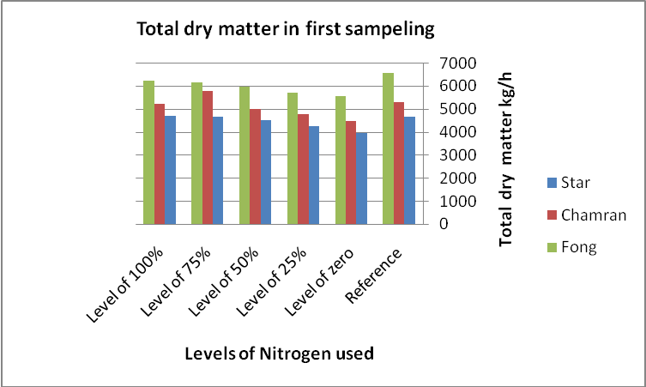
Fig. (1): A comparison of average produced dry matter values in the first sampling (60 days after planting)

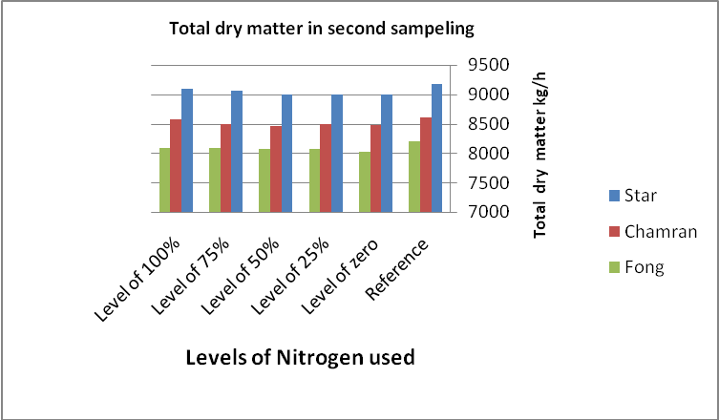

Fig. (2): A comparison of average produced dry matter values in the second sampling (90 days after planting)

Fig. (3): A comparison of average produced dry matter values during harvest period (120 days after planting)
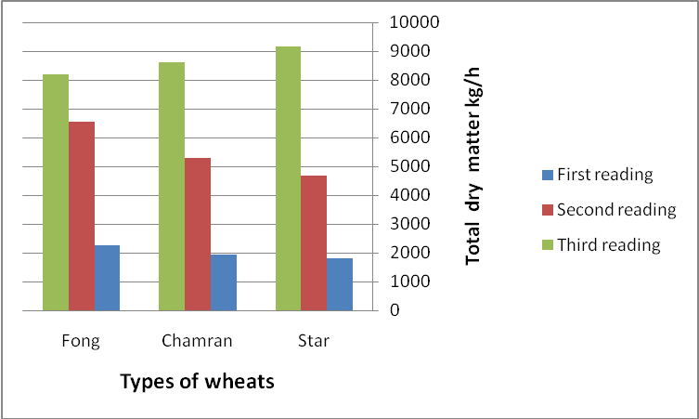
Fig. (4): Dry matter production in three wheat cultivars over three sampling stages

